DMclient working perfectly

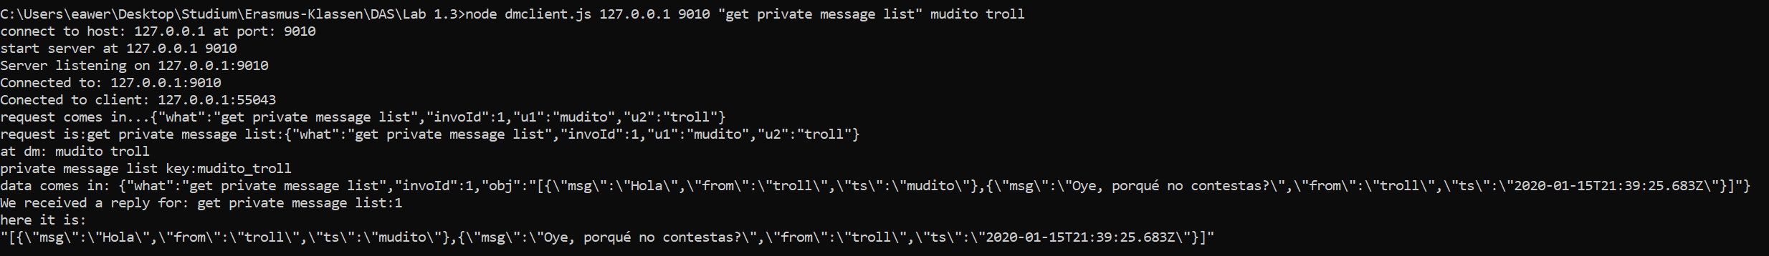

TCP error when substituting it to work with the forum

