Defining event periods:

Precipitation events:
1 day storm event with precip data:
Period defined by rise and fall of loads in subsequent days. Ex. Otter 10/10/90

Multiple day event with precip data:
If sequential days of precip produce a rise and fall in loads without a clear break between events
Period defined by rise and fall of loads in subsequent days. Ex. Otter 11/03/90

Missing precipitation event:
If a rise and fall in loads occurs without a recorded event, yet there is precip recorded at nearby NWS station, the event is discarded due to lack of variable data. Ex. Otter 10/21/90

Undetermined event:
If a rise and fall in loads occurs without a clear cause, the event is discarded due to lack of variable data. Ex: Otter 11/30/90

Winter events:

Missing Precip Data:
If a rise and fall in loads occur and a nearby NWS station indicates significant precip, event is defined because rain data may have been edited out during winter months due to accompanying snow fall or assumed melt. (May not be able to analyze due to lack of all rainfall variables)

Melt Periods:
Defined when significant melting is occurring as indicated by a drop in snow depth over 2 to several days. Always accompanies a rise and fall in loading values, may span several days.

Melt periods with zero snow depth.
If a clear rise and fall in loading occurs with a zero snow depth during the winter months, following some amount of snow, and temperatures are high, the event is defined. This is assumed to be snow melt due to snow remaining in depressions.
Ex: Otter 3/30/1992

Precip plus melt:
If Precip occurs on top of a recorded depth of snow, there is assumed melt also, and Event is considered a precip plus melt event. If precip occurs during winter months when snow depth is zero, melt is probable, but cannot be assumed because the rise and fall of the load cannot be separated.

Snow water equivalent

Calculate percentages for WI stations.
Use closest station or weighted average for 2 closest stations.
If one of the stations did not have a value, resorted to using value that was available.
If Value = 0%, not used, changed to NA

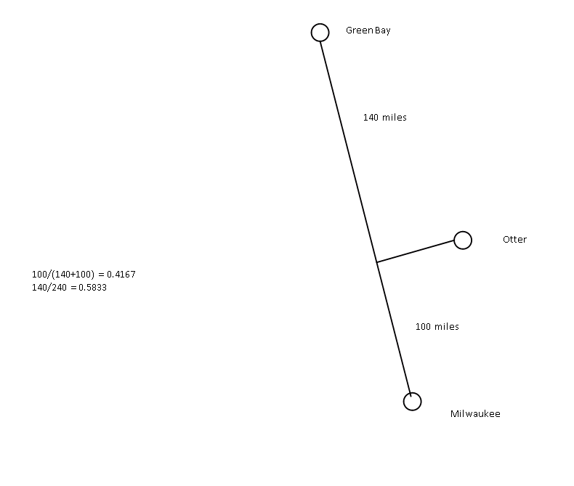
Ex. Otter creek:
Note: distances are inaccurate, correct distances were determined using Google Earth.
Correct values:
102 Milwaukee to GreenBay
51 GB to Plymouth
51 Plymouth to MKE
Eagle:
41 miles to Rochester
95 miles to Mpls
138 miles to MSN
Inverse distance weighted interpolation:
SWEQ=see http://www.uiowa.edu/~geog/health/interp/inv.html

Event type classification:
- Precip only
- Precip plus melt (precip data available)
- Precip plus melt (precip data missing)
- Precip only (winter) – data missing
- Melt (snow depth available)
- Melt with zero snow depth
- Melt (no depth available)
- Melt (do change detected)

Breakdown Otter:

- 285
- 30
- 61
- 0
- 17
- 26
- 5
Total 424

Measuring Melt:
Melt was attributed to day in which drop in snow depth began.
Melt amount was measured by taking the difference in depth of snow were available.
Melt was estimated when snow depth measurements were intermittent, yet a pre or post event measurement was suitable for estimating melt.
If melt plus snowfall occurred, snowfall was considered in calculating total melt.

There are many cases where melt was occurring, but snowfall data is intermittent or the amount of melt did not register in the snow depth measurements. The following codes were used:

U (Undetectable) Indicates a situation where rain fell on snow and no detectable melt was measured. Snow depth data available, but didn’t change, or melt occurred, but wasn’t detectable in snow depths recorded
Z (Zero depth) Event has classification 6 above.
N (NA) Snow depth data was not available for period, and insufficient data available to confidently estimate

Breakdown Otter:
48 melt events have no SWEQ
67 have no snow depth data or no measurable melt (33 of which also have no SWEQ)
22N(4) 18U(5) 26Z(24) 73depthavail(15)

139 melt events total (can include precip)
81 not usable?
58 usable?

List of Variables: List of Responses:
# distinct events |  | Total Phos Max Daily
Total theisen rainfall |  | Total Phos Total
p5max |  | Total Phos Avg Daily
p10max |  | Stormflow Phos Max Daily
p15max |  | Stormflow Phos Total
p30max |  | Stormflow Phos Avg Daily
p60max |  | Total Solids Max Daily
Erosivity index |  | Total Solids Total
Total storm duration |  | Total Solids Avg Daily
intensity |  | Stormflow Solids Max Daily
1 Day Antecedent Precip |  | Stormflow Solids Total
2 Day Antecedent Precip |  | Stormflow Solids Avg Daily
3 Day Antecedent Precip |  | Total Discharge Max Daily
Tmax (?) |  | Total Discharge Total
Tmin (?) |  | Total Discharge Avg Daily
Tmean (?) |  | Stormflow Discharge Max Daily
NWS Precip (?) |  | Stormflow Discharge Total
NWS Snow (?) |  | Stormflow Discharge Avg Daily
Melt(in)
Precip indicator (?)
Snow indicator (?)
Melt indicator (?)
Event Type (1-7)
SWEQ
Melt water
Total Water

