Place to put code ideas

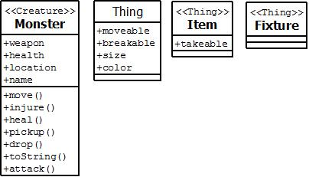

General Ideas:
[1] Thing classes will probably be mostly comprised of attributes rather than methods.
[2] Considering making subclasses of “Item” and “Fixture” such as weapons that
extend the “Item” class.

Todo:
Friday, February 24, 2012
[1] Design of Components --- done as team
-UML diagrams (object structures)
-Build the Components to implement given functionality
-Document the Structure (Javadoc)
-Build some testing code

Friday, March 2, 2012 --- Presentation
[1] Diagram your design
-Explain why you decided on this design
-Set of alternatives you checked out before deciding design
[2] Give sample code of design
-Look ahead to what needs to be done to have finished program

What we think should be done for the presentation (feel free to add/remove from list):
[1] Possible ways to implement designs
[2] Settle on ideas for designs
[3] Draw UML’s for sample classes (complete those above)
[4] Discuss pros/cons of our designs

