Forecasting daily store demand
Wesley Gates, September 2026. Summary of the full report.
A daily, store-level demand forecast, tested on a full year at ten stores against the forecasts an orderer might use without it. Project analyzes public data (the M5 dataset of Walmart daily sales, with a calendar of holidays and SNAP benefit days).
84% of seven-day forecasts better than ordering from last week's number, by a median of 28%, on a fast, regular mover.
10 of 10 stores better than ARIMA, the strongest statistical model, over the full year on that item.
23% less weekly order error than last week's number on that item, 36 units a week per store down to 27.6.
Five years of daily history, ten stores, 358 forecast origins per store, 3,580 seven-day forecasts per method (358 origins × 10 stores), ten methods (two benchmarks, four statistical models and four machine learning variants), and every model was refit at each origin.
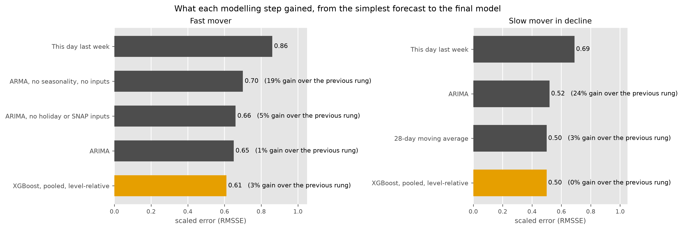
Figure 1. What each modelling step gained, from the simplest forecast (top) to the final model (bottom, gold). The label on each bar is the median gain over the step before it. The final model is a machine learning model, gradient-boosted trees (XGBoost) trained across all ten stores on a level-relative target. Each step is measured against the one before it, so the final model's gain is over a strong statistical model.
Table 1. The fast mover, every day of the test year as a forecast origin, for ten stores. Each rung is scored against the previous rung and against the first, store-week by store-week. RMSSE is the scaled error the M5 competition used, and 1.0 is last week's number on the training history. Weekly error is the average miss on a week's total order, in units. For the final model that is about 9% of a typical week's sales, and 11% for last week's number.
rung | RMSSE | weekly error, units | vs the previous rung |  |  | vs seasonal naive
 |  |  | weeks won | median gain | stores won of 10 | weeks won | median gain
This day last week (seasonal naive) | 0.86 | 36.0
ARMA, no seasonality, no inputs | 0.70 | 33.5 | 77% | 19% | 10 | 77% | 19%
ARIMA, no holiday or SNAP inputs | 0.66 | 32.7 | 65% | 5% | 10 | 82% | 24%
ARIMA | 0.65 | 31.5 | 58% | 1% | 9 | 83% | 25%
XGBoost, pooled, level-relative (final) | 0.61 | 27.6 | 58% | 3% | 10 | 84% | 28%
On a slow mover in decline (0.6 to 7 units a day) a 28-day moving average is the best forecast and the final XGBoost model ties it. Every series is classified by demand class before anything is fitted, and the rule for a wider catalogue is to give steady daily movers the machine learning model and items that do not sell every day the simple average. On this item the machine learning model still beats last week's number in 82% of store-weeks and is ahead of ARIMA at nine of ten stores.
Table 2. The slow mover, the same methods scored against last week's number. The full ladder is in the main report.
method | RMSSE | weekly error, units | weeks won vs seasonal naive | median gain vs seasonal naive
This day last week (seasonal naive) | 0.69 | 5.9
ARIMA | 0.52 | 5.8 | 77% | 24%
28-day moving average | 0.50 | 5.1 | 82% | 26%
XGBoost, pooled, level-relative (final) | 0.50 | 5.2 | 82% | 26%

What the system does
- Forecasts a seven-day order window from every day of the year, refitting at each origin, the way an ordering system might use them.
- Holiday and SNAP effects measured from the data. Seven of thirty calendar events move this item's sales, and the model sees the days until and since each.
- Bias reported beside error throughout. A forecast that runs systematically high is shrink every week and one that runs low is a stockout.
- All resulting numbers are byte-identical on subsequent runs. Each change to a model is scored against the previous version on the same 3,580 store-weeks, so noise shows up as a win rate close to 50%. The run records live in SQLite and load into SQL Server with one script, where the report's numbers come back by query.
- A full-year evaluation of all methods on one item in about fifteen minutes, and a validator that has to pass before any number is quoted.
The model's inputs are recent sales (the last three days and the same weekday over the last four weeks), the weekly pattern, the level and its spread over the last week to two months, the calendar and how many days ahead the forecast is, the days until and since the seven holidays that matter, SNAP benefit days, and, in the pooled model, the store.
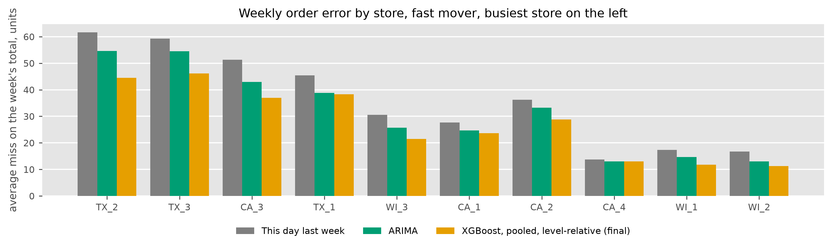
Figure 2. The average miss on a week's total order, in units, by store, busiest on the left. The final model misses by less than last week's number at every store and by less than ARIMA at nine of ten, level at the tenth. The busiest store benefits the most, 17 fewer units a week.

Next steps
- Turn the forecast into an order quantity at a chosen service level, which sets the trade-off between shrink and stockouts once, and score the orders on how often they would have run short.
- Use the built-in demand classifier to route each item to a method, and extend the routing to intermittent items with Croston's method and to new items with no sales history.
- Add the yearly pattern with Fourier terms or an STL decomposition, the approach recommended for daily data with a yearly cycle (Hyndman et al., 2026, §13.1).
- Scale from two items and ten stores to a department of 800 items, with the SQL Server store shared.
Full report and code: github.com/wesGates/demand-forecasting.
Hyndman, R. J., Athanasopoulos, G., Garza, A., Challu, C., Mergenthaler, M., and Olivares, K. G. (2026). Forecasting: Principles and Practice, the Pythonic Way. OTexts.
Makridakis, S., Spiliotis, E., and Assimakopoulos, V. (2022). M5 accuracy competition. International Journal of Forecasting, 38(4), 1346–1364.

