Paper Title (use style: paper title)
Subtitle as needed (paper subtitle)

Authors Name/s per 1st Affiliation (Author)
line 1 (of Affiliation): dept. name of organization
line 2: name of organization, acronyms acceptable
line 3: City, Country
line 4: e-mail address if desired
Authors Name/s per 2nd Affiliation (Author)
line 1 (of Affiliation): dept. name of organization
line 2: name of organization, acronyms acceptable
line 3: City, Country
line 4: e-mail address if desired

Abstract—This electronic document is a “live” template. The various components of your paper [title, text, heads, etc.] are already defined on the style sheet, as illustrated by the portions given in this document. (Abstract)
Keywords-component; formatting; style; styling; insert (key words)

Introduction

- Example of a figure caption. (figure caption)
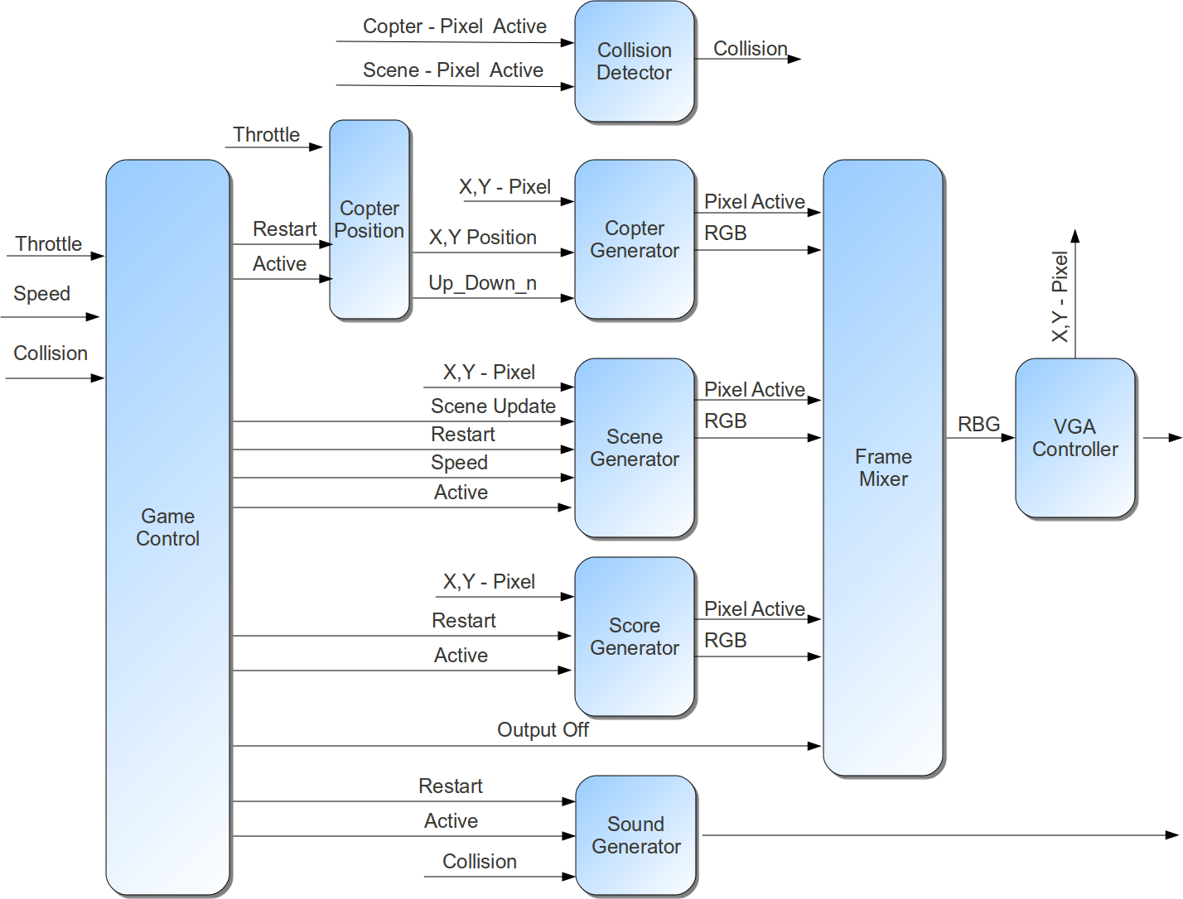

….

Background

Selecting a Template (Heading 2)
...

Game Controller Module
The Game Controller Module is comprised built using a Finite State Machine (FSM) of seven (7) states as shown in Illustration XXXX.. The seven After the asynchronous reset is release the state machine enters the 'IDLE' state. This state and the next state ('SETUP') are responsible for for allowing the other modules to initialize but prevents output from being sent to the VGA Controller. This prevents image artifacts from being displayed just after reset but before the game has started. After the other modules in the game have been given time to initialize, the FSM enters the 'WAIT_FOR_START' state. In this state the FSM waits until the users presses the throttle button. When the throttle pressed condition is met the FSM enters the 'IN_PROGRESS' state. In this state the 'GAME_IN_PROGRESS' signal set to '1' and the internal update image pulse generator is enabled. In this state the other game modules are allowed to run. The FSM will remain in this state until the Collision signal is set to '1'. When the Collision signal is asserted the FSM transitions to the 'DISPLAY_END' state where is will remains for about two (2) seconds before transitioning into the 'WAIT_END_ACK_PRESS' state. The delay was used to allow the users brain to process the fact that they have crashed and should stop toggling the throttle button. Without this state the user could unintentionally enter into a new game. After the display end delay, the FSM is waiting for the throttle to be pressed and then release. This acts as the continue after game over. When the throttle release the FSM transitions from the 'WAIT_END_ACK_RELEASE' back into the 'IDLE' state.
Identify applicable sponsor/s here. (sponsors)
- Example of a figure caption. (figure caption)
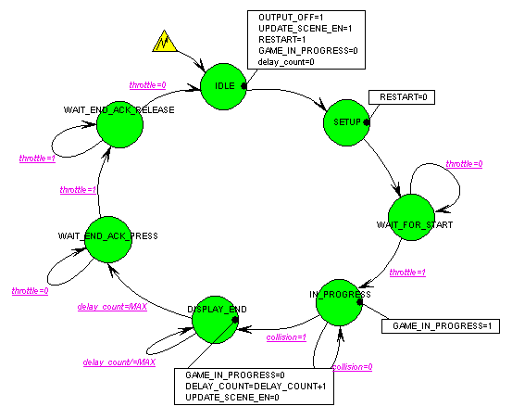

Copter Position Module
The Copter Position Module is used to take the user throttle input and determine the proper xy base coordinates to feed into the Copter Generation Module. It is also responsible for keeping tracking of the last direction of the copter (up or down) and feeding that into the Copter Generation. To prevent the copter from moving to quickly this module uses an internal pulse generator that slows the user input down

Copter Generation Module
The Copter Generation Module take the current copter base position and the current VGA x,y pixel position and determines if the copter is present. This is calculated using the known height and width and creating and imaginary box around the area on the screen. If the VGA x,y pixel position is inside the box then this module look into one of the two copter image lookup tables to determine if it needs to drive a RGB value out.
- Example of a figure caption. (figure caption)
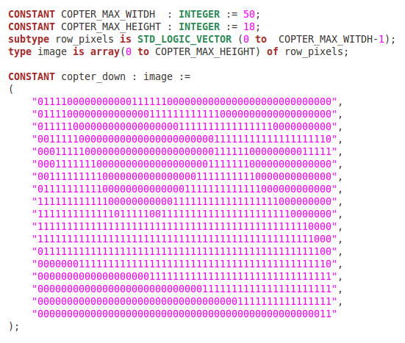

VGA Mixer Module
The VGA Mixer module provides a mechanism to layer the four video components (background, scene, copter and score) into a single layer that feeds pixel data into the VGA Controller. Each source layer provides the mixer their 8-bit Red Green Blue (RGB) value for the current x,y pixel and a pixel active signal to indicate if they would like to drive a color out to the VGA controller. The background layer is an implied layer; in the absence of a pixel active from any of the source layers the default color is driven out to the VGA controller. The default color is set using a VHDL generic.
The following were using for the layering in the Throttle Copter game. The list is organized from the back layer to the top layer.
- Implied Background Layer
- Scene and Obstacles
- Copter
- Score

Collision Detetection Module
The Collision Detection module is responsible for detecting when the copter has crash into the cave walls or the obstacle blocks. The detection is done by performing a logic AND with the copter pixel active signal and the scene pixel active signal. For proper handshaking of the collision signal back to the Game Controller module the Collision Detection modules also performs and rising edge edge detection of the collision signal and will only clear this flag when the Game Controller module triggers and Game Restart condition.

Prepare Your Paper Before Styling
Before you begin to format your paper, first write and save the content as a separate text file. Keep your text and graphic files separate until after the text has been formatted and styled. Do not use hard tabs, and limit use of hard returns to only one return at the end of a paragraph. Do not add any kind of pagination anywhere in the paper. Do not number text heads-the template will do that for you.
Finally, complete content and organizational editing before formatting. Please take note of the following items when proofreading spelling and grammar:

Abbreviations and Acronyms
Define abbreviations and acronyms the first time they are used in the text, even after they have been defined in the abstract. Abbreviations such as IEEE, SI, MKS, CGS, sc, dc, and rms do not have to be defined. Do not use abbreviations in the title or heads unless they are unavoidable.

Units
- Use either SI (MKS) or CGS as primary units. (SI units are encouraged.) English units may be used as secondary units (in parentheses). An exception would be the use of English units as identifiers in trade, such as “3.5-inch disk drive”.
- Avoid combining SI and CGS units, such as current in amperes and magnetic field in oersteds. This often leads to confusion because equations do not balance dimensionally. If you must use mixed units, clearly state the units for each quantity that you use in an equation.
- Do not mix complete spellings and abbreviations of units: “Wb/m2” or “webers per square meter”, not “webers/m2”. Spell out units when they appear in text: “. . . a few henries”, not “. . . a few H”.
- Use a zero before decimal points: “0.25”, not “.25”. Use “cm3”, not “cc”. (bullet list)

Equations
The equations are an exception to the prescribed specifications of this template. You will need to determine whether or not your equation should be typed using either the Times New Roman or the Symbol font (please no other font). To create multileveled equations, it may be necessary to treat the equation as a graphic and insert it into the text after your paper is styled.
Number equations consecutively. Equation numbers, within parentheses, are to position flush right, as in (1), using a right tab stop. To make your equations more compact, you may use the solidus ( / ), the exp function, or appropriate exponents. Italicize Roman symbols for quantities and variables, but not Greek symbols. Use a long dash rather than a hyphen for a minus sign. Punctuate equations with commas or periods when they are part of a sentence, as in
       
Note that the equation is centered using a center tab stop. Be sure that the symbols in your equation have been defined before or immediately following the equation. Use “(1)”, not “Eq. (1)” or “equation (1)”, except at the beginning of a sentence: “Equation (1) is . . .”

Some Common Mistakes
- The word “data” is plural, not singular.
- The subscript for the permeability of vacuum μ₀, and other common scientific constants, is zero with subscript formatting, not a lowercase letter “o”.
- In American English, commas, semi-/colons, periods, question and exclamation marks are located within quotation marks only when a complete thought or name is cited, such as a title or full quotation. When quotation marks are used, instead of a bold or italic typeface, to highlight a word or phrase, punctuation should appear outside of the quotation marks. A parenthetical phrase or statement at the end of a sentence is punctuated outside of the closing parenthesis (like this). (A parenthetical sentence is punctuated within the parentheses.)
- A graph within a graph is an “inset”, not an “insert”. The word alternatively is preferred to the word “alternately” (unless you really mean something that alternates).
- Do not use the word “essentially” to mean “approximately” or “effectively”.
- In your paper title, if the words “that uses” can accurately replace the word “using”, capitalize the “u”; if not, keep using lower-cased.
- Be aware of the different meanings of the homophones “affect” and “effect”, “complement” and “compliment”, “discreet” and “discrete”, “principal” and “principle”.
- Do not confuse “imply” and “infer”.
- The prefix “non” is not a word; it should be joined to the word it modifies, usually without a hyphen.
- There is no period after the “et” in the Latin abbreviation “et al.”.
- The abbreviation “i.e.” means “that is”, and the abbreviation “e.g.” means “for example”.
An excellent style manual for science writers is [7].

Using the Template
After the text edit has been completed, the paper is ready for the template. Duplicate the template file by using the Save As command, and use the naming convention prescribed by your conference for the name of your paper. In this newly created file, highlight all of the contents and import your prepared text file. You are now ready to style your paper; use the scroll down window on the left of the MS Word Formatting toolbar.

Authors and Affiliations
The template is designed so that author affiliations are not repeated each time for multiple authors of the same affiliation. Please keep your affiliations as succinct as possible (for example, do not differentiate among departments of the same organization). This template was designed for two affiliations.

For author/s of only one affiliation (Heading 3): To change the default, adjust the template as follows.

Selection (Heading 4): Highlight all author and affiliation lines.

Change number of columns: Select the Columns icon from the MS Word Standard toolbar and then select “1 Column” from the selection palette.

Deletion: Delete the author and affiliation lines for the second affiliation.

For author/s of more than two affiliations: To change the default, adjust the template as follows.

Selection: Highlight all author and affiliation lines.

Change number of columns: Select the “Columns” icon from the MS Word Standard toolbar and then select “1 Column” from the selection palette.

Highlight author and affiliation lines of affiliation 1 and copy this selection.

Formatting: Insert one hard return immediately after the last character of the last affiliation line. Then paste down the copy of affiliation 1. Repeat as necessary for each additional affiliation.

Reassign number of columns: Place your cursor to the right of the last character of the last affiliation line of an even numbered affiliation (e.g., if there are five affiliations, place your cursor at end of fourth affiliation). Drag the cursor up to highlight all of the above author and affiliation lines. Go to Column icon and select “2 Columns”. If you have an odd number of affiliations, the final affiliation will be centered on the page; all previous will be in two columns.

Identify the Headings
Headings, or heads, are organizational devices that guide the reader through your paper. There are two types: component heads and text heads.
Component heads identify the different components of your paper and are not topically subordinate to each other. Examples include Acknowledgments and References and, for these, the correct style to use is “Heading 5”. Use “figure caption” for your Figure captions, and “table head” for your table title. Run-in heads, such as “Abstract”, will require you to apply a style (in this case, italic) in addition to the style provided by the drop down menu to differentiate the head from the text.
Text heads organize the topics on a relational, hierarchical basis. For example, the paper title is the primary text head because all subsequent material relates and elaborates on this one topic. If there are two or more sub-topics, the next level head (uppercase Roman numerals) should be used and, conversely, if there are not at least two sub-topics, then no subheads should be introduced. Styles named “Heading 1”, “Heading 2”, “Heading 3”, and “Heading 4” are prescribed.

Figures and Tables

Positioning Figures and Tables: Place figures and tables at the top and bottom of columns. Avoid placing them in the middle of columns. Large figures and tables may span across both columns. Figure captions should be below the figures; table heads should appear above the tables. Insert figures and tables after they are cited in the text. Use the abbreviation “Fig. 1”, even at the beginning of a sentence.
- Table Type Styles
Table Head | Table Column Head
Table Head | Table column subhead | Subhead | Subhead
copy | More table copyª
a. Sample of a Table footnote. (Table footnote)

- Example of a figure caption. (figure caption)
We suggest that you use a text box to insert a graphic (which is ideally a 300 dpi TIFF or EPS file, with all fonts embedded) because, in an MSW document, this method is somewhat more stable than directly inserting a picture.
To have non-visible rules on your frame, use the MSWord “Format” pull-down menu, select Text Box > Colors and Lines to choose No Fill and No Line.
Figure Labels: Use 8 point Times New Roman for Figure labels. Use words rather than symbols or abbreviations when writing Figure axis labels to avoid confusing the reader. As an example, write the quantity “Magnetization”, or “Magnetization, M”, not just “M”. If including units in the label, present them within parentheses. Do not label axes only with units. In the example, write “Magnetization (A/m)” or “Magnetization {A[m(1)]}”, not just “A/m”. Do not label axes with a ratio of quantities and units. For example, write “Temperature (K)”, not “Temperature/K”.

Acknowledgment (Heading 5)
The preferred spelling of the word “acknowledgment” in America is without an “e” after the “g”. Avoid the stilted expression, “One of us (R. B. G.) thanks . . .” Instead, try “R. B. G. thanks”. Put sponsor acknowledgments in the unnum-bered footnote on the first page.

References
The template will number citations consecutively within brackets [1]. The sentence punctuation follows the bracket [2]. Refer simply to the reference number, as in [3]—do not use “Ref. [3]” or “reference [3]” except at the beginning of a sentence: “Reference [3] was the first . . .”
Number footnotes separately in superscripts. Place the actual footnote at the bottom of the column in which it was cited. Do not put footnotes in the reference list. Use letters for table footnotes.
Unless there are six authors or more give all authors' names; do not use “et al.”. Papers that have not been published, even if they have been submitted for publication, should be cited as “unpublished” [4]. Papers that have been accepted for publication should be cited as “in press” [5]. Capitalize only the first word in a paper title, except for proper nouns and element symbols.
For papers published in translation journals, please give the English citation first, followed by the original foreign-language citation [6].

- G. Eason, B. Noble, and I. N. Sneddon, “On certain integrals of Lipschitz-Hankel type involving products of Bessel functions,” Phil. Trans. Roy. Soc. London, vol. A247, pp. 529–551, April 1955. (references)
- J. Clerk Maxwell, A Treatise on Electricity and Magnetism, 3rd ed., vol. 2. Oxford: Clarendon, 1892, pp.68–73.
- I. S. Jacobs and C. P. Bean, “Fine particles, thin films and exchange anisotropy,” in Magnetism, vol. III, G. T. Rado and H. Suhl, Eds. New York: Academic, 1963, pp. 271–350.
- K. Elissa, “Title of paper if known,” unpublished.
- R. Nicole, “Title of paper with only first word capitalized,” J. Name Stand. Abbrev., in press.
- Y. Yorozu, M. Hirano, K. Oka, and Y. Tagawa, “Electron spectroscopy studies on magneto-optical media and plastic substrate interface,” IEEE Transl. J. Magn. Japan, vol. 2, pp. 740–741, August 1987 [Digests 9th Annual Conf. Magnetics Japan, p. 301, 1982].
- M. Young, The Technical Writer's Handbook. Mill Valley, CA: University Science, 1989.

