SiaqodbManager 3.0
SiaqodbManager manage siaqodb databases by loading objects data stored and also let possibility to developer to run LINQ queries over stored objects.

There are 2 main features of SiaqodbManager:

- Through SiaqodbManager you are able to retrieve objects stored in database without having Type loaded at runtime. So by double click/Open a Type from “Database explorer” panel, there are opened all objects of a certain Type stored in current database and SiaqodbManager is using for this the Metadata stored along with objects in db files. After objects are loaded, you are able to Add/Edit/Delete objects from database in similar way like Microsoft SQL Management Studio does:
- Insert: you can add objects for an existing Type by going to last line and hit Enter after you fill the row
- Edit: you can edit on the fly and Save occur after you leave the current cell
- Delete: you can delete an object by selecting row header and hit “Delete” button on your keyboard

- Through SiaqodbManager you are able to run LINQ queries on the fly over stored objects but this require to load Types at runtime, so you have to “Add references” and/or “Namespaces” before run a LINQ statement. SiaqodbManager compile your LINQ query using CodeDom and run the LINQ over Siaqodb live like you would run from your code, so in same optimized way. Current LINQ is always running on current database selected and opened. Always you have to use “siaqodb” when you are referring the database variable, example:
var q = from Item item in siaqodb
select item;

All LINQ statements can be saved on disk and opened later on. Only one LINQ statement is possible to run once.
The result is readonly and also important behavior is that ONLY properties values of objects are showed in result grid, fields are not showed.

Menu and shortcuts:

- File
    - New LINQ Editor – Ctrl+N – open a new window to write and run a LINQ statement
    - Open LINQ file –Ctrl+O – open a .linq file saved on disk
    - Save –Ctrl+S –save current LINQ statement to disk
    - Save as –save to a certain file current LINQ statement to disk
    - Exit –close the application

- Query
    - Execute – F5 –Execute current LINQ statement
    - References… –Add/Remove references and namespaces. SiaqodbManager, to be able to run a LINQ query, needs references to assemblies where the Types are defined.
Important:To run a LINQ query over a Silverlight database(IsolatedStorage or not) your Types are defined inside a Silverlight assembly, so you need to add as reference that assembly but also SiaqodbSL.dll + Silverlight assemblies. Remove all defaults, so the minimum list of references would be:
- C:\Program Files (x86)\Reference Assemblies\Microsoft\Framework\Silverlight\v4.0\System.Core.dll
-SiaqodbSL.dll
-YourSilverlightApp.dll
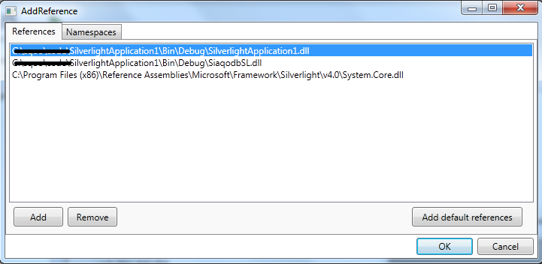

Similar for WindowsPhone7 assemblies you need to take System.Core from :
C:\Program Files (x86)\Reference Assemblies\Microsoft\Framework\Silverlight\v4.0\Profile\WindowsPhone\ System.Core.dll
Similar for Monodroid.
- Encryption… - settings for encryption if your database is encrypted

