# Team Trekker (trkr)

## Wesley Folz

## Ryan Hoefferle

### ECE 473 Spring 2015

Contents

1. Front Matter 3

1.1 Table of Figures 3

1.2 Table of Tables 3

1.3 Executive Summary 3

1.4 Project Overview 3

2. Analysis and Models 4

2.1 Requirements 4

2.2 Application Analysis 6

2.3 Domain Analysis 7

2.4 Important Algorithms: 9

3. Design and Test 9

3.1 Class Design 9

3.2 Testing Strategy 9

3.3 Integration with Platform 9

4. Implementation Plan 9

4.1 Task Allocation and Breakdown 9

4.2 Timeline for Completion 9

4.3 Tasks and Experience 9

# Front Matter

## 1.1 Table of Figures

Figure 1: Main Menu Screen 6

Figure 2: Image Capture Screen 6

Figure 3: Image Gallery Screen 6

Figure 4: Help Screen 6

Figure 5: Model View Screen 6

Figure 6: Use Case Diagram 7

Figure 7: Sequence Diagram 7

Figure 8: Application Activity Diagram 8

Figure 9: Image to 3D Model Conversion Activity Diagram 8

## 1.2 Table of Tables

Table 1: Functional Requirements 4

Table 2: Non-Functional Requirements 5

## 1.3 Executive Summary

The proposed app will create a digital 3D model of an object from multiple photos of an object captured by the camera on a smartphone. This 3D model would be a collection of vertices, edges and potentially faces. The model of the object could then be exported into a standard graphics file such as a “.obj” or “.stl” file. Optionally, the app could display the 3D model that was created and allow the user to move it around and view it from different angles. Our app would start out simple by attempting its function on something like Lego blocks and if successful attempt the 3D capture of more complex shapes.

## 1.4 Project Overview

Simulating the world around us can be a difficult task; sometimes it requires creating accurate models of physical objects in the real world. Simulations are also much more interesting and easy for humans to understand and enjoy when a visual representation of the simulation is provided. This application hopes to aid in both of these problems with the conversion of simple two dimensional images of physical objects into three dimensional models. The overall goal of this application is to allow users to easily create digital models which accurately capture the physical reality of real world objects. By outputting these three dimensional models into standard graphics file formats, they can be used in all sorts of physical simulations for the purpose of scientific testing or entertainment. Delivering a mobile application that is capable of creating three dimensional models, takes advantage of the convenience of the camera and mobile computing power available in most smartphones.

# Analysis and Models

## 2.1 Requirements

|  |  |  |  |  |
| --- | --- | --- | --- | --- |
| **Functional Requirements** | | | | |
| Req# | TSS = The Software Shall | Difficulty  1/E - 5/H | Prerequisite Requirements | List |
| 1.1 | TSS will allow the user to take pictures with the smartphone camera. | 1 | n/a | B |
| 1.2 | TSS save multiple images as internal data structures. | 1 | n/a | B |
| 1.3 | TSS automatically differentiate a user selected object in an image from the background of that image. | 2 | 1.2 | A |
| 1.4 | TSS automatically detect outer edges of a user selected object. | 2 | 1.2 | A |
| 1.5 | TSS match similar features from multiple images taken of the same object from different angles. | 3 | 1.1, 1.2 | B |
| 1.6 | TSS convert images into a collection of vertices with xyz coordinates. | 3 | 1.5 | B |
| 1.7 | TSS combine vertices into triangulated faces. | 2 | 1.6 | B |
| 1.8 | TSS save output to the sd card on the device. | 1 | 1.7 | B |
| 1.9 | TSS share output files with other devices (e.g. email, cloud storage, etc.) | 1 | n/a | A |
| 1.10 | TSS allow users to rotate and view 3D models from different angles. | 3 | 1.11 | A |
| 1.11 | On shutdown of device or app, TSS compress current object files. | 2 | n/a | A |
|  |  |  |  |  |

Table 1: Functional Requirements

|  |  |  |  |  |
| --- | --- | --- | --- | --- |
| **Non-Functional Requirements** | | | | |
| Req# | TSS = The Software Shall | Difficulty  1/E - 5/H | Prerequisite Requirements | List |
| 2.1 | TSS be compatible with Andoird API 14 (Ice Cream Sandwich) to ensure compatibility with at least 85% of Android devices. | 1 | n/a | B |
| 2.2 | TSS require the capture of 2 or more images of an object from different angles before 3D conversion. | 1 | 1.1 | B |
| 2.3 | TSS output and save .obj files to the sd card. | 2 | 1.7 | B |
| 2.4 | TSS output and save .stl files to the sd card. | 3 | 1.7 | A |
| 2.5 | TSS import .obj files and render them as 3D models. | 4 | n/a | A |
| 2.6 | TSS will give dimensional ratios (height, width, and length) within an accuracy of a 10% POE (percent of Error) | 2 | n/a | B |

Table 2: Non-Functional Requirements

## 

## 2.2 Application Analysis

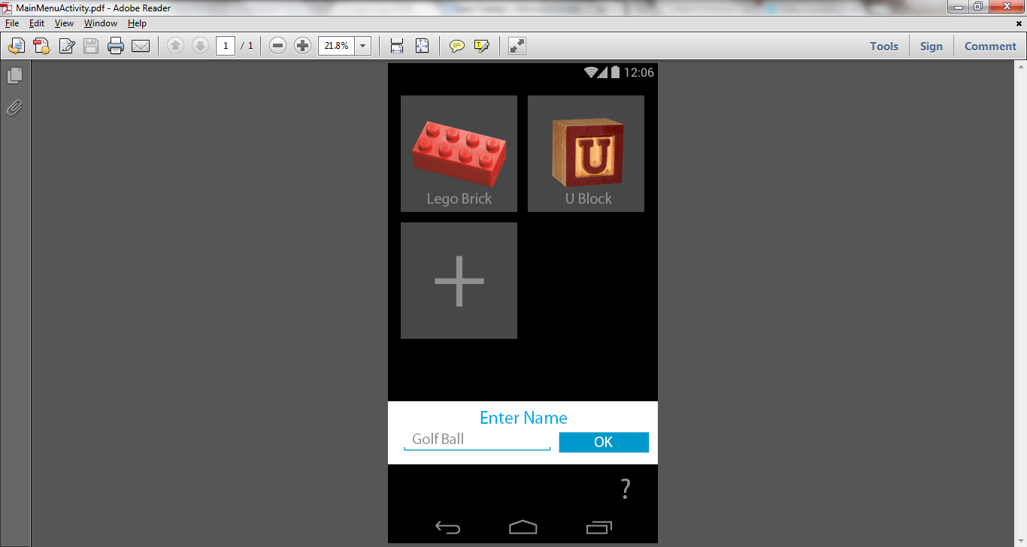 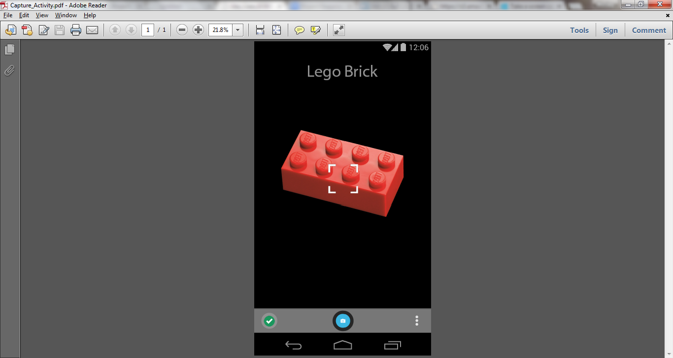 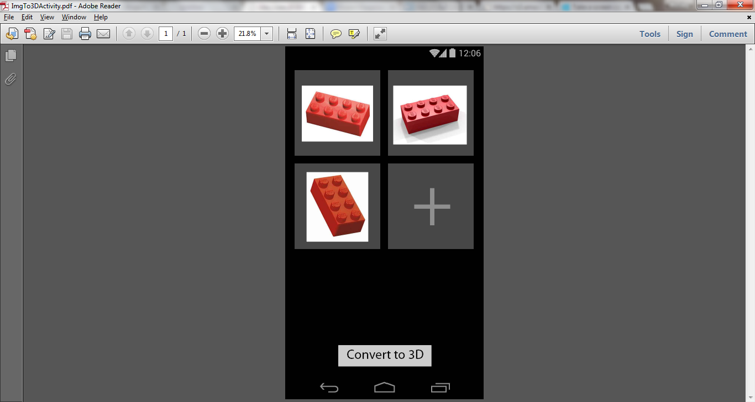

Figure 1: Main Menu Screen Figure 2: Image Capture Screen Figure 3: Image Gallery Screen

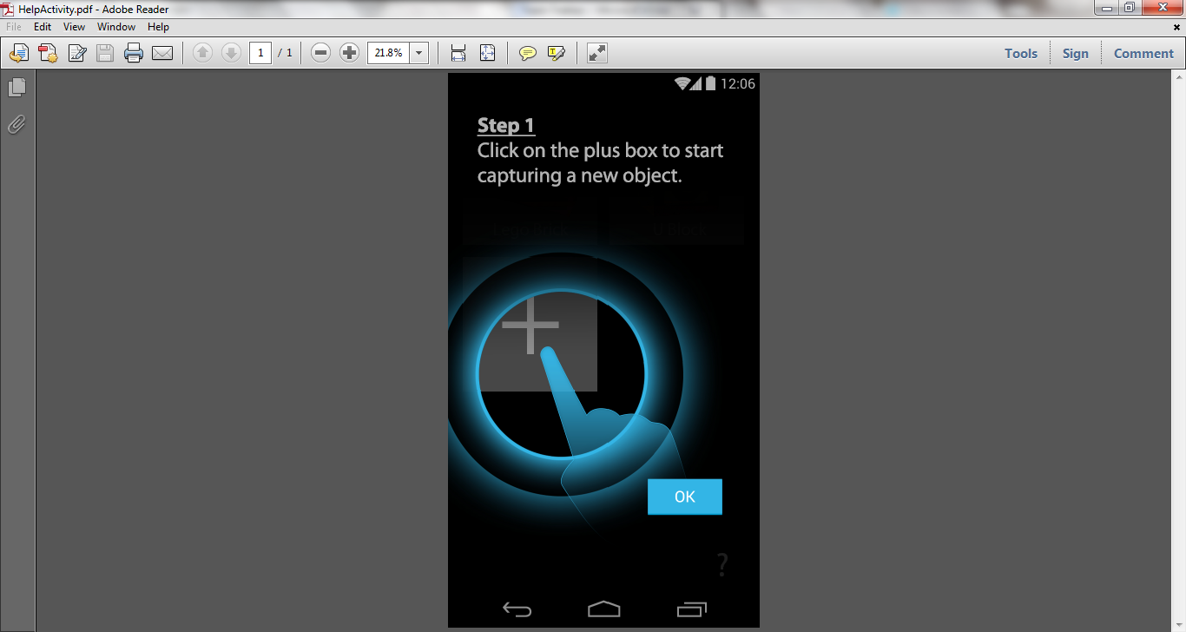 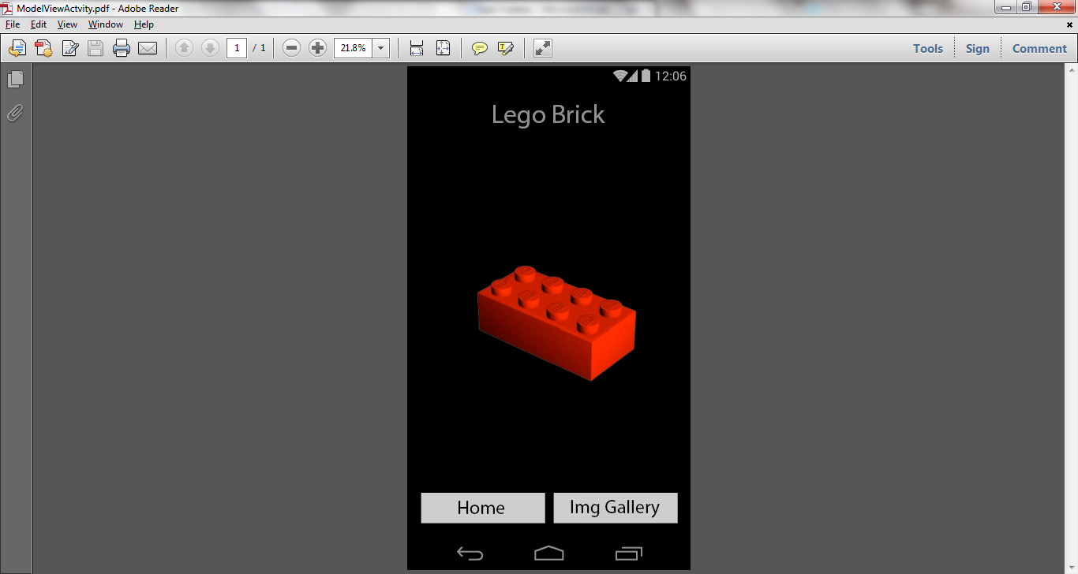

Figure 4: Help Screen Figure 5: Model View Screen

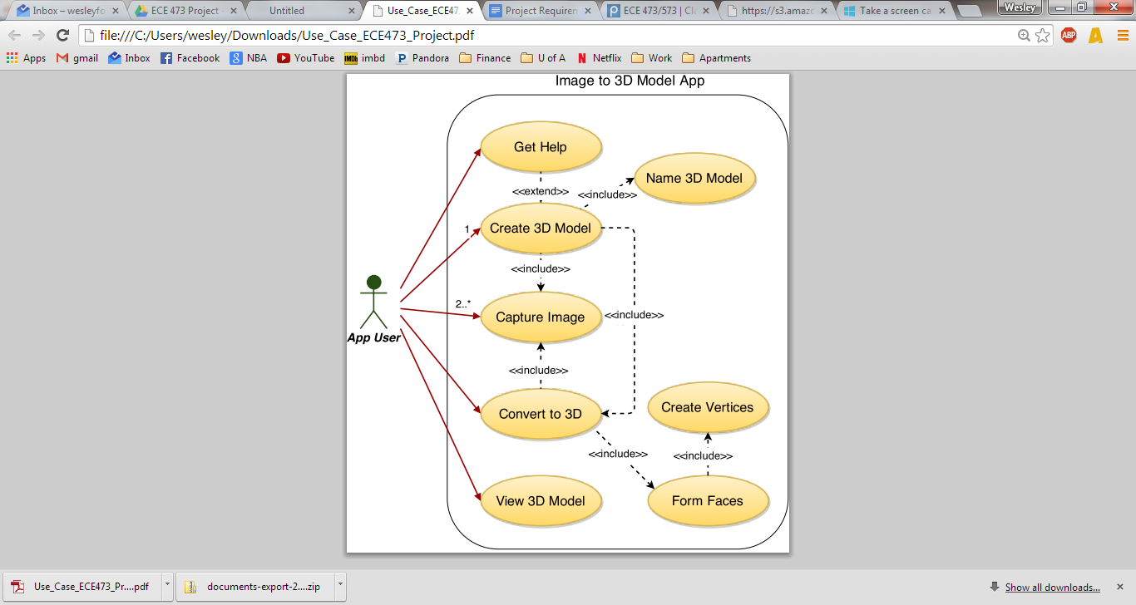

Figure 6: Use Case Diagram

## 2.3 Domain Analysis

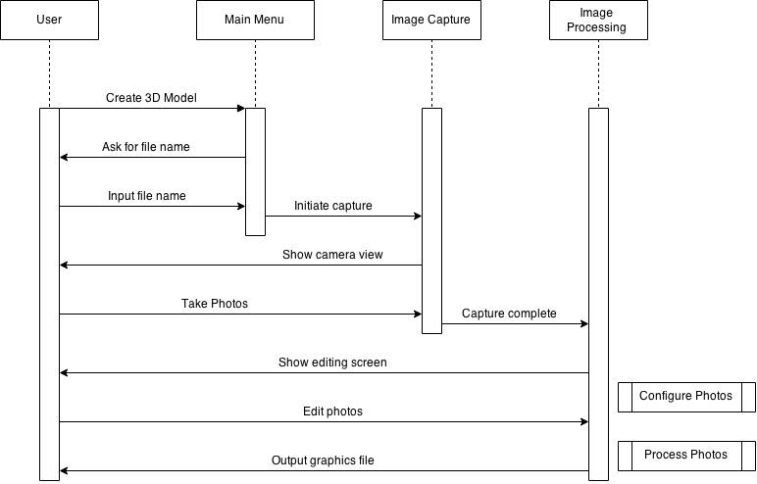

Figure 7: Sequence Diagram

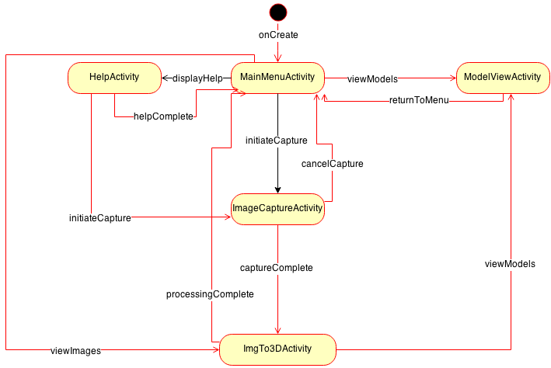

Figure 8: Application Activity Diagram

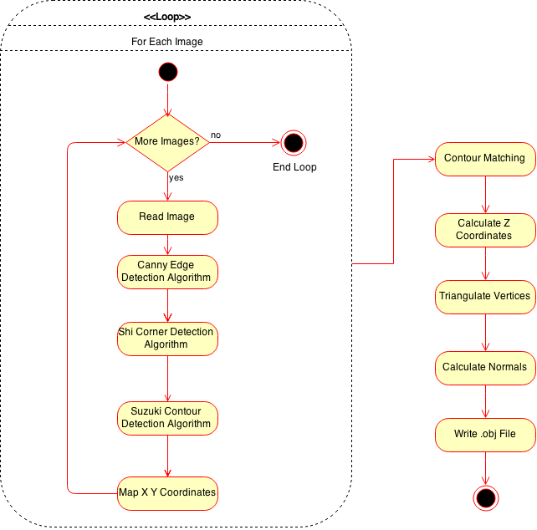

Figure 9: Image to 3D Model Conversion Activity Diagram

## 2.4 Important Algorithms:

* Canny86 algorithm: This algorithm will be used to detect the edges of an object in an image.   
  *J. Canny. A Computational Approach to Edge Detection, IEEE Trans. on Pattern Analysis and Machine Intelligence, 8(6), pp. 679-698 (1986).*
* Suzuki85 algorithm: This algorithm finds color contours which will help with object reconstruction.

*Suzuki, S. and Abe, K.,*Topological Structural Analysis of Digitized Binary Images by Border Following*. CVGIP 30 1, pp 32-46 (1985)*

* Shi94 algorithm: This algorithm detects strong corners of an object in an image.  
  *J. Shi and C. Tomasi. Good Features to Track. Proceedings of the IEEE Conference on Computer Vision and Pattern Recognition, pages 593-600, June 1994.*

# Design and Test

## 3.1 Class Design

## 3.2 Testing Strategy

## Integration with Platform

This application will require integration with the camera on an Android phone. The camera will take multiple pictures of an object that will eventually be converted into a 3D model. The CameraBridgeViewBase view, which is a class in the OpenCV library, will be used to display the camera image on the phone screen. When an image is captured with the camera, the image pixels will be internally stored in a Mat object, which is another class in the OpenCV library.

# Implementation Plan

## 4.1 Task Allocation and Breakdown

## 4.2 Timeline for Completion

## 4.3 Tasks and Experience