# http://ecx.images-amazon.com/images/I/61Mo5rrGr2L.gif Team Trekker (trkr)

## Wesley Folz

#### wesfolz@email.arizona.edu

## Ryan Hoefferle

#### drhoeffe@email.arizona.edu

### ECE 473 Project

### Spring 2015

Contents

1. Front Matter 3

1.1 Table of Figures 3

1.2 Table of Tables 3

1.3 Executive Summary 3

1.4 Project Overview 3

2. Analysis and Models 4

2.1 Requirements 4

2.2 Application Analysis 6

2.3 Domain Analysis 7

2.4 Important Algorithms: 9

3. Design and Test 9

3.1 Class Design 9

3.2 Testing Strategy 10

3.3 Integration with Platform 12

4. Implementation Plan 12

4.1 Task Allocation and Breakdown 12

4.2 Timeline for Completion 14

4.3 Tasks and Experience 14

# Front Matter

## 1.1 Table of Figures

Figure 1: Main Menu Screen Figure 2: Image Capture Screen Figure 3: Image Gallery Screen 6

Figure 6: Use Case Diagram 6

Figure 4: Help Screen Figure 5: Model View Screen 6

Figure 7: GUI State Diagram 7

Figure 8: Sequence Diagram 7

Figure 9: Application Activity Diagram 8

Figure 10: Image to 3D Model Conversion Activity Diagram 8

Figure 11: UML Object Diagram 10

Figure 12: Gantt Chart Timeline 14

## 1.2 Table of Tables

Table 1: Functional Requirements 5

Table 2: Non-Functional Requirements 5

Table 3: Functional Requirement Testing 11

Table 4: Non-Functional Requirement Testing 12

Table 5: Functional Requirement Assignments 13

Table 6: Non-Functional Requirement Assignments 13

## 1.3 Executive Summary

The proposed app will create a digital 3D model of an object from multiple photos of an object captured by the camera on a smartphone. This 3D model would be a collection of vertices, edges and potentially faces. The model of the object could then be exported into a standard graphics file such as a “.obj” or “.stl” file. Optionally, the app could display the 3D model that was created and allow the user to move it around and view it from different angles. Our app would start out simple by attempting its function on something like Lego blocks and if successful attempt the 3D capture of more complex shapes.

## 1.4 Project Overview

Simulating the world around us can be a difficult task; sometimes it requires creating accurate models of physical objects in the real world. Simulations are also much more interesting and easy for humans to understand and enjoy when a visual representation of the simulation is provided. This application hopes to aid in both of these problems with the conversion of simple two dimensional images of physical objects into three dimensional models. The overall goal of this application is to allow users to easily create digital models which accurately capture the physical reality of real world objects. By outputting these three dimensional models into standard graphics file formats, they can be used in all sorts of physical simulations for the purpose of scientific testing or entertainment. Delivering a mobile application that is capable of creating three dimensional models, takes advantage of the convenience of the camera and mobile computing power available in most smartphones.

# Analysis and Models

## 2.1 Requirements

|  |  |  |  |  |
| --- | --- | --- | --- | --- |
| **Functional Requirements** | | | | |
| Req# | TSS = The Software Shall | Difficulty  1/E - 5/H | Prerequisite Requirements | List |
| 1.1 | TSS will allow the user to take pictures with the smartphone camera. | 1 | n/a | B |
| 1.2 | TSS save multiple images as internal data structures. | 1 | n/a | B |
| 1.3 | TSS automatically differentiate a user selected object in an image from the background of that image. | 2 | 1.2 | A |
| 1.4 | TSS automatically detect outer edges of a user selected object. | 2 | 1.2 | A |
| 1.5 | TSS match similar features from multiple images taken of the same object from different known positions. | 3 | 1.1, 1.2 | B |
| 1.6 | TSS convert images into a collection of vertices with xyz coordinates. | 3 | 1.5 | B |
| 1.7 | TSS combine vertices into triangulated faces. | 2 | 1.6 | B |
| 1.8 | TSS save output to the sd card on the device. | 1 | 1.7 | B |
| 1.9 | TSS share output files with other devices (e.g. email, cloud storage, etc.) | 1 | n/a | A |
| 1.10 | TSS allow users to rotate and view 3D models from different angles. | 3 | 1.11 | A |
| 1.11 | On shutdown of device or app, TSS compress current object files. | 2 | n/a | A |
| 1.12 | TSS match similar features from multiple images taken of the same object from different unknown positions. | 4 | 1.5 | A |
| 1.13 | TSS allow the user to calibrate camera settings. | 1 | 1.1 | A |
|  |  |  |  |  |

Table 1: Functional Requirements

|  |  |  |  |  |
| --- | --- | --- | --- | --- |
| **Non-Functional Requirements** | | | | |
| Req# | TSS = The Software Shall | Difficulty  1/E - 5/H | Prerequisite Requirements | List |
| 2.1 | TSS be compatible with Andoird API 14 (Ice Cream Sandwich) to ensure compatibility with at least 85% of Android devices. | 1 | n/a | B |
| 2.2 | TSS require the capture of 2 or more images of an object from different angles before 3D conversion. | 1 | 1.1 | B |
| 2.3 | TSS output and save .obj files to the sd card. | 2 | 1.7 | B |
| 2.4 | TSS output and save .stl files to the sd card. | 3 | 1.7 | A |
| 2.5 | TSS import .obj files and render them as 3D models. | 4 | n/a | A |
| 2.6 | TSS will give dimensional ratios (height, width, and length) within a to be determined accuracy. | 2 | n/a | B |

Table 2: Non-Functional Requirements

## 2.2 Application Analysis

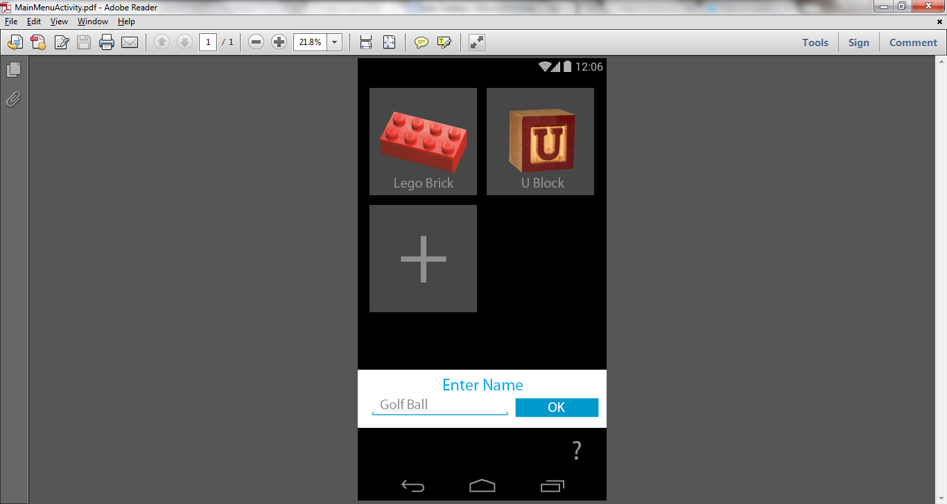 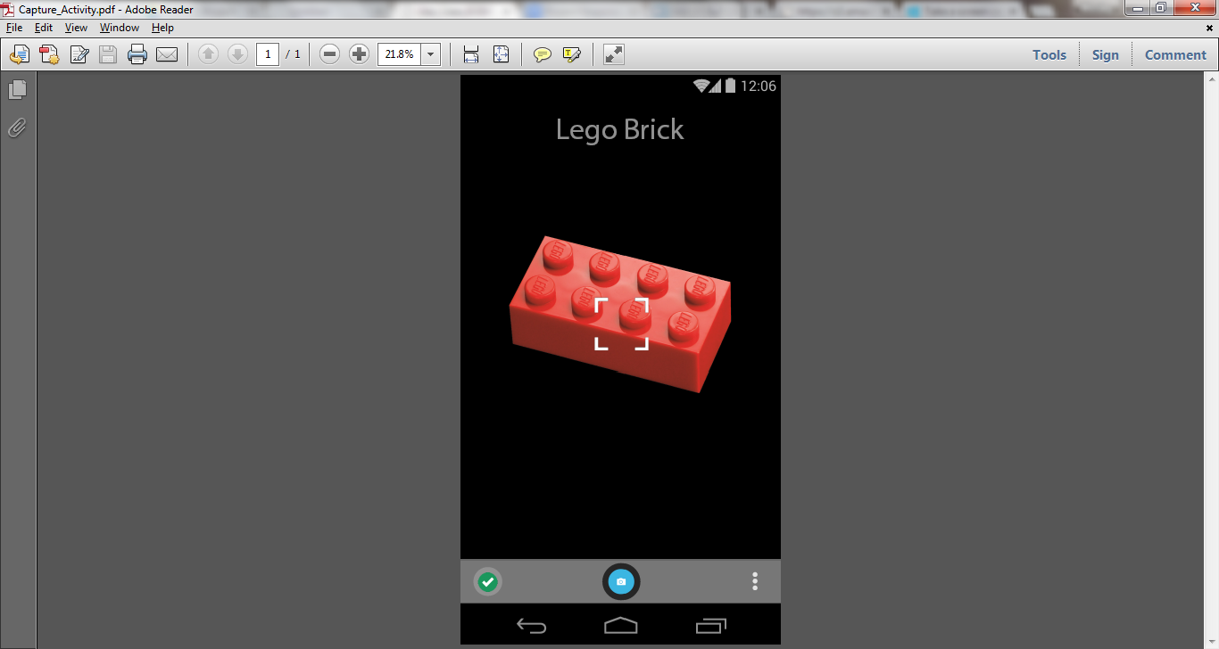 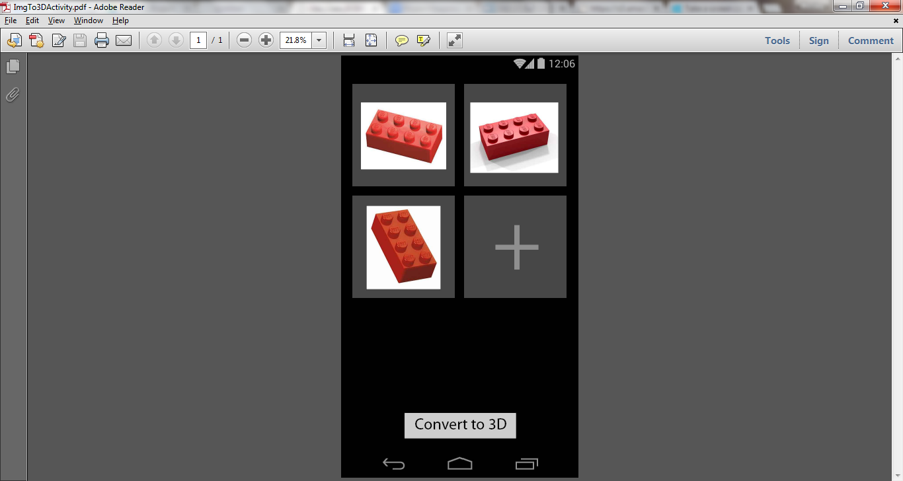

Figure 1: Main Menu Screen Figure 2: Image Capture Screen Figure 3: Image Gallery Screen

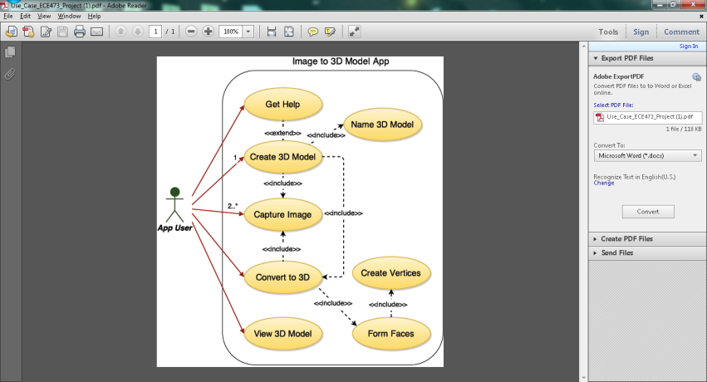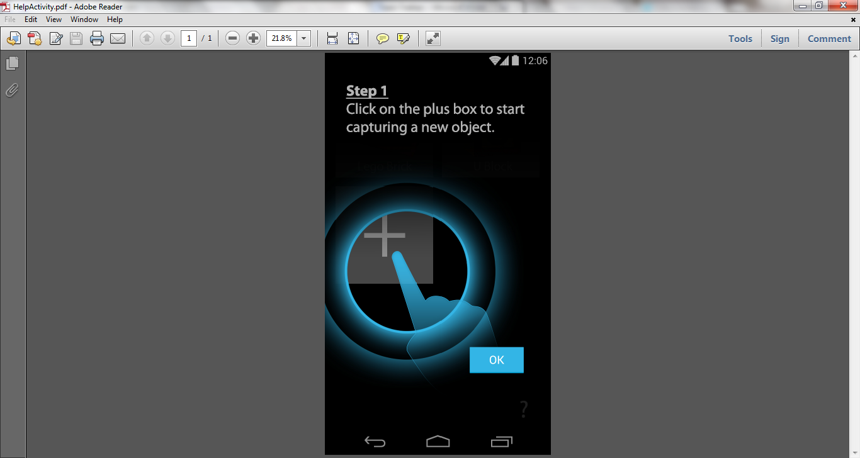 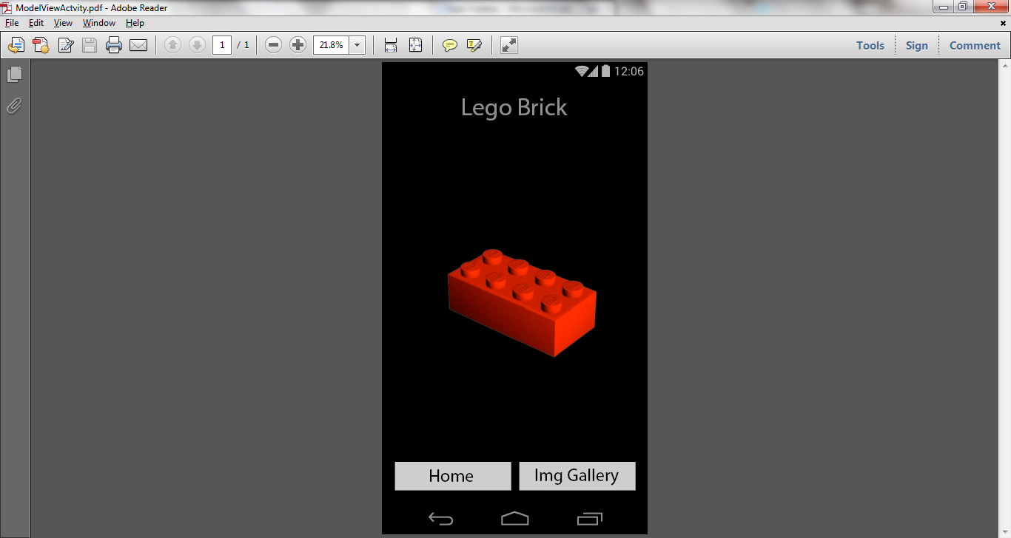

Figure 5: Help Screen Figure 6: Model View Screen

Figure 4: Use Case Diagram

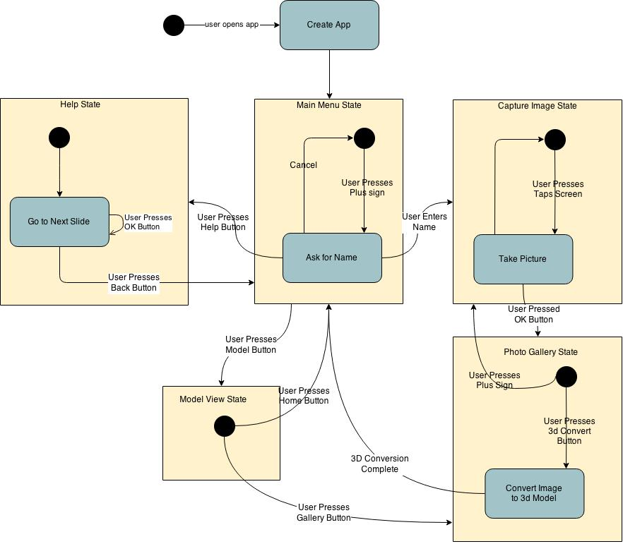

Figure 7: GUI State Diagram

## 2.3 Domain Analysis

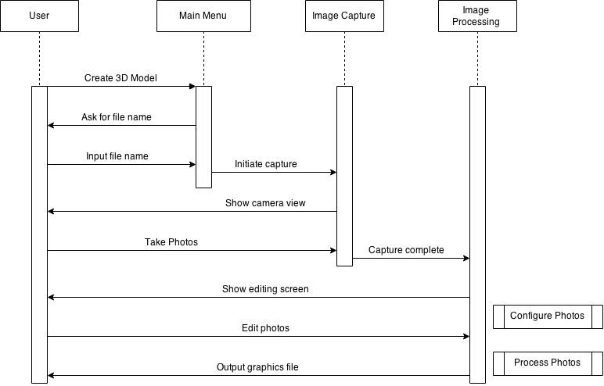

Figure 8: Sequence Diagram

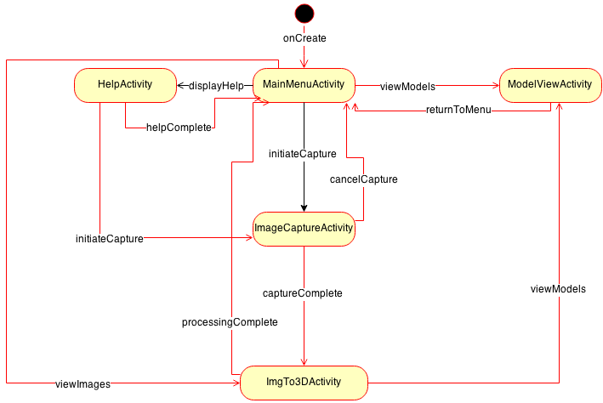

Figure 9: Application Activity Diagram

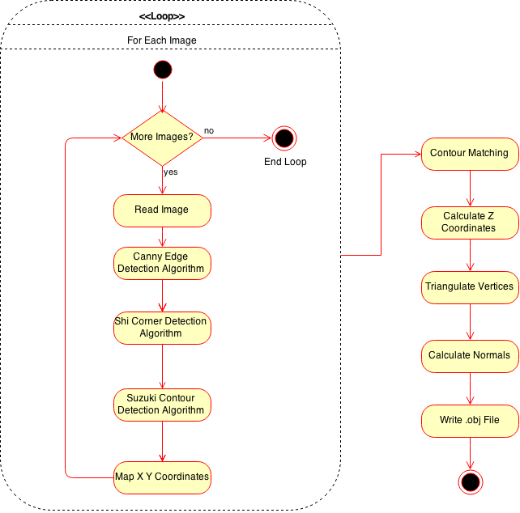

Figure 10: Image to 3D Model Conversion Activity Diagram

## 2.4 Important Algorithms:

* Canny86 algorithm: This algorithm will be used to detect the edges of an object in an image. It works by looking at color gradients, when it finds a spot in an image where the color gradient is changing drastically it marks it as an edge.   
  *J. Canny. A Computational Approach to Edge Detection, IEEE Trans. on Pattern Analysis and Machine Intelligence, 8(6), pp. 679-698 (1986).*
* Suzuki85 algorithm: This algorithm finds color contours which will help with object reconstruction. Color contours are lines of pixels within an image that have essentially the same color; these contours give us locations of different features within an image that can later be mapped compared to similar features in other images.

*Suzuki, S. and Abe, K.,*Topological Structural Analysis of Digitized Binary Images by Border Following*. CVGIP 30 1, pp 32-46 (1985)*

* Shi94 algorithm: This algorithm detects strong corners of an object in an image. It works similarly to the edge detection, but it looks at color gradients in multiple directions to determine specific points where object corners are likely to be.  
  *J. Shi and C. Tomasi. Good Features to Track. Proceedings of the IEEE Conference on Computer Vision and Pattern Recognition, pages 593-600, June 1994.*

Once we map edges, corners and contours onto each individual image, these features can be compared and lined up with features on each other image to stitch them together. Since each image will be taken from a known location, we will be able to interpolate the z-coordinate of each image point to give us a 3D representation of the images.

# Design and Test

## 3.1 Class Design

The diagram below shows the classes below and how they are associated. The MainMenuAcitivty is initially created at start up in the “Main Menu State”. If the plus button is pressed the MainMenuActivity creates a new Object3DModel and passes the focus of the app to the ImageCaptureActivity, which is part of the “Image Capture State”. After the user is done taking pictures the focus is handed off to the ModelPhotoGalleryActivity, which is in the “Photo Gallery State”. If the user decides to take more pictures by pressing the plus button in the photo gallery state the ModelPhotoGalleryActivity class hands the focus back to the ImageCaptureActivity, else if the minimum number of pictures has been reached and the user presses the “Convert to 3D” button the main 3D model algorithms are called. These Algorithms will create the vertices and faces for the Object3DModel class. A 3D object must have at least 4 vertices and 4 faces to be considered a 3D object, and a face or plane is a triangle which requires 3 vertices. As soon as the 3D object is created the focus is given back to the MainMenuActivity. To other classes can be given focus by the MainMenuActivity, these include the HelpActivity class and the ModelView Activity class. The ModelViewActivity class is associated with exactly one Object3DModel in the “Model View State” and the HelpActivity class is associated with the “Help State”.

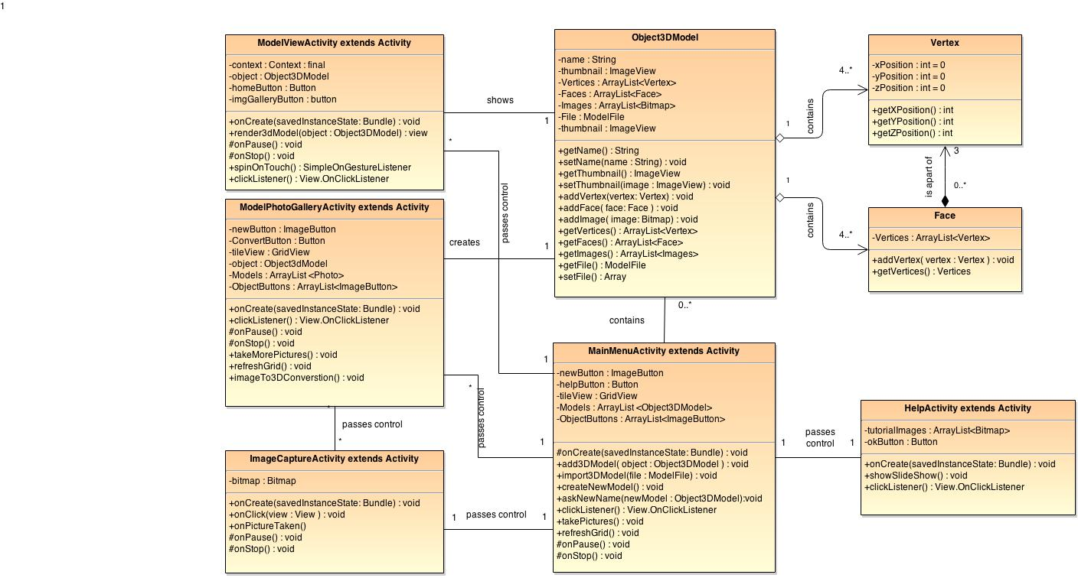

Figure 11: UML Object Diagram

## 3.2 Testing Strategy

|  |  |  |  |  |
| --- | --- | --- | --- | --- |
| **Testing Functional Requirements** | | U = Unit Test  M = Measure  I = Inspect | | |
| Req# | TSS = The Software Shall | U | M | I |
| 1.1 | TSS will allow the user to take pictures with the smartphone camera. Inspect pictures by looking for existence in the directory. |  |  | X |
| 1.2 | TSS save multiple images as internal data structures. | X |  |  |
| 1.3 | TSS automatically differentiates a user selected object in an image from the background of that image. |  |  | X |
| 1.4 | TSS automatically detect outer edges of a user selected object. | X |  |  |
| 1.5 | TSS match similar features from multiple images taken of the same object from different known positions. |  |  | X |
| 1.6 | TSS convert images into a collection of vertices with xyz coordinates. | X |  |  |
| 1.7 | TSS combine vertices into triangulated faces. | X |  |  |
| 1.8 | TSS save output to the sd card on the device. | X |  |  |
| 1.9 | TSS allow sharing of output files with other devices (e.g. email, cloud storage, etc.) | X |  |  |
| 1.10 | TSS allow users to rotate and view 3D models from different angles. |  |  | X |
| 1.11 | TSS compress current output files after creation. | X |  |  |
| 1.12 | TSS match similar features from multiple images taken of the same object from different unknown positions. |  |  | X |
| 1.13 | TSS allow the user to calibrate camera settings. | X |  |  |

Table 3: Functional Requirement Testing

|  |  |  |  |  |
| --- | --- | --- | --- | --- |
| **Testing Non-Functional Requirements** | | U = Unit Test  M = Measure  I = Inspect | | |
| Req# | TSS = The Software Shall | U | M | I |
| 2.1 | TSS be compatible with Andoird API 14 (Ice Cream Sandwich) to ensure compatibility with at least 85% of Android devices. |  |  | X |
| 2.2 | TSS require the capture of 2 or more images of an object from different angles before 3D conversion. | X |  |  |
| 2.3 | TSS output and save .obj files to the sd card. Inspect existence of file on sd card and open file in separate 3d model software. |  |  | X |
| 2.4 | TSS output and save .ply files to the sd card. Inspect existence of file on sc card and open file in separate 3d model software. |  |  | X |
| 2.5 | TSS import .obj files and render them as 3D models. | X |  | X |
| 2.6 | TSS will give dimensional ratios (height, width, and length) within a to be determined accuracy. |  | X |  |

Table 4: Non-Functional Requirement Testing

## Integration with Platform

This application will require integration with the camera on an Android phone. The camera will take multiple pictures of an object that will eventually be converted into a 3D model. The CameraBridgeViewBase view, which is a class in the OpenCV library, will be used to display the camera image on the phone screen. When an image is captured with the camera, the image pixels will be internally stored in a Mat object, which is another class in the OpenCV library.

# Implementation Plan

## 4.1 Task Allocation and Breakdown

|  |  |  |
| --- | --- | --- |
| **Functional Requirement Assignments** | | |
| Req# | TSS = The Software Shall | Assigned To |
| 1.1 | TSS will allow the user to take pictures with the smartphone camera. | Wesley |
| 1.2 | TSS save multiple images as internal data structures. | Ryan |
| 1.3 | TSS automatically differentiate a user selected object in an image from the background of that image. | Wesley |
| 1.4 | TSS automatically detect outer edges of a user selected object. | Wesley |
| 1.5 | TSS match similar features from multiple images taken of the same object from different known positions. | Wesley |
| 1.6 | TSS convert images into a collection of vertices with xyz coordinates. | Wesley |
| 1.7 | TSS combine vertices into triangulated faces. | Wesley |
| 1.8 | TSS save output to the sd card on the device. | Wesley |
| 1.9 | TSS allow sharing of output files with other devices (e.g. email, cloud storage, etc.) | Ryan |
| 1.10 | TSS allow users to rotate and view 3D models from different angles. | Wesley |
| 1.11 | On shutdown of device or app, TSS compress current object files. | Ryan |
| 1.12 | TSS match similar features from multiple images taken of the same object from different unknown positions. | Wesley |
| 1.13 | TSS allow the user to calibrate camera settings. | Ryan |

Table 5: Functional Requirement Assignments

|  |  |  |
| --- | --- | --- |
| **Testing Non-Functional Requirements** | | |
| Req# | TSS = The Software Shall | Assigned To |
| 2.1 | TSS be compatible with Andoird API 14 (Ice Cream Sandwich) to ensure compatibility with at least 85% of Android devices. | Ryan |
| 2.2 | TSS require the capture of 2 or more images of an object from different angles before 3D conversion. | Ryan |
| 2.3 | TSS output and save .obj files to the sd card. | Wesley |
| 2.4 | TSS output and save .stl files to the sd card. | Ryan |
| 2.5 | TSS import .obj files and render them as 3D models. | Wesley |
| 2.6 | TSS will give dimensional ratios (height, width, and length) within a to be determined accuracy. | Wesley |

Table 6: Non-Functional Requirement Assignments

## 4.2 Timeline for Completion

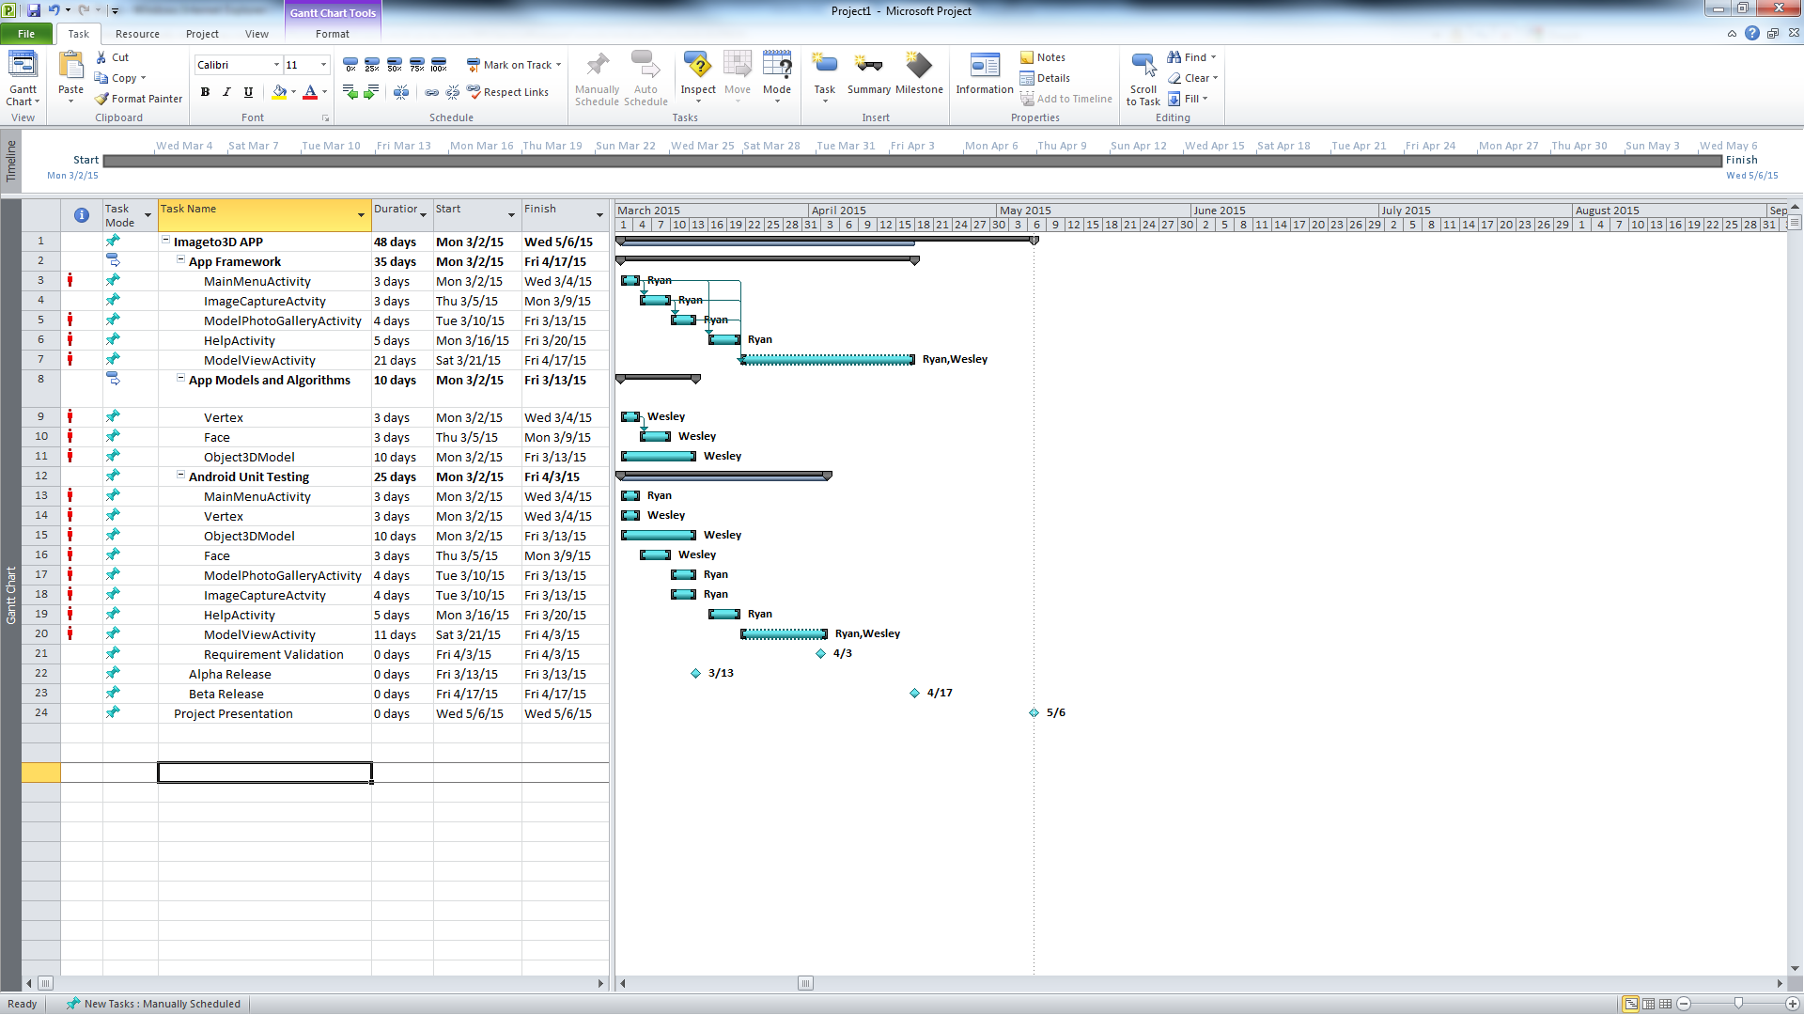

Figure 12: Gantt Chart Timeline

## 4.3 Tasks and Experience

Wesley has a background in algorithm development and has a keen eye for logical analysis, which would make him more apt to develop the 3D conversion and image processing algorithms. Ryan has experience in GUI development, website development and graphic design, which would make him more suited for creating the app framework.