Swift Programming Language Screenshots - Swift guided tour
Print out hello world and my name
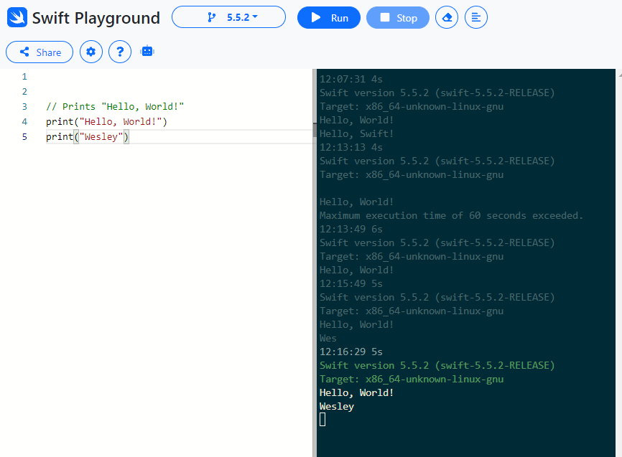
------------------------------------------------------------------------------------------------------------------------------------------
Print out a constant variable then use variable names inside string
Create array and dictionary then update dictionary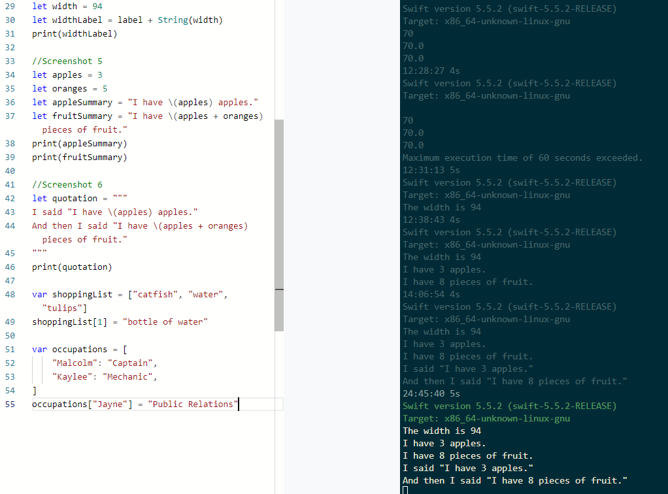

Print out shoppingList array and occupations dictionary
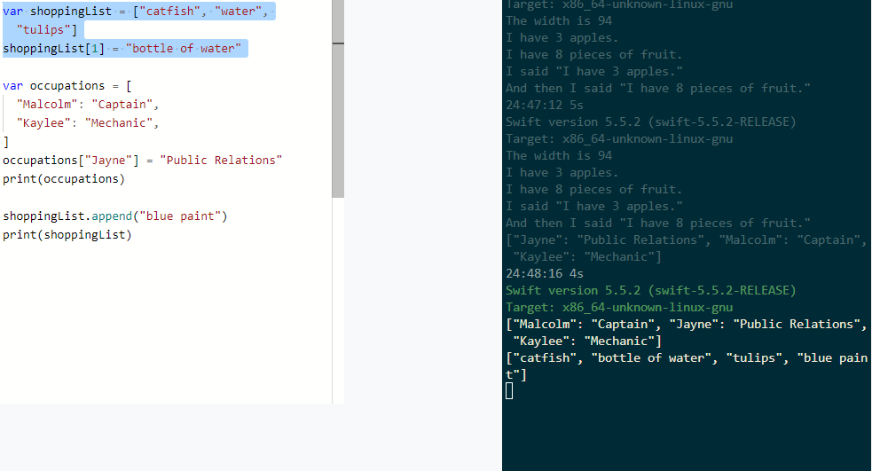
------------------------------------------------------------------------------------------------------------------------------------------
Using for loop perform mathematical assignments and prints value
(remaining swiftfiddle outputs are on MacOS font. Slightly less visible)
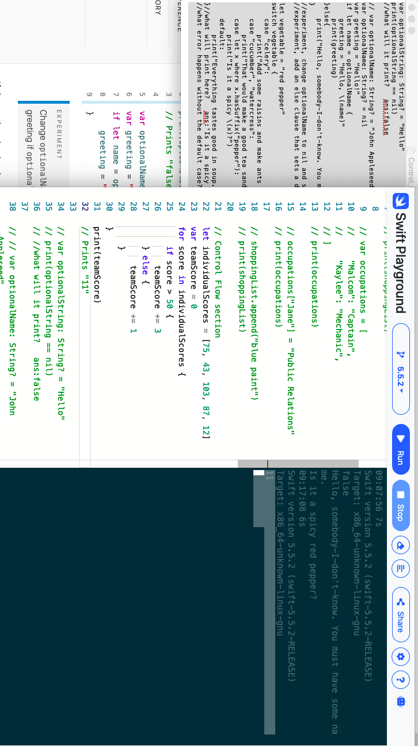
------------------------------------------------------------------------------------------------------------------------------------------

Sets an optional string value to either “Hello” or nil
Resets the variable to a name, if commented and replaced with a new value of nil the program prints the else clause
Using a switch clause to check a String with three possible outcomes aside from the default “Everything tastes good in soup”
The final case is a primitive function to check for only partial matching characters
Print the greeting with the optional variables inside the string, Final greeting print is a ?? optional variable in string, either thisVariable ?? thatVariable
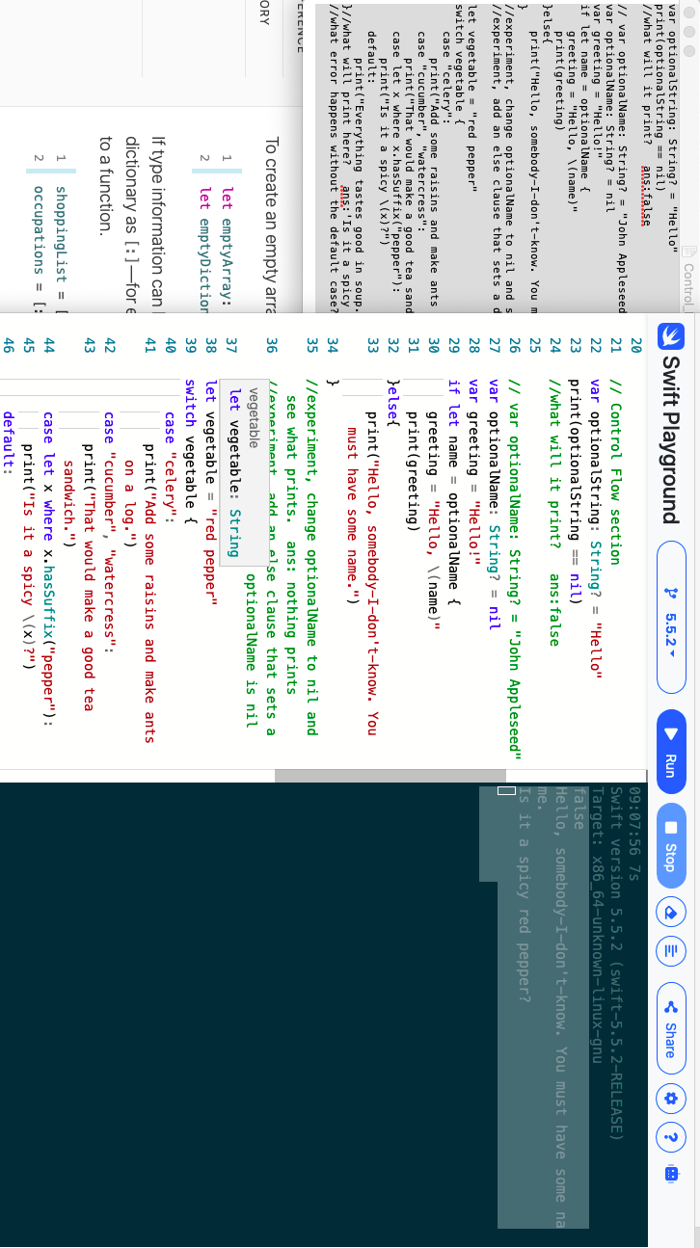
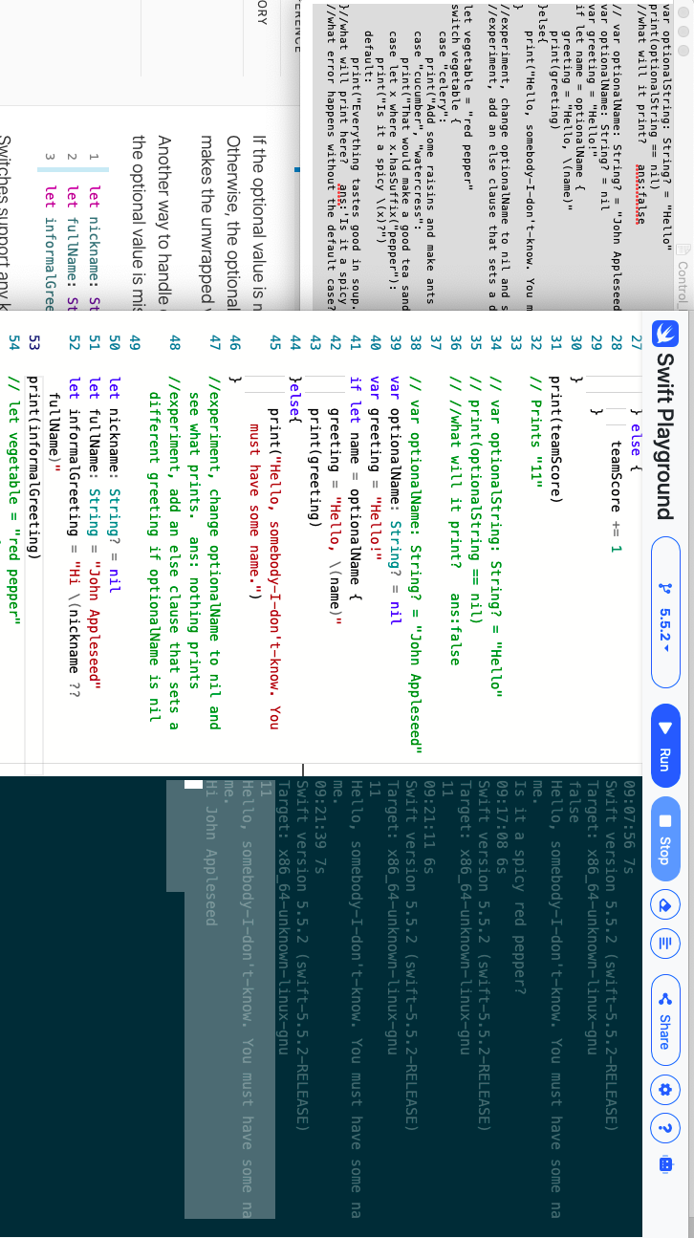

------------------------------------------------------------------------------------------------------------------------------------------
Began getting some errors with running swiftfiddle
Looping through an dictionary to determine the largest int value
Looping and arithmetically assigning a variable by 2 times itself by using while loop and repeat/while loop
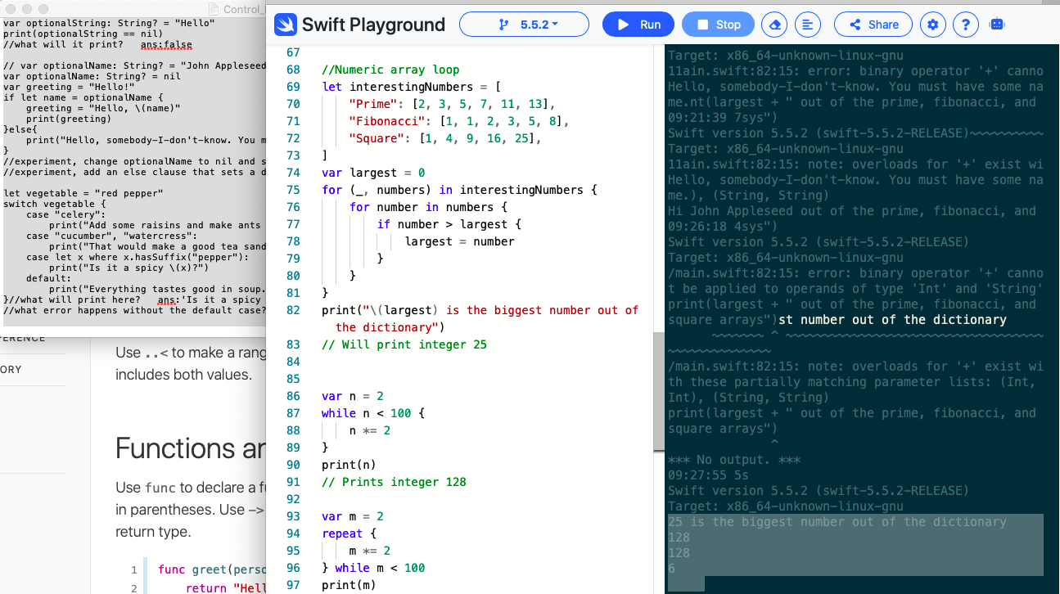
Print out a variable name and a greeting with the day of the week and another variable and name with a lunch option
Using an array of integers create functions to reassign each number by itself times 3
Failed to return 7 as a number less than 10
Prints out new array and old array but in sorted order
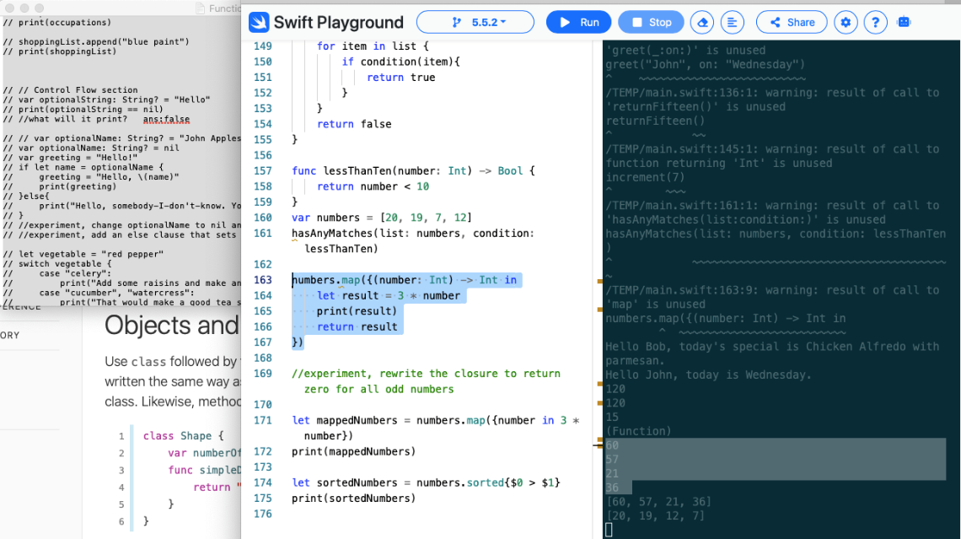
------------------------------------------------------------------------------------------------------------------------------------------
Create classes of shapes: Square, EquilateralTriangle, and TriangleAndSquare
Using these classes create variables: test = Square(…, …), and print out results of their side lengths and perimeter sizes, and area values. simpleDescription did not get to work in the online editor.
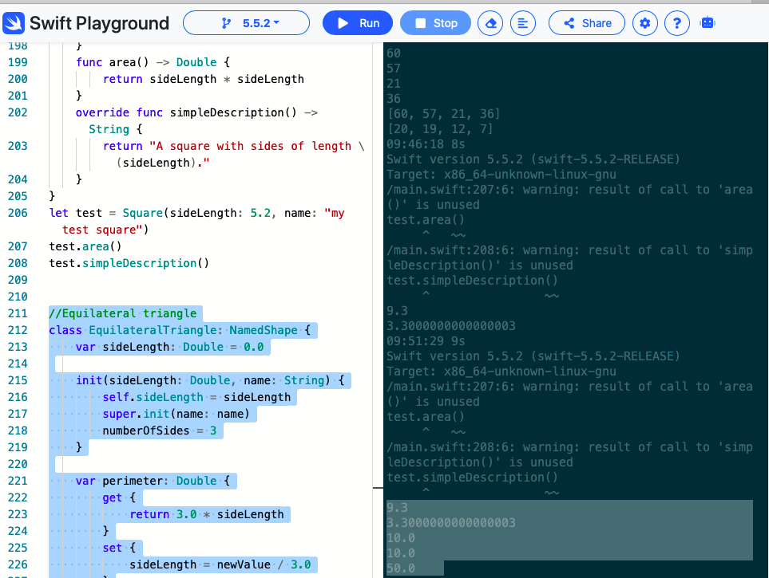
------------------------------------------------------------------------------------------------------------------------------------------
Using enumeration cases and switch cases
Using let constants for the enumeration function response cases, switch case prints a result depending on which constant is set
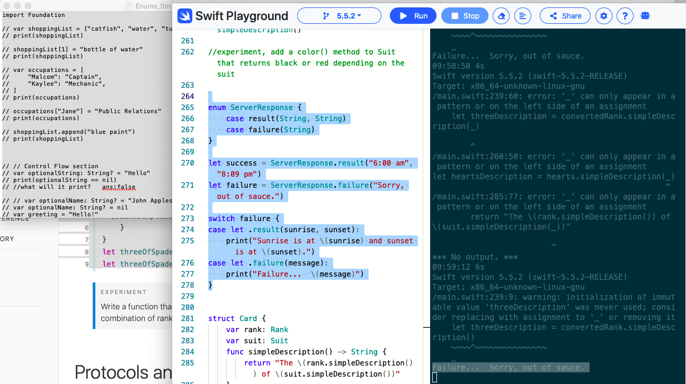
------------------------------------------------------------------------------------------------------------------------------------------
Using an extension function for Int print out a description of either a variable of same type or just 7
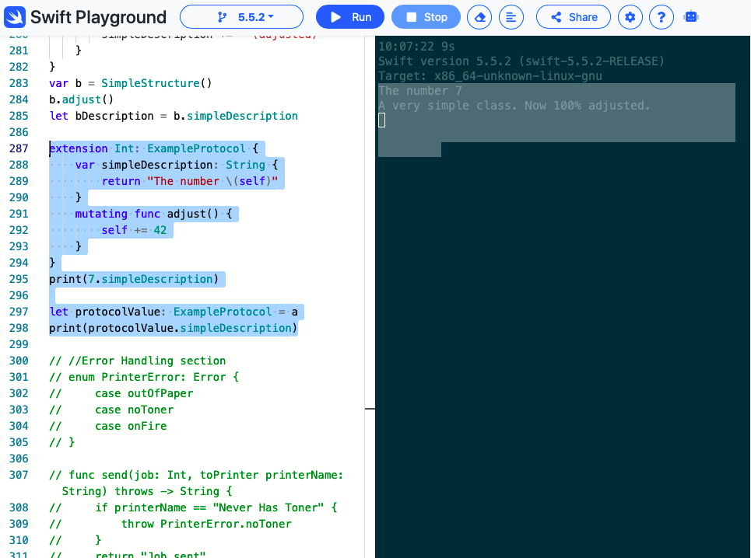
------------------------------------------------------------------------------------------------------------------------------------------
Using error handling do/catch block to handle error without causing program to exit
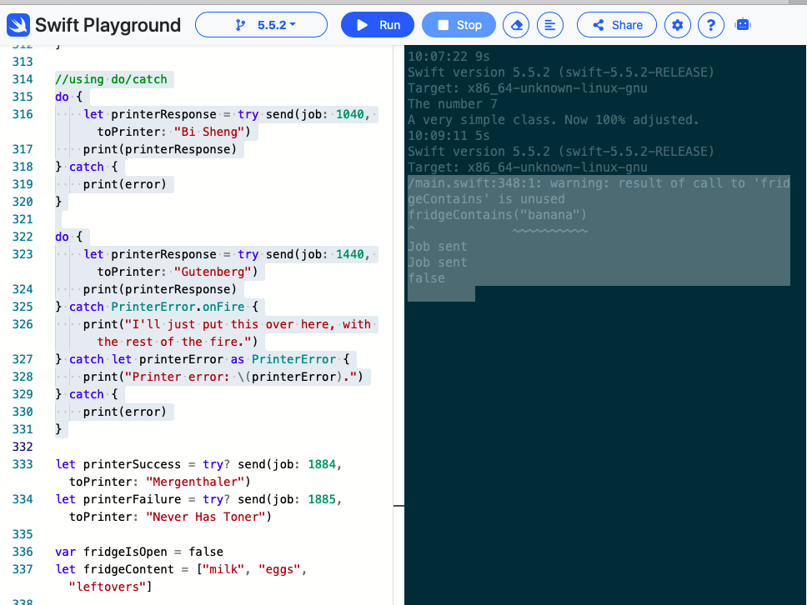
------------------------------------------------------------------------------------------------------------------------------------------
Unsure of how Generics section works line by line
Creating a function with an array with a custom <data type> and for loop to iterate through array and append an item to a new array result[]
Knock printed knocked 4 times, and printed common elements array
