Create empty set of type characters with a name ‘letters’
Create a set of type strings with a name ‘favoriteGenres’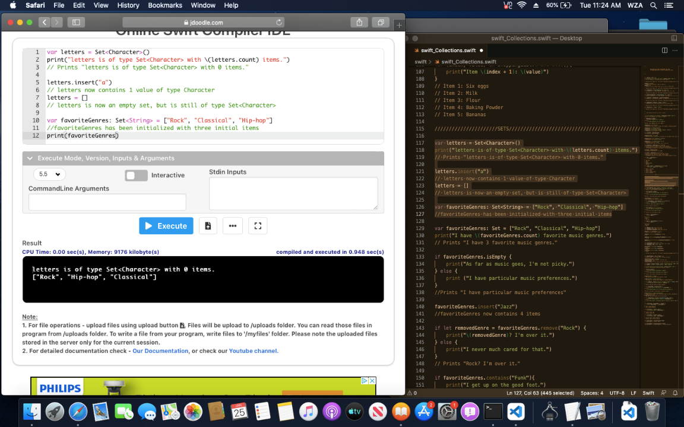

Create if conditional because favoriteGenres.isEmpty is either True or False value
Insert a value to favoriteGenres set
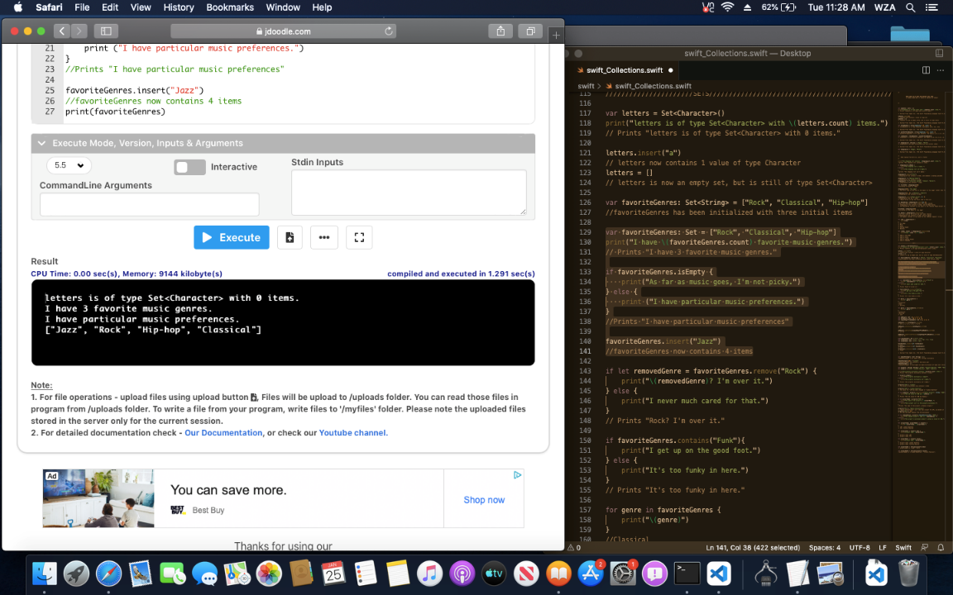

Remove a value from favorite genres
Check for a value that is not present using if/else conditionals
Sort the values in the set
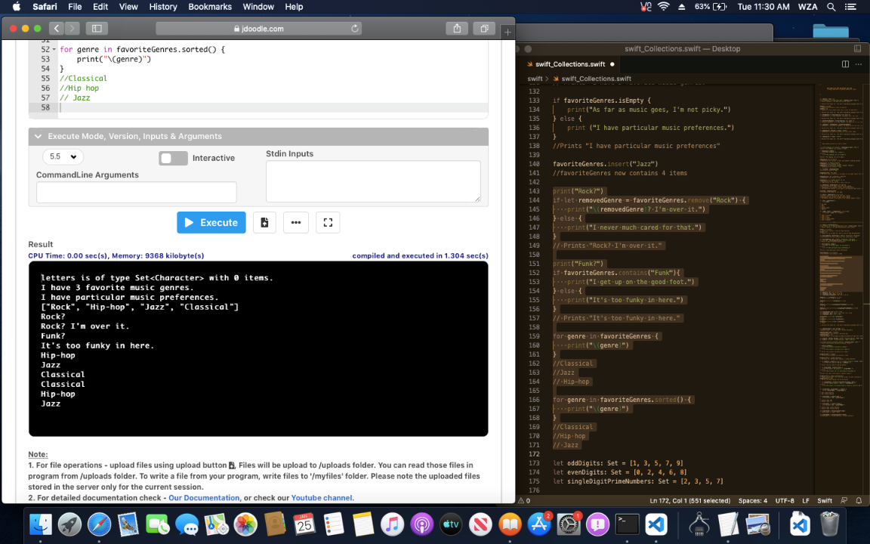

Create three separate sets
Print the union, intersection, subtraction, and difference of each set
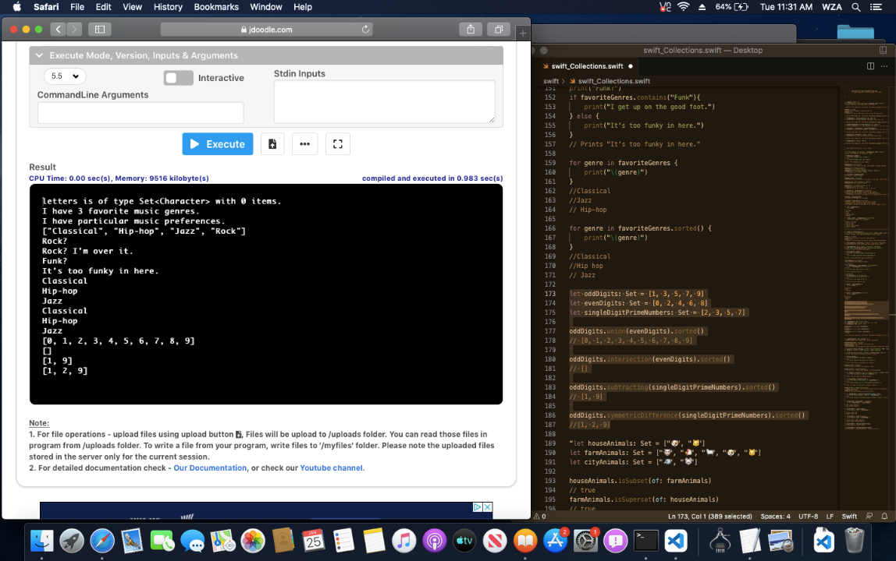

Create three sets using Unicode characters
Print the True/False value whether a set is a subset of another (includes derived values), a superset of another (contains a set within itself as a value), or is a disjoint of another
Create empty dictionary of type integers as indexes and strings as values. An empty dictionary with a key-value pair
Create a variable dictionary called airports with both type string as its key-value pairs
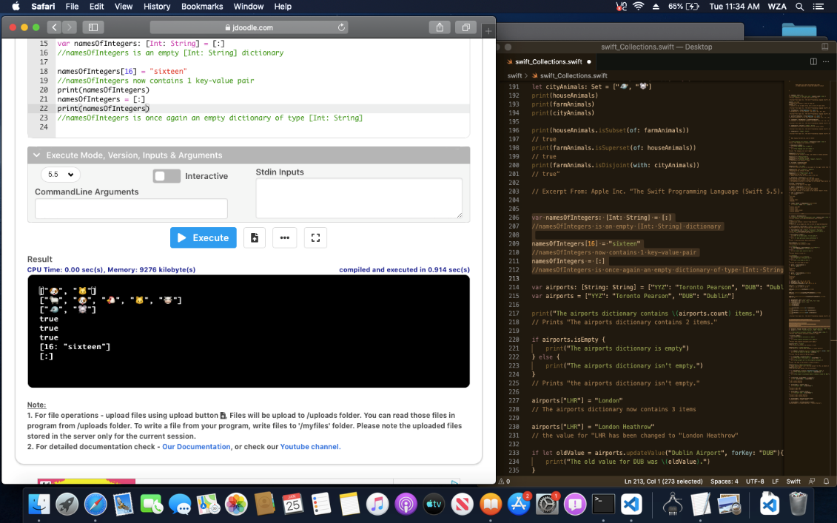

Using primitive function ‘.count’ to output the number of values within the dictionary collection
Adding a value to the airports dictionary and then updating the value for the key name “LHR”
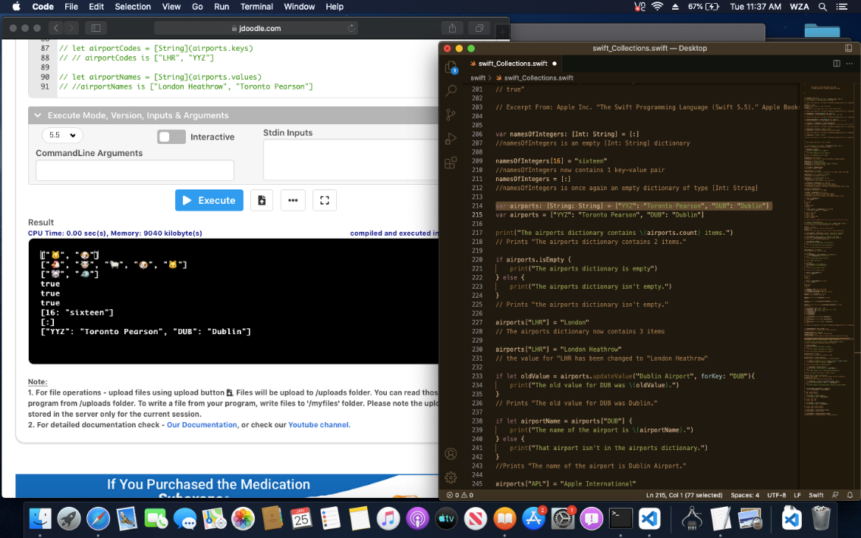
Remove a value from the airports dictionary
Print only the key names of the dictionary (263)
