Task 0 Execution
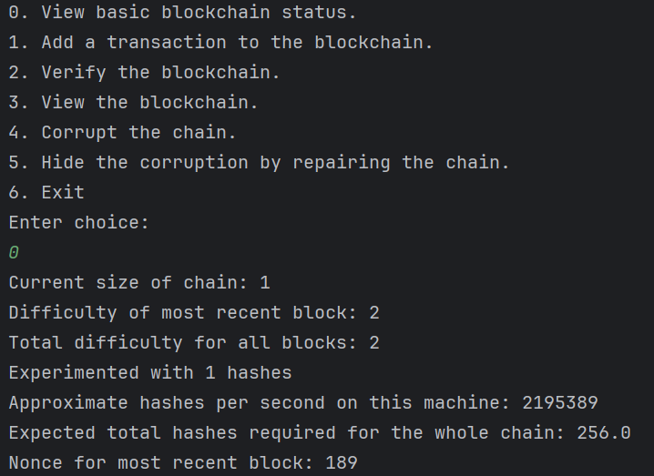
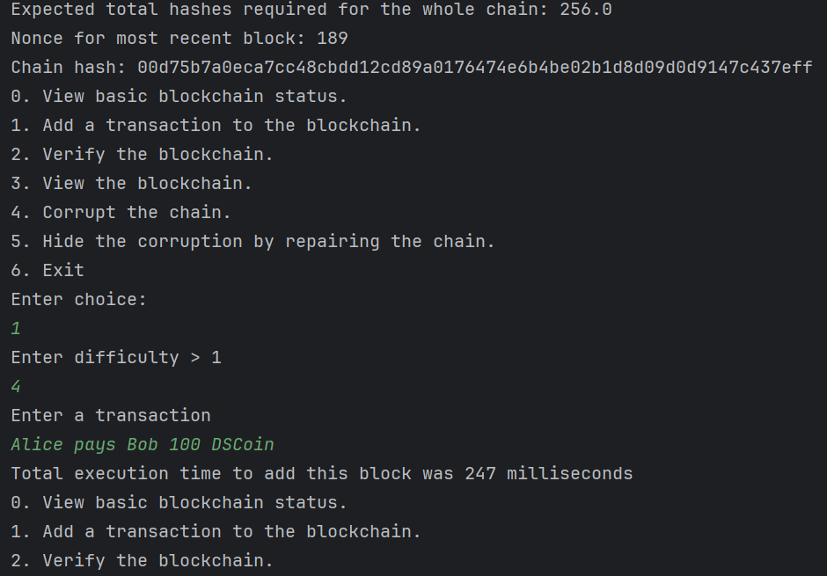
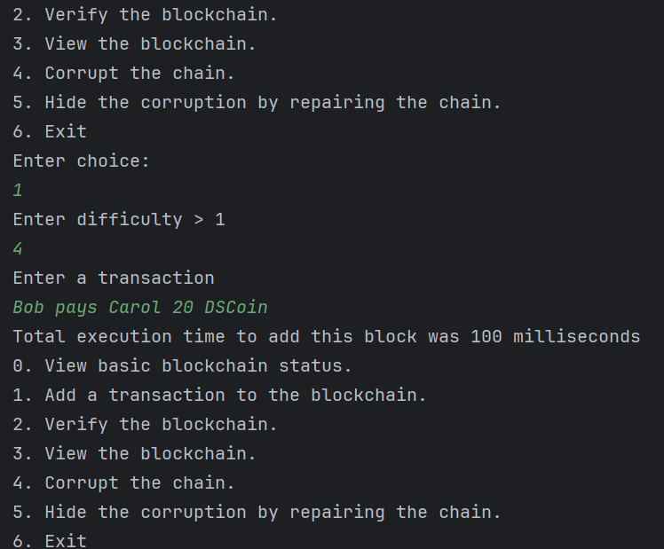
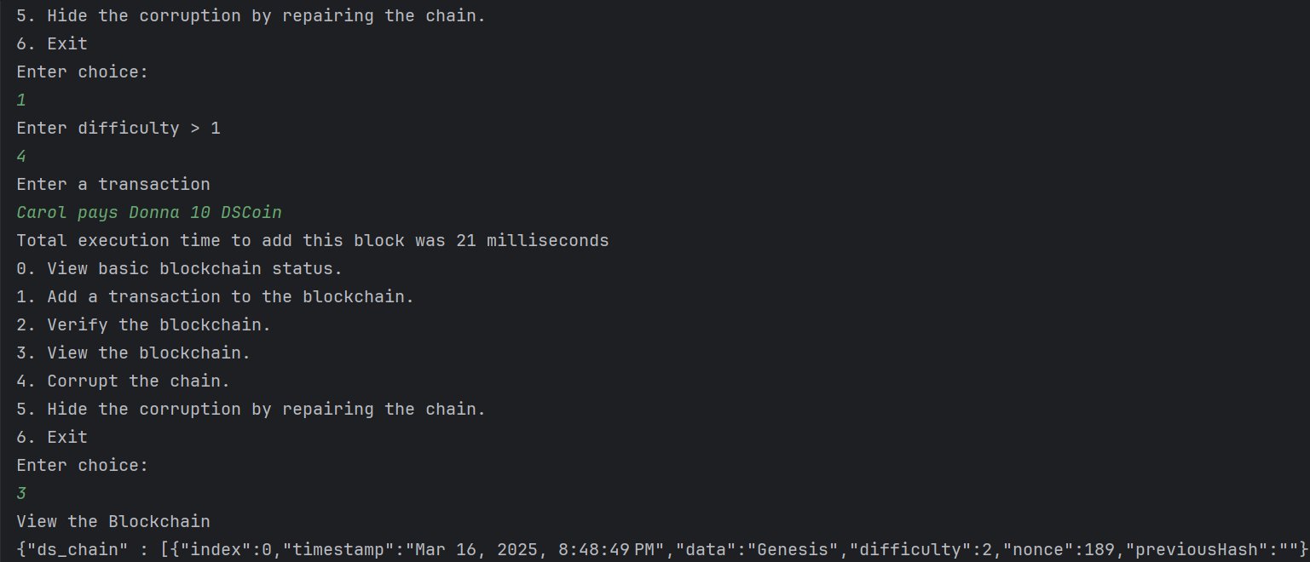
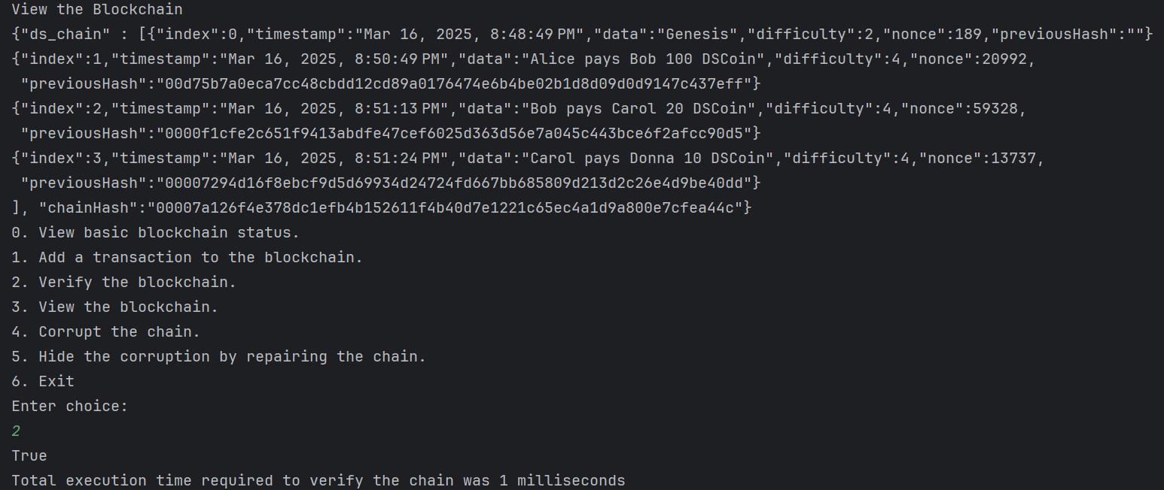
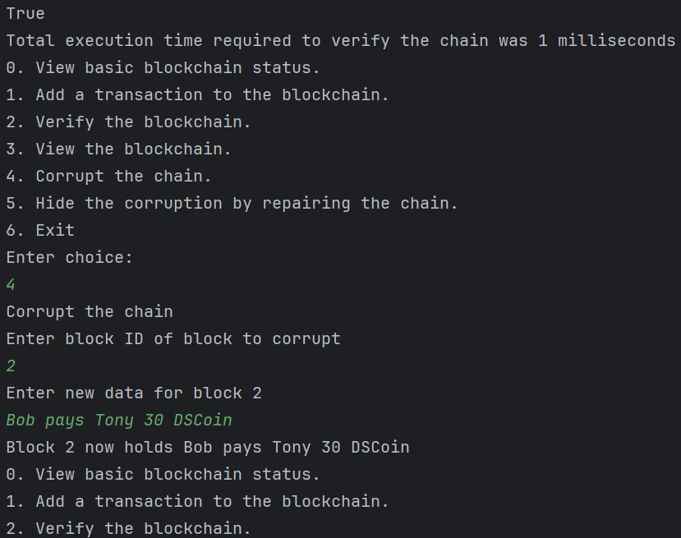
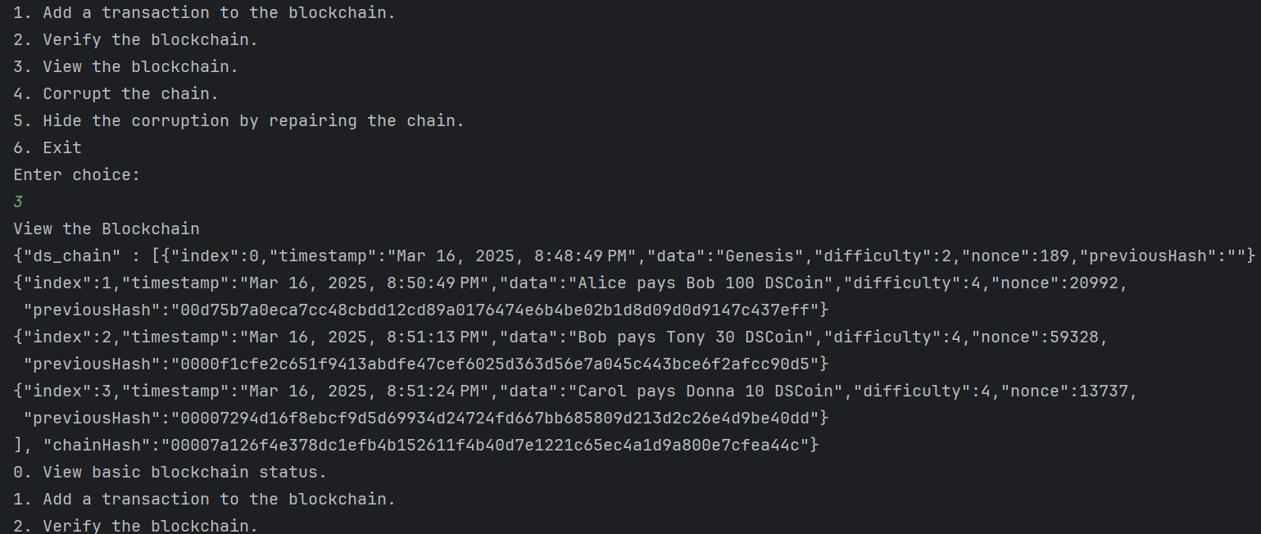
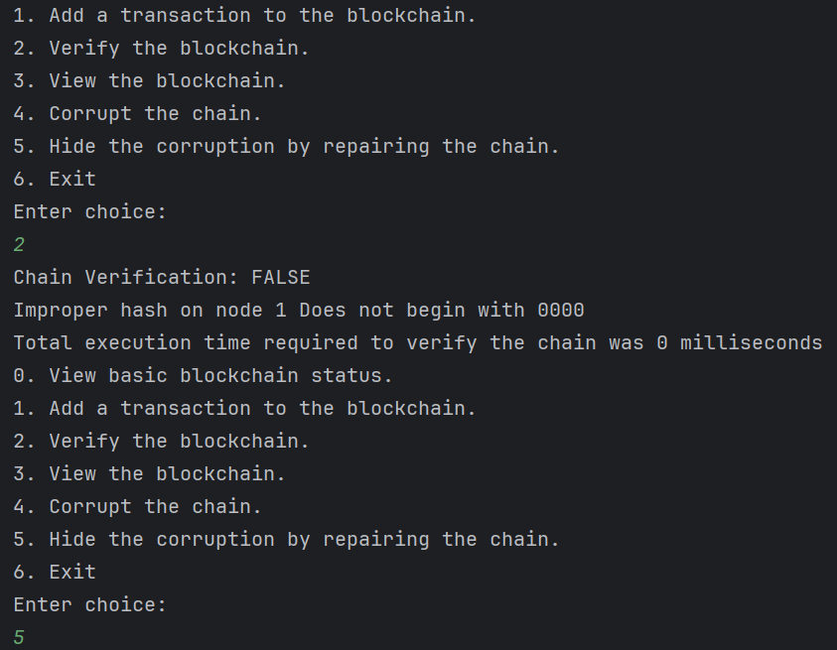
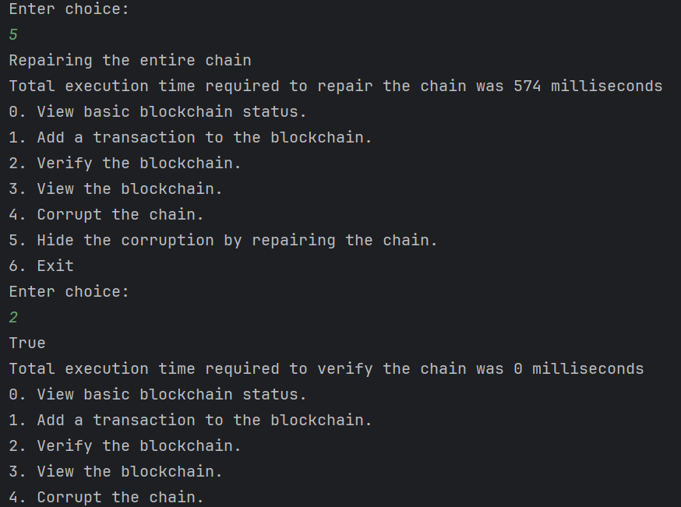
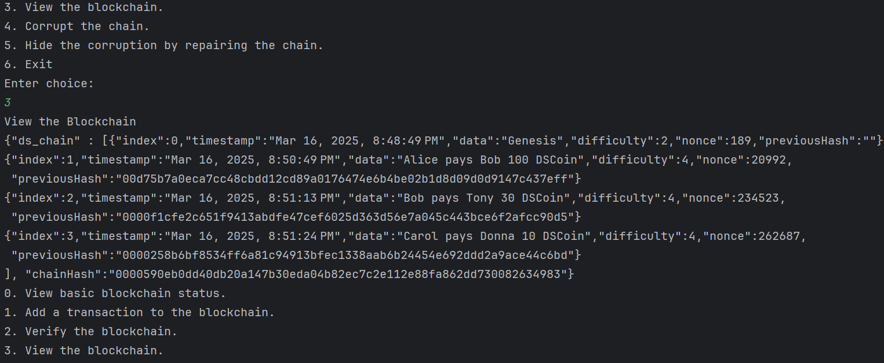
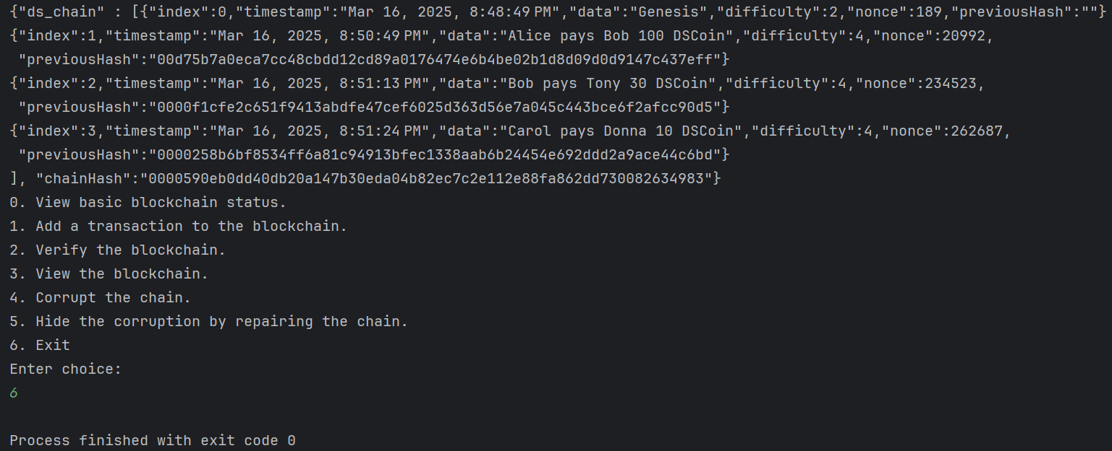
Task 0 Block.java
import java.math.BigInteger;
import java.security.MessageDigest;
import com.google.gson.Gson;
public class Block {
private int index;
private java.sql.Timestamp timestamp;
private java.lang.String data;
private int difficulty;
private java.math.BigInteger nonce = BigInteger.ZERO;
private java.lang.String previousHash = "";
public Block(int index, java.sql.Timestamp timestamp, java.lang.String data, int difficulty) {
this.index = index;
this.timestamp = timestamp;
this.data = data;
this.difficulty = difficulty;
}
public java.lang.String getData(){return data;}
public int getDifficulty(){return difficulty;}
public int getIndex(){return index;}
public java.math.BigInteger getNonce(){return nonce;}
public java.lang.String getPreviousHash(){return previousHash;}
public java.sql.Timestamp getTimestamp(){return timestamp;}
public void setData(java.lang.String data){this.data = data;}
public void setDifficulty(int difficulty){this.difficulty = difficulty;}
public void setIndex(int index){this.index = index;}
public void setPreviousHash(java.lang.String previousHash){this.previousHash = previousHash;}
public void setTimestamp(java.sql.Timestamp timestamp){this.timestamp = timestamp;}
public java.lang.String calculateHash(){
try{
MessageDigest digest = MessageDigest.getInstance("SHA-256");
String input = index + timestamp.toString() + data + difficulty + previousHash + nonce;
byte[] hashBytes = digest.digest(input.getBytes("UTF-8"));
StringBuilder hexString = new StringBuilder();
for (byte b : hashBytes) {
String hex = Integer.toHexString(0xff & b);
if (hex.length() == 1) {
hexString.append('0');
}
hexString.append(hex);
}
return hexString.toString();
} catch (Exception e) {
throw new RuntimeException(e);
}
}
public java.lang.String proofOfWork(){
String target = String.format("%0"+difficulty+"d",0);
while(true){
String hash = calculateHash();
if(hash.startsWith(target)){
return calculateHash();
}
nonce = nonce.add(BigInteger.ONE);
}
}
public static void main(java.lang.String[] args){}
public java.lang.String toString(){
Gson gson = new Gson();
return gson.toJson(this);
}
}

Task 0 BlockChain.java
import java.io.BufferedReader;
import java.io.InputStreamReader;
import java.security.MessageDigest;
import java.security.Timestamp;
import java.util.ArrayList;
public class BlockChain {
private ArrayList<Block> blocks;
private String chainHash;
private int hps;
public BlockChain(ArrayList<Block> blocks, String chainHash, int hps) {
this.blocks = new ArrayList<Block>();
this.chainHash = "";
this.hps = 0;
Block genesisBlock = new Block(0,new java.sql.Timestamp(System.currentTimeMillis()),"Genesis",2);
genesisBlock.setPreviousHash("");
genesisBlock.proofOfWork();
this.blocks.add(genesisBlock);
this.chainHash = genesisBlock.calculateHash();
}
public void addBlock(Block newBlock) {
Block previousBlock = blocks.get(blocks.size()-1);
newBlock.setPreviousHash(previousBlock.calculateHash());
newBlock.proofOfWork();
chainHash = newBlock.calculateHash();
blocks.add(newBlock);
}
public void computeHashesPerSecond(){
String hashString = "oooooooo";
long start = System.currentTimeMillis();
try{
MessageDigest md = MessageDigest.getInstance("SHA-256");
for( int i =0; i<=2000000; i++){
md.update(hashString.getBytes());
md.digest();
}
}catch(Exception e){
e.printStackTrace();
}
long end = System.currentTimeMillis();
double duration = (end-start)/1000.0;
hps = (int)(2000000/duration);
}
public void repairChain(){
for(int i = 0; i<blocks.size(); i++){
Block currentBlock = blocks.get(i);
currentBlock.proofOfWork();
if(i<blocks.size()-1){
Block nextBlock = blocks.get(i+1);
nextBlock.setPreviousHash(currentBlock.calculateHash());
}
}
this.chainHash = blocks.get(blocks.size()-1).calculateHash();
}
public Block getBlock(int i){return blocks.get(i);}
public Block getLatestBlock(){return blocks.get(blocks.size()-1);}
public java.lang.String getChainHash(){return this.chainHash;}
public int getChainSize(){return blocks.size();}
public int getHashesPerSecond(){return this.hps;}
public java.sql.Timestamp getTime(){return new java.sql.Timestamp(System.currentTimeMillis());}
public int getTotalDifficulty(){
int difficulty = 0;
for(Block block: blocks){
difficulty += block.getDifficulty();
}
return difficulty;
}
public double getExpectedHashes(){
double total = 0.0;
for(Block block: blocks){
total+= Math.pow(16,block.getDifficulty());
}
return total;
}
public java.lang.String isChainValid() {
if(blocks.size()==1){
Block genesisBlock = blocks.get(0);
String genesisHash = genesisBlock.calculateHash();
String requiredPrefix = "0".repeat(genesisBlock.getDifficulty()); // Corrected prefix generation
if (!genesisHash.startsWith(requiredPrefix)) {
return "Chain Verification: FALSE\nGenesis block's proof of work is invalid";
}
if (!genesisHash.equals(this.chainHash)) {
return "Chain Verification: FALSE\nGenesis block's hash does not match the Chain hash";
}
}
for (int i = 1; i < blocks.size(); i++) {
Block currentBlock = blocks.get(i);
Block previousBlock = blocks.get(i - 1);
if (!currentBlock.getPreviousHash().equals(previousBlock.calculateHash())) {
return "Chain Verification: FALSE\nPrevious block's hash does not match the Chain hash";
}
String currentRequiredPrefix = "0".repeat(currentBlock.getDifficulty()); // Corrected prefix generation
if (!currentBlock.calculateHash().startsWith(currentRequiredPrefix)) {
return "Chain Verification: FALSE\nImproper hash on node " + (i - 1) + " Does not begin with " + currentRequiredPrefix;
}
}
Block lastBlock = blocks.get(blocks.size() - 1);
if (!chainHash.equals(lastBlock.calculateHash())) {
return "Chain Verification: FALSE\nChain's hash does not match the last block's hash";
}
return "True";
}
public java.lang.String toString(){
StringBuilder str = new StringBuilder();
str.append("{\"ds_chain\" : [");
for(Block b : blocks){
str.append(b.toString()).append("\n");
}
str.append("], \"chainHash\":\"").append(chainHash).append("\"}");
return str.toString();
}
public static void main(String[] args){
BufferedReader br = new BufferedReader(new InputStreamReader(System.in));
BlockChain blockChain = new BlockChain(new ArrayList<Block>(), "",0);
blockChain.computeHashesPerSecond();
try{
while(true){
System.out.println("""
0. View basic blockchain status.
1. Add a transaction to the blockchain.
2. Verify the blockchain.
3. View the blockchain.
4. Corrupt the chain.
5. Hide the corruption by repairing the chain.
6. Exit""");
System.out.println("Enter choice:");
String choice = br.readLine();
switch (choice){
case "0":
System.out.println("Current size of chain: "+blockChain.getChainSize());
System.out.println("Difficulty of most recent block: "+blockChain.getLatestBlock().getDifficulty());
System.out.println("Total difficulty for all blocks: "+blockChain.getTotalDifficulty());
System.out.println("Experimented with "+blockChain.getChainSize()+" hashes");
System.out.println("Approximate hashes per second on this machine: "+blockChain.getHashesPerSecond());
System.out.println("Expected total hashes required for the whole chain: "+blockChain.getExpectedHashes());
System.out.println("Nonce for most recent block: "+blockChain.getLatestBlock().getNonce());
System.out.println("Chain hash: "+blockChain.getChainHash());
break;
case "1":
System.out.println("Enter difficulty > 1");
String difficulty = br.readLine();
System.out.println("Enter a transaction");
String transaction = br.readLine();
Block block = new Block(blockChain.getChainSize(),new java.sql.Timestamp(System.currentTimeMillis()),transaction,Integer.parseInt(difficulty));
long startTime = System.currentTimeMillis();
blockChain.addBlock(block);
long endTime = System.currentTimeMillis();
System.out.println("Total execution time to add this block was "+(endTime-startTime)+" milliseconds");
break;
case "2":
long startTime2 = System.currentTimeMillis();
System.out.println(blockChain.isChainValid());
long endTime2 = System.currentTimeMillis();
System.out.println("Total execution time required to verify the chain was "+(endTime2-startTime2)+" milliseconds");
break;
case "3":
System.out.println("View the Blockchain");
System.out.println(blockChain.toString());
break;
case "4":
System.out.println("Corrupt the chain");
System.out.println("Enter block ID of block to corrupt");
int id = Integer.parseInt(br.readLine());
System.out.println("Enter new data for block "+id);
String data = br.readLine();
blockChain.getBlock(id).setData(data);
System.out.println("Block "+id+" now holds "+data);
break;
case "5":
System.out.println("Repairing the entire chain");
long startTime3 = System.currentTimeMillis();
blockChain.repairChain();
long endTime3 = System.currentTimeMillis();
System.out.println("Total execution time required to repair the chain was "+(endTime3-startTime3)+" milliseconds");
break;
case "6":
return;
default:
System.out.println("Invalid choice");
break;
}
}
}catch(Exception e){
e.printStackTrace();
}
}
}

Task 1 Client Side Execution
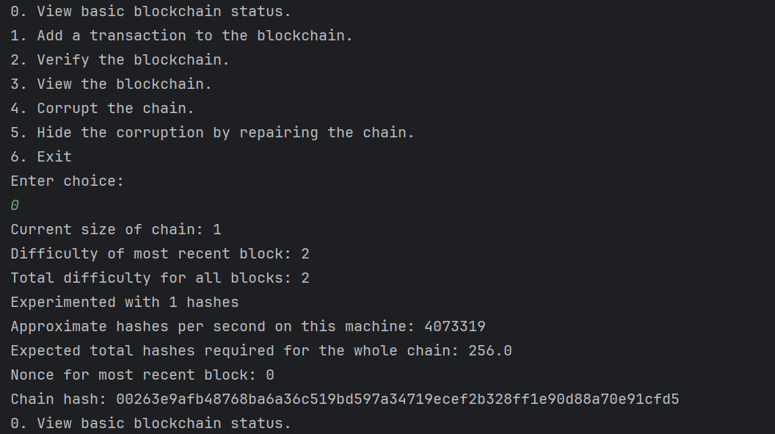
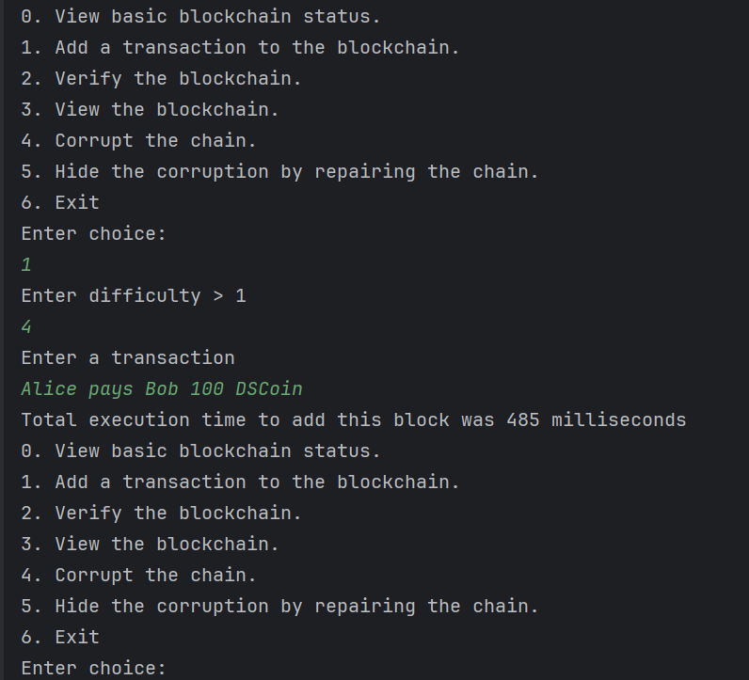
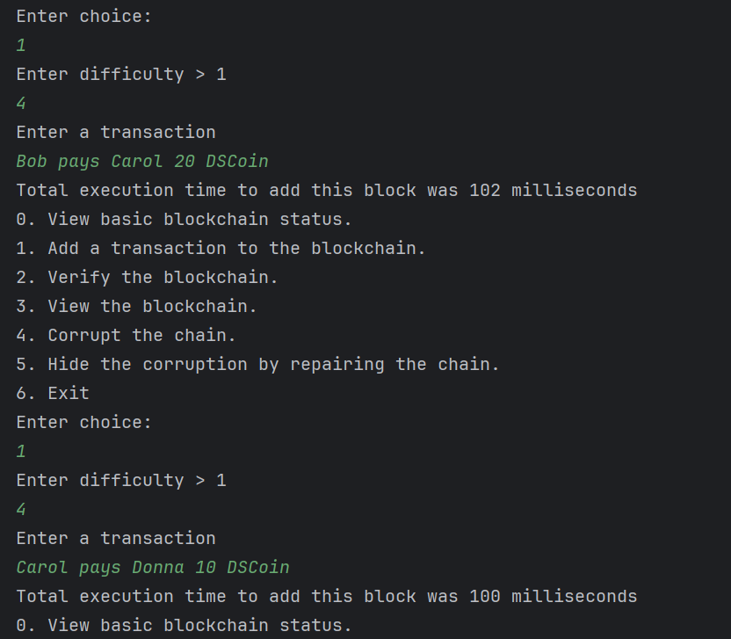
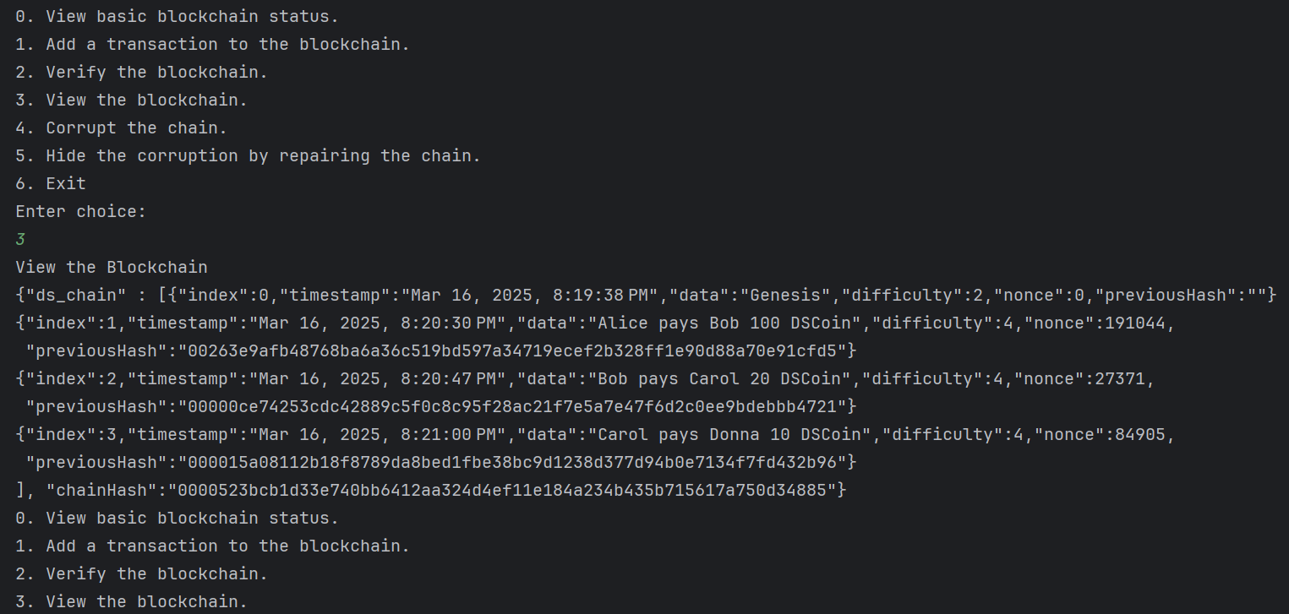
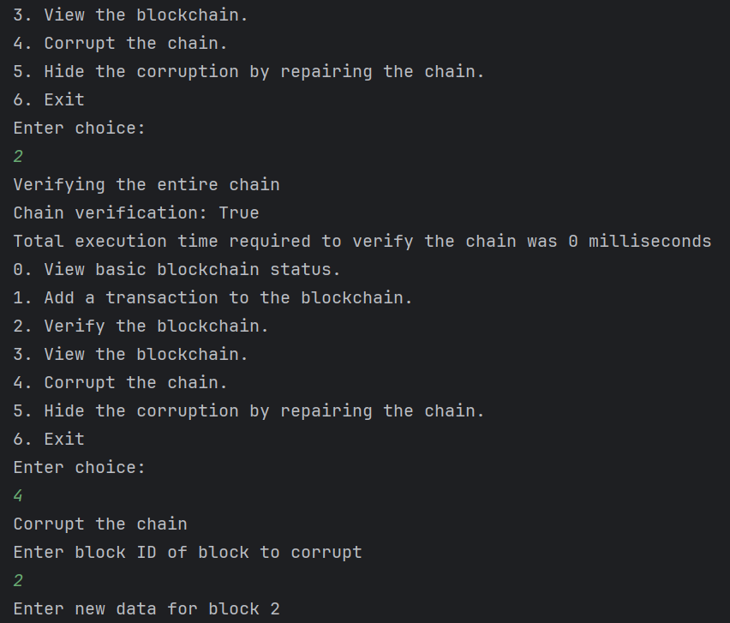
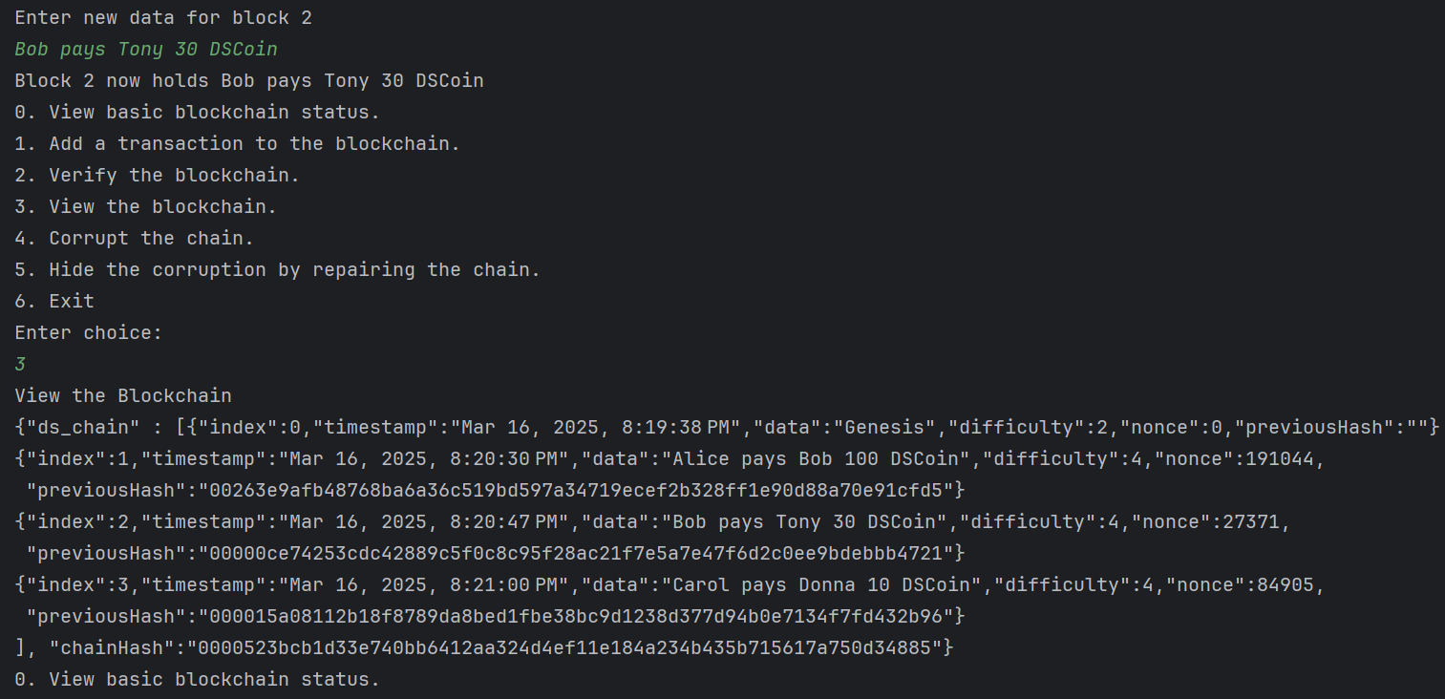
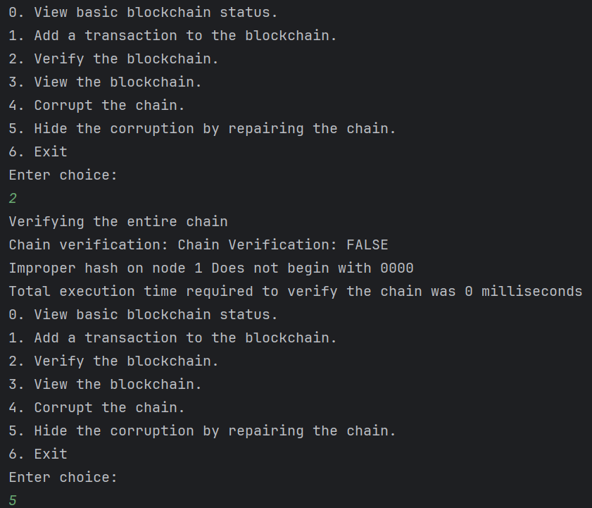
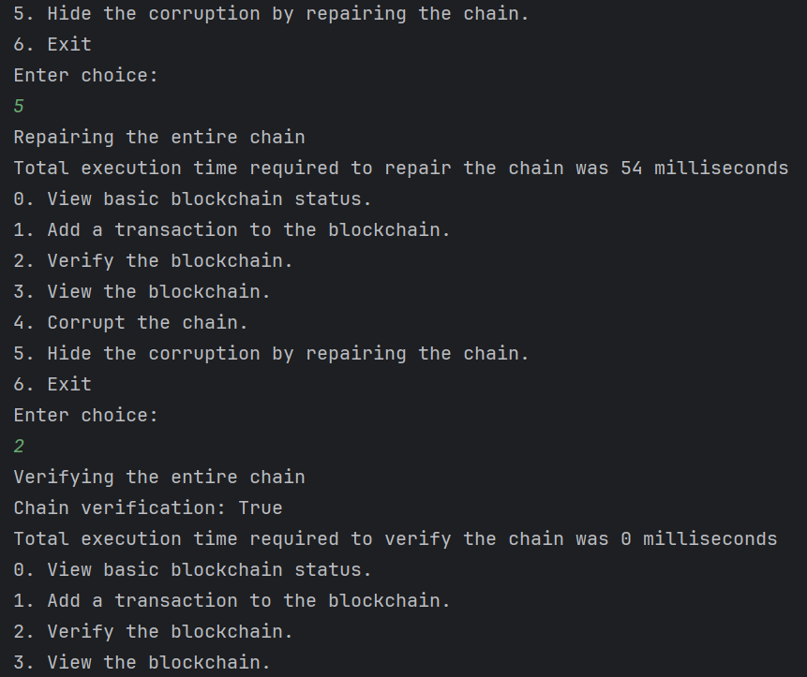
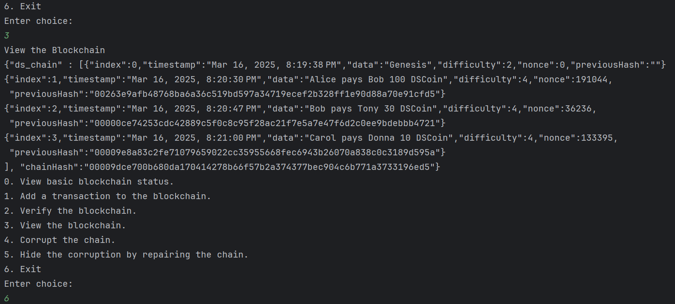
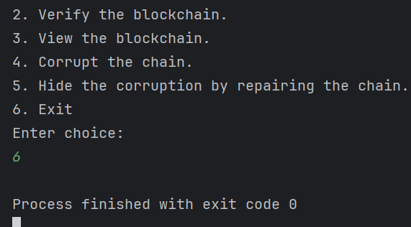
Task 1 Server Side Execution
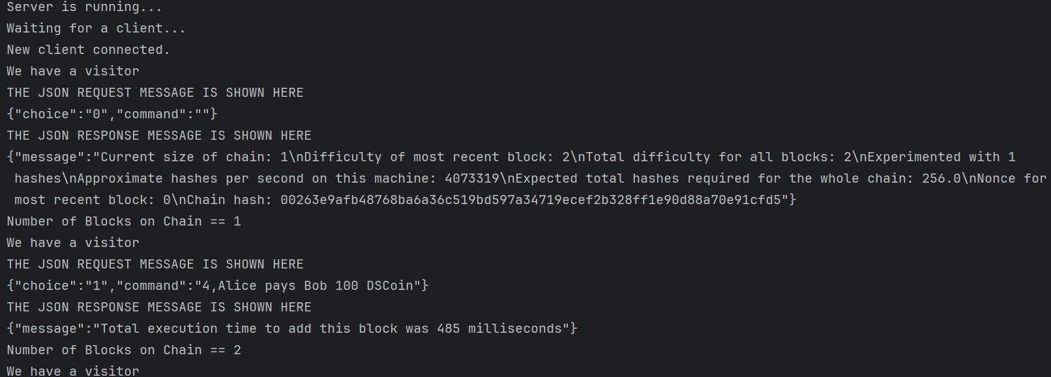
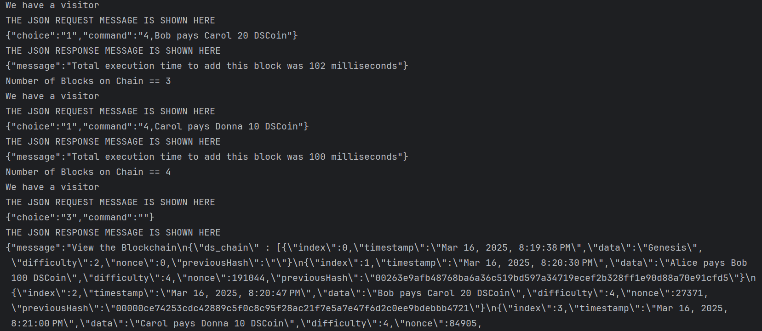
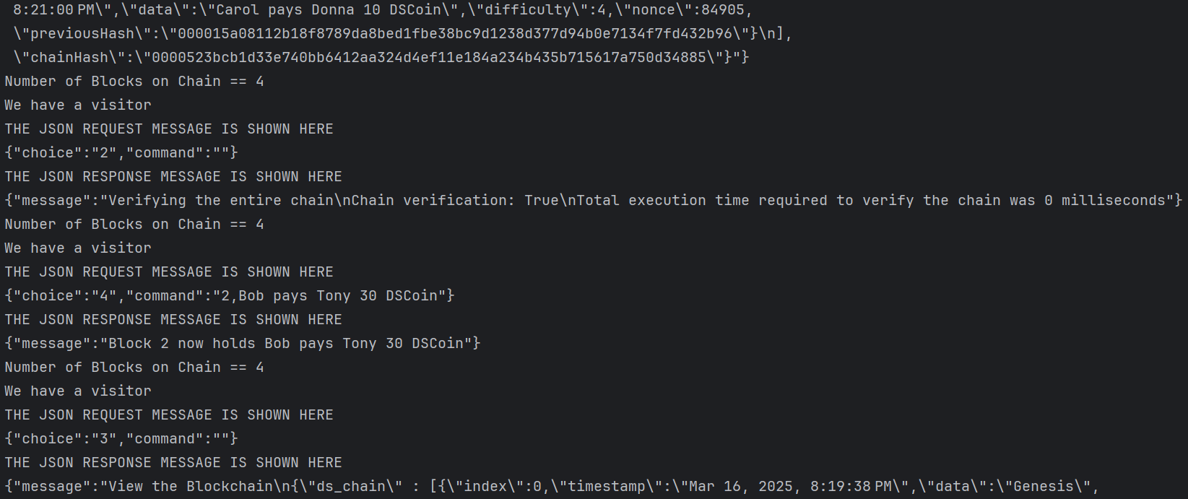
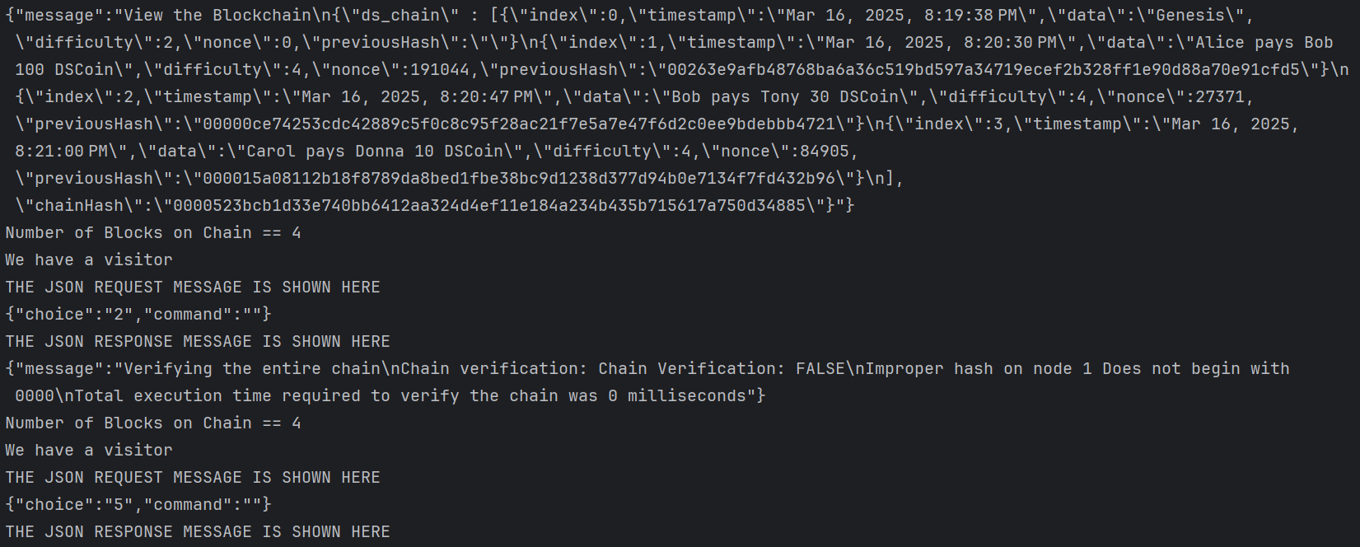
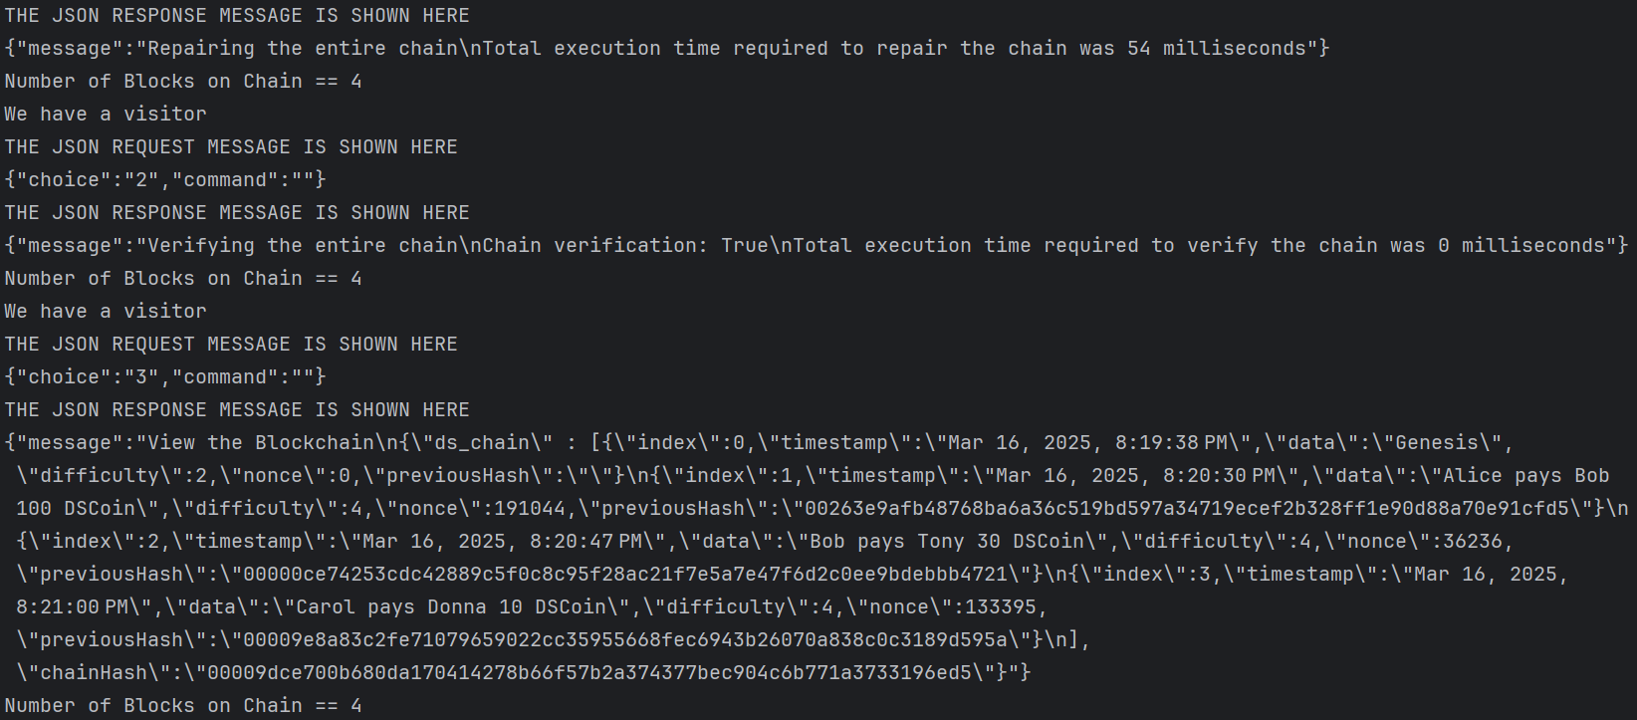
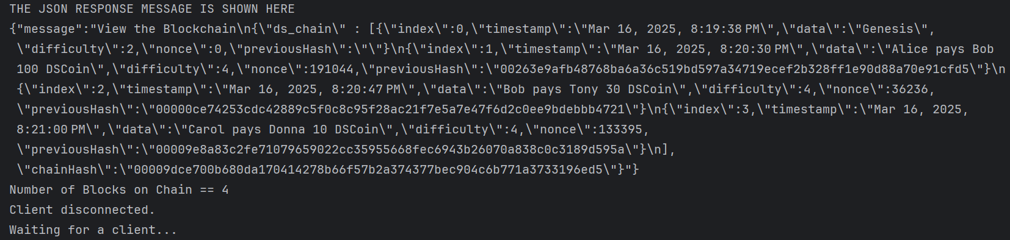
Task 1 Client Source Code in the file ClientTCP.java.
import com.google.gson.Gson;
import java.net.*;
import java.io.*;
public class ClientTCP {
public static void main(String args[]) {
// arguments supply hostname
Socket clientSocket = null;
try {
// Define the server port to connect to
int serverPort = 7777;
// Establish a connection to the server at localhost on the specified port
clientSocket = new Socket("localhost", serverPort);
// Input and output streams for communication with the server
BufferedReader in = new BufferedReader(new InputStreamReader(clientSocket.getInputStream()));
PrintWriter out = new PrintWriter(new BufferedWriter(new OutputStreamWriter(clientSocket.getOutputStream())));
RequestMessage requestMessage = null; // Request message to be sent to the server
ResponseMessage responseMessage = null; // Response message received from the server
String requestJson = ""; // JSON representation of the request message
// BufferedReader for reading user input from the console
BufferedReader typed = new BufferedReader(new InputStreamReader(System.in));
// Main loop to interact with the user and send commands to the server
while (true) {
// Display the menu options to the user
System.out.println("""
0. View basic blockchain status.
1. Add a transaction to the blockchain.
2. Verify the blockchain.
3. View the blockchain.
4. Corrupt the chain.
5. Hide the corruption by repairing the chain.
6. Exit""");
System.out.println("Enter choice:");
// Read the user's choice
String choice = typed.readLine();
String command = ""; // Command data for specific requests
switch (choice) {
// Handle cases that require no additional user input
case "0", "2", "3", "5":
// Create a request message for the selected option
requestMessage = new RequestMessage(choice, command);
requestJson = requestMessage.toJson(); // Convert the request to JSON
out.println(requestJson); // Send the request to the server
out.flush(); // Ensure data is sent immediately
// Read and parse the response message from the server
responseMessage = ResponseMessage.fromJson(in.readLine());
System.out.println(responseMessage.toString()); // Display the server's response
break;
// Handle adding a transaction to the blockchain
case "1":
System.out.println("Enter difficulty > 1"); // Prompt for difficulty level
String difficulty = typed.readLine();
System.out.println("Enter a transaction"); // Prompt for transaction details
String transaction = typed.readLine();
command = difficulty + "," + transaction; // Combine inputs into a single command
requestMessage = new RequestMessage(choice, command); // Create the request
requestJson = requestMessage.toJson(); // Convert to JSON
out.println(requestJson); // Send to server
out.flush(); // Ensure data is sent
responseMessage = ResponseMessage.fromJson(in.readLine()); // Read server response
System.out.println(responseMessage.toString()); // Display the response
break;
// Handle corrupting the blockchain
case "4":
System.out.println("Corrupt the chain");
System.out.println("Enter block ID of block to corrupt"); // Prompt for block ID
String id = typed.readLine();
System.out.println("Enter new data for block " + id); // Prompt for new data
String data = typed.readLine();
command = id + "," + data; // Combine inputs into a single command
requestMessage = new RequestMessage(choice, command); // Create the request
requestJson = requestMessage.toJson(); // Convert to JSON
out.println(requestJson); // Send to server
out.flush(); // Ensure data is sent
responseMessage = ResponseMessage.fromJson(in.readLine()); // Read server response
System.out.println(responseMessage.toString()); // Display the response
break;
// Exit the program
case "6":
return;
// Handle invalid input
default:
System.out.println("Invalid choice");
break;
}
}
} catch (IOException e) {
// Handle exceptions related to input/output operations
System.out.println("IO Exception:" + e.getMessage());
} finally {
try {
// Close the client socket to release resources
if (clientSocket != null) {
clientSocket.close();
}
} catch (IOException e) {
// Ignore exceptions that occur during socket closure
}
}
}
}
/**
* Represents a request message with a choice and command.
* This class is used to communicate between the client and server by converting
* objects to JSON and vice versa.
*/
class RequestMessage {
private String choice; // The choice made by the user (menu option)
private String command; // The command or data associated with the choice
/**
* Constructs a new RequestMessage with the specified choice and command.
*
* @param choice The choice made by the user.
* @param command The command or data associated with the choice.
*/
public RequestMessage(String choice, String command) {
this.choice = choice;
this.command = command;
}
/**
* Gets the choice.
*
* @return The choice made by the user.
*/
public String getChoice() {
return choice;
}
/**
* Gets the command.
*
* @return The command or data associated with the choice.
*/
public String getCommand() {
return command;
}
/**
* Sets the choice.
*
* @param choice The choice to set.
*/
public void setChoice(String choice) {
this.choice = choice;
}
/**
* Sets the command.
*
* @param command The command or data to set.
*/
public void setCommand(String command) {
this.command = command;
}
/**
* Converts this RequestMessage object to a JSON string.
*
* @return A JSON representation of this object.
*/
public String toJson() {
return new Gson().toJson(this);
}
/**
* Creates a RequestMessage object from a JSON string.
*
* @param json The JSON string representing a RequestMessage.
* @return A RequestMessage object parsed from the JSON string.
*/
public static RequestMessage fromJson(String json) {
return new Gson().fromJson(json, RequestMessage.class);
}
}
/**
* Represents a response message with a message string.
* This class is used to communicate responses between the server and client
* by converting objects to JSON and vice versa.
*/
class ResponseMessage {
private String message; // The response message content
/**
* Constructs a new ResponseMessage with the specified message.
*
* @param message The response message to set.
*/
public ResponseMessage(String message) {
this.message = message;
}
/**
* Gets the response message.
*
* @return The response message.
*/
public String getMessage() {
return message;
}
/**
* Sets the response message.
*
* @param message The response message to set.
*/
public void setMessage(String message) {
this.message = message;
}
/**
* Returns the string representation of the response message.
*
* @return The response message as a string.
*/
@Override
public String toString() {
return message;
}
/**
* Converts this ResponseMessage object to a JSON string.
*
* @return A JSON representation of this object.
*/
public String toJson() {
return new Gson().toJson(this);
}
/**
* Creates a ResponseMessage object from a JSON string.
*
* @param json The JSON string representing a ResponseMessage.
* @return A ResponseMessage object parsed from the JSON string.
*/
public static ResponseMessage fromJson(String json) {
return new Gson().fromJson(json, ResponseMessage.class);
}
}
Task 1 Server Source Code in the file ServerTCP.java.
import java.net.*;
import java.io.*;
import java.util.ArrayList;
import java.util.Scanner;
public class ServerTCP {
public static void main(String[] args) {
int serverPort = 7777; // The port number the server will listen on
// Initialize a shared blockchain instance with an empty list of blocks
BlockChain blockChain = new BlockChain(new ArrayList<Block>(), "", 0);
try (ServerSocket listenSocket = new ServerSocket(serverPort)) {
System.out.println("Server is running...");
while (true) {
System.out.println("Waiting for a client...");
try (Socket clientSocket = listenSocket.accept()) { // Accept incoming client connections
System.out.println("New client connected.");
// Set up "in" to read client input
Scanner in = new Scanner(clientSocket.getInputStream());
// Set up "out" to send responses to the client
PrintWriter out = new PrintWriter(new BufferedWriter(new OutputStreamWriter(clientSocket.getOutputStream())), true);
// Delegate client interaction to the handleClient method
handleClient(in, out, blockChain);
} catch (IOException e) {
// Handle client-specific connection errors
System.out.println("Client connection error: " + e.getMessage());
}
}
} catch (IOException e) {
// Handle errors related to starting or running the server
System.out.println("Server error: " + e.getMessage());
}
}
/**
* Handles interaction with a single client.
*
* @param in Scanner to read client input.
* @param out PrintWriter to send responses to the client.
* @param blockChain Shared instance of the blockchain.
*/
private static void handleClient(Scanner in, PrintWriter out, BlockChain blockChain) {
try {
// Continuously read input from the client
while (in.hasNextLine()) {
System.out.println("We have a visitor"); // Indicate a client request is being processed
// Read the JSON request message from the client
String data = in.nextLine();
System.out.println("THE JSON REQUEST MESSAGE IS SHOWN HERE\n" + data);
// Parse the client's JSON request into a RequestMessage object
RequestMessage requestMessage = RequestMessage.fromJson(data);
// Process the request and generate a response
String response = blockChain.response(requestMessage, blockChain);
// Wrap the response in a ResponseMessage object and convert it to JSON
ResponseMessage responseMessage = new ResponseMessage(response);
String responseJson = responseMessage.toJson();
// Display the JSON response being sent to the client
System.out.println("THE JSON RESPONSE MESSAGE IS SHOWN HERE\n" + responseJson);
// Send the JSON response back to the client
out.println(responseJson);
// Log the number of blocks in the blockchain for debugging
System.out.println("Number of Blocks on Chain == " + blockChain.getChainSize());
}
} catch (Exception e) {
// Handle exceptions that occur during request processing
System.out.println("Error processing client request: " + e.getMessage());
} finally {
// Log when a client disconnects
System.out.println("Client disconnected.");
}
}
}
/**
* Represents a request message with a choice and command.
* This class is used to communicate between the client and server by converting
* objects to JSON and vice versa.
*/
class RequestMessage {
private String choice; // The choice made by the user (menu option)
private String command; // The command or data associated with the choice
/**
* Constructs a new RequestMessage with the specified choice and command.
*
* @param choice The choice made by the user.
* @param command The command or data associated with the choice.
*/
public RequestMessage(String choice, String command) {
this.choice = choice;
this.command = command;
}
/**
* Gets the choice.
*
* @return The choice made by the user.
*/
public String getChoice() {
return choice;
}
/**
* Gets the command.
*
* @return The command or data associated with the choice.
*/
public String getCommand() {
return command;
}
/**
* Sets the choice.
*
* @param choice The choice to set.
*/
public void setChoice(String choice) {
this.choice = choice;
}
/**
* Sets the command.
*
* @param command The command or data to set.
*/
public void setCommand(String command) {
this.command = command;
}
/**
* Converts this RequestMessage object to a JSON string.
*
* @return A JSON representation of this object.
*/
public String toJson() {
return new Gson().toJson(this);
}
/**
* Creates a RequestMessage object from a JSON string.
*
* @param json The JSON string representing a RequestMessage.
* @return A RequestMessage object parsed from the JSON string.
*/
public static RequestMessage fromJson(String json) {
return new Gson().fromJson(json, RequestMessage.class);
}
}
/**
* Represents a response message with a message string.
* This class is used to communicate responses between the server and client
* by converting objects to JSON and vice versa.
*/
class ResponseMessage {
private String message; // The response message content
/**
* Constructs a new ResponseMessage with the specified message.
*
* @param message The response message to set.
*/
public ResponseMessage(String message) {
this.message = message;
}
/**
* Gets the response message.
*
* @return The response message.
*/
public String getMessage() {
return message;
}
/**
* Sets the response message.
*
* @param message The response message to set.
*/
public void setMessage(String message) {
this.message = message;
}
/**
* Returns the string representation of the response message.
*
* @return The response message as a string.
*/
@Override
public String toString() {
return message;
}
/**
* Converts this ResponseMessage object to a JSON string.
*
* @return A JSON representation of this object.
*/
public String toJson() {
return new Gson().toJson(this);
}
/**
* Creates a ResponseMessage object from a JSON string.
*
* @param json The JSON string representing a ResponseMessage.
* @return A ResponseMessage object parsed from the JSON string.
*/
public static ResponseMessage fromJson(String json) {
return new Gson().fromJson(json, ResponseMessage.class);
}
}

Project3Task2SigningClient
import com.google.gson.Gson;
import java.math.BigInteger;
import java.net.*;
import java.io.*;
import java.nio.charset.StandardCharsets;
import java.security.MessageDigest;
public class SigningClientTCP {
public static void main(String[] args) {
// arguments supply hostname
Socket clientSocket = null;
try {
// Define the server port to connect to
int serverPort = 7777;
// Establish a connection to the server at localhost on the specified port
clientSocket = new Socket("localhost", serverPort);
// Input and output streams for communication with the server
BufferedReader in = new BufferedReader(new InputStreamReader(clientSocket.getInputStream()));
PrintWriter out = new PrintWriter(new BufferedWriter(new OutputStreamWriter(clientSocket.getOutputStream())));
RequestMessage requestMessage = null; // Request message to be sent to the server
ResponseMessage responseMessage = null; // Response message received from the server
String requestJson = ""; // JSON representation of the request message
// BufferedReader for reading user input from the console
BufferedReader typed = new BufferedReader(new InputStreamReader(System.in));
// Main loop to interact with the user and send commands to the server
while (true) {
// Display the menu options to the user
System.out.println("""
0. View basic blockchain status.
1. Add a transaction to the blockchain.
2. Verify the blockchain.
3. View the blockchain.
4. Corrupt the chain.
5. Hide the corruption by repairing the chain.
6. Exit""");
System.out.println("Enter choice:");
// Read the user's choice
String choice = typed.readLine();
String command = ""; // Command data for specific requests
RSA rsa = new RSA();
SigningClientTCP signingClientTCP = new SigningClientTCP();
String ID = signingClientTCP.calculateID(rsa.getE(),rsa.calculateN());
MessageSign messageSign = new MessageSign(rsa.calculateD(),rsa.calculateN());
System.out.println("Public Key: "+rsa.getE().add(rsa.calculateN()));
System.out.println("Private Key: "+rsa.calculateD().add(rsa.calculateN()));
String hash = "";
String signature = "";
switch (choice) {
// Handle cases that require no additional user input
case "0", "2", "3", "5":
hash = ID+(rsa.getE().add(rsa.calculateN())).toString()+choice+command;
signature = messageSign.sign(signingClientTCP.calculateHash(hash));
// Create a request message for the selected option
requestMessage = new RequestMessage(choice, command, ID, rsa.getE(), rsa.calculateN(), signature);
requestJson = requestMessage.toJson(); // Convert the request to JSON
out.println(requestJson); // Send the request to the server
out.flush(); // Ensure data is sent immediately
// Read and parse the response message from the server
// System.out.println(in.readLine());
responseMessage = ResponseMessage.fromJson(in.readLine());
System.out.println(responseMessage.toString()); // Display the server's response
break;
// Handle adding a transaction to the blockchain
case "1":
System.out.println("Enter difficulty > 1"); // Prompt for difficulty level
String difficulty = typed.readLine();
System.out.println("Enter a transaction"); // Prompt for transaction details
String transaction = typed.readLine();
command = difficulty + "," + transaction; // Combine inputs into a single command
hash = ID+(rsa.getE().add(rsa.calculateN())).toString()+choice+command;
signature = messageSign.sign(signingClientTCP.calculateHash(hash));
requestMessage = new RequestMessage(choice, command, ID, rsa.getE(), rsa.calculateN(), signature); // Create the request
requestJson = requestMessage.toJson(); // Convert to JSON
out.println(requestJson); // Send to server
out.flush(); // Ensure data is sent
// System.out.println(in.readLine());
responseMessage = ResponseMessage.fromJson(in.readLine()); // Read server response
System.out.println(responseMessage.toString()); // Display the response
break;
// Handle corrupting the blockchain
case "4":
System.out.println("Corrupt the chain");
System.out.println("Enter block ID of block to corrupt"); // Prompt for block ID
String id = typed.readLine();
System.out.println("Enter new data for block " + id); // Prompt for new data
String data = typed.readLine();
command = id + "," + data; // Combine inputs into a single command
hash = ID + (rsa.getE().add(rsa.calculateN())).toString() + choice + command;
signature = messageSign.sign(signingClientTCP.calculateHash(hash));
requestMessage = new RequestMessage(choice, command, ID, rsa.getE(), rsa.calculateN(), signature); // Create the request
requestJson = requestMessage.toJson(); // Convert to JSON
out.println(requestJson); // Send to server
out.flush(); // Ensure data is sent
// System.out.println(in.readLine());
responseMessage = ResponseMessage.fromJson(in.readLine()); // Read server response
System.out.println(responseMessage.toString()); // Display the response
break;
// Exit the program
case "6":
return;
// Handle invalid input
default:
System.out.println("Invalid choice");
break;
}
}
} catch (IOException e) {
// Handle exceptions related to input/output operations
System.out.println("IO Exception:" + e.getMessage());
} catch (Exception e) {
throw new RuntimeException(e);
} finally {
try {
// Close the client socket to release resources
if (clientSocket != null) {
clientSocket.close();
}
} catch (IOException e) {
// Ignore exceptions that occur during socket closure
}
}
}
public java.lang.String calculateID(BigInteger e, BigInteger n) {
try {
// Create a SHA-256 MessageDigest instance
MessageDigest digest = MessageDigest.getInstance("SHA-256");
// Concatenate the block's properties to form the input string
String input = (e.add(n)).toString();
// Generate the hash as a byte array
byte[] hashBytes = digest.digest(input.getBytes(StandardCharsets.UTF_8));
byte[] last20 = new byte[20];
System.arraycopy(hashBytes, hashBytes.length-20, last20, 0, 20);
StringBuilder hexString = new StringBuilder();
for(byte b: last20){
hexString.append(String.format("%02x",b));
}
return hexString.toString(); // Return the hash as a string
} catch (Exception exception) {
throw new RuntimeException(exception); // Handle exceptions
}
}
public java.lang.String calculateHash(String input) {
try {
// Create a SHA-256 MessageDigest instance
MessageDigest digest = MessageDigest.getInstance("SHA-256");
// Generate the hash as a byte array
byte[] hashBytes = digest.digest(input.getBytes(StandardCharsets.UTF_8));
// Convert the byte array to a hexadecimal string
StringBuilder hexString = new StringBuilder();
for (byte b : hashBytes) {
String hex = Integer.toHexString(0xff & b);
if (hex.length() == 1) {
hexString.append('0'); // Ensure two-character representation
}
hexString.append(hex);
}
return hexString.toString(); // Return the hash as a string
} catch (Exception exception) {
throw new RuntimeException(exception); // Handle exceptions
}
}
}

Project3Task2VerifyingServer
import java.math.BigInteger;
import java.net.*;
import java.io.*;
import java.util.ArrayList;
import java.util.Scanner;
import java.util.concurrent.Executors;
public class VerifyingServerTCP {
public static void main(String[] args) {
int serverPort = 7777; // Server port
BlockChain blockChain = new BlockChain(new ArrayList<>(), "", 0); // Shared blockchain instance
try (ServerSocket listenSocket = new ServerSocket(serverPort)) {
System.out.println("Server is running...");
var threadPool = Executors.newCachedThreadPool(); // Thread pool for handling clients
while (true) {
System.out.println("Waiting for a client...");
Socket clientSocket = listenSocket.accept();
System.out.println("New client connected.");
threadPool.execute(() -> handleClient(clientSocket, blockChain));
}
} catch (IOException e) {
System.err.println("Server error: " + e.getMessage());
e.printStackTrace();
}
}
private static void handleClient(Socket clientSocket, BlockChain blockChain) {
try (Scanner in = new Scanner(clientSocket.getInputStream());
PrintWriter out = new PrintWriter(new BufferedWriter(new OutputStreamWriter(clientSocket.getOutputStream())), true)) {
while (in.hasNextLine()) {
String data = in.nextLine();
System.out.println("THE JSON REQUEST MESSAGE IS SHOWN HERE\n" + data);
String responseJson;
try {
// Parse the request
RequestMessage requestMessage = RequestMessage.fromJson(data);
// Verify ID and Signature
SigningClientTCP signingClientTCP = new SigningClientTCP();
MessageVerify messageVerify = new MessageVerify(requestMessage.getE(), requestMessage.getN());
System.out.println("Client's public key: "+requestMessage.getE().add(requestMessage.getN()));
// Calculate hash for verification
String concatHash = requestMessage.getID()+(requestMessage.getE().add(requestMessage.getN())).toString()+requestMessage.getChoice()+requestMessage.getCommand();
String hash = signingClientTCP.calculateHash(concatHash);
// Check validity of the request
if (!signingClientTCP.calculateID(requestMessage.getE(), requestMessage.getN()).equals(requestMessage.getID())) {
String errorResponse = new ResponseMessage("Invalid ID").toJson();
System.out.println("Invalid ID.");
out.println(errorResponse);
return;
}
if (!messageVerify.verify(hash, requestMessage.getSignature())) {
String errorResponse = new ResponseMessage("Invalid signature").toJson();
System.out.println("Invalid signature.");
out.println(errorResponse);
return;
}else
System.out.println("Signature verified.");
// If valid, process the request
String response = blockChain.response(requestMessage.getChoice(), requestMessage.getCommand(), blockChain);
ResponseMessage responseMessage = new ResponseMessage(response);
responseJson = responseMessage.toJson();
out.println(responseJson);
} catch (Exception e) {
responseJson = new ResponseMessage("Error processing request: " + e.getMessage()).toJson();
e.printStackTrace();
}
// Send response
System.out.println("THE JSON RESPONSE MESSAGE IS SHOWN HERE:\n" + responseJson);
out.println(responseJson);
System.out.println("Number of Blocks on Chain: " + blockChain.getChainSize());
}
} catch (IOException e) {
System.err.println("Client error: " + e.getMessage());
} finally {
try {
clientSocket.close();
} catch (IOException e) {
System.err.println("Error closing client socket: " + e.getMessage());
}
System.out.println("Client disconnected.");
}
}
}

Project3Task2ClientConsole
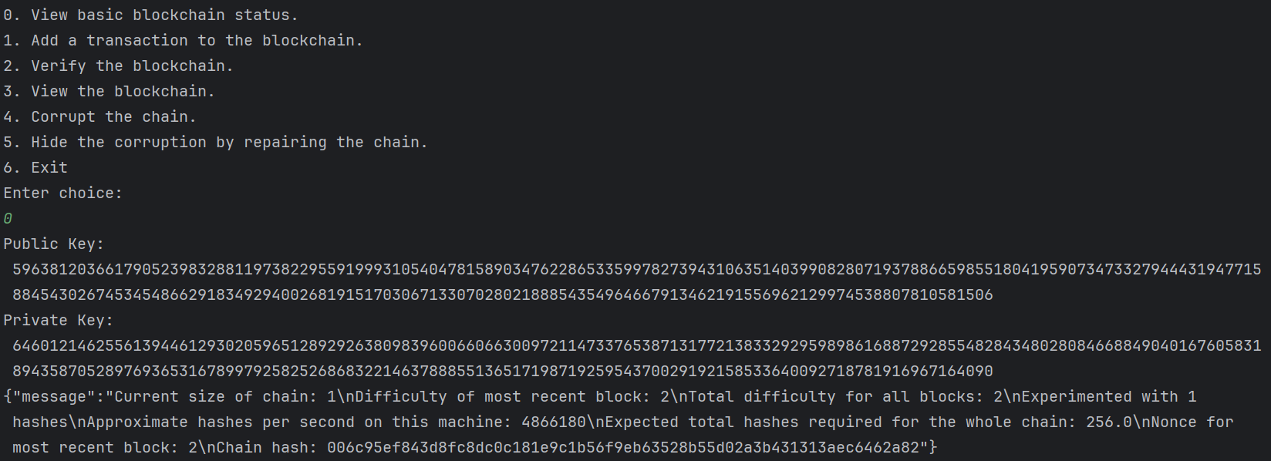
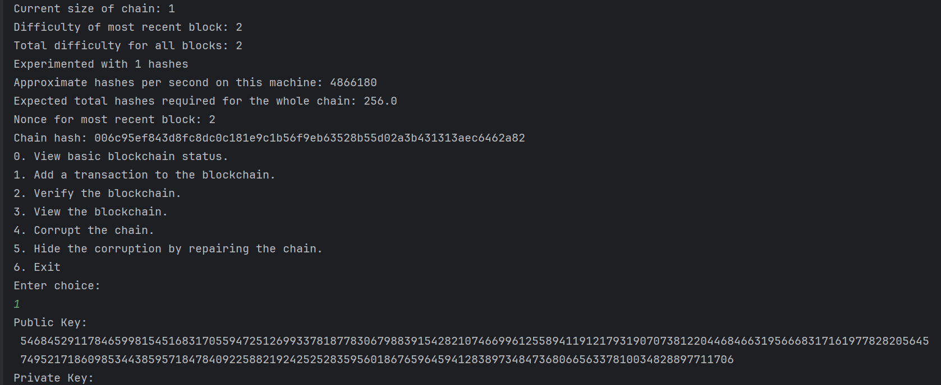
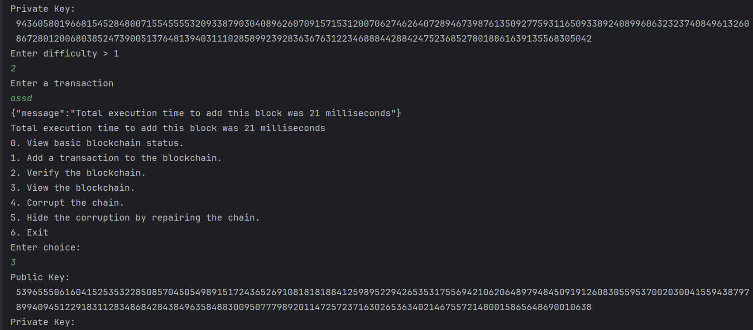
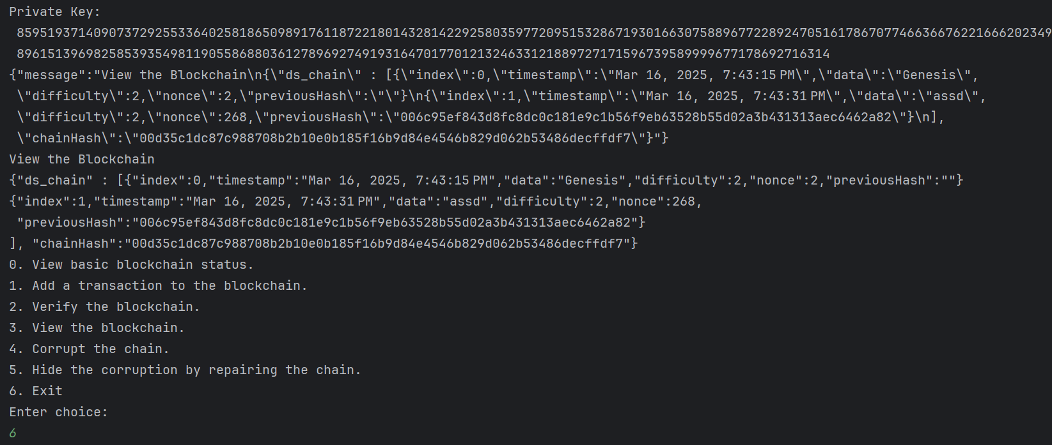
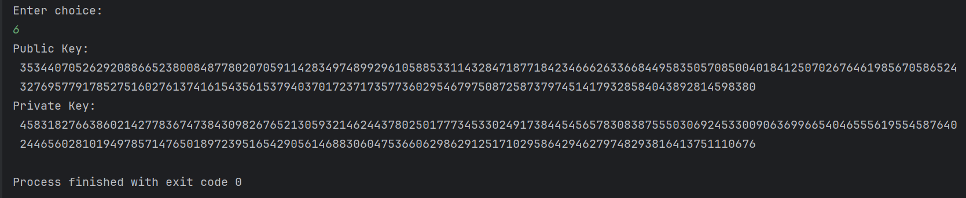
Project3Task2ServerConsole
