Project 4 Task 1
a. Name: Vishal Chatterjee Andrew ID: vchatter
b. football-data.org API: https://api.football-data.org/v4/
c. Documentation link: https://www.football-data.org/documentation/quickstart
d. Short Description: My application will retrieve and display data from different soccer competitions held across the world. It will allow users to keep up with the hectic soccer schedule and get all the latest info of matches, results and best players.
e. Screenshot of the console output from section 1b.
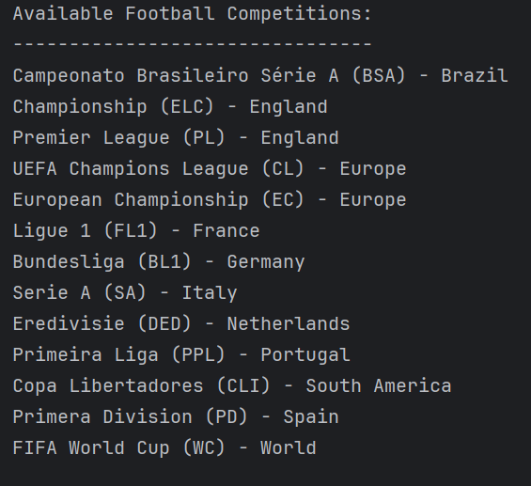
f. A screenshot of the console output from section 2c which shows connecting to the MongoDB and inserting a document.
