Project 4 - Documentation
Name: Vishal Chatterjee
AndrewID: vchatter
Overview:
This project is a distributed football analytics system combining an Android app, a Java servlet backend, MongoDB logging, and a JSP-based dashboard. The Android app allows users to search for top scorers, upcoming matches, and team details across major football competitions. These requests are sent to a servlet deployed on Tomcat, which fetches data from the Football-Data.org API and logs each query into MongoDB Atlas with metadata like type, competition, and timestamp.
A web-based dashboard displays aggregated insights from the logs, including the most queried competitions, common query types, recent user activity, and average result counts. The project is fully containerized with Docker for easy deployment and integrates end-to-end data flow across mobile, backend, and database layers.

Android Application:
Key Features
- Activities Used: app consists of three main Activity classes, each serving a specific role:

1. MainActivity.java
This is the entry point of the app and allows users to:
- Enter a football league name (e.g., “Premier League”).
- Click on one of the buttons to request:
  - FixturesActivity
  - TeamsActivity
  - TopScorersActivity
Logic:
Button fixturesButton = findViewById(R.id.fixturesButton);
fixturesButton.setOnClickListener(v -> {
String leagueName = inputField.getText().toString().trim();
if (!leagueName.isEmpty()) {
Intent intent = new Intent(MainActivity.this, FixturesActivity.class);
intent.putExtra("leagueName", leagueName);
startActivity(intent);
} else {
Toast.makeText(this, "Please enter a league name", Toast.LENGTH_SHORT).show();
}
});

2. FixturesActivity.java
This screen fetches and displays the next 5 fixtures.
- Uses a TableLayout to dynamically populate matchday, date, home team, and away team.
- Sends HTTP requests using OkHttp.
- Parses JSON returned from your servlet.
Network call (background thread):
String url = BASE_URL + "?competitionId=" + competitionId + "&type=matches";
Request request = new Request.Builder().url(url).build();

client.newCall(request).enqueue(new Callback() {
@Override
public void onResponse(@NonNull Call call, @NonNull Response response) throws IOException {
JSONArray jsonArray = new JSONArray(response.body().string());
runOnUiThread(() -> populateTable(jsonArray));
}
});

populateTable() builds the table:
private void populateTable(JSONArray fixtures) {
for (int i = 0; i < fixtures.length(); i++) {
JSONObject match = fixtures.getJSONObject(i);
TableRow row = new TableRow(this);
row.addView(createTextView(match.getString("homeTeam")));
row.addView(createTextView(match.getString("awayTeam")));
tableLayout.addView(row);
}
}

3. TopScorersActivity.java
Displays a leaderboard of top 10 scorers with goals, matches, assists.
- Follows same background-fetch approach using OkHttp.
- UI is also a TableLayout populated from parsed JSON data.
Sample JSON parsing and UI update:
String name = player.optString("name", "N/A");
int goals = player.optInt("goals", 0);
TextView nameView = new TextView(this);
nameView.setText(name + " - Goals: " + goals);
tableLayout.addView(nameView);

- HTTP Failure Handling: All OkHttp requests include an onFailure override:
@Override
public void onFailure(Call call, IOException e) {
runOnUiThread(() ->
Toast.makeText(getApplicationContext(), "Network error: " + e.getMessage(), Toast.LENGTH_LONG).show());
}

- JSON Parsing Safety: Each field is accessed using optString() or optInt() to avoid exceptions:
String position = player.optString("position", "N/A");

Workflow / Data Flow
- User Input (MainActivity)
  - Enters league (e.g., "Premier League")
  - Clicks a button to go to Fixtures, Teams, or Top Scorers.

- Send Request
  - Activity sends GET request to: http://<backend-url>/fetchFootballData?competition=Premier%20League&type=matches
- Servlet Receives & Responds
  - Maps competitionName to competitionId
  - Calls Football-Data.org API
  - Sends a cleaned JSON response
- Activity Receives Response
  - Parses JSON
  - Builds TableLayout with UI rows
- MongoDB Logs
  - Backend logs each request with timestamp, type, result count.
UI Layouts:
Each activity uses:
- A TextView for title.
- A ProgressBar for loading state.
- A TableLayout (within ScrollView) for display.
<TableLayout
android:id="@+id/fixturesTable"
android:layout_width="match_parent"
android:layout_height="wrap_content"
android:stretchColumns="*"
android:padding="12dp"/>

Servlet:
The FootballDataServlet.java is the central backend endpoint that serves your Android app. It performs 3 main tasks:
- Receives HTTP GET requests with competition or competitionId and a type (matches, teams, topscorers, or list).
- Fetches data from the Football-Data.org API.
- Returns structured JSON to the frontend and logs the event in MongoDB.
WorkFlow:
Android App → Servlet → Football-Data API → Servlet → JSON Response → Android UI
↓
MongoDB Logs
Request/Response Mapping:
The servlet handles get requests at:
/fetchFootballData?competitionId=2021&type=matches
Or
/fetchFootballData?competition=Premier%20League&type=topscorers

Football-Data API Integration:
Use a static API key to authenticate calls.
Each data type hits a different endpoint:
- Matches: /competitions/{id}/matches
- Teams: /competitions/{id}/teams
- Top Scorers: /competitions/{id}/scorers
- Competitions List: /competitions

Structured JSON Response
Json object returned
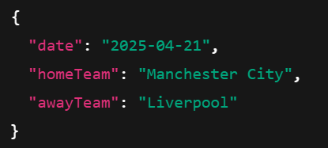
Each type handler builds a clean JSONArray, so Android does minimal parsing.
MongoDB Logging
Each successful request is logged to MongoDB Atlas with:
private void logToMongoDB(String competitionQuery, String dataType, int compId, JSONArray result)
Data Stored as:
{
"competition": "Premier League",
"type": "matches",
"competitionId": 2021,
"resultCount": 5,
"timestamp": 1744340780788
}
Error Handling:
Missing parameters:
if (compId == -1 || dataType == null || dataType.isEmpty()) {
response.setStatus(HttpServletResponse.SC_BAD_REQUEST);
response.getWriter().write("{\"error\": \"Missing or invalid 'competitionId' or 'type' parameter\"}");
return;
}

Football API Failure:

catch (IOException | JSONException e) {
e.printStackTrace();
return null;
}
Servlet Configuration
Using @WebServlet("/fetchFootballData") to automatically mapped without needing web.xml.
Dashboard:
The Dashboard module is a web-based analytical interface built using a Java Servlet (Dashboard.java) and a JSP front-end (dashboard.jsp) that provides real-time insights into how users are interacting with your football data platform. Its core purpose is to visualize backend activity—specifically API usage patterns, popular competitions, and user interests—by leveraging log entries stored in a MongoDB Atlas database.
This dashboard is a powerful administrator or analytics view that helps developers, instructors, or stakeholders understand which parts of the football API are being most heavily used, what queries are being run, and what competitions or data types are most popular. The backend servlet uses MongoDB's aggregation pipeline framework to efficiently compute metrics, while the frontend renders them in HTML tables and an interactive Google Pie Chart.
- User interactions on the Android app trigger API calls (e.g., fetching top scorers, matches, teams).
- The FootballDataServlet logs each request to MongoDB.
- The DashboardServlet reads and aggregates these logs, then passes the computed statistics to the dashboard.jsp.
- dashboard.jsp displays tables, textual insights, and a Google Chart.
Code:
// Mongo Connection
MongoClient client = MongoClients.create(MONGO_URI);
MongoDatabase db = client.getDatabase("Cluster-task4");
MongoCollection<Document> logs = db.getCollection("logs");
// Top Queried Competition
logs.aggregate(Arrays.asList(
Aggregates.group("$competition", Accumulators.sum("count", 1)),
Aggregates.sort(Sorts.descending("count")),
Aggregates.limit(1)
))
// Most Common Query Type
logs.aggregate(Arrays.asList(
Aggregates.group("$type", Accumulators.sum("count", 1)),
Aggregates.sort(Sorts.descending("count")),
Aggregates.limit(1)
))
// Recent Logs
Recent Logs
// Average Results per Type
logs.aggregate(Arrays.asList(
Aggregates.group("$type", Accumulators.avg("averageResults", "$resultCount"))
))
// Pie Chart: Competition → Count
logs.aggregate(Arrays.asList(
Aggregates.group("$competition", Accumulators.sum("count", 1)),
Aggregates.sort(Sorts.descending("count"))
))
All data is passed into the request scope using req.setAttribute(...)
The dashboard JSP renders:
- Most Queried Competition (top header)
- Most Common Type (e.g., top scorers, matches)
- Table of Recent Queries (last 5)
- Table of Average Result Counts per Type
- Google Pie Chart to visualize query distribution

<table>
<tr>
<th>Competition</th><th>Type</th><th>ID</th><th>Results</th><th>Timestamp</th>
</tr>
<% for (Document doc : recentLogs) { %>
<tr>
<td><%= doc.getString("competition") %></td>
...
</tr>
<% } %>
</table>

This dashboard reveals:
- Which leagues are most viewed?
- What types of data (matches, teams, top scorers) are in demand?
- When was the last query made?
- What’s the average size of results returned by API types?
- Trend visualization of engagement by competition via Pie Chart
The Dashboard:
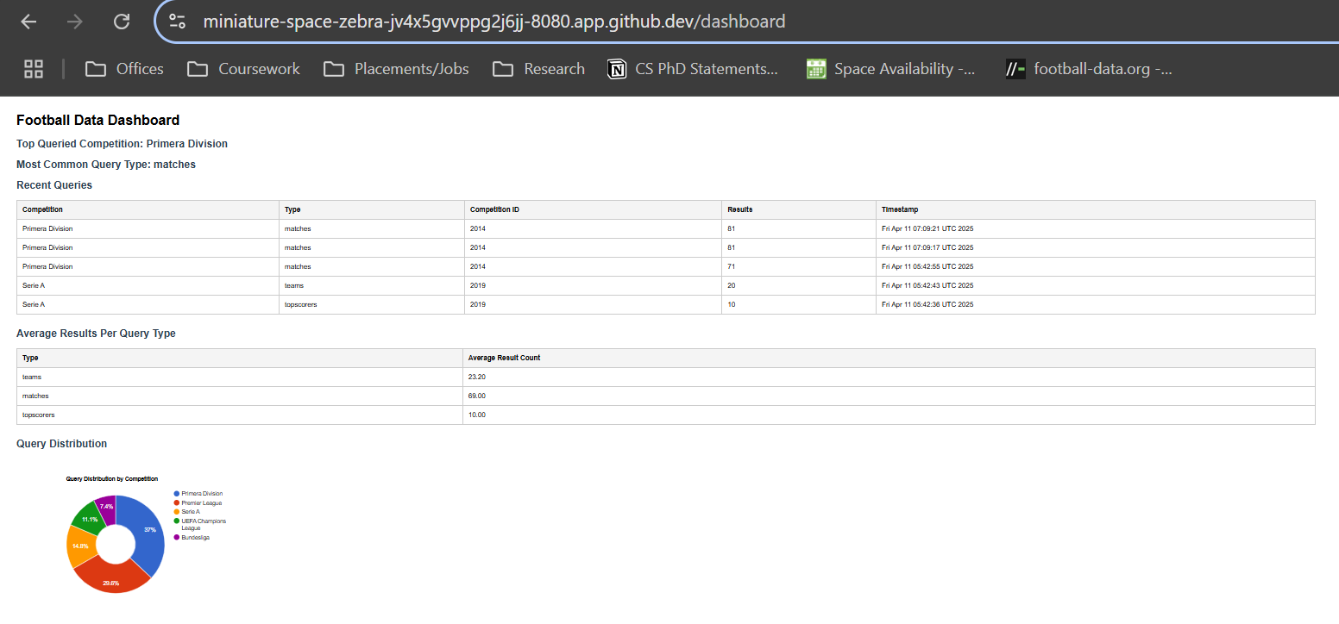

Mongo DB collections:
Here is a sample of the data collected in the Mongo DB
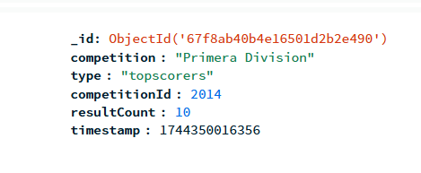

Andriod App UI:
Landing Screen:
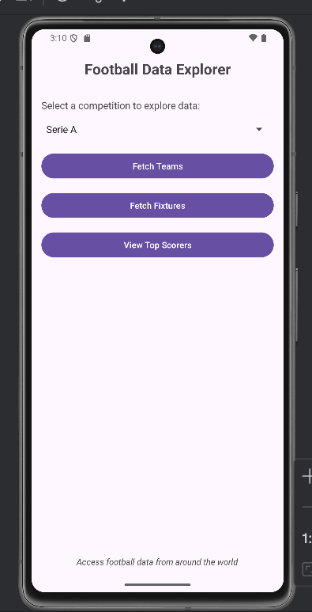

Drop Down menu with all the competitions:
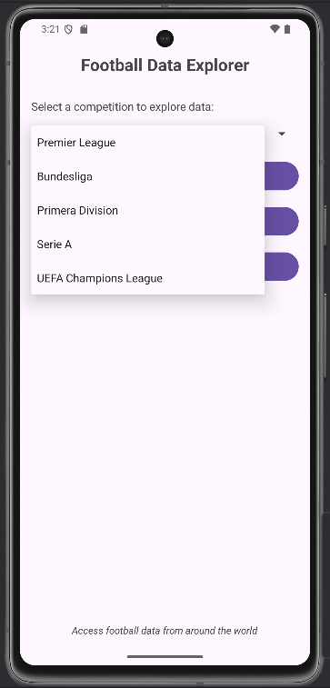

Loading Screen:
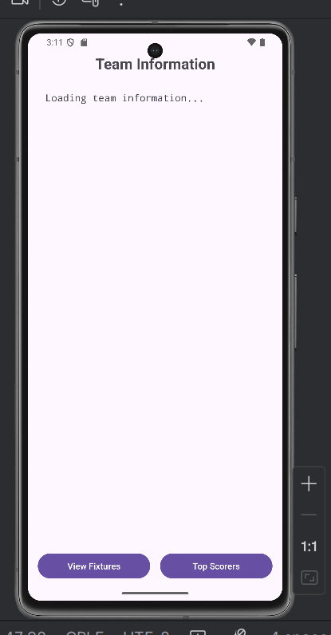

Team Information Screen:
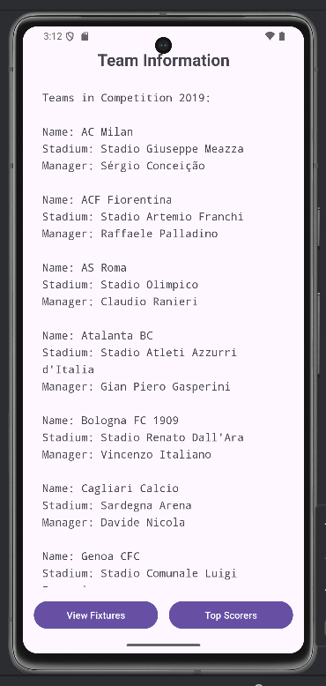

Upcoming Fixtures Screen:
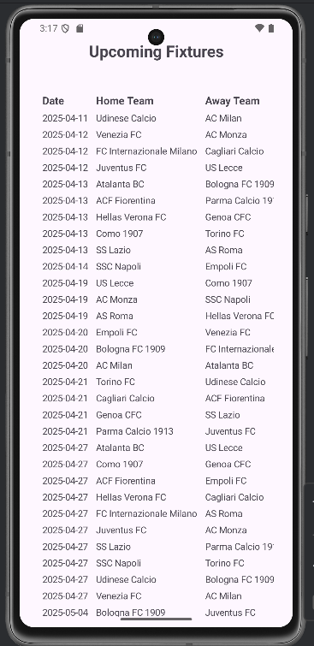

Top Scorers Screen:
