# app接口文档

### **开发IP地址**

http://47.97.100.29

### **token说明**

除了登录接口意外所有的接口都要传递token。

**传递方法：在header中增加一个head名为：**Authorization

值为登录返回的token字符串。

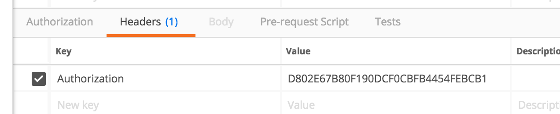

### **接口返回值结构**

{  
    **"code"**:**1**,  
    **"msg"**:**"SUCCESS"**,  
    **"data"**:{  
  
    }  
}

### **Code值说明:**

|  |  |  |
| --- | --- | --- |
| 值 | 含义 | 备注 |
| 0 | 失败 |  |
| 1 | 成功 |  |
| 1001 | 非法请求 |  |
| 1002 | token过期 |  |

## 登录

### URL

/account/login

### 参数

|  |  |  |  |
| --- | --- | --- | --- |
| 名称 | 说明 | 必填 | 备注 |
| userName |  | y |  |
| password |  | y |  |

### 方法

get

### 返回

{  
    **"code"**:**1**,  
    **"msg"**:**"SUCCESS"**,  
    **"data"**:**"C22C375B90279F93C72FEDA499DF03D4_app"**  
}

## 退出登录

### URL

/account/logout

### 参数

无

### 方法

get

### 返回

{  
    **"code"**:**1**,  
    **"msg"**:**"SUCCESS"**,  
    **"data"**:**""**  
}

## 修改密码

### URL

/account/app/changePass

### 参数

|  |  |  |  |
| --- | --- | --- | --- |
| 名称 | 说明 | 必填 | 备注 |
| newPass |  | y |  |

### 方法

get

### 返回

{  
    **"code"**:**1**,  
    **"msg"**:**"SUCCESS"**,  
    **"data"**:**"C22C375B90279F93C72FEDA499DF03D4_app"**  
}

## 查询当前登录用户信息

### URL

/app/user/queryUserInfo

### 参数

无

### 方法

get

### 返回

{  
    **"code"**:**1**,  
    **"msg"**:**"SUCCESS"**,  
    **"data"**:{  
        **"id"**:**1**,  
        **"userName"**:**"admin"**,  
        **"password"**:**"123"**,  
        **"realName"**:**"管理员"**,  
        **"roleId"**:**1**,  
        **"scope"**:**0**,  
        **"createTime"**:**"2018-09-09 21:10:48"**,  
        **"createUser"**:**1**,  
        **"updateTime"**:**null**,  
        **"updateUser"**:**null**,  
        **"roleName"**:**null**,  
        **"role"**:**null**  
    }  
}

## 查询字典【根据传入的type】

### URL

/common/queryDicByType

### 参数

type值：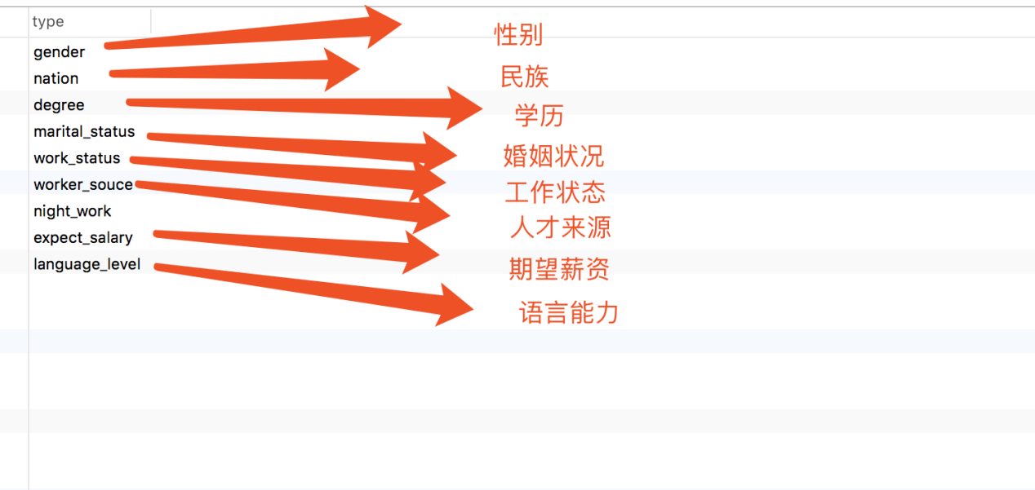

|  |  |  |  |
| --- | --- | --- | --- |
| 名称 | 说明 | 必填 | 备注 |
| type |  | y |  |

### 方法

get

### 返回

{  
    **"code"**:**1**,  
    **"msg"**:**"SUCCESS"**,  
    **"data"**:[  
        {  
            **"id"**:**1**,  
            **"type"**:**"gender"**,  
            **"code"**:**0**,  
            **"name"**:**"男"**,  
            **"sort"**:**1**,  
            **"createTime"**:**"2018-09-01 19:57:58"**,  
            **"createUser"**:**1**,  
            **"updateTime"**:**"2018-09-01 19:58:03"**,  
            **"updateUser"**:**1**  
        },  
        {  
            **"id"**:**2**,  
            **"type"**:**"gender"**,  
            **"code"**:**1**,  
            **"name"**:**"女"**,  
            **"sort"**:**2**,  
            **"createTime"**:**"2018-09-01 19:57:58"**,  
            **"createUser"**:**1**,  
            **"updateTime"**:**"2018-09-01 19:58:03"**,  
            **"updateUser"**:**1**  
        }  
    ]  
}

## 查询所有省份

### URL

/common/queryAllProvince

### 参数

无

### 方法

get

### 返回

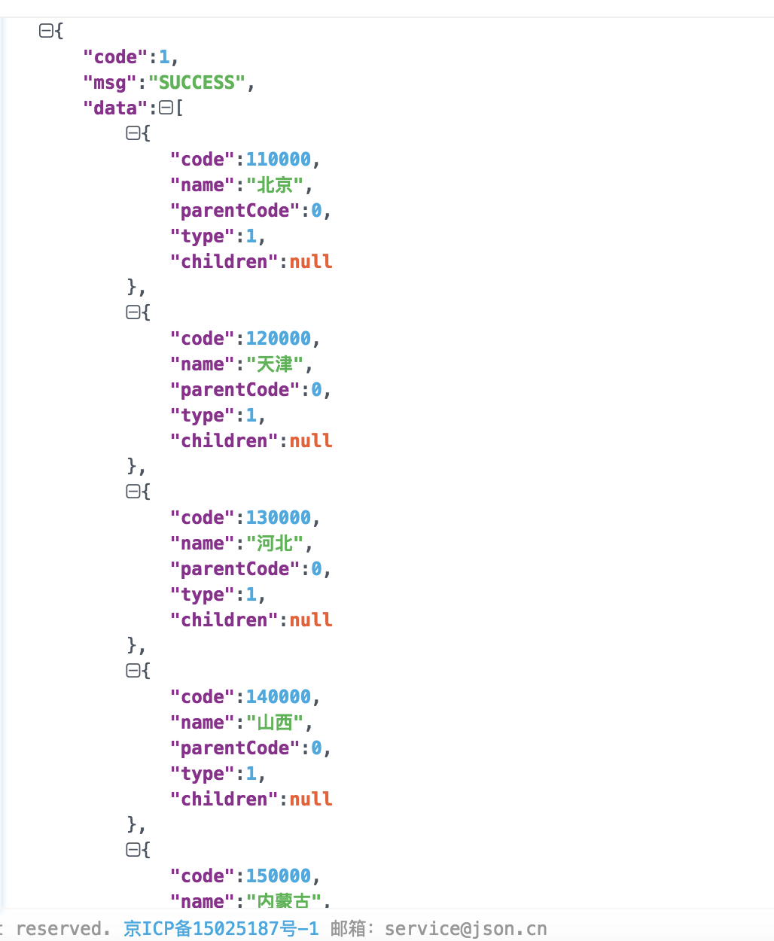

## 根据上级code查询地区子集

### URL

/common/queryAreaByParentCode

### 参数

parentCode

### 方法

get

### 返回

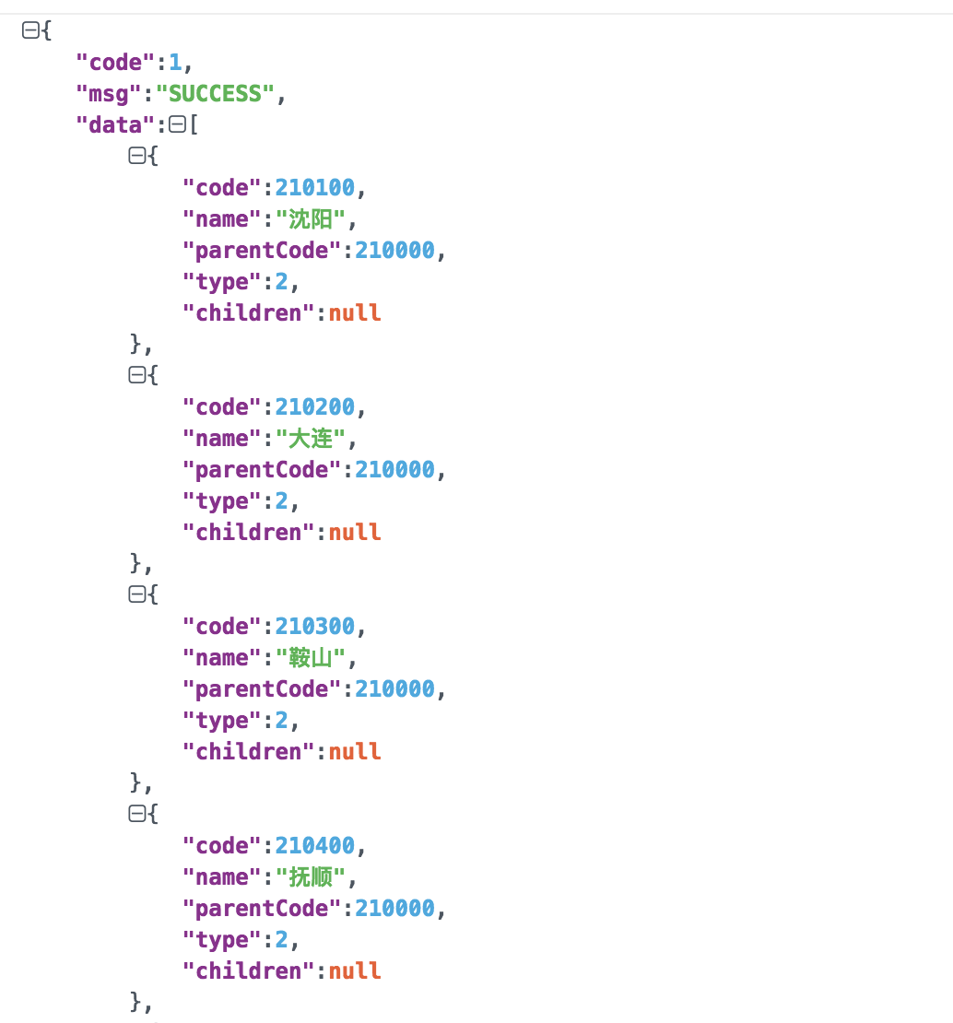

## 查询所有地区树

### URL

/common/queryAreaByParentCode

### 参数

parentCode

### 方法

get

### 返回

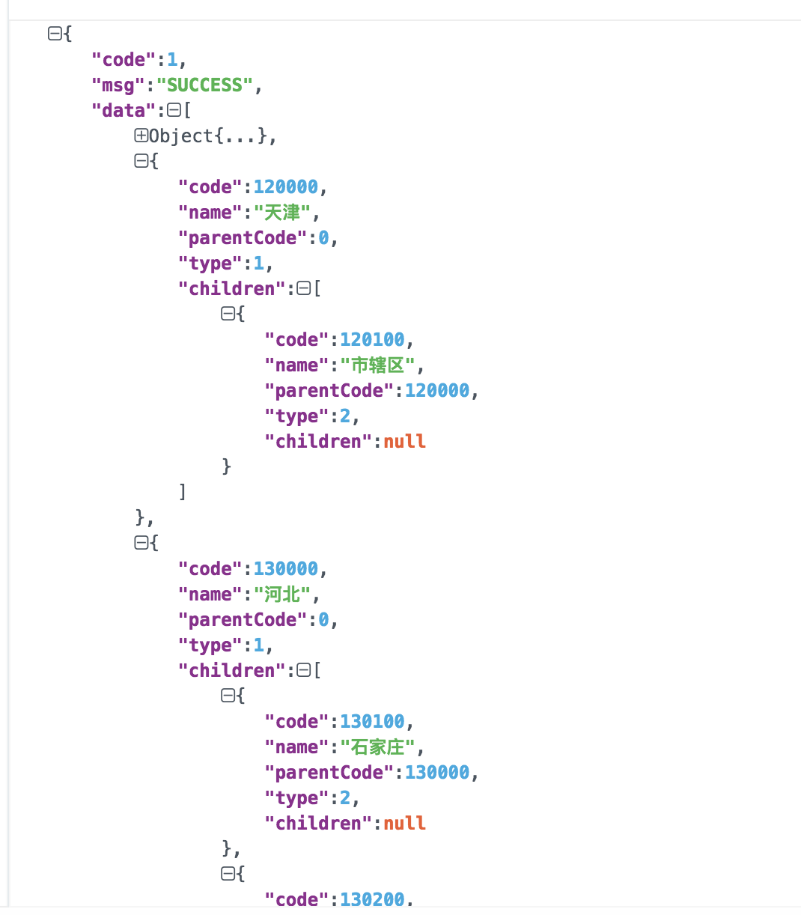

## 人才信息列表

### URL

/app/worker/list

### 参数

|  |  |  |  |
| --- | --- | --- | --- |
| 名称 | 说明 | 必填 | 备注 |
| pageNumber | 当前页 | y |  |
| pageSize | 页大小 | n | 默认8 |
| keyWord | 关键字 | n |  |
| beginTime | 开始时间 | n |  |
| endTime | 结束时间 | n |  |

### 方法

get

### 返回

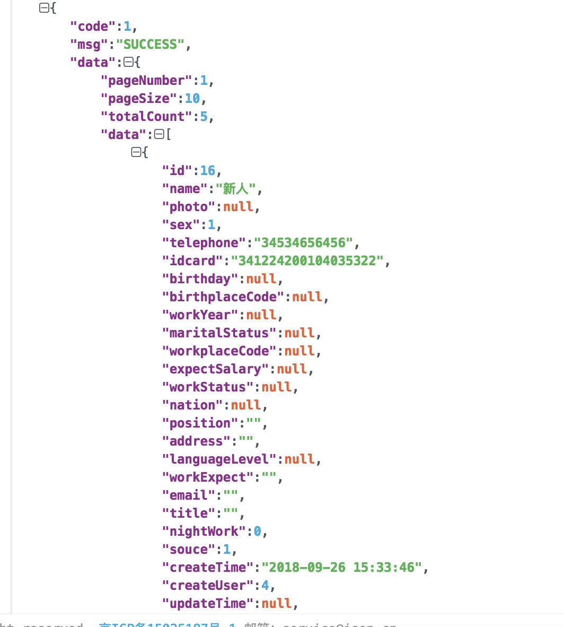

## 新增人才信息

### URL

/app/worker/addWorker

### 参数

worker对象[json方式传递]

### 方法

post

### 返回

## 更新人才信息

### URL

/app/worker/updateWorker

### 参数

worker对象[json方式传递]

### 方法

post

### 返回

## 查询工种树【包含选中状态】

### URL

/app/worker/querySelectedJobType

### 参数

workerId

### 方法

get

### 返回

{  
    **"code"**:**1**,  
    **"msg"**:**"SUCCESS"**,  
    **"data"**:[  
        {  
            **"id"**:**1**,  
            **"name"**:**"互联网"**,  
            **"level"**:**1**,  
            **"parentId"**:**0**,  
            **"createTime"**:**"2018-08-30 11:46:19"**,  
            **"createUser"**:**null**,  
            **"updateTime"**:**null**,  
            **"updateUser"**:**null**,  
            **"selected"**:**1**,  
            **"children"**:[  
                {  
                    **"id"**:**2**,  
                    **"name"**:**"java开发"**,  
                    **"level"**:**2**,  
                    **"parentId"**:**1**,  
                    **"createTime"**:**"2018-08-30 11:46:47"**,  
                    **"createUser"**:**null**,  
                    **"updateTime"**:**null**,  
                    **"updateUser"**:**null**,  
                    **"selected"**:**1**,  
                    **"children"**:[  
  
                    ]  
                },  
                {  
                    **"id"**:**3**,  
                    **"name"**:**"C语言开发"**,  
                    **"level"**:**2**,  
                    **"parentId"**:**1**,  
                    **"createTime"**:**"2018-08-30 11:47:11"**,  
                    **"createUser"**:**null**,  
                    **"updateTime"**:**null**,  
                    **"updateUser"**:**null**,  
                    **"selected"**:**1**,  
                    **"children"**:[  
  
                    ]  
                },  
                {  
                    **"id"**:**4**,  
                    **"name"**:**"前端"**,  
                    **"level"**:**2**,  
                    **"parentId"**:**1**,  
                    **"createTime"**:**"2018-08-30 11:47:36"**,  
                    **"createUser"**:**null**,  
                    **"updateTime"**:**null**,  
                    **"updateUser"**:**null**,  
                    **"selected"**:**1**,  
                    **"children"**:[  
  
                    ]  
                },  
                {  
                    **"id"**:**5**,  
                    **"name"**:**"DBA"**,  
                    **"level"**:**2**,  
                    **"parentId"**:**1**,  
                    **"createTime"**:**"2018-08-30 11:48:05"**,  
                    **"createUser"**:**null**,  
                    **"updateTime"**:**null**,  
                    **"updateUser"**:**null**,  
                    **"selected"**:**1**,  
                    **"children"**:[  
  
                    ]  
                }  
            ]  
        },  
        {  
            **"id"**:**6**,  
            **"name"**:**"试飞员"**,  
            **"level"**:**1**,  
            **"parentId"**:**0**,  
            **"createTime"**:**"2018-09-17 19:28:00"**,  
            **"createUser"**:**null**,  
            **"updateTime"**:**"2018-09-17 19:42:35"**,  
            **"updateUser"**:**null**,  
            **"selected"**:**0**,  
            **"children"**:[  
                {  
                    **"id"**:**7**,  
                    **"name"**:**"飞行员"**,  
                    **"level"**:**2**,  
                    **"parentId"**:**6**,  
                    **"createTime"**:**"2018-09-17 19:32:44"**,  
                    **"createUser"**:**null**,  
                    **"updateTime"**:**null**,  
                    **"updateUser"**:**null**,  
                    **"selected"**:**0**,  
                    **"children"**:[  
  
                    ]  
                },  
                {  
                    **"id"**:**8**,  
                    **"name"**:**"航天员"**,  
                    **"level"**:**2**,  
                    **"parentId"**:**6**,  
                    **"createTime"**:**"2018-09-17 19:33:03"**,  
                    **"createUser"**:**null**,  
                    **"updateTime"**:**"2018-09-17 19:41:47"**,  
                    **"updateUser"**:**null**,  
                    **"selected"**:**0**,  
                    **"children"**:[  
  
                    ]  
                }  
            ]  
        },  
        {  
            **"id"**:**12**,  
            **"name"**:**"呃呃呃"**,  
            **"level"**:**1**,  
            **"parentId"**:**0**,  
            **"createTime"**:**"2018-09-17 20:30:04"**,  
            **"createUser"**:**null**,  
            **"updateTime"**:**null**,  
            **"updateUser"**:**null**,  
            **"selected"**:**0**,  
            **"children"**:[  
  
            ]  
        }  
    ]  
}

窗体顶端

窗体底端