Here is the method how to adjust the APKs space.
I will try the simplest way to describe and demonstrate the entire process.

1> Download the tool and extract it, then open the tool folder.
2>Copy the update.img to the tool folder
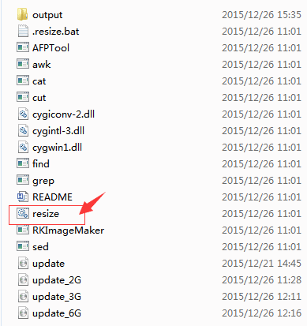

3>Double click AdjustAppSpace.bat to run the process.
4>Select userdata partition size
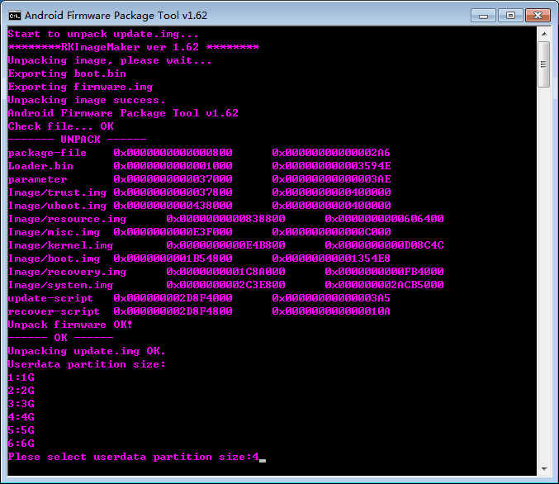

5>If you select 4 then it will generate update_4G.img on current directory.
It is similar for others partition size.
6>Use FactoryTool to flash the update_4G.img into the machine,Now you can get 4G userdata partition size.

