# Have you seen this Indian sculpture park in… Wicklow? · TheJournal.ieVictor's Way Park

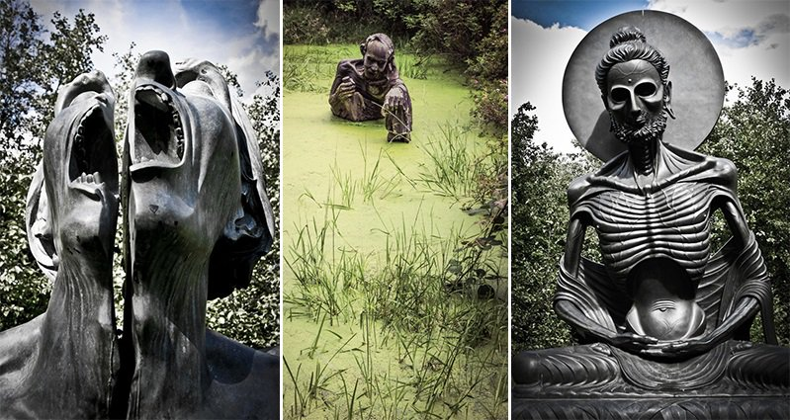

Contents

Victor's Way Park 1

1. Victor's Way 3

2.The park 4

3. Sculptures 5

3.1 Fasting Buddha 6

3.2. The entrance to Victor's Way 7

3.3 Lord Shiva 8

4. Ownership 9

5. References 10

# 1. Victor's Way

(Previously **Victoria's Way**), located near Roundwood, County Wicklow, Ireland, is a privately owned meditation garden notable for its black granite sculptures. The 9-hectare property includes a number of small lakes and forested areas.

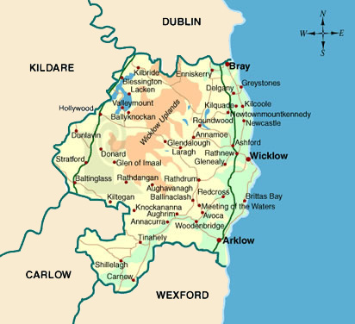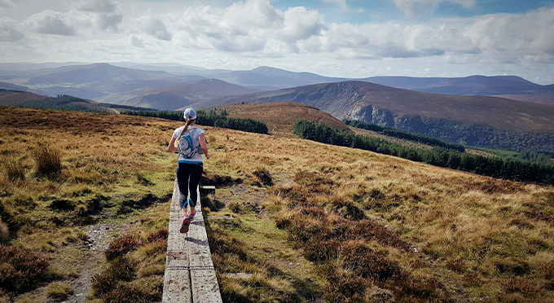

# 2.The park

The Park closed in 2015 as *Victoria's Way* with the owner stating *"Too may day-trippers came turned it into a fun park for parents with children. It was designed as a contemplative garden for over 28's."* but was then re-opened under its original name *Victor's Way* on 15 April 2016, with new age restrictions and higher entrance fee.

The Park is open to the public during the summer months. A plaque by the entrance says the park is dedicated to cryptographer Alan Turing.

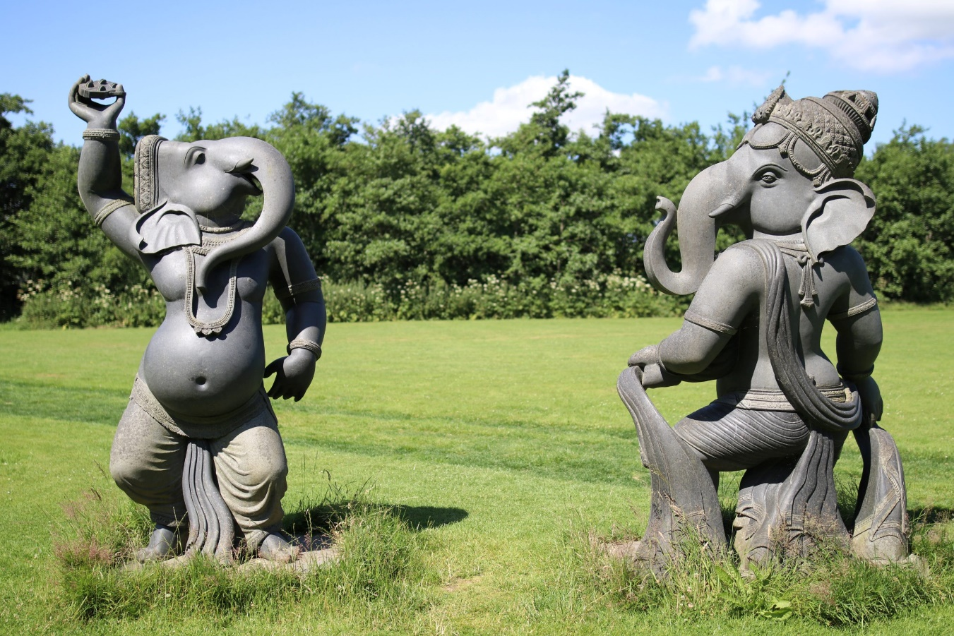

# 3. Sculptures

Most of the park's statues are made of black granite, with some in bronze and range in height from 1.5m to 4.9m. The first structure by the entrance is a sculpted tunnel based on the idea of vagina dentata. The first statue added to the park was the fasting Buddha.

Eight statues are dedicated to Ganesha, showing the elephant god dancing, reading, and playing musical instruments. All the Ganesha sculptures were made in Tamil Nadu, India, and each took five craftsmen a year to make.

Other statues include a large python-shaped seat, a solitary index finger pointing at the sky, and interpretations of Buddha, Shiva, Eve, and others.

Many of the sculptures include small motifs of modernity, such as a small pint of Guinness beside a Ganesha and a mobile telephone tucked into the back of a starving Buddha.

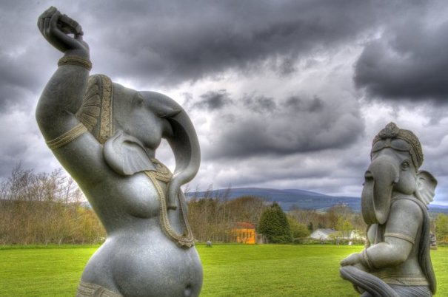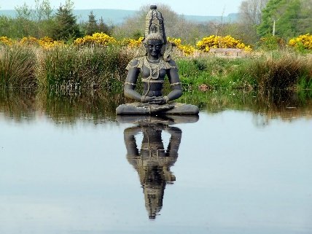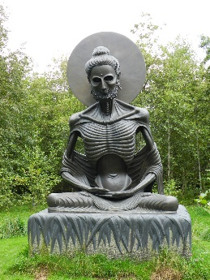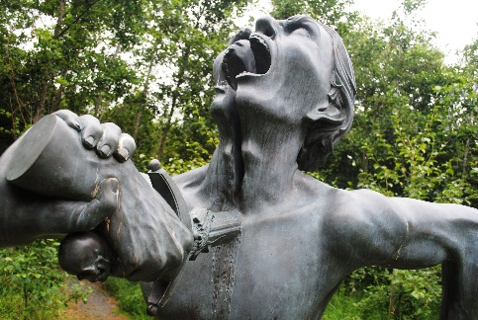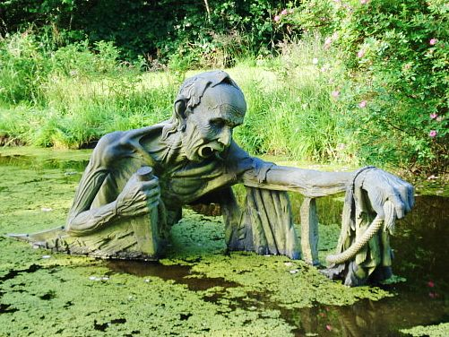

## 3.1 Fasting Buddha

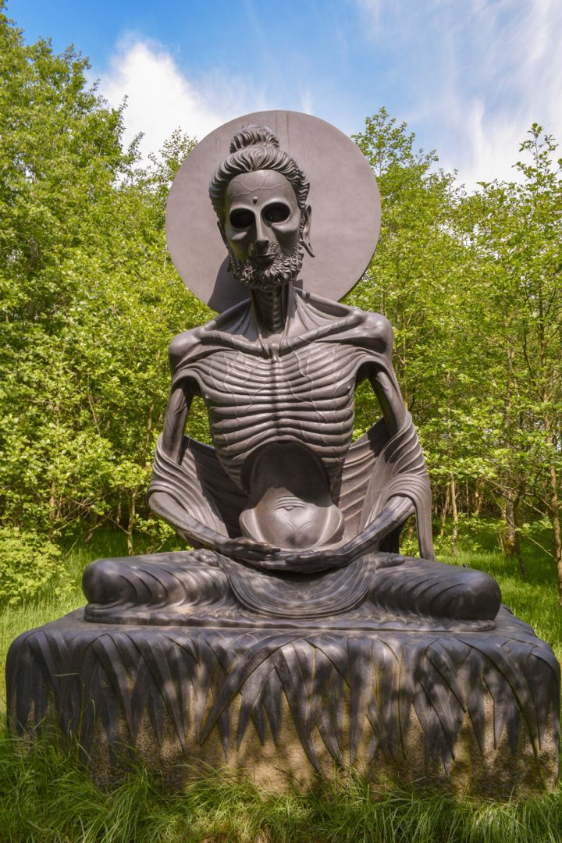

## 3.2. The entrance to Victor's Way

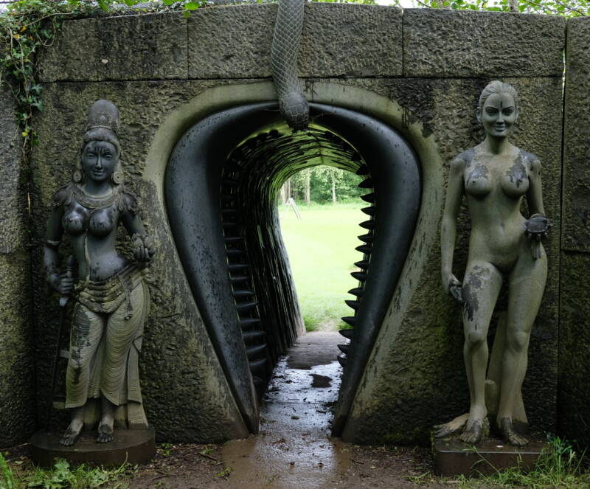

## 3.3 Lord Shiva

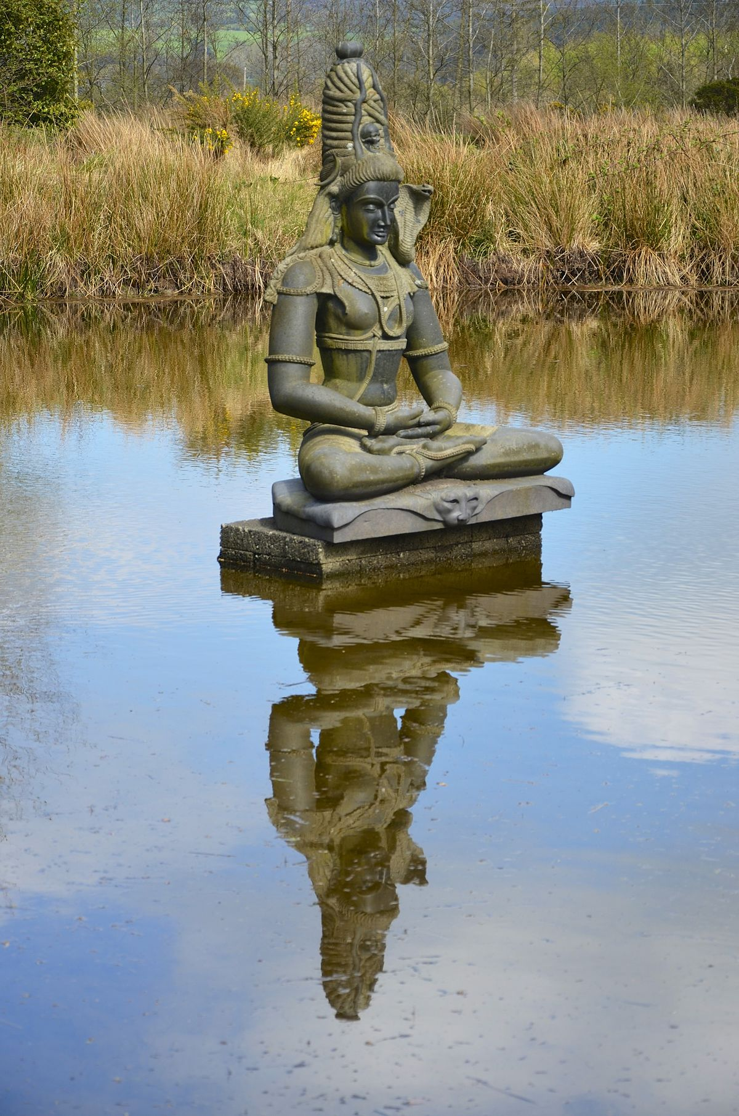

# 4. Ownership

The Park is owned and maintained by Victor Langheld, who was born in 1940 in Berlin and has lived with a number of different religious orders in India, Thailand, Japan, and Sri Lanka. Family inheritance allowed Langheld to spend most of his adult life travelling to spiritual sites in Asia, before travelling to Ireland and sponsoring the construction of the sculpture park.

Langheld designed most of the sculptures, and continues to curate the park and welcome visitors.

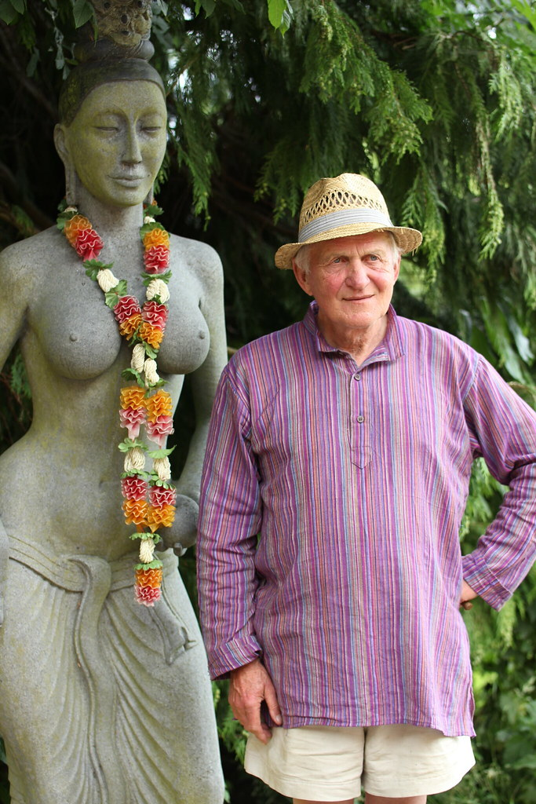

# 5. References

* 1. [Jump up to:***a***](https://en.wikipedia.org/wiki/Victor%27s_Way#cite_ref-youtube-interview_1-0) [***b***](https://en.wikipedia.org/wiki/Victor%27s_Way#cite_ref-youtube-interview_1-1) [*"Victor's way Indian sculpture park Roundwood Co. Wicklow Ireland by Martin Varghese/IvisionIreland"*](https://www.youtube.com/watch?v=xPI21C-dib4). youtube.com*. Retrieved 26 June 2016*.
  2. ^ [Jump up to:***a***](https://en.wikipedia.org/wiki/Victor%27s_Way#cite_ref-access_2-0) [***b***](https://en.wikipedia.org/wiki/Victor%27s_Way#cite_ref-access_2-1) [*"Victor's Way Opening Times & Access"*](http://www.victorsway.eu/open.htm). victorsway.eu*. Retrieved 26 June 2016*.
  3. [**^**](https://en.wikipedia.org/wiki/Victor%27s_Way#cite_ref-tripadvisor_3-0) [*"Victor's Way Q&A answers by Victor Langheld"*](https://www.tripadvisor.co.uk/Attraction_Review-g1391463-d1523388-Reviews-or50-Victor_s_Way-Roundwood_County_Wicklow.html#REVIEWS). tripadvisor.co.uk*. Retrieved 26 June 2016*.
  4. [**^**](https://en.wikipedia.org/wiki/Victor%27s_Way#cite_ref-originalname_4-0) [*"Victoria's Way - Originally Victor's Way (1:58s)"*](https://www.youtube.com/watch?v=4d9A3mCYPhk&t=1m58s). youtube*. Retrieved 26 June 2016*.
  5. [**^**](https://en.wikipedia.org/wiki/Victor%27s_Way#cite_ref-5) [Victoria's Way, Spiritual Sculpture Park](http://homepage.eircom.net/~victoriasway/about_us.htm) [Archived](https://web.archive.org/web/20080921172123/http:/homepage.eircom.net/~victoriasway/about_us.htm) 21 September 2008 at the [Wayback Machine](https://en.wikipedia.org/wiki/Wayback_Machine" \o "Wayback Machine)
  6. [**^**](https://en.wikipedia.org/wiki/Victor%27s_Way#cite_ref-firststatue_6-0) [*"Victoria's Way - First Statue (2:33s)"*](https://www.youtube.com/watch?v=4d9A3mCYPhk&t=2m33s). youtube*. Retrieved 26 June 2016*.
  7. [**^**](https://en.wikipedia.org/wiki/Victor%27s_Way#cite_ref-7) [*"The Irish Ganesh Exhibition, @ Victoria's Way, Roundwood, Co Wicklow"*](http://arquivo.pt/wayback/20141122170856/http:/www.victoriasway.eu/ganeshexh.htm). Archived from [*the original*](http://www.victoriasway.eu/ganeshexh.htm) on 22 November 2014*. Retrieved 15 December 2010*.
  8. ^ [Jump up to:***a***](https://en.wikipedia.org/wiki/Victor%27s_Way#cite_ref-autogenerated1_8-0) [***b***](https://en.wikipedia.org/wiki/Victor%27s_Way#cite_ref-autogenerated1_8-1) [David Kenny's Erindipity](http://www.tribune.ie/arts/article/2008/aug/10/david-kennys-erindipity/)[[*dead link*](https://en.wikipedia.org/wiki/Wikipedia:Link_rot)]
  9. [**^**](https://en.wikipedia.org/wiki/Victor%27s_Way#cite_ref-9) [Wicklow Daily Photo: Indian Sculpture Park VI](http://wicklowdailyphoto.blogspot.com/2010/08/indian-sculpture-park-vi.html)
  10. [**^**](https://en.wikipedia.org/wiki/Victor%27s_Way#cite_ref-10) [Victor, of Victoria's Way](http://homepage.eircom.net/~victoriasway/about_v.htm) [Archived](https://web.archive.org/web/20100124185321/http:/homepage.eircom.net/~victoriasway/about_v.htm) 24 January 2010 at the [Wayback Machine](https://en.wikipedia.org/wiki/Wayback_Machine" \o "Wayback Machine)