pyecharts是一个用于生成Echarts图表的Python库。Echarts是百度开源的一个数据可视化JS库，可以生成一些非常酷炫的图表。

饼图
from pyecharts.charts import Pie
from pyecharts import options as opts
# 示例数据
cate = ['Apple', 'Huawei', 'Xiaomi', 'Oppo', 'Vivo', 'Meizu']
data = [153, 124, 107, 99, 89, 46]
pie = (Pie()
.add('', [list(z) for z in zip(cate, data)],
radius=["30%", "75%"],
rosetype="radius")
.set_global_opts(title_opts=opts.TitleOpts(title="Pie-基本示例", subtitle="我是副标题"))
.set_series_opts(label_opts=opts.LabelOpts(formatter="{b}: {d}%"))
)
#pie.render_notebook()
pie.render("888.html")

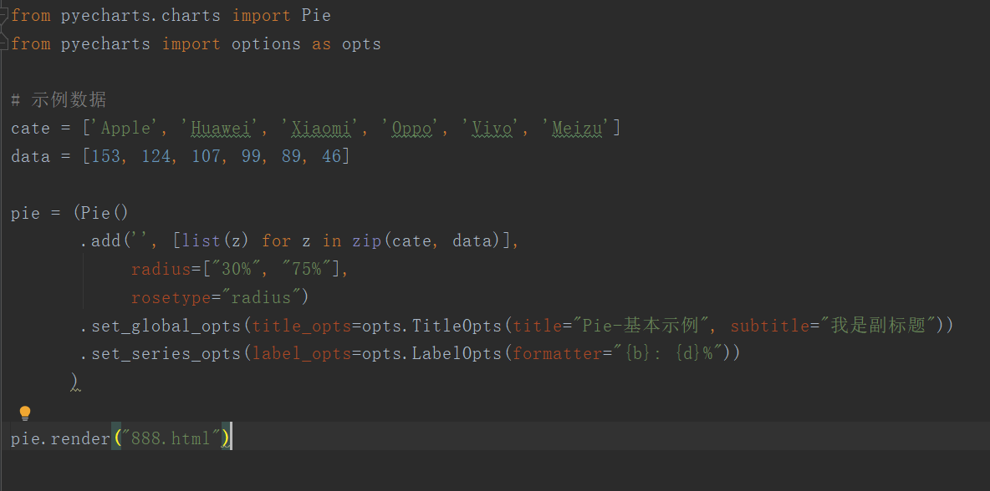
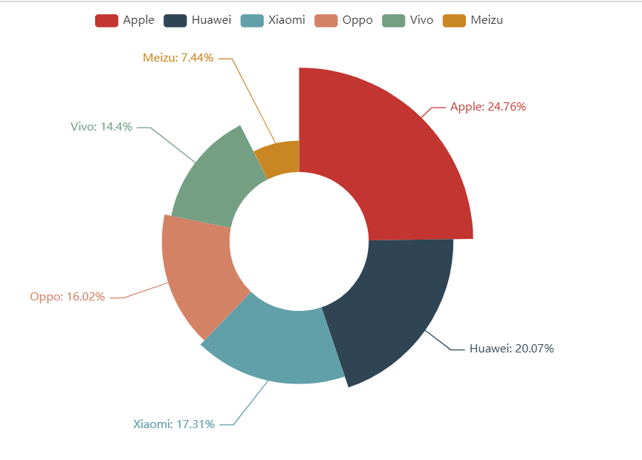

漏斗图
from pyecharts.charts import Funnel
from pyecharts import options as opts
# 示例数据
cate = ['访问', '注册', '加入购物车', '提交订单', '付款成功']
data = [30398, 15230, 10045, 8109, 5698]
"""
漏斗图示例：
1. sort_控制排序，默认降序；
2. 标签显示位置
"""
pie = (Funnel()
.add("用户数", [list(z) for z in zip(cate, data)],
sort_='ascending',
label_opts=opts.LabelOpts(position="inside"))
.set_global_opts(title_opts=opts.TitleOpts(title="Funnel-基本示例", subtitle="我是副标题"))
)
# funnel.render_notebook()
pie.render("555.html")

