**DIC HW3**

312510190 張家瑋

**(1). Without Pipeline:**

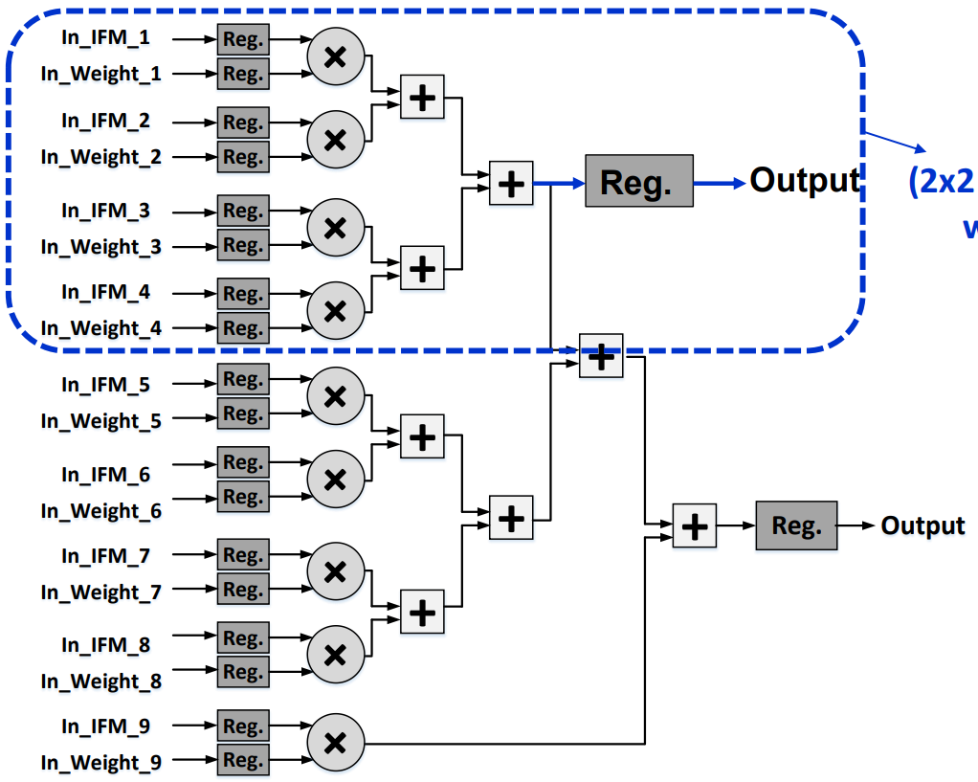

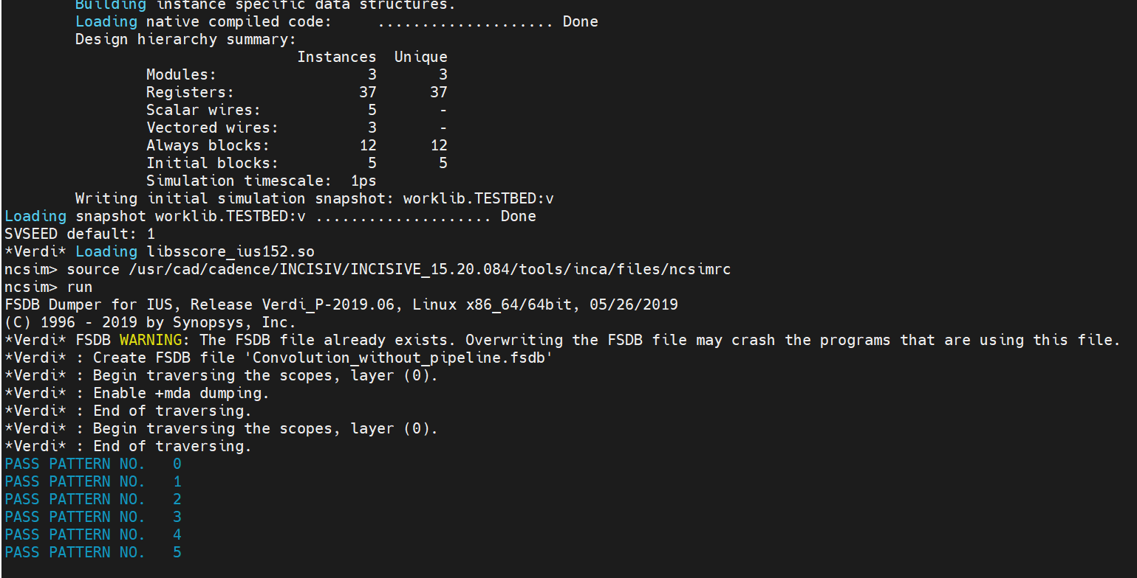

|  |  |  |  |  |
| --- | --- | --- | --- | --- |
| **Without Pipeline** | | | | |
| **Cycle Period (ps)** | **Area** | **Latency**  **(ps)** | **Throughput**  **(G OP/S)** | **Timing** |
| 1250 | 34511.9 | 95625 | 4.705 | MET |
| 1200 | 32586.6 | 91800 | 4.9019 | MET |
| 1150 | 33492.2 | 87975 | 5.115 | MET |
| 1100 | 34633.6 | 84150 | 5.347 | VIOLATE |
| 1050 | 35000.3 | 80325 | 5.602 | VIOLATE |

**(2). With Pipeline:**

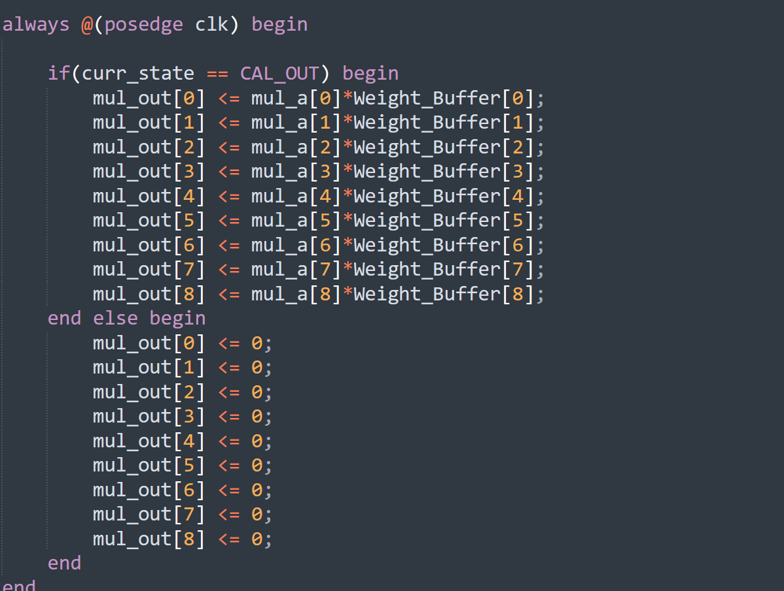

|  |  |  |  |  |
| --- | --- | --- | --- | --- |
| **With Pipeline** | | | | |
| **Cycle Period (ps)** | **Area** | **Latency**  **(ps)** | **Throughput**  **(G op/s)** | **Timing** |
| 1150 | 35736.1 | 89125 | 5.049 | MET |
| 1000 | 35076.4 | 77500 | 5.806 | MET |
| 900 | 36406.6 | 69750 | 6.451 | MET |
| 850 | 37371.4 | 65875 | 6.831 | MET |
| 800 | 37879 | 62000 | 7.258 | MET |
| 700 | 38180 | 54250 | 8.189 | VIOLATE |

**(3)Optimistic**

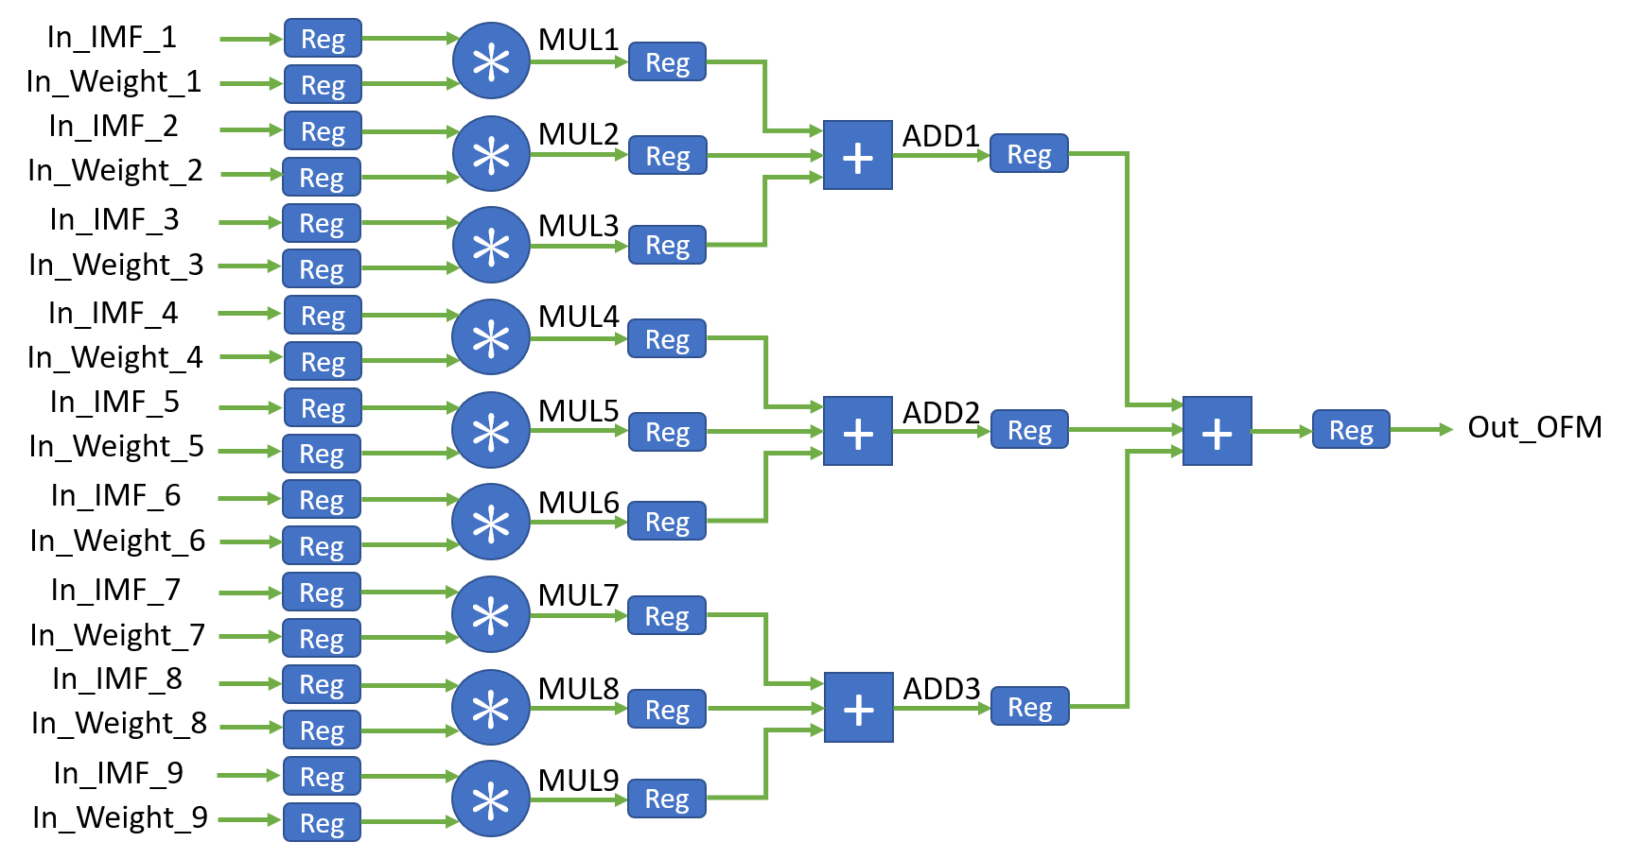

|  |  |  |  |  |  |
| --- | --- | --- | --- | --- | --- |
|  | **OPTIMISTIC** | | | | |
| **Cycle Period (ps)** | **Area** | **Latency**  **(ps)** | **Throughput**  **(G op/s)** | **Area Efficient**  **(Gops/mm)** | **Timing** |
| 850 | 36072.7 | 45475 | 9.895 | 274.3 | MET |
| 700 | 36097.9 | 37450 | 12.016 | 332.8 | MET |
| 600 | 37057.2 | 32100 | 14.018 | 378.2 | MET |
| 550 | 37796.9 | 29425 | 15.293 | 404.6 | MET |
| 500 | 39154.6 | 39750 | 16.822 | 429.6 | VIOLATE |