**DIC HW4**

312510190 張家瑋

**4-1:**

**PART1: Synthesize the 2x2 convolution kernel provided by TA based on ASAP 7nm standard cells.**

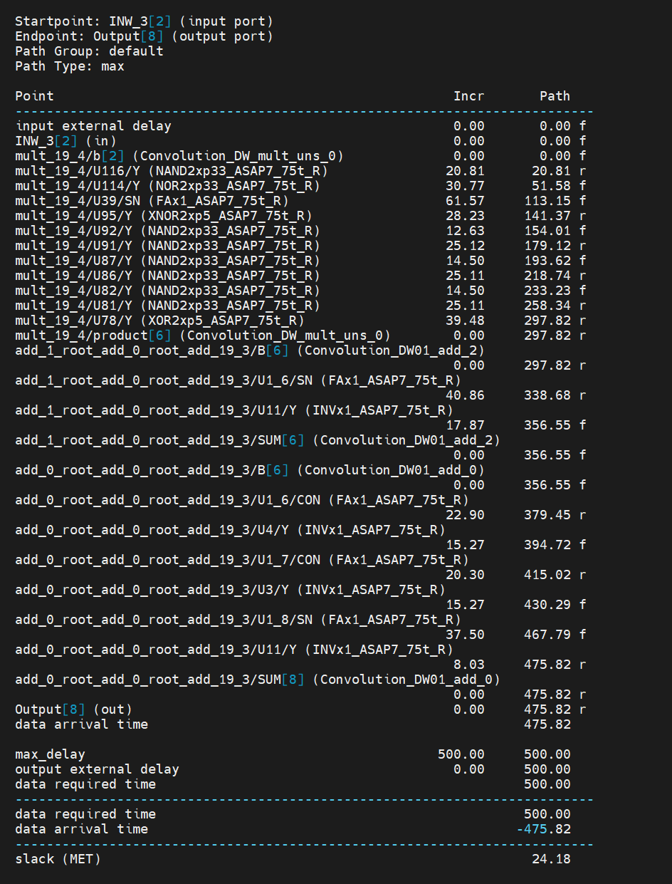

**Critical Path:** FromIFM_3[0] to Output[8]

1

**Input Pattern:**

|  |  |  |  |  |  |  |  |  |  |
| --- | --- | --- | --- | --- | --- | --- | --- | --- | --- |
| **Vector num** | **IFM0** | **INW0** | **IFM1** | **INW1** | **IFM2** | **INW2** | **IFM3** | **INW3** | **Output** |
| **1** | 0000 | 0000 | 0000 | 0000 | 0000 | 0000 | 0000 | 0000 | 0000000000 |
|  | **0** | **0** | **15** | **15** | **15** | **2** | **0** | **1** | **255** |
| **2** | 0000 | 0000 | 1111 | 1111 | 1111 | 0010 | 0000 | 0001 | 0011111111 |
| **3** | 0000 | 0000 | 1111 | 1111 | 1111 | 0010 | 0000 | 0001 | 0011111111 |
| **4** | 0000 | 0000 | 1111 | 1111 | 1111 | 0010 | 0000 | 0001 | 0011111111 |
| **5** | 0000 | 0000 | 1111 | 1111 | 1111 | 0010 | 0000 | 0001 | 0011111111 |
| **6** | 0000 | 0000 | 1111 | 1111 | 1111 | 0010 | 0000 | 0001 | 0011111111 |
| **7** | 0000 | 0000 | 1111 | 1111 | 1111 | 0010 | 0000 | 0001 | 0011111111 |
| **8** | 0000 | 0000 | 1111 | 1111 | 1111 | 0010 | 0000 | 0001 | 0011111111 |
| **9** | 0000 | 0000 | 1111 | 1111 | 1111 | 0010 | 0000 | 0001 | 0011111111 |
|  | **0** | **0** | **15** | **15** | **15** | **2** | **1** | **1** | **256** |
| **10** | 0000 | 0000 | 1111 | 1111 | 1111 | 0010 | 0001 | 0001 | 0100000000 |
| **11** | 0000 | 0000 | 1111 | 1111 | 1111 | 0010 | 0001 | 0001 | 0100000000 |
| **12** | 0000 | 0000 | 1111 | 1111 | 1111 | 0010 | 0001 | 0001 | 0100000000 |
| **13** | 0000 | 0000 | 1111 | 1111 | 1111 | 0010 | 0001 | 0001 | 0100000000 |
| **14** | 0000 | 0000 | 1111 | 1111 | 1111 | 0010 | 0001 | 0001 | 0100000000 |
| **15** | 0000 | 0000 | 1111 | 1111 | 1111 | 0010 | 0001 | 0001 | 0100000000 |
| **16** | 0000 | 0000 | 1111 | 1111 | 1111 | 0010 | 0001 | 0001 | 0100000000 |
| **17** | 0000 | 0000 | 1111 | 1111 | 1111 | 0010 | 0001 | 0001 | 0100000000 |
|  | **0** | **0** | **15** | **15** | **15** | **2** | **0** | **1** | **255** |
| **18** | 0000 | 0000 | 1111 | 1111 | 1111 | 0010 | 0000 | 0001 | 0011111111 |
| **19** | 0000 | 0000 | 1111 | 1111 | 1111 | 0010 | 0000 | 0001 | 0011111111 |
| **20** | 0000 | 0000 | 1111 | 1111 | 1111 | 0010 | 0000 | 0001 | 0011111111 |
| **21** | 0000 | 0000 | 1111 | 1111 | 1111 | 0010 | 0000 | 0001 | 0011111111 |
| **22** | 0000 | 0000 | 1111 | 1111 | 1111 | 0010 | 0000 | 0001 | 0011111111 |
| **23** | 0000 | 0000 | 1111 | 1111 | 1111 | 0010 | 0000 | 0001 | 0011111111 |
| **24** | 0000 | 0000 | 1111 | 1111 | 1111 | 0010 | 0000 | 0001 | 0011111111 |
| **25** | 0000 | 0000 | 1111 | 1111 | 1111 | 0010 | 0000 | 0001 | 0100000011 |

2

|  |
| --- |
| **Input Data Wave** |
|  |
| **Output Data Wave** |
|  |
| **Critical Path Wave** |
|  |

3

**PART2: Analyze and Plot EDP-voltage figure.**

|  |  |  |  |  |
| --- | --- | --- | --- | --- |
| **VDD (V)** | **Power (uW)** | **Energy (fJ)** | **Delay (ps)** | **Product (J·s)** |
| **1.0** | 43.2955 | 259.7730 | 226.7129 | 58.8942 ${ e}^{-24}$ |
| **0.9** | 33.7150 | 202.2900 | 246.6001 | 49.8846 ${ e}^{-24}$ |
| **0.8** | 25.6047 | 153.6282 | 279.7146 | 42.9720 ${ e}^{-24}$ |
| **0.7** | 18.8691 | 113.2146 | 337.3468 | 38.1924 ${ e}^{-24}$ |
| **0.6** | 13.4108 | 80.4648 | 446.4564 | 35.9241 ${ e}^{-24}$ |
| **0.5** | 8.9527 | 53.7162 | 699.0870 | 37.5522 ${ e}^{-24}$ |
| **0.4** | 5.4503 | 32.7018 | 1559.0 | 50.9982 ${ e}^{-24}$ |

**如何得到Energy？**

|  |  |
| --- | --- |
| **Step1:**  **測量power** |  |
|  |
| **Step2:**  **乘transition time** |
|  |

4

**PART3:Find out the minimal energy-delay product of the 2x2 convolution kernel by voltage scaling**

在VDD=0.6V，可得到最小的product (最佳解)；波形及delay、power等資訊如下圖所示：

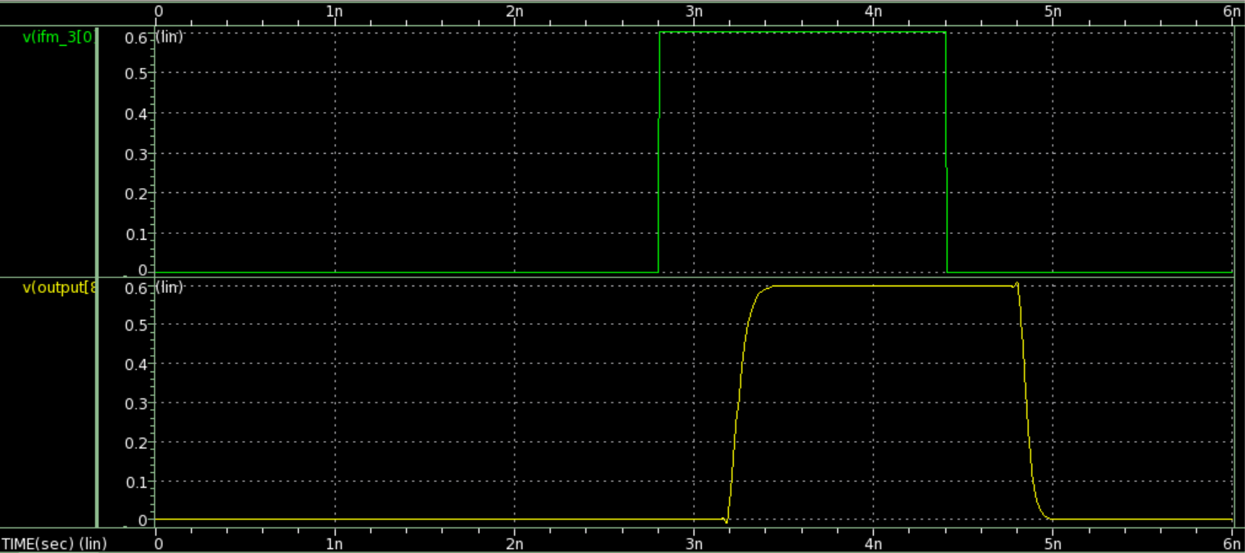

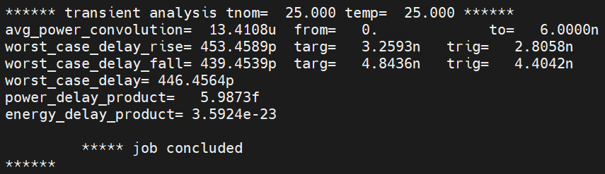

5

**4-2:**

**PART1: Synthesize the comparator provided by TA based on ASAP 7nm standard cells then convert the .v to .sp for measurement.**

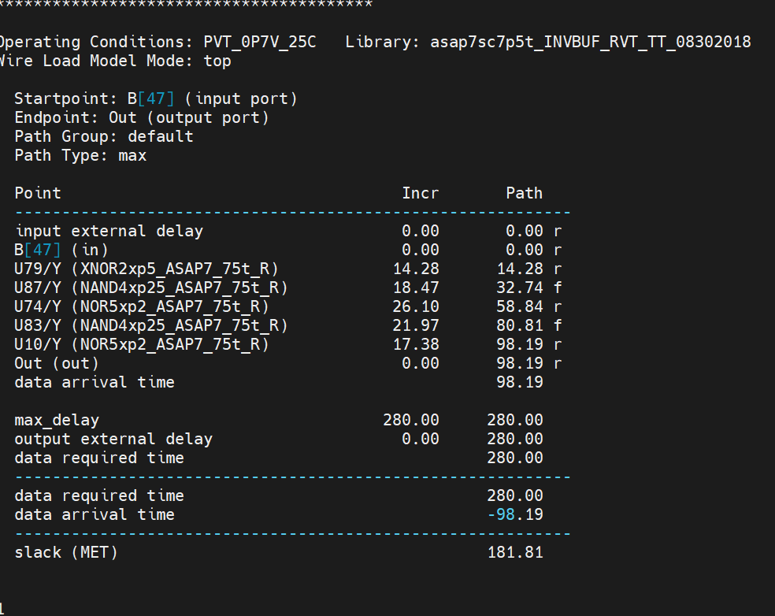

.sp檔模擬成功結果:

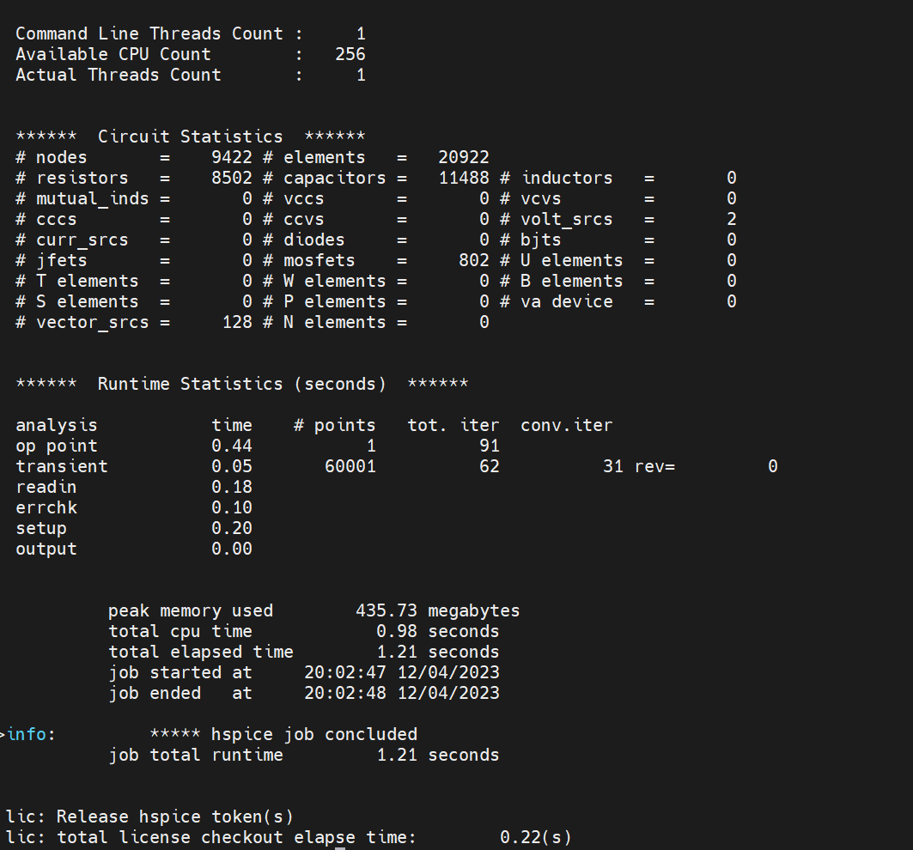

透過增加INVBUF_RVT datasheet 中的buffer來降低delay:

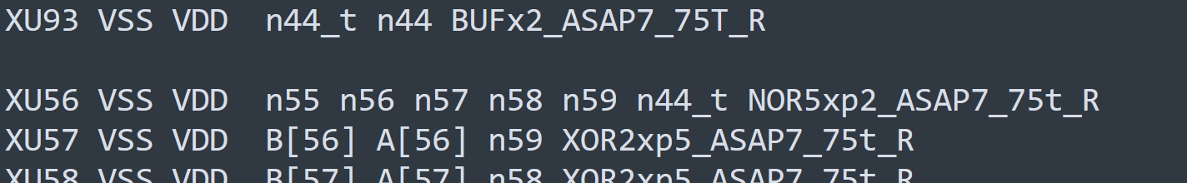

由圖可以發現，out的Tr及Tf都小於100ps，且minimum delay小於1.5ns:

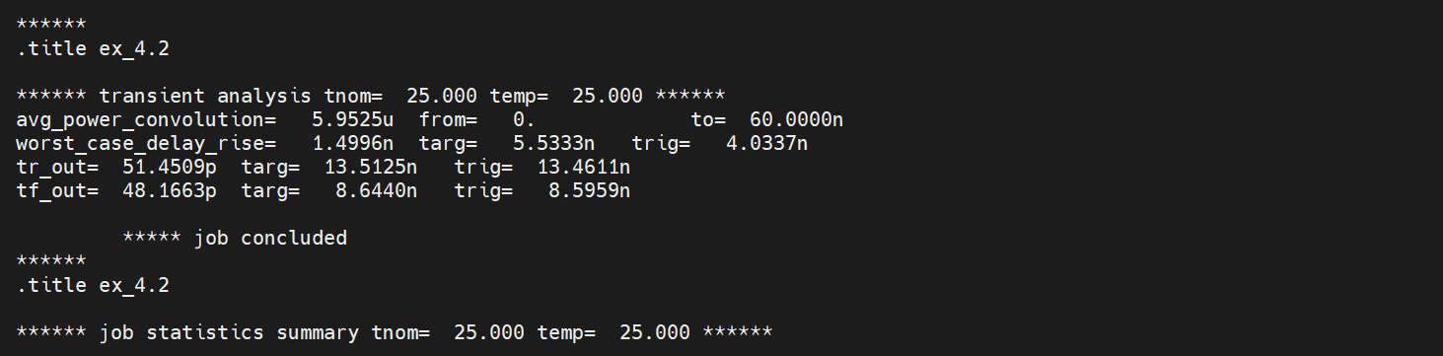

**PART2: Measure the PPA at 0.4v and 0.7v of minimized and synthesized comparator, and analyze**

**Under 0.4V:**



**Under 0.7V:**

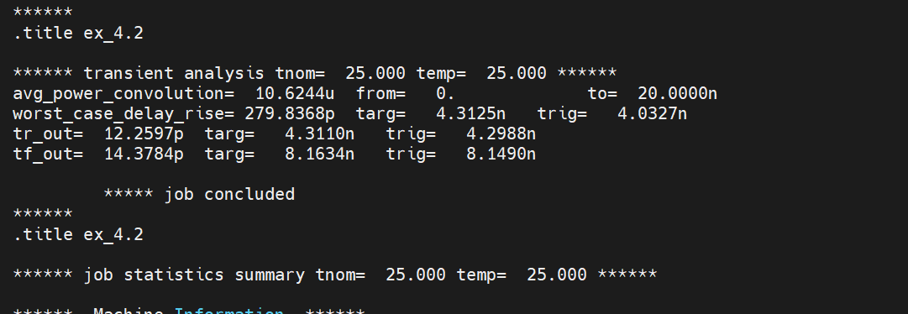

|  |  |  |  |
| --- | --- | --- | --- |
| V | Worst_delay | power | Area counts |
| 0.4v | 1499.6ps | 5.9525uW | 9114 |
| 0.7v | 279.8368ps | 10.6244uW | 9114 |

**由此可知，當0.7V時，雖功率增加約一倍，但minimum worst delay縮小5倍之多，為ECO的效用。**