Educational Blockchain Research Program

Aiden Wesley   
Wentworth Instituite of TechnologyBoston, United States  
wesleya@wit.edu

Abstract—Blockchain technology is a cutting-edge innovation that is transforming a number of industries by offering a secure and decentralized transaction framework. Comprehending the fundamental ideas behind blockchain technology is essential for its extensive implementation and well-informed choices. In this paper, I provide a straightforward but powerful example of a blockchain system intended for teaching. With the help of a hands-on experience that allows users to interact with the technology and gain a deeper understanding of its functionalities, my project seeks to illustrate the complexities of blockchain.

Keywords—Block, Blockchain, Block Creation, Wallet, Wallet Generation, Hash, Hash Generation, Transaction Commitment.

# Introduction

Blockchain technology, initially introduced as the underlying infrastructure for cryptocurrencies, has evolved into a versatile and impactful solution with applications ranging from finance to supply chain management. As its prominence grows, so does the need for accessible educational resources to bridge the knowledge gap and empower individuals with a foundational understanding of this technology.

In this context, my project introduces a user-friendly and interactive blockchain demonstration for educational environments. The demonstration is designed to demonstrate the core concepts of blockchain in a practical manner, allowing users to engage with the technology and witness firsthand its key components such as blocks, hashes, and transactions and wallet creation.

# Ease of Use

Blockchain technologies cryptographic concepts and decentralized nature, can be challenging for newcomers to grasp. In this section, I evaluate the ease of use of my blockchain demonstration, highlighting design choices and features that contribute to an educational user experience.

## User Onboarding:

The onboarding process is a critical aspect of user experience, especially for those unfamiliar with blockchain technology. My demonstration prioritizes a user-friendly onboarding process, allowing users to effortlessly create a wallet and explore the blockchain environment. The steps involved are intuitive, requiring only basic information such as a username and initial balance.

## Wallet Creation:

Creating a wallet is a fundamental step in the user journey. My system makes this process easy by providing clear instructions and generating a unique wallet identifier. The inclusion of an initial balance input ensures that users can immediately engage in transactions without complex setup procedures.

## user_creation (uc)

Figure 1 user_creation method

The user_creation method allows for the creation of new users and their wallets in my blockchain demonstration. This code snippet captures the essential steps: prompting the user for a username and initial balance, generating a unique wallet ID, and adding the new wallet to the system. This method ensures a user-friendly onboarding experience and provides crucial credentials for engaging in blockchain transactions. The concise design emphasizes simplicity and accessibility in the educational exploration of blockchain technology.

## Transaction Execution:

Initiating transactions is a key component of the demonstration, and we have implemented a straightforward process. Users can select the sender and receiver from a list of available wallets, input the transaction amount, and seamlessly execute the transaction. To enhance clarity, I have incorporated informative prompts and visual cues at each step of the transaction process.

## commit_transaction (ct)

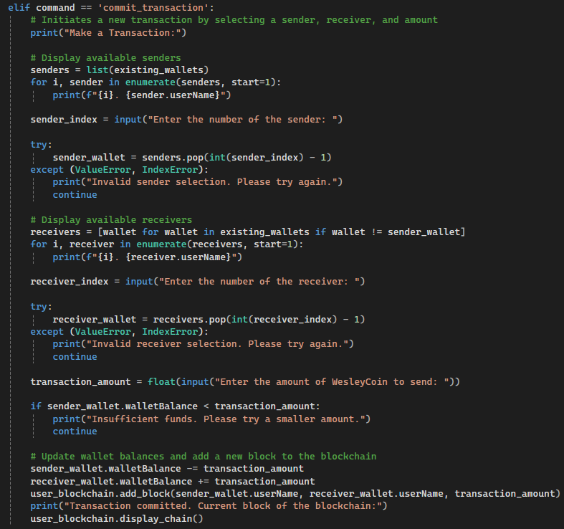

Figure 2 commit_transaction method

The commit_transaction method allows the initiation of transactions within the blockchain demonstration. In this code snippet, users are prompted to select a sender and receiver from a list of available wallets, input the transaction amount, and execute the transaction. The method includes error handling to address potential issues such as invalid inputs or insufficient funds. Upon successful execution, the sender's wallet balance is appropriately deducted, and the receiver's balance is incremented. This method not only streamlines the transaction process but also integrates real-time updates to the blockchain, allowing users to visually track the addition of new blocks. The code reflects a user-friendly and informative transaction workflow, contributing to a seamless and educational user experience in the context of blockchain technology.

## Wallet Balances

In the context of the blockchain demonstration project, wallet balances represent the amount of WesleyCoin associated with each user's digital wallet. Each wallet has an initial balance that users can customize during the wallet creation process. As users engage in transactions, their wallet balances are dynamically adjusted to reflect the changes resulting from these transactions. When a user initiates a transaction, the corresponding amount is deducted from the sender's wallet balance and added to the receiver's wallet balance, ensuring that the total amount of WesleyCoin in the system remains constant. The wallet balances play a crucial role in determining the feasibility of transactions, as insufficient funds will prevent users from committing transactions. This balance mechanism adds a practical layer to the educational blockchain demonstration, allowing users to experience the impact of transactions on their individual wallets within the broader blockchain framework.

## check_balance (cb)

Figure 3 check_balance method

The check_balance method is a fundamental functionality within the blockchain demonstration, providing users with the ability to inquire about the balance of a specific wallet. In the displayed code snippet, the method prompts the user to select a wallet from the list of existing wallets and subsequently retrieves and displays the associated balance. This user-friendly method enhances transparency, enabling users to monitor their WesleyCoin balance and make informed decisions about initiating transactions based on their available funds. The code ensures clarity and simplicity in presenting this essential wallet management feature, contributing to a seamless and educational user experience within the blockchain environment.

## Viewing the blockchain

Being able to view the entire blockchain is a valuable educational feature as it provides users with a tangible and visual representation of the transaction history and structural integrity of the blockchain. This transparency allows users to witness the chronological sequence of blocks, understand the interconnection between each block, and observe how transactions contribute to the ongoing evolution of the ledger. By visually tracing the blockchain, users gain insights into the decentralized and distributed nature of the technology, reinforcing their understanding of its core principles. This feature not only demonstrates the intricacies of blockchain but also empowers users to comprehend the security and immutability aspects of the ledger. Ultimately, the ability to view the entire blockchain fosters a hands-on and interactive learning experience, making blockchain concepts more accessible and engaging for educational purposes.

## Display_chain

Figure 4 display_chain method

The displayed code snippet showcases the display_chain method, a key component in the blockchain demonstration. The method provides a clear representation of how users can access and visualize the entire blockchain. The code enables users to inspect specific blocks or view the most recent block, presenting essential information such as block index, previous hash, timestamp, transaction data, and hash. This image visually captures the simplicity and user-friendly nature of the method, illustrating how it contributes to the educational aspect of the project. The display_chain method, depicted in the code snippet, empowers users to explore and understand the sequential and interconnected nature of the blockchain, enhancing their comprehension of this foundational technology.

## exit_0

Figure 5 exit_0

The displayed code snippet captures the implementation of the exit_0 command, enabling users to gracefully terminate the blockchain demonstration. This feature ensures a user-friendly experience, allowing individuals to conclude their interaction with the program efficiently.

## Class: Blockchain

Figure 6 Blockchain Class

The Blockchain class serves as the backbone of my educational blockchain demonstration. In the code snippet representing the class, the constructor initializes an empty chain and creates the genesis block – the first block in the blockchain. The create_genesis_block method encapsulates this process, ensuring the blockchain starts with a well-defined initial state. The calculate_hash method computes the hash of a block based on its index, incorporating critical block information. This hash is crucial for maintaining the integrity and security of the blockchain. The add_block method extends the blockchain by creating and appending a new block with transaction details, sender, receiver, and other necessary information. This method showcases the simplicity of adding transactions to the blockchain, fostering a hands-on understanding of the technology. The display_chain method allows users to inspect the state of the blockchain, with the option to specify a particular block index. This visual representation enhances the educational aspect, allowing users to observe the chronological evolution of the blockchain. Overall, the Blockchain class encapsulates key functionalities, illustrating the core concepts of blockchain technology in an accessible and educational manner.

## Class: Block

Figure 7 Block Class

The Block class serves as the fundamental building block of my educational blockchain. In the code snippet representing this class, the constructor initializes a block with crucial attributes, including the block index, previous hash, timestamp, transaction data, hash, sender, and receiver. Each block in the blockchain contains this information, forming a transparent and secure ledger.

## Class: Wallet

Figure 8 Wallet Class

The Wallet class is a crucial component of the educational blockchain demonstration, encapsulating the attributes and functionalities of individual user wallets. In the displayed code image, the constructor initializes a wallet with a unique username, a randomly generated 64-character wallet ID, and an initial wallet balance. The Wallet class allows users to interact with the blockchain by creating distinct identities for transactions. Each wallet is associated with a balance, ensuring the seamless execution of transactions within the blockchain environment. This class promotes simplicity and accessibility, providing users with an intuitive interface to engage with the broader educational blockchain framework.

## Real-time Blockchain Display:

Understanding the impact of user actions on the blockchain is crucial for educational purposes. My real-time display of the evolving blockchain allows users to witness the addition of new blocks with each transaction. This visual feedback reinforces the cause-and-effect relationship between user actions and the underlying blockchain structure.

## Educational Impact:

Beyond ease of use, the user interface and interaction flow are intentionally designed to be easily accessible and optimal for educational impact. Users not only engage with the technology but also gain a practical understanding of blockchain concepts through hands-on experience.

# Conclusion

In conclusion, my Educational Blockchain Program presents a hands-on and user-friendly approach to demystifying the complexities of blockchain technology. The project prioritizes ease of use, emphasizing a seamless onboarding process, intuitive wallet creation, and straightforward transaction execution. By providing users with the ability to view the entire blockchain in real-time, the program offers a valuable educational experience, allowing individuals to witness the chronological sequence of blocks and understand the decentralized and distributed nature of blockchain technology. The integration of user-friendly methods such as check_balance and display_chain enhances transparency and encourages users to actively explore the blockchain environment. The implementation of the exit_0 command ensures a graceful termination of the program, contributing to the overall user-friendly design. The Blockchain, Block, and Wallet classes encapsulate core functionalities, promoting simplicity and accessibility in the educational exploration of blockchain concepts. As the project combines theoretical knowledge with practical implementation, it stands as a valuable resource for individuals seeking a foundational understanding of blockchain technology.