CloudWatch

* CW is a monitoring service for AWS cloud resouces and the applications you run on AWS
* 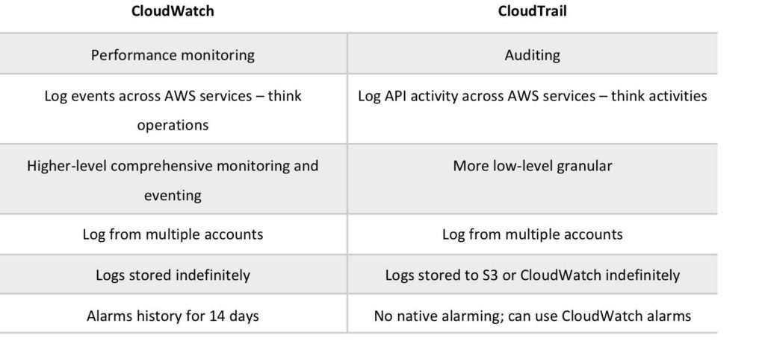
* Used to collect and track metris, collect and monitor log files, and set alarms
* Automatically react to changes in your AWS resouces
* With CW you can monitor resources such as:
  + EC2 instances
  + DynamoDB tables
  + RDS DB instances
  + Custom metrics generated by applications and services
  + Any log files generated by your applications
* Gain system-wide visibility into resource utilization
* Montiro application performanace
* Monitor operation health
* CW is accessed via API, CLI, SDKs, and AWS Management Console
* Integrates with IAM
* CW Logs
  + CW Logs lets you monitor and troubleshoot your systems and applications using your existing system, application and custom log files
  + You can use CW Logs to monitor, store and access your log files from EC2 instances, CT, R53 and other instances
  + CW Logs can be used for real time application and ystem monitoring as well as long term retention
  + CW Logs keeps logs indefinitely by default
  + CT logs can be sent to CW Logs for real-time streaming
  + CW Logs metric filters can evaluate CT logs for specific terms, phrases or values
* CW retains metric data as follows
  + Data points with a period of less than 60 seconds are available for 3 hours. These data points are high-resolution custom metrics
  + Data points with a period of 60 seconds are available for 15 days
  + Data points with a period of 300 seconds(5 minutes) are available for 63 days
  + Data points with a period of 3600 seconds(1 hour) are available for 455 days(15 months)