**Direct Connect**

* DC is a network service that provides an alternative to using the internet to connect a customer’s on premise sites to AWS
* Data is transmitted through a private network connection between AWS and a customer’s datacenter or corporate network
* Benefits:
  + Reduce cost when using large volumes of traffic
  + Increase reliability(predictable performance)
  + Increase bandwidth(predictable bandwidth)
  + Decrease latency
* Each AWS DC connection can be configured with one or more virtual interfaces(VIFs)
* Public VIFs allow access to public services such as S3, EC2, and DynamoDB
* Private VIFs allow access to your VPC
* Must use public IP addresses in public VIFs
* Must use private IP addresses on private VIFs
* Cannot do layer 2 over Direct Connect(L3 only)
* From Direct Connect you can connect to al Azs **within a region**
* You can establish IPSec connections over public VIFs to remote regions
* Route propagation can be used to send customer side routes to the VPC
* You can only have one 0.0.0.0/0 (all IP addresses) entry per route table
* You can bind multiple ports for higher bandwidth
* Virtual interfaces are configured to connect to either AWS public services(EC2 or S3) or private services(VPC based resouces)
* 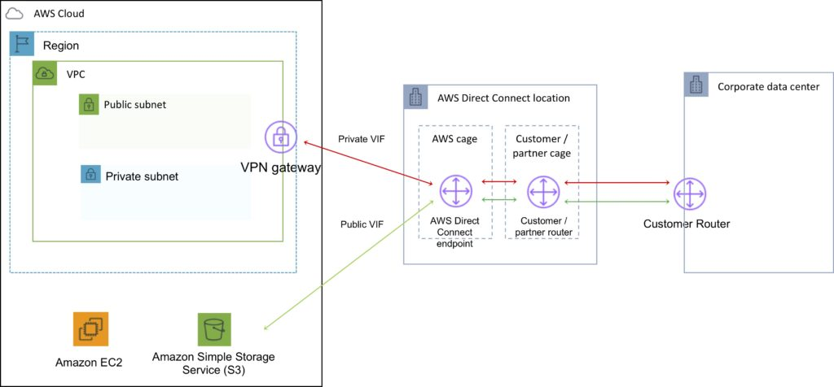
* DC is charged by port hours and data transfer
* Available in 1Gbps and 10Gbps
* Speeds of 50Mbps, 100Mbps, 200Mbps, 300Mbps 400Mbps, 500 Mbps can be purchased through AWS DC Partners
* Uses Ethernet trunking(802.1q)
* Each connection consists of a single dedicated connection between ports on the customer route and an Amazon router
* For HA you must have 2 DX connections – can be active/active or active/standby
* Route tables need to be updated to point to a DC connection
* VPN can be maintained as a backup with a higher BGP priority
* Recommended to enable Bidirectional Forwarding Detection(BFD) for faster detection and failover
* You cannot extend your on-premise VLANs into the AWS cloud using DC
* Can aggregate up to 4 DC ports into a single conneciton using Link Aggregation Groups(LAG)
* AWS DC supports both single(Ipv3) and dual stack(Ipv4/Ipv6) configuraionts on public and private VIFs
* Technical requirements for connecting virtual interfaces:
  + A public or pirvate ASN. If you are using a public ASN you must own it. If you are using a private ASN it must be in the 64512-65535 range
  + A new unused VLAN tag that you select
  + **Private Connection(VPC)** – the VPC Virtual Private Gateway(VGW) ID
  + **Public Connection** – Public Ips (/30) allocated by you for the BGP session
* **Direct Connect Gateway**
  + Grouping of Virtual Private Gateways(VGWs) and Private Virtual Interfaces(VIFs) that belong to the same account
  + Direct Connect Gateway enables you to interface with VPCs in any AWS Region
  + You associate an AWS Direct Connect gateway with either of the following gateways
    - A TRANSIT GATEWAY WHEN YOU HAVE MULTIPLE vpcS IN THE SAME Region
    - A virtual private gateway
  + Can share private virtual interface to interface with more than one Virtual Private Clouds(VPCs) reducing the number of BGP sesisons
  + A Direct Connect gateway is a vglobally available resource
  + You can create the DC gateway in any public Region and access it from all other public Regions
* 