**Athena**

* Athena is an interactive query service that makes it easy to analyze data in S3 using starndard SQL
* Athena is serverless, so there is no infrastructure to manage and you only pay for the queries that you run
* Athena is easy to use – simply point to your data in S3, define the schema and start querying using standard SQL
* Athena uses Presto with full standard SQL support and works with a variety of standard data formats including CSV, JSON, ORC, Parquet and Avro
* While Athena is ideal for quick ad-hoc querying it integrates with QuickSight for easy visualization, it can alos handle complex analysis including large joins, window functions and arrays
* Athena uses managed Data Catalog to store information and schemas about the databases and tables that you create for your data stored in S3
* With Athena, you don’t have to worry about managin or tuning clusters to get fast performance
* Athena is optimized for fast performance with S3
* Athena automatically executes queries in parallel so you can get query results in seconds, even on large datasets
* Most results are delivered iwthin seconds
* With Athena, there’s no need for complex ETL jobs to prepare data for analysis
* This makes it easy for anyone with SQL skills to quickly analyze large-scale datasets
* Athena is out-of-the-box integrated with Glue Data Catalog, allowing you to create a unified metadata repositor across various services, crawl data sources to discover schemas and populate your Catalog with new and modified table and partition definitions, and maintain schema versioning
* You can also use Glue’s fully managed ETL capabilities to transform data or convert it into columnar formats to ptimize cost and improve performance
* Use Cases
  + Query services like Athena, data warehouses like Redshift, and sophisticated data processing frameworks like EMR, all address different needs and use cases
  + Redshift provides the fastest query performance for enterprise reporting and business intelligence workloads, particularly those involving extremely complex SQL with multip joins and sub-queries
  + EMR makes it simple and cost effective to run highly distributed processing frameworks such as Hadoop, Spark and Presto when compared to an on-premises deployments. EMR is flexible – you can run custom applications and code, and define specific compute, memory, storage, and appliactaion parameters to optimize your analytic requirements
  + Athena provides the easiest way to run ad-hoc queries for data in S3 without the need to setup or manage any servers
  + This table shows primary use casees and situations for using a few query and analytics services:
  + 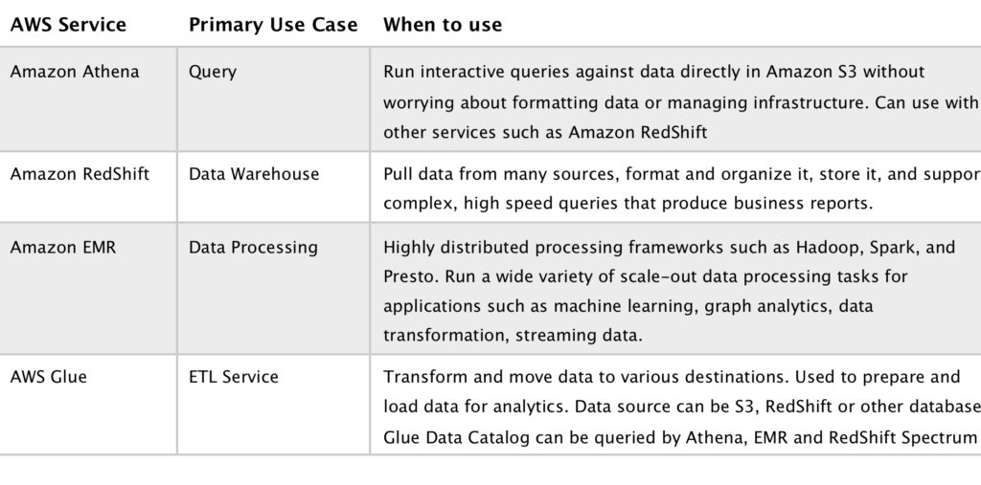
  + Pricing
    - With Athena you pay only for the queries that you run
    - You are charged based on the amount of data scanned by each query
    - You can get significant cost savings and performance gains by compressing, partitioning, or converting your data to a columnar format, because each of those operations reduces the amount of data that Athena needs to scan to execute a query