Wesley Gomersall
Git Assignment

Part 1.
Merge conflict:
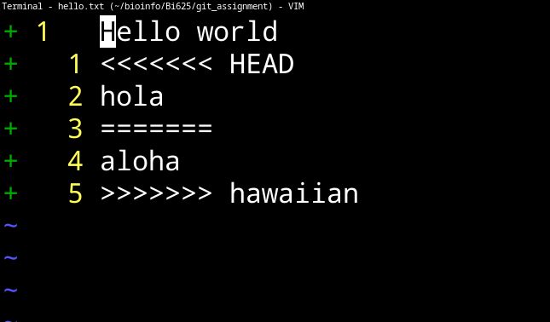
Completed merge:
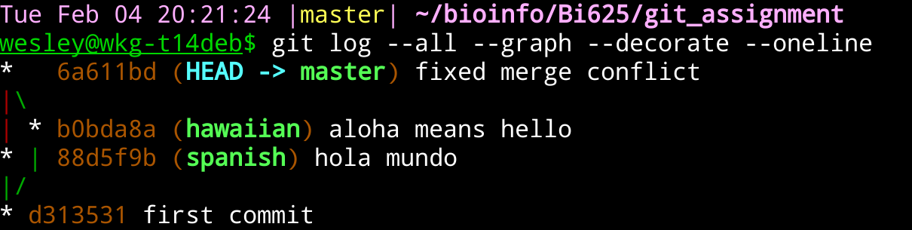
Detached head:
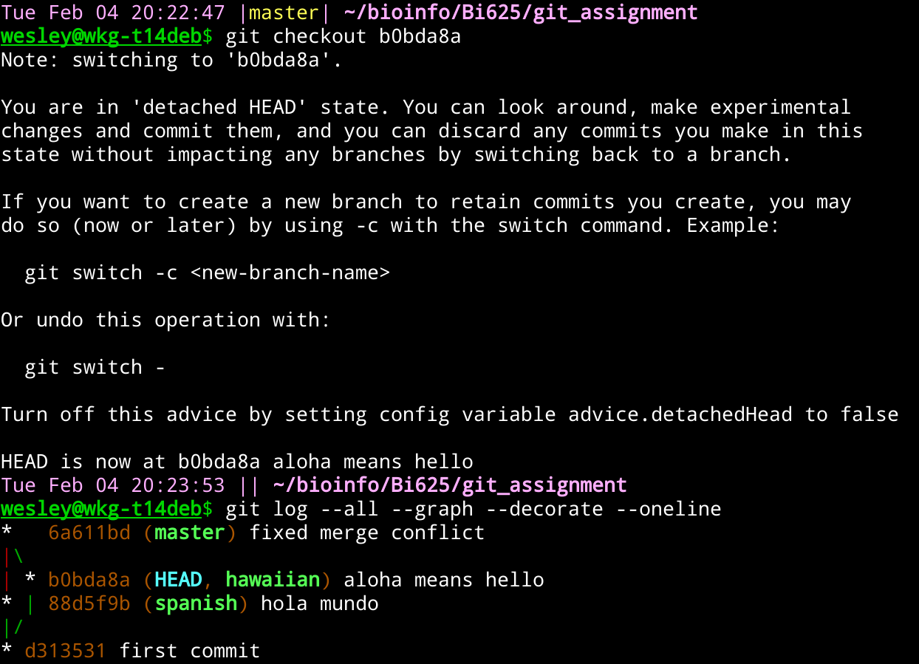

Change to new head:
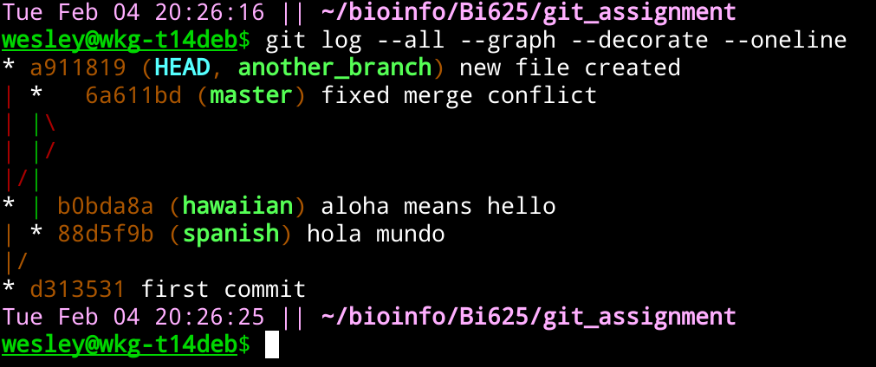
Final merge:
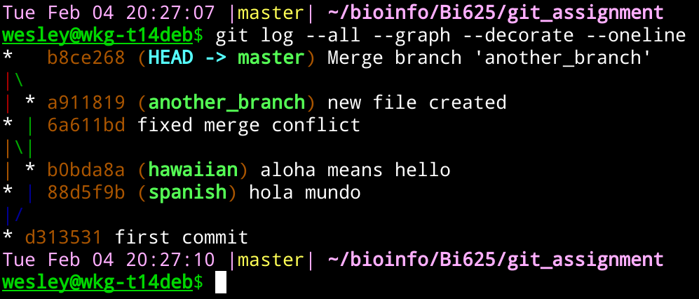
Part 2.
Output of git log --all --graph --decorate --oneline:
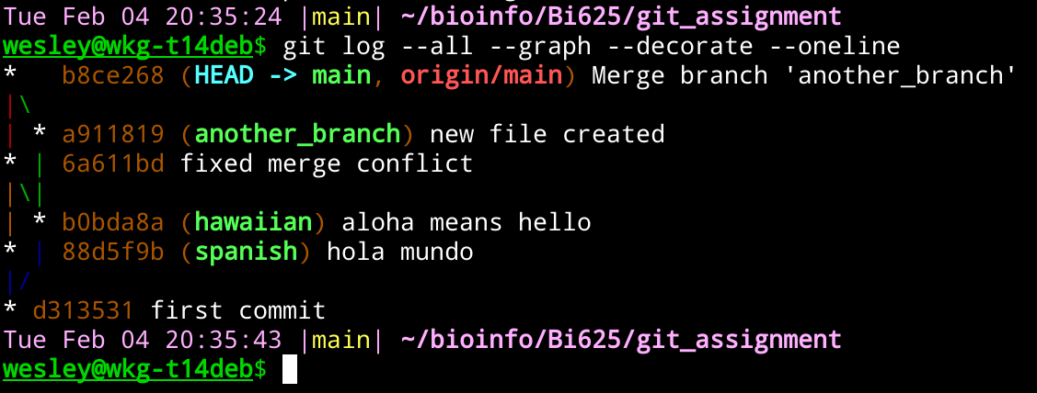
Screenshot of GitHub network:
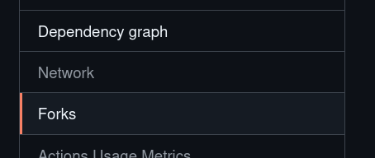
There is no network visible here, it is grayed out and cannot be selected. :-(
P.S. I figured it out that the repository was private. I made it public but the repo had already been pushed to from Talapas. See the screenshot below.
Part 3.
Made change on Talapas:
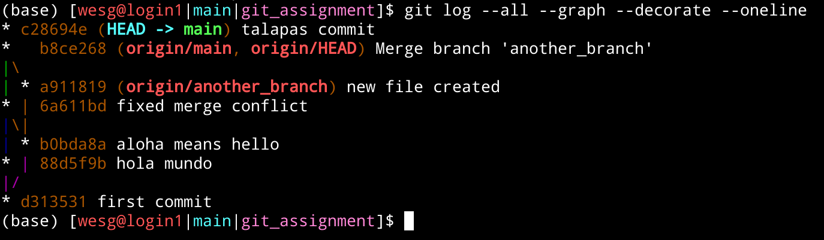
Screenshot of GitHub network:
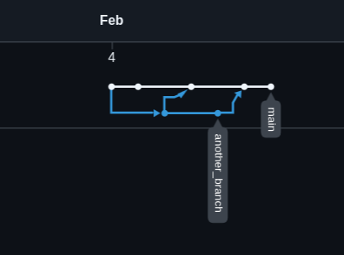
Output of git log --all --graph --decorate --oneline on local machine:
