**CE88 Homework 1**

10 points

Please write up answers to the following questions. Submit a .pdf with your answers via bcourses by the published deadline. You are allowed to discuss the problems with your classmates, but all work you turn in should be individual.

**Questions 1.** (2 points) Tell us in a few sentences why you are interested in smart cities.

Questions 2-3 are related to the minilab we worked on in class. If you have not done so already, please go to the mini-lab 1, complete (or review) it before trying to answer the following questions.

**Question 2.** (4 points) In mini-lab 1 we noticed that strangely low traffic counts were caused by the “Black Lives Matter” protest on MLK day that blocked traffic heading westward over the Bay Bridge. While in this case the low traffic flow was caused by a protest, in general low traffic counts can be caused by many things including vehicle collisions, broken sensors, construction, or, as seen on 1/18/16, a protest. Explain how you could use sensor data to distinguish between the following incident types:

* 1. A collision,
  2. A broken traffic sensor,
  3. A protest
  4. Construction

(**Hint** – we gave you traffic counts from one sensor. There are hundreds of sensors in the bay area. Below is a map of the sensors near the bay bridge. Could you make use of data from multiple sensors to distinguish between event types? Think about how the per-lane data from a collision would look different than data from from a broken sensor.)

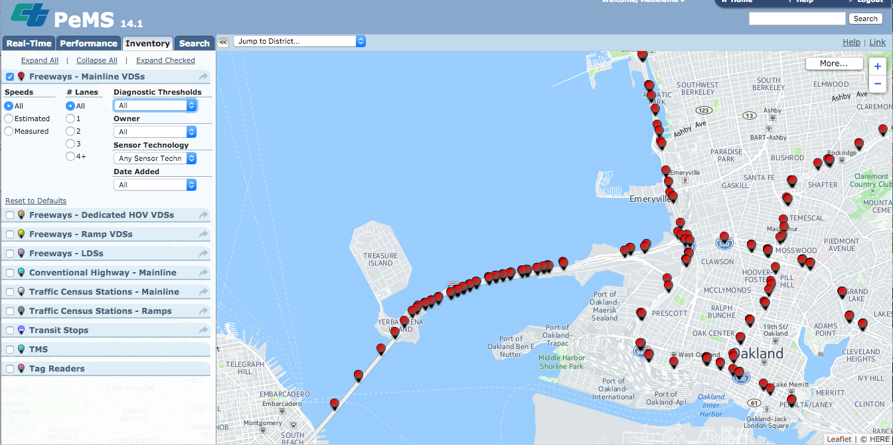

**Question 3.** (4 points + bonus) In this lab we noticed the cyclical nature of traffic flows with apparent diurnal (i.e. day/night) cycles. In this exercise we ask you to forecast future traffic volumes based on the trends you saw. What do you think the west-bound per hour traffic counts will be over the Bay Bridge on Tuesday, September 13, 2016?

* 1. (4 points) Create a **graphical** representation of the expected traffic counts per hour for Tuesday, September 13, 2016. You can use any means and tools to answer this question. If you are comfortable with using Python, demonstrate it here. If you are not a Python guru yet, you are free to use the tools you got at your disposal (Matlab, Excel, Paintbrush, hand drawing).
  2. (**Extra credit -** 2 bonus points) Provide numbers for the expected traffic count per hour for each hour from 1 am to midnight on Wednesday, February 3rd and explain the process you used to come up with these numbers