**CS171 Project Proposal**

Global Energy Consumption by Type (1971-2007)

**Team:**

Muhammad Ibrahim

Wahaj Ahmed Chaudhry

Wesley King Chen

**Background and Motivation:**

Visualization is a tool to help show trends and relationships that may be difficult to see from the looking at the numbers. For our CS171 project, we knew that we wanted to visualize something of global relevance. Wahaj and Wesley are taking a Frontiers of Modern Chemistry, where a chapter was devoted into energy consumption and efficiency of various systems. Among various case studies included global energy consumption. There are many types of energy consumption - all with certain effects. We wanted to show not just the trends of total energy use, but also the types of energy that each country used relative to all other countries. Our goal is to highlight trends that are occurring both throughout the world and over the decades. From such trends, we hope to also be able to make inferences on related consequences - such as greenhouse gas release and global warming.

**Project Objectives:**

* What are the relative amounts of total energy consumption between countries and how can we most clearly show these comparisons?
* What are the specific types of energy (e.g. coal, nuclear, solar, etc.) that are being by each country and what are the underlying trends between countries of the world and over the past four decades?
* What is the power consumption and distribution losses in the context of energy extraction and consumption from one country to the next?
* How much energy is imported and how much is exported of each type?
* What is the total global energy consumption? What is the total global energy consumption of each type of power source? Scaled per capita?
* Are certain countries more progressive in their use of alternative energy sources? Do we see trends in this shift? By region? By GDP?
* Is there a direct correlation between a country's use of a specific resource and its capacity to produce it (e.g. Does Saudi Arabia consume more oil relative to its other sources?)

**Data:**

Global energy data was found from The World Bank and can be found [here](http://www.visualizing.org/sites/default/files/data_set/Marc%20Schwartz/globalenergyuse-production.xls). A library of related global datasets and non-interactive graph summaries are also on the site, found [here](http://www.visualizing.org/). The source of most of the above data has been extracted and compiled from the World Health Organization, the World Bank, and research institutes concerned with global health, energy consumption, poverty rates, and additional sociological studies, forming a reliable, open data set.

**Data Processing:**

We spent a lot of time searching for a data set to ensure that we would be able to work with a data set that is fairly complete without needing to scrape a website. The data set that we found is already compiled into an excel file. However, there is no real-world data set that is perfect. There are still some parsing and some filtering we will have to do with our data. First of all, our data set is 3-dimensional - varying by country, by energy type and per year. Because we would want to look at this data on all three dimensions, we will need to further organize (either create copies or map out where each dimension is located when reading the file in). There are also some missing data point which we could decide either to extrapolate or ignore. These decisions will be made once we start working with the data more.

**Visualization:**

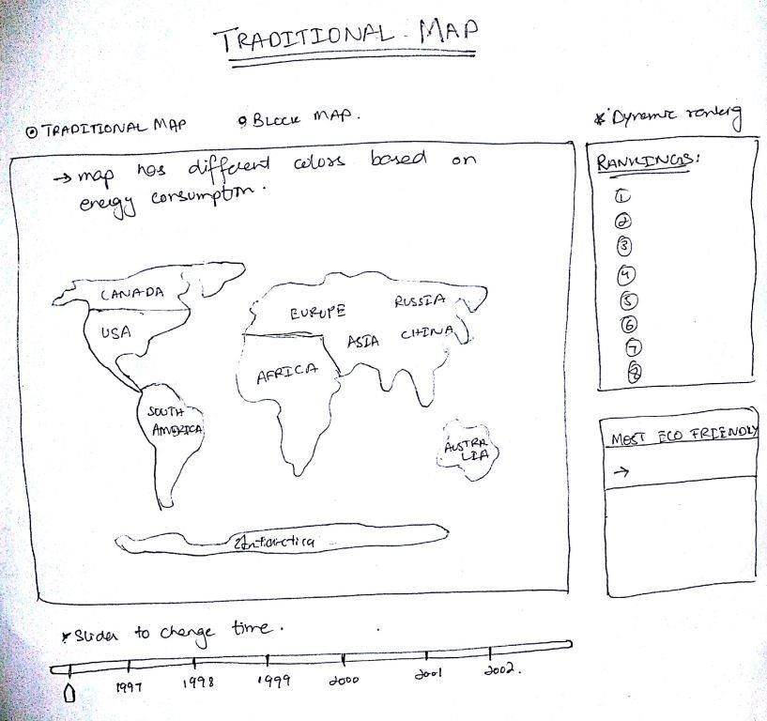

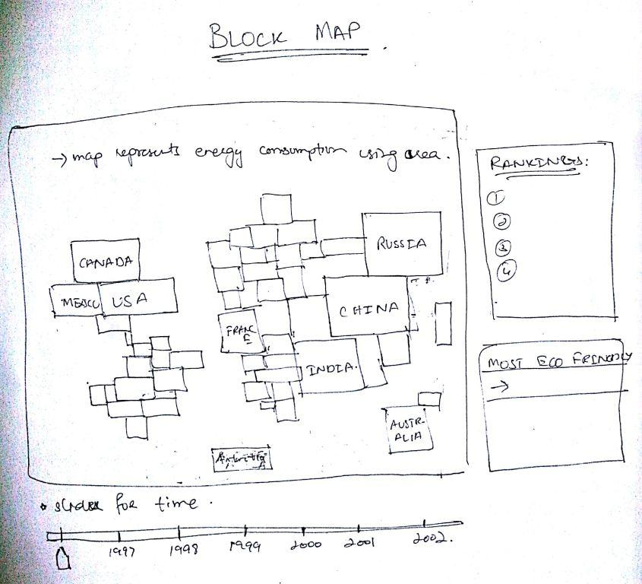

We have data on energy consumption for different countries by type and how it changes over time. From a high level, we want our visualization to tell a story. We will start with an introduction animation which will include an option tutorial of how to interact with our visualization. The main part of the visualization will be a map of the world. We will distinguish each country by its proportion of energy consumption. This can be done by a heat map of color or by an area-resized map. There will be some degree of interactivity to include radio buttons to filter by energy type. Users can also click on the country and have it highlighted to show a tooltip for more information. For a more detailed overview, see the breakdown of features:

**Must-Have Features:**

* Intro animation that introduces the visualization and all its features
* The traditional map showing the countries with respect to energy consumption using color
* The timeline feature which shows changes in energy consumption over the years
* Filtering data with respect to different categories
* Summary of best/worst 1/3/5 countries per category listed as a summary table
* More details upon clicking on a country

**Optional Features:**

* The area-based map representing the different countries of the world with respect to their energy consumption
* Color the area-based map by primary source
* Title boxes and rankings of countries based on energy consumption
* Sort by combinations of energy type - so checkboxes that are cumulative rather than radio buttons that are exclusive
* Filter by energy consumption relative to the country’s own total consumption (eg: 45% of China energy is coal vs. 10% of US energy is coal)
* Put individual pie chart per country in tooltip

**Project Schedule:**

The implementation section of the process book will be updated every week in addition to the following:

* Wednesday, March 19: Wahaj, Wesley, Ibrahim: Finish cleaning data and decide on which components of data set we will be using
* Sunday March, 23: Ibrahim: Select libraries and frameworks for use.   
  Wahaj: Find source code necessary for creating visualizations   
  Wesley: Implement website php and hosting on google drive
* Friday, March 28: Wesley, Ibrahim: Bind data to elements of map   
  Wahaj: Classify filter techniques and force diagram for data presentation
* Friday, April 4: Wahaj: Complete animation functions for website access  
  Ibrahim: Complete timeline interactivity with slider  
  Wesley: Complete functions for radio button transitions
* Thursday, April 10: Functional project prototype due  
  Wahaj, Wesley, Ibrahim: Complete color and size binding of SVG elements representing countries
* Week of April 14: Project review with the TFs  
  Wahaj, Wesley, Ibrahim: Clean up and optimize code, add usage details, clean up transitions and optimize force diagram
* Week of April 21:  
  Process Book Completion*  
  Wahaj: Complete compilation of figures, screenshots, images, and links in process book. Write Overview, related work, and questions   
  Wesley: Write Data scraping process and Exploratory Data analysis   
  Ibrahim: Write Design evolution, evaluation, and include all design sketches   
  * Implementation section should be up to date
* Wesley, Wahaj, Ibrahim: Complete Screencast
* **Thursday, May 1: Projects due (including screencast)**