**Activities**

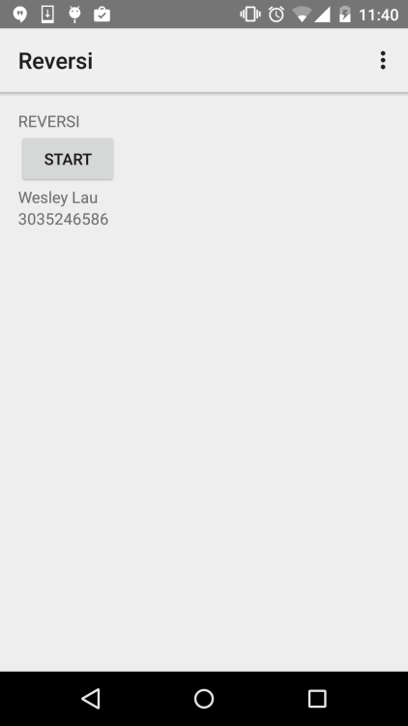

This is the first activity where user can click the start button to launch the game.

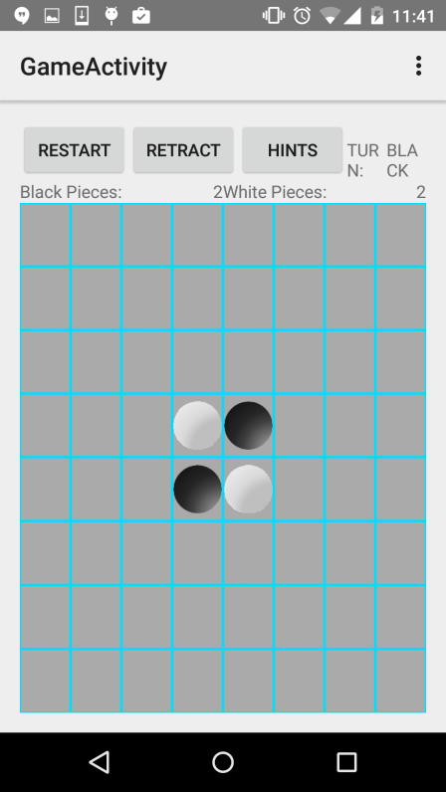

As you can see, there is a game grid along with several buttons and some game details.

Restart button - When user click this button, the whole grid will be reset to the initial state as shown in the diagram above.

Retract button - When user click this button, the system will go back to the previous grid configuration. When retract button is clicked, it will automatically turn off the hint.

Hint button - When user click this button, the system will show possible moves for the player. The first diagram is a result of pressing the button in Black's turn. As you can see, there are 4 transparent chess pieces. These are the possible moves for Black. The second diagram is a result of pressing the button in White's turn. The two transparent are very similar (Sorry for the inconvenience).

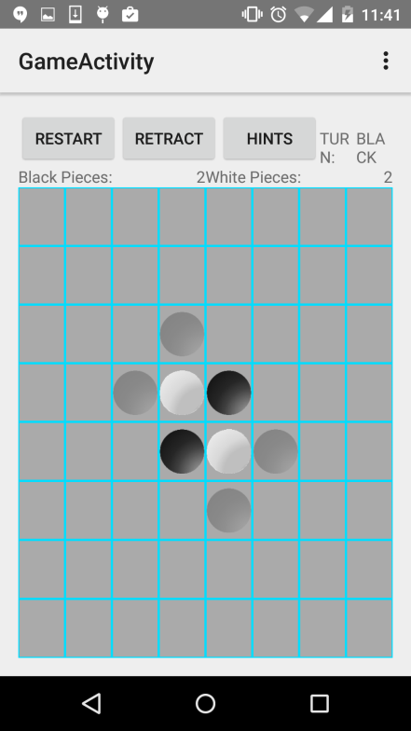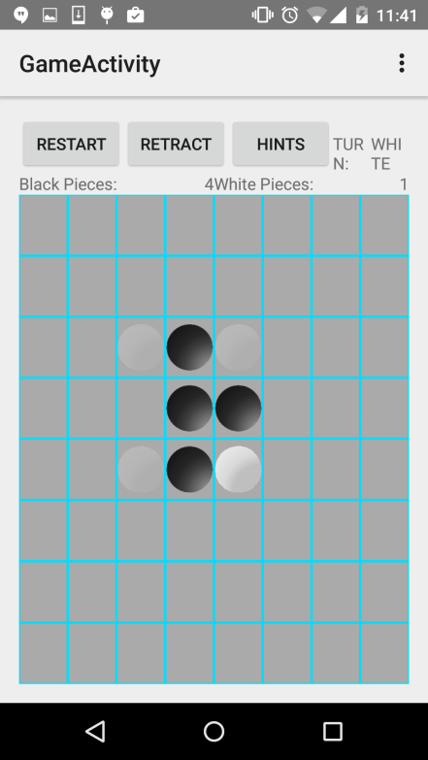Turn label - This textview shows who's turn is it.  
Scores label - These textviews show the current scores of each player.

**Game Flow**

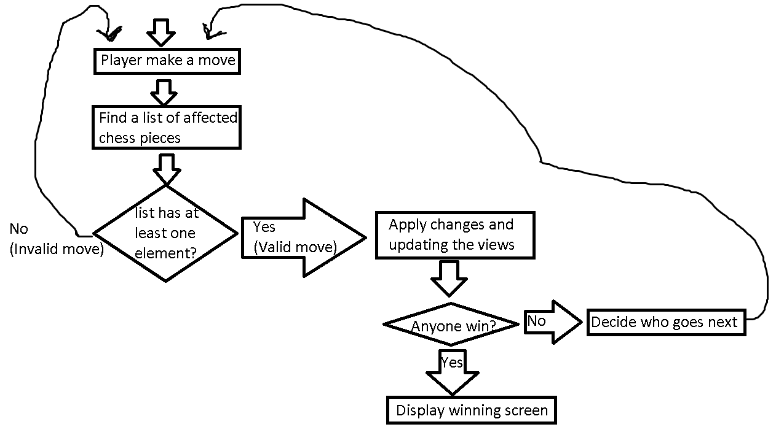  
When player made a valid move, the system will generate a list of all affected chess pieces and this list will be pushed into a stack. The major purpose of having this stack is to save the history so that retract can be done simply by popping off the stack and updating the views. In this app, I also maintain a hashmap of imageviews with coordinate as a key which allows me to manipulate each view easily. In addition, this map can be used to restore the game states from activity recreation (E.g orientation change). One of the main feature of this game is that it preserves all game states such as scores, turn, grid. The two diagrams below illustrated this feature.  
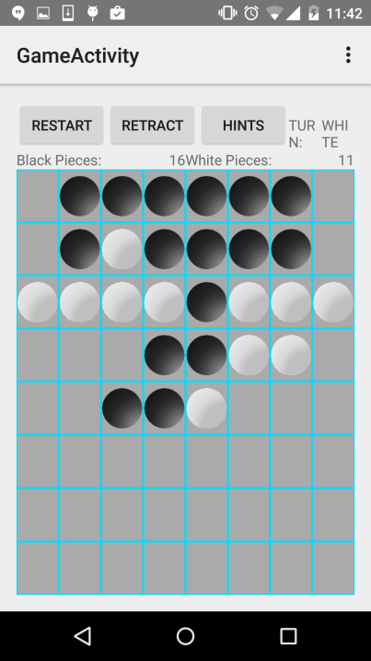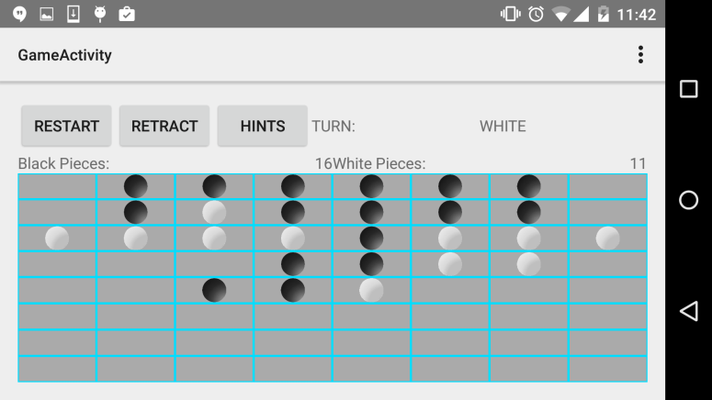

When the game meet the ending condition, there will be a pop up showing the winner. The player may click on restart to start a new game.

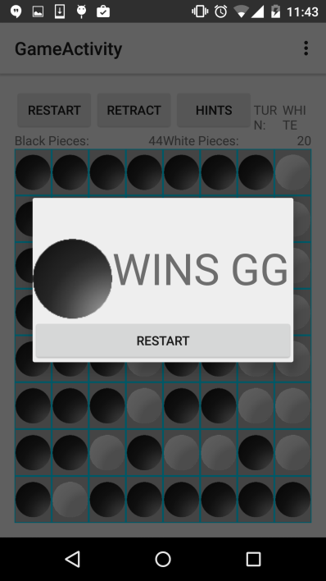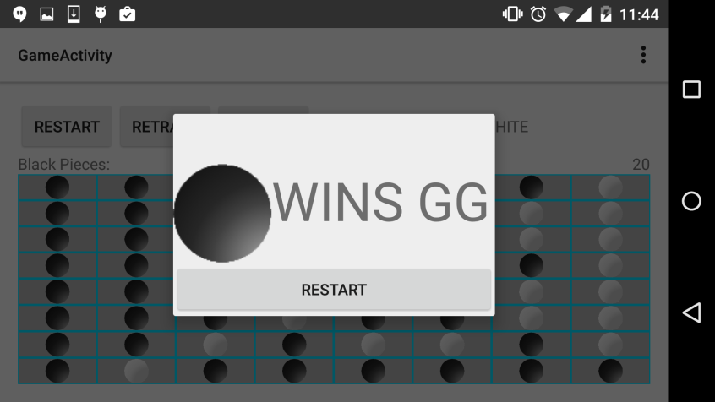

**Limitations**

This app is developed on API 21. I tried running it in HW312 but it required some extra plugins to be installed before running. (Please be patient during installation)

**References**

I used the following resources in my app:

https://sharecoding.wordpress.com/2012/02/24/set-border-to-android-imageview/

http://stackoverflow.com/questions/13509495/uses-of-fragment-tags

http://stackoverflow.com/questions/9039877/android-fragment-screen-rotate

http://developer.android.com/reference/android/app/Fragment.html

http://developer.android.com/reference/android/app/Activity.html

http://developer.android.com/reference/java/util/HashMap.html

http://stackoverflow.com/questions/7220404/what-is-the-trick-with-0dip-layout-height-or-layouth-width

http://developer.android.com/reference/android/app/DialogFragment.html