Introduction to High Performance Computing
Assignment 2

Wesley Liao
2019-09-27

- Because the dot_prod is assigned to its current value plus the calculated vector product, this creates an opportunity for threads to use an old value of dot_prod. Code on page 2.
- The order of the chunk execution and the printout of “Thread id: x working on index i” may change but the end result of the program will be the same.

  - For 3 OpenMP threads, the initialization for loop will run in all 3 threads, and each omp section will execute in parallel.
  - For 5 OpenMP threads, the initialization for loop will run in all 5 threads, but after that there are only 3 sections, so there will be only work for 3 of the threads.
  - With just 1 OpenMP thread, each of the three sections will essentially be executed sequentially.
  - In general, there will be very little to no performance improvement when there are more threads than parallel sections.
- Code on page 3. When compiled, p4 accepts 1 argument, an integer number of threads to run. Performance was measured using the “time” utility, running 1 through 8 threads 4 times each and plotting the resulting time reported below:
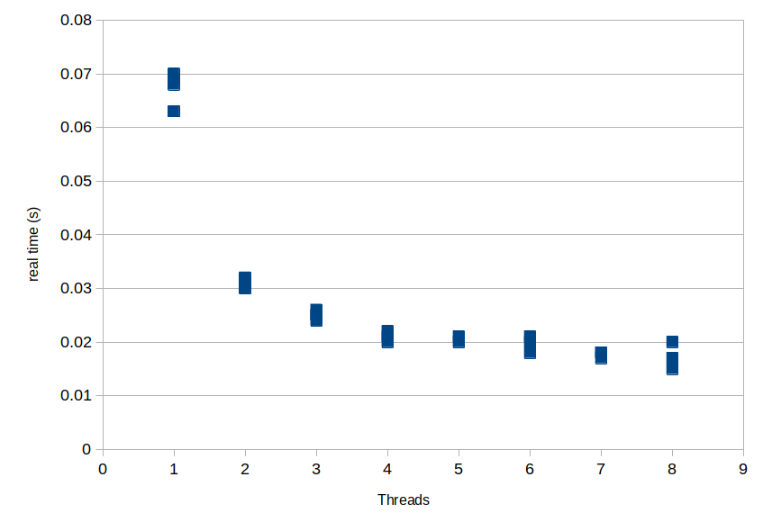
Code for part 1:

#include <stdio.h>
#include <omp.h>

// compute the dot product of two vectors

int main() {
int const N=100;
int i;
double a[N], b[N];
double dot_prod = 0.0;

int thread_id;
//Arbitrarily initialize vectors a and b
for (i = 0; i < N; i++) {
a[i] = 3.14;
b[i] = 6.67;
}

#pragma omp parallel private(thread_id)
{
thread_id = omp_get_thread_num();
printf("This thread is: %d\n", thread_id);
#pragma omp for
for(i=0; i < N; i++) {
// sum up the element-wise product of the two arrays
#pragma omp atomic
{
dot_prod = dot_prod + (a[i] * b[i]);
}
}
}

printf("Dot product of the two vectors is %g\n", dot_prod);

return 0;
}
Code for part 4:

#include <stdio.h>
#include <stdlib.h>
// link with -lm at compile time
#include <math.h>
#include <omp.h>

int main(int argc, char* argv[]) {

int threads = atoi(argv[1]);
int const N=1000;
int i, j, ij;

double A[N*N];
double x[N], b[N];

// initialize the matrix and the vector
#pragma omp parallel for num_threads(threads)
for (ij = 0; ij < N*N; ij++) {
A[ij] = sin(0.01*(ij));
}

#pragma omp parallel for num_threads(threads)
for (i = 0; i < N; i++) {
b[i] = cos(0.01*i);
x[i] = 0.0;
}

// matrix vector multiplication
#pragma omp parallel for num_threads(threads)
for (ij = 0; ij < N*N; ij++) {
#pragma omp atomic
x[(ij - (ij%N))/N] = x[(ij - (ij%N))/N] + (A[ij]*b[ij%N]);
}

printf("x[%d] = %g\n", 505, x[505]);

return 0;
}

