* LProject-1 (10%)
  + Suggested using Boost to exercise its Boolean geometry APIs
  + Display the results

First, we define a simple language to describe shapes.

# (first char # means comments)

# defining layers and the associated colors

# number_of_layers (total # of layers)

# layer_number layer_name

number_of_layers 3

layer 1 M1

layer 2 M2

layer 3 M3

end_of_layer

# descriptions of polygon

# layer_number x1 y1, x2 y2, x3 y3, x4 y4, x1 y1 (enclosed. Let’s use “,” to separate)

number_of_polygons 2

1 0 0, 0 10, 5 10, 5 -2, 0 0

2 1 1, 1 8, 7 8, 5 5, 1 1

end_of_polygon

# description of rectangles

# layer_number x1 y1, x2 y2

number_of_rectangles 1

3 2 4, 14 8

end_of_rectangle

# description of texts (which is placed at a location. For now, we do not define the font size)

# layer_number text location (x y)

number_of_texts 1

1 A 4 5

end_of_text

Now let’s do this project – to merge several M1 shapes and produce M1 blockages as big as possible. Then, there are shapes defining a pin. We need to carve out those pin shapes for connection.

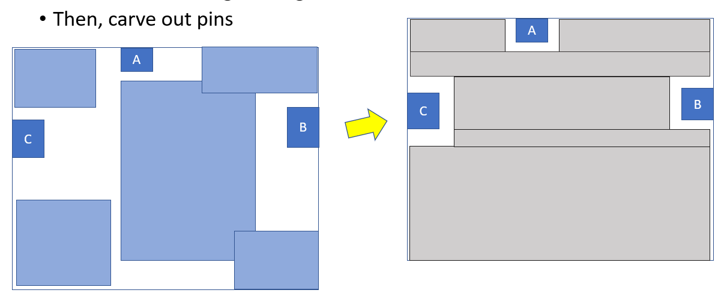

number_of_layers 1

layer 1 M1

end_of_layer

number_of_polygons 5

1 0 0, 0 10, 10 10, 10 0, 0 0

1 12 3, 12 30, 32 30, 32 3, 12 3

1 30 0, 30 5, 40 5, 40 0, 30 0

1 0 40, 0 50, 6 50, 6 40, 0 40

1 30 42, 30 50, 40 50, 40 42, 30 42

end_of_polygon

number_of_rectangles 3

1 0 20, 3 24

1 13 46, 17 50

1 38 10, 40 13

end_of_rectangle

number_of_texts 3

1 C 21 21

1 A 14 47

1 B 39 12

end_of_text

Please write a parser to read in all the polygons, rectangles and texts.

1. Find the smallest enclosing rectangle of all these objects. This rectangle serves as a big blockage.
2. From the texts and their locations, please identify which shapes will be touched by them. Those shapes will become pins for future connections.
3. Then, carve out pin shapes from the big blockage obtained in (1). In this exercise, please use 0.5 as min spacing for M1 (in other words, you need to leave 0.5 spacing around the pin shapes.)

Please show a layout right after your parsing those shapes.

Then, display the result of (3) and the resulting polygons/rectangles.