Project 3 Report – Group 3

1. Original Schematic

1. Output Waveform from Schematic Layout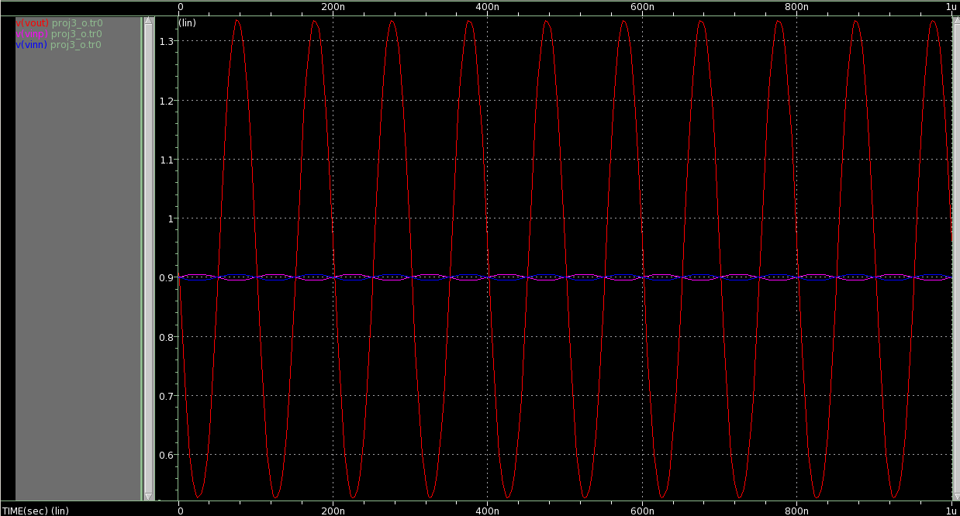
2. Common Centroid Layout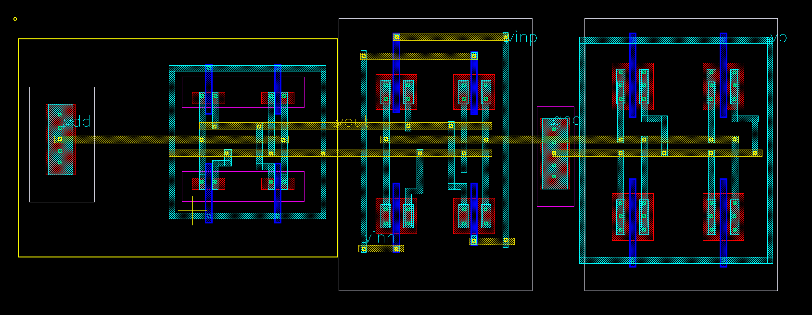
3. Regular Layout (not CCM) 一張含有 文字 的圖片

   自動產生的描述
4. Waveform Comparison一張含有 圖表 的圖片

   自動產生的描述
5. Conclusion

In the Waveform above, we can see that CCM layout have larger latency than normal layout. In my opinion, this may because of our layout is not very large, therefore, the advantage of CCM is not significant. And due to CCM, we need to draw more metal line in layout, cause larger parasitic resistance and capacitance.