**Project-4 (20%) – how to use capacitance models to compute C from layout**

It is about capacitance extraction. We discuss capacitance models. Let’s think about how to use those tables in configurations to extract capacitance. Some sort of pattern matching techniques need to be used. Please describe your algorithms. This time no need to write a program.

Let’s use the layouts you created in project-3 for differential pair. First, see how many metal layers you used. Usually 2~3 metal layers and poly are used. Assuming the values in TLU tables are already known, how are you going to extract cap?

For instance, from layout,

1. pick a wire segment:

In your Laker layout, I think there is no connectivity. How shall we fix it?

Can we highlight connected shapes for that net?

1. Create halos surrounding the connected wires; find its neighboring wires;
2. Decide which configurations you will use? Which look-up tables you will use?

Basically please describe the steps you use to extract capacitances of all the nets.

Then, comment on your ideas about dealing with vias in terms of capacitance.

Below is a layout example. From a wire we select, we start to extract.

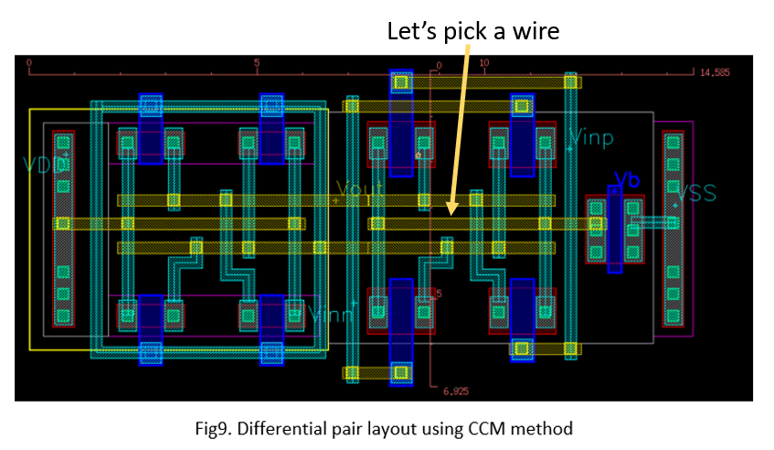

Outputs of this projects are:

1. First, list the layers used in the layout (OD, Poly, M1, M2, …, via0, via1, …)
2. List the configurations and the cap tables we need to prepare
3. From the min width, min spacing on each layer, please list the values of two indices for each table.
4. From a wire, we form a halo surrounding it. Find other wires surrounding it. From the spacings and environments, identify which configurations and cap tables and which entries we will use to get capacitance coefficients.
5. From the connectivity, get next wire segment and extract capacitance until all the connected wires are analyzed.
6. We fracture wires into pieces and let’s use R to represent all the resistors in this network. Can we draw a R/C network for this net?
7. Then, extract another net. In this homework, please extract two nets.

A purpose of this homework is to let us go through steps on the paper before we start developing programs to automate it.