Wesley Jones D479 Task 1

A. Timeline of UX Design Activities:

Week 1: Research and Planning (Days 1-5)

* Identify users and their needs.
* Define project goals and scope.
* Conduct competitive analysis of other tourism websites.

Week 2: Design (Days 6-12)

* Create a user flow diagram to map out website navigation.
* Develop low-fidelity wireframes for key pages.
* Create high-fidelity mockups based on wireframes.
* Conduct usability testing on mockups and iterate based on feedback.

Week 3: Development (Days 13-19)

* Begin development of the website based on approved designs.
* Implement design for mobile compatibility.
* Integrate booking functionality and links to attractions.
* Test the website for compatibility and performance.

Week 4: Finalization and Launch (Days 20-30)

* Finalize content and graphics.
* Conduct the final round of usability testing.
* Address any remaining bugs or issues.
* Launch the website and monitor for feedback and performance.

B. User Persona:

Name: David Thompson  
Age: 45  
Occupation: Software Engineer  
Marriage Status: Married  
Home Location: Seattle, Washington  
Income: $120,000

Personality:

Adventurous

Family-oriented

Curious

Easygoing

Motivation:  
David is motivated by a sense of adventure and a desire to explore new places and cultures. He seeks experiences that enrich his life and broaden his perspective.

Goals:  
David's life goals include traveling to new destinations, experiencing different cultures, and creating lasting memories with his family. He also strives to excel in his career, continuously learn new skills, and contribute meaningfully to his field.

Bio:  
David is a software engineer from Seattle, Washington. He is married with two children. David enjoys outdoor activities such as hiking and biking, and he is always eager to try new experiences. He values family time and looks forward to vacations as an opportunity to bond with his loved ones.

C. Low Fidelity Wireframe:

Accommodations Page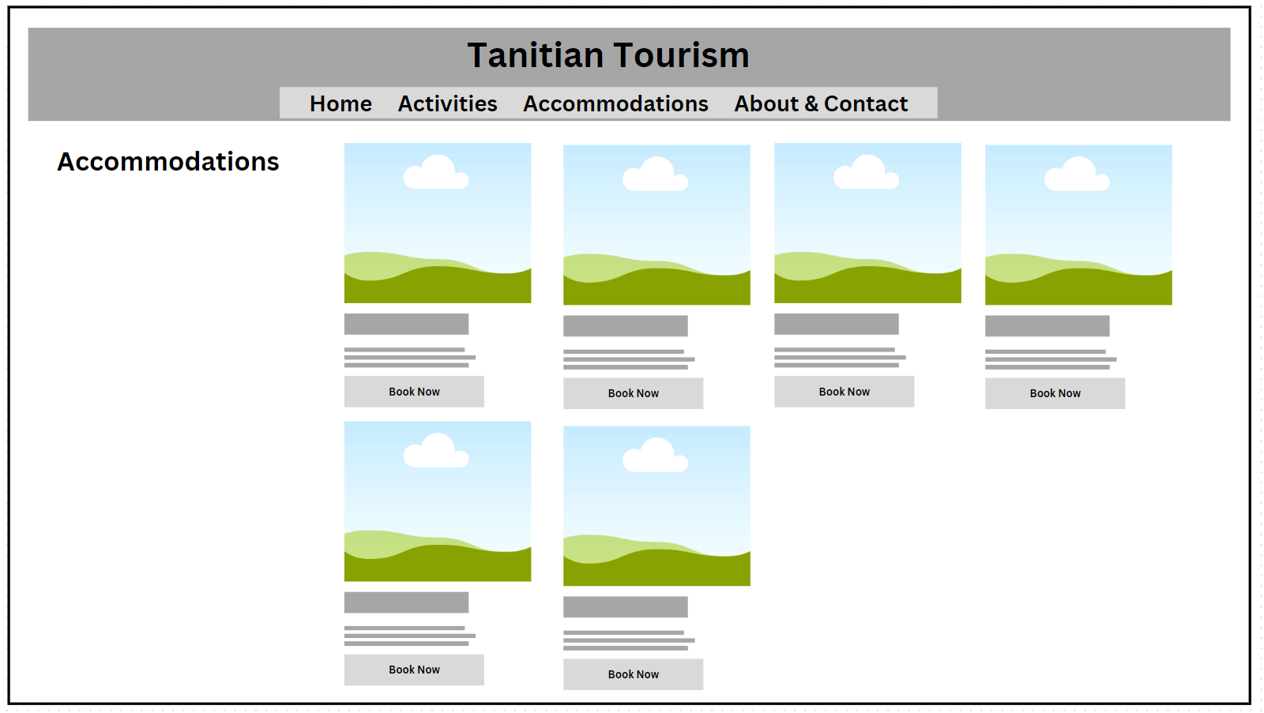

D. Gorilla Testing:

Tester 1:

* Feedback: Found the navigation menu confusing and had difficulty locating specific information.
* Actionable: Yes, will improve navigation clarity and organization.
* Relevant: Yes, helps improve user experience and ease of use.

Tester 2:

* Feedback: Liked the overall design and found it visually appealing.
* Actionable: No.
* Relevant: Yes, helps reinforce effective design elements.

Tester 3:

* Feedback: Had trouble understanding the pricing information for accommodations.
* Actionable: Yes, will clarify pricing details for better understanding.
* Relevant: Yes, improves user understanding and decision-making.

Incorporating Feedback:

Improve Navigation: Simplify and clarify the navigation menu to make it more intuitive for users to find information.

Visual Appeal: Maintain the visually appealing design elements while ensuring they do not overshadow usability.

Clarify Pricing: Revise the pricing information for accommodations to be more clear and concise.

E. Interactive website:

www.tanitivacation.infinityfreeapp.com

F. Objective Usability test:

1. How would you get to the activities page?
2. How would you Contact the island?
3. How would you rent a car on the island?
4. If you wanted to learn about the different beaches, where would you go?
5. How would you find a hotel on the island?