Análisis de datos para la determinación de la precisión, exactitud de los datos, así como la disponibilidad de los sensores de medición de la estación WEMA

Weslin R. Silva

2025-02-04

Índice de Contenido

# Fechas con mediciones recolectadas por la estación OFENA

Fechas con mediciones recolectadas

| Fecha |
| --- |
| 2024-12-19 |
| 2025-01-06 |
| 2025-01-07 |
| 2025-01-08 |
| 2025-01-09 |
| 2025-01-10 |
| 2025-01-11 |
| 2025-01-12 |
| 2025-01-13 |
| 2025-01-14 |
| 2025-01-15 |
| 2025-01-16 |
| 2025-01-24 |
| 2025-01-25 |
| 2025-01-26 |
| 2025-01-27 |
| 2025-01-28 |
| 2025-01-29 |
| 2025-01-30 |
| 2025-01-31 |

# Resultados por variable

## Resultados para la temperatura

### Limpieza de Datos OFENA

Resumen de limpieza de datos, para la variable de temperatura datos OFENA

|  | Resultado |
| --- | --- |
| Cantidad datos OFENA original | 4999 |
| Cantidad de datos Nulos OFENA | 465 |
| Cantidad de datos limpios en intervalos de 5 minutos | 4534 |

### Limpieza de Datos WEMA

Resumen limpieza de datos, para la variable de temperatura

|  | Resultado |
| --- | --- |
| Cantidad datos WEMA original | 8257 |
| Cantidad de datos Nulos WEMA | 0 |
| Cantidad de datos limpios en intervalos de 5 minutos | 1655 |

### Series de Datos Analizados

|  | Resultado |
| --- | --- |
| Cantidad de series a analizar | 28 series |
| Cantidad de series descartadas | 71 series |
| Cantidad de series encontradas | 99 series |

### Resumen Series de Mediciones Temperatura

| Max. Prom E. Abs. | Min. Prom E. Abs. | Max. Prom E. Rel. | Min. Prom E. Rel |
| --- | --- | --- | --- |
| 3.092598 | 0.4371663 | 0.278318 | 0.278318 |

| Prom. General E. Abs. | Prom. General E. Rel. | Mediciones Totales |
| --- | --- | --- |
| 1.463243 | 0.4234002 | 440 |

### Comparación de Errores para las Series de Temperatura

Promedio de Errores para las series de temperatura

| cantMediciones | PromEAbs | PromERel | PromEPorc |
| --- | --- | --- | --- |
| 15 | 0.4624417 | 0.0219595 | 2.1959492 |
| 15 | 0.4538794 | 0.0222425 | 2.2242545 |
| 10 | 0.1711686 | 0.0052836 | 0.5283556 |
| 13 | 0.2097346 | 0.0074782 | 0.7478157 |
| 11 | 0.3044481 | 0.0113491 | 1.1349141 |
| 18 | 0.7432906 | 0.0281142 | 2.8114234 |
| 11 | 0.0481573 | 0.0019031 | 0.1903098 |
| 21 | 0.0829383 | 0.0033510 | 0.3350972 |
| 10 | 0.4499733 | 0.0139716 | 1.3971625 |
| 29 | 0.2875197 | 0.0087273 | 0.8727254 |
| 13 | 0.6715118 | 0.0208769 | 2.0876921 |
| 19 | 0.6078616 | 0.0185770 | 1.8577008 |
| 27 | 1.7390102 | 0.0680540 | 6.8053968 |
| 16 | 0.3637465 | 0.0143495 | 1.4349502 |
| 12 | 0.3294360 | 0.0135665 | 1.3566457 |
| 21 | 0.4113826 | 0.0168578 | 1.6857817 |
| 12 | 0.4124439 | 0.0166292 | 1.6629223 |
| 16 | 0.4291451 | 0.0136923 | 1.3692308 |
| 14 | 1.4834985 | 0.0574482 | 5.7448183 |
| 11 | 1.4489127 | 0.0584733 | 5.8473297 |
| 11 | 1.1463224 | 0.0485121 | 4.8512105 |
| 15 | 0.4147762 | 0.0170077 | 1.7007724 |
| 14 | 0.4077881 | 0.0162967 | 1.6296698 |
| 13 | 0.4254689 | 0.0175436 | 1.7543640 |
| 14 | 0.4448207 | 0.0189020 | 1.8902029 |
| 11 | 0.6887729 | 0.0240972 | 2.4097168 |
| 16 | 0.5572072 | 0.0169461 | 1.6946120 |
| 18 | 0.4397884 | 0.0134470 | 1.3446978 |

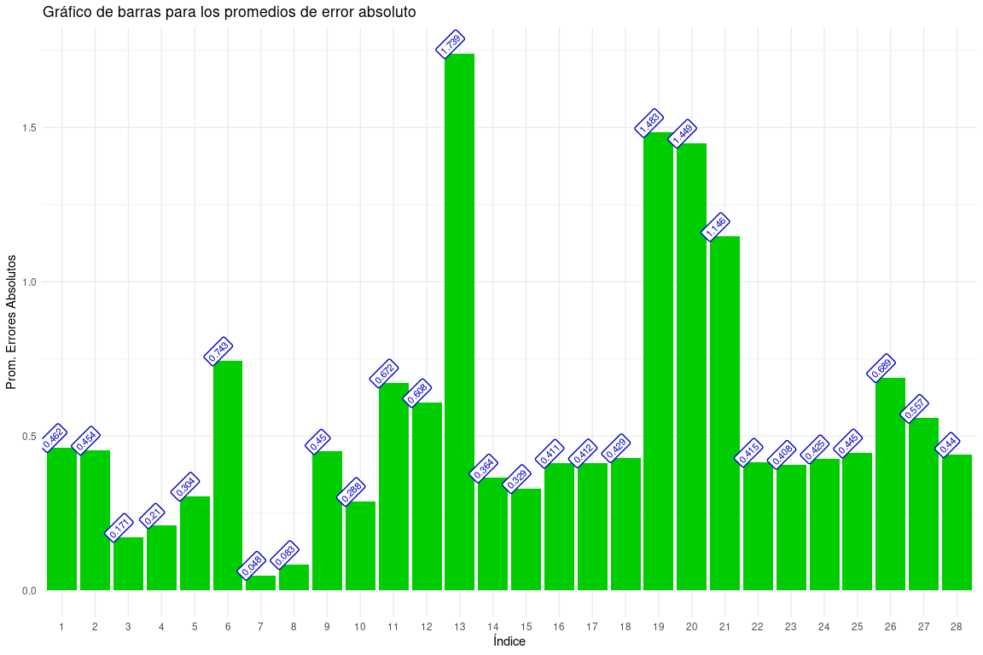

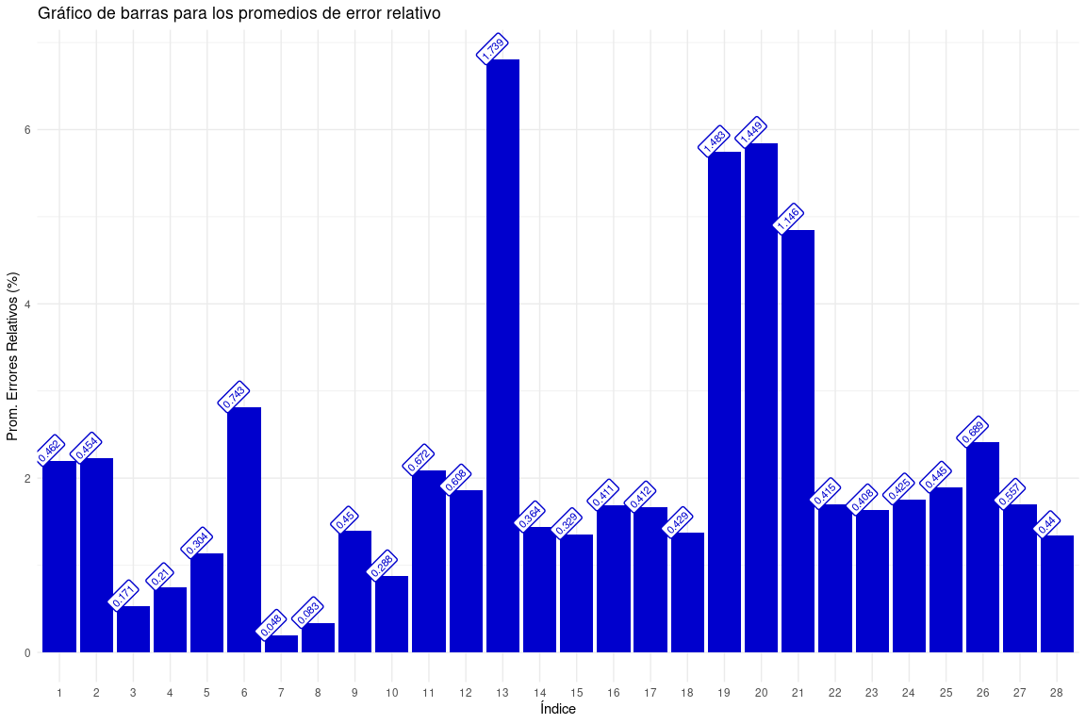

### Comparación Coeficiente de Variacion Entre Temperatura Real y Mediciones de la Estación WEMA

coeficiente de variacion, para las series de temperatura encontrada

| NoSerie | FechaInicio | HoraInicio | FechaFin | HoraFin | CantDatos | CoefVariacionOFENA | CoefVariacionWEMA | dif C.V |
| --- | --- | --- | --- | --- | --- | --- | --- | --- |
| 1 | 2024-12-19 | 02:05:00 | 2024-12-19 | 03:25:00 | 16 | 0.0061348 | 0.0061221 | 0.0000127 |
| 2 | 2024-12-19 | 03:35:00 | 2024-12-19 | 05:00:00 | 16 | 0.0090051 | 0.0090193 | 0.0000141 |
| 15 | 2025-01-08 | 15:55:00 | 2025-01-08 | 16:45:00 | 11 | 0.0084635 | 0.0106093 | 0.0021457 |
| 16 | 2025-01-08 | 19:00:00 | 2025-01-08 | 20:00:00 | 13 | 0.0069068 | 0.0098794 | 0.0029726 |
| 17 | 2025-01-08 | 20:45:00 | 2025-01-08 | 21:40:00 | 11 | 0.0060712 | 0.0108651 | 0.0047939 |
| 18 | 2025-01-08 | 21:50:00 | 2025-01-08 | 23:20:00 | 18 | 0.0101745 | 0.0202061 | 0.0100316 |
| 19 | 2025-01-09 | 01:25:00 | 2025-01-09 | 02:15:00 | 11 | 0.0071376 | 0.0071555 | 0.0000178 |
| 20 | 2025-01-09 | 03:30:00 | 2025-01-09 | 05:10:00 | 21 | 0.0119246 | 0.0125388 | 0.0006141 |
| 21 | 2025-01-09 | 12:20:00 | 2025-01-09 | 13:15:00 | 11 | 0.0102601 | 0.0136894 | 0.0034292 |
| 22 | 2025-01-09 | 13:25:00 | 2025-01-09 | 15:55:00 | 31 | 0.0060177 | 0.0069252 | 0.0009075 |
| 44 | 2025-01-13 | 12:25:00 | 2025-01-13 | 13:25:00 | 13 | 0.0093587 | 0.0127775 | 0.0034188 |
| 45 | 2025-01-13 | 13:35:00 | 2025-01-13 | 15:10:00 | 19 | 0.0052968 | 0.0127247 | 0.0074279 |
| 46 | 2025-01-13 | 19:50:00 | 2025-01-13 | 22:00:00 | 27 | 0.0115429 | 0.0091695 | 0.0023733 |
| 47 | 2025-01-14 | 00:00:00 | 2025-01-14 | 01:15:00 | 16 | 0.0067403 | 0.0082731 | 0.0015328 |
| 48 | 2025-01-14 | 01:25:00 | 2025-01-14 | 02:25:00 | 12 | 0.0094496 | 0.0094656 | 0.0000161 |
| 49 | 2025-01-14 | 04:40:00 | 2025-01-14 | 06:20:00 | 21 | 0.0098300 | 0.0098168 | 0.0000133 |
| 50 | 2025-01-14 | 06:30:00 | 2025-01-14 | 07:25:00 | 12 | 0.0141513 | 0.0142101 | 0.0000588 |
| 65 | 2025-01-25 | 15:10:00 | 2025-01-25 | 16:25:00 | 16 | 0.0063534 | 0.0075415 | 0.0011881 |
| 66 | 2025-01-25 | 20:05:00 | 2025-01-25 | 21:10:00 | 14 | 0.0049445 | 0.0141529 | 0.0092084 |
| 67 | 2025-01-25 | 22:00:00 | 2025-01-25 | 22:50:00 | 11 | 0.0102593 | 0.0160446 | 0.0057853 |
| 68 | 2025-01-25 | 23:00:00 | 2025-01-25 | 23:50:00 | 11 | 0.0051323 | 0.0107043 | 0.0055720 |
| 69 | 2025-01-26 | 00:40:00 | 2025-01-26 | 01:55:00 | 16 | 0.0091011 | 0.0089088 | 0.0001923 |
| 70 | 2025-01-26 | 03:25:00 | 2025-01-26 | 04:30:00 | 14 | 0.0098598 | 0.0094144 | 0.0004454 |
| 71 | 2025-01-26 | 04:40:00 | 2025-01-26 | 05:45:00 | 13 | 0.0066515 | 0.0069152 | 0.0002637 |
| 72 | 2025-01-26 | 05:55:00 | 2025-01-26 | 07:05:00 | 15 | 0.0067825 | 0.0067641 | 0.0000184 |
| 73 | 2025-01-26 | 08:35:00 | 2025-01-26 | 09:30:00 | 12 | 0.0068890 | 0.0073811 | 0.0004921 |
| 74 | 2025-01-26 | 12:20:00 | 2025-01-26 | 13:35:00 | 16 | 0.0070058 | 0.0100954 | 0.0030896 |
| 75 | 2025-01-26 | 14:35:00 | 2025-01-26 | 16:05:00 | 19 | 0.0061625 | 0.0076346 | 0.0014721 |

| Max. C.V WEMA | Min C.V WEMA | Max C.V OFENA | Min C.V OFENA |
| --- | --- | --- | --- |
| 0.0202061 | 0.0061221 | 0.0141513 | 0.0049445 |

| Promedio General C.V OFENA | Promedio General C.V WEMA | Promedio General dif. C.V |
| --- | --- | --- |
| 0.0081288 | 0.0103216 | 0.002411 |

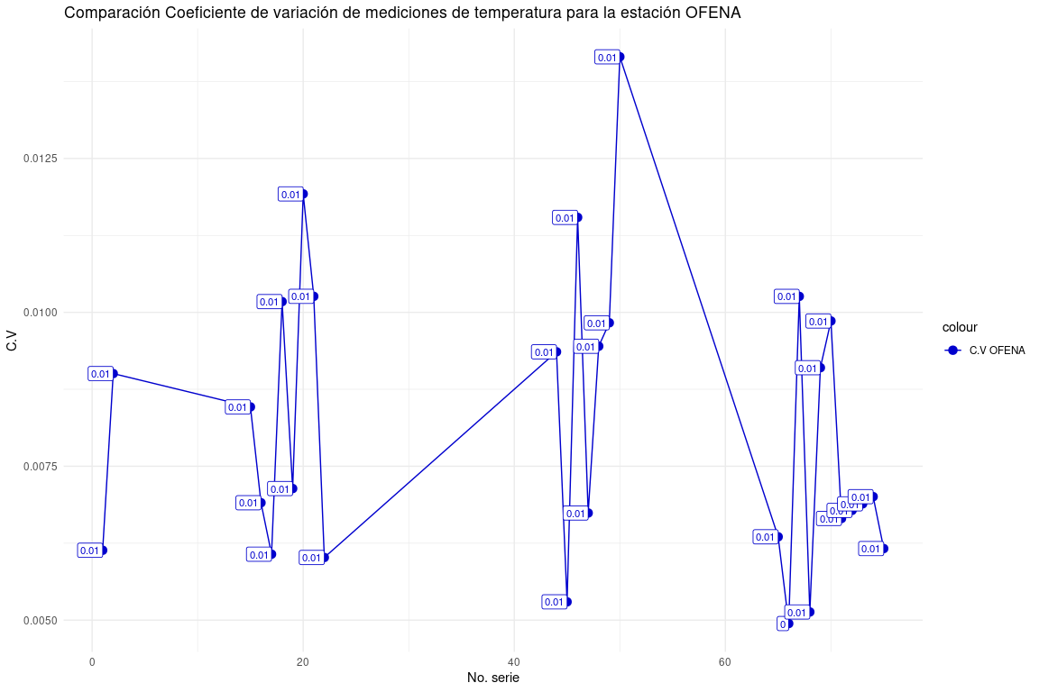

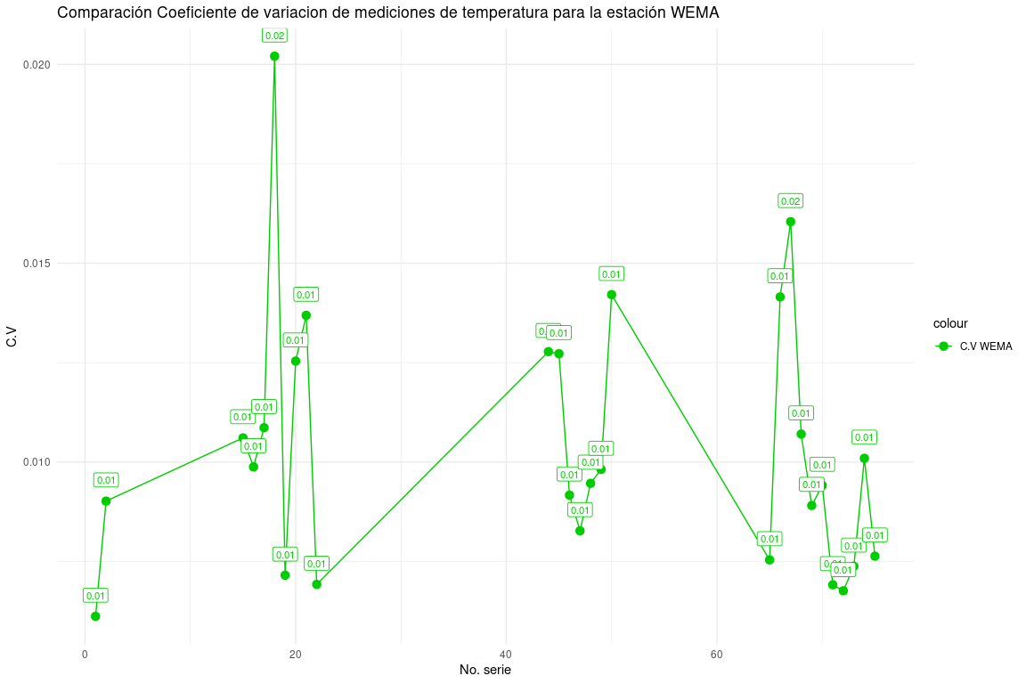

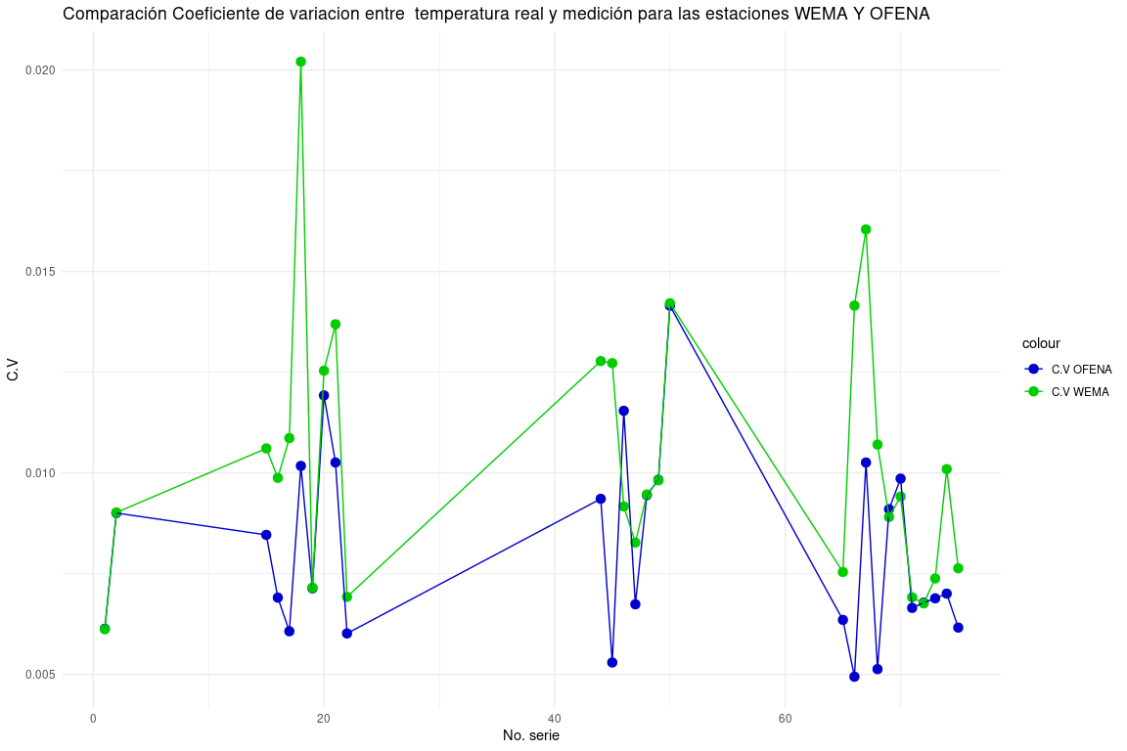

### Disponibilidad de la Variable Temperatura

* Fecha de inicio: 19/12/2024.
* Fecha de fin: 02/02/2024.

Frecuencia de interrupciones en la medición de temperatura

| MinutosNoDisponible | Frecuencia | TotalMinutos |
| --- | --- | --- |
| 2 | 170 | 340 |
| 3 | 1 | 3 |
| 26 | 1 | 26 |
| 293 | 1 | 293 |
| 1850 | 1 | 1850 |
| 5406 | 1 | 5406 |
| 8260 | 1 | 8260 |
| 16062 | 1 | 16062 |
| 25757 | 1 | 25757 |

Resumen de interrupciones en la medición de temperatura

| cantMinutosInterrupcion | cantHorasInterrupcion | cantParadas | TiempoTotalDispMin | TiempoTotalDispHora |
| --- | --- | --- | --- | --- |
| 57997 | 966.6167 | 178 | 8257 | 137.6167 |

Resultados de disponibilidad para la medición de temperatura

| MTBF | MTTR | Horas.Planificadas |
| --- | --- | --- |
| 0.636985 | 5.430431 | 1080 |

## Resultados de la Variable Presión

### Limpieza de Datos OFENA

Resumen de limpieza de datos, para la variable de presión datos OFENA

|  | Resultado |
| --- | --- |
| Cantidad datos OFENA original | 4999 |
| Cantidad de datos Nulos OFENA | 0 |
| Cantidad de datos limpios en intervalos de 5 minutos | 4999 |

### Limpieza de Datos WEMA

Resumen limpieza de datos, para la variable de presión

|  | Resultado |
| --- | --- |
| Cantidad datos WEMA original | 8257 |
| Cantidad de datos Nulos WEMA | 0 |
| Cantidad de datos limpios en intervalos de 5 minutos | 1655 |

### Series de Datos Analizados

Resumen de las series de datos para la variable de presión

|  | Resultado |
| --- | --- |
| Cantidad de series a analizar | 11 series |
| Cantidad de series descartadas | 22 series |
| Cantidad de series encontradas | 33 series |

### Resumen de Series de Mediciones Presión

| Max. Prom E. Abs. | Min. Prom E. Abs. | Max. Prom E. Rel. | Min. Prom E. Rel |
| --- | --- | --- | --- |
| 0.5834864 | 0.0950111 | 9.45e-05 | 9.45e-05 |

| Prom. General E. Abs. | Prom. General E. Rel. | Mediciones Totales |
| --- | --- | --- |
| 0.406206 | 0.000405 | 440 |

Resumen para las series de mediciones de presion

| MedicionesTotales | MaxErrorAbs | MinErrorAbs |
| --- | --- | --- |
| 893 | 0.5834864 | 0.0950111 |

### Comparación de Errores para las Series de Presión

Promedio de Errores para las series de presión

| cantMediciones | PromEAbs | PromERel | PromEPorc |
| --- | --- | --- | --- |
| 150 | 0.1189986 | 0.0001185 | 0.0118541 |
| 56 | 0.5553462 | 0.0005540 | 0.0553976 |
| 161 | 0.4209056 | 0.0004195 | 0.0419465 |
| 22 | 0.5834864 | 0.0005832 | 0.0583155 |
| 48 | 0.0950111 | 0.0000945 | 0.0094546 |
| 85 | 0.3586424 | 0.0003574 | 0.0357439 |
| 107 | 0.2398489 | 0.0002384 | 0.0238424 |
| 22 | 0.5461706 | 0.0005445 | 0.0544463 |
| 54 | 0.5579300 | 0.0005562 | 0.0556232 |
| 156 | 0.4421284 | 0.0004400 | 0.0440031 |
| 32 | 0.5497983 | 0.0005488 | 0.0548790 |

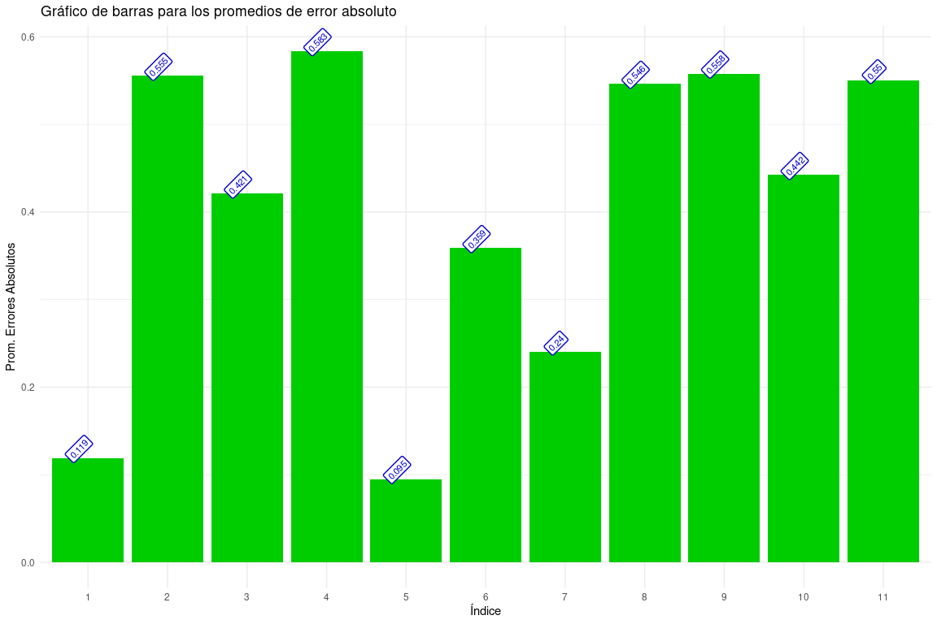

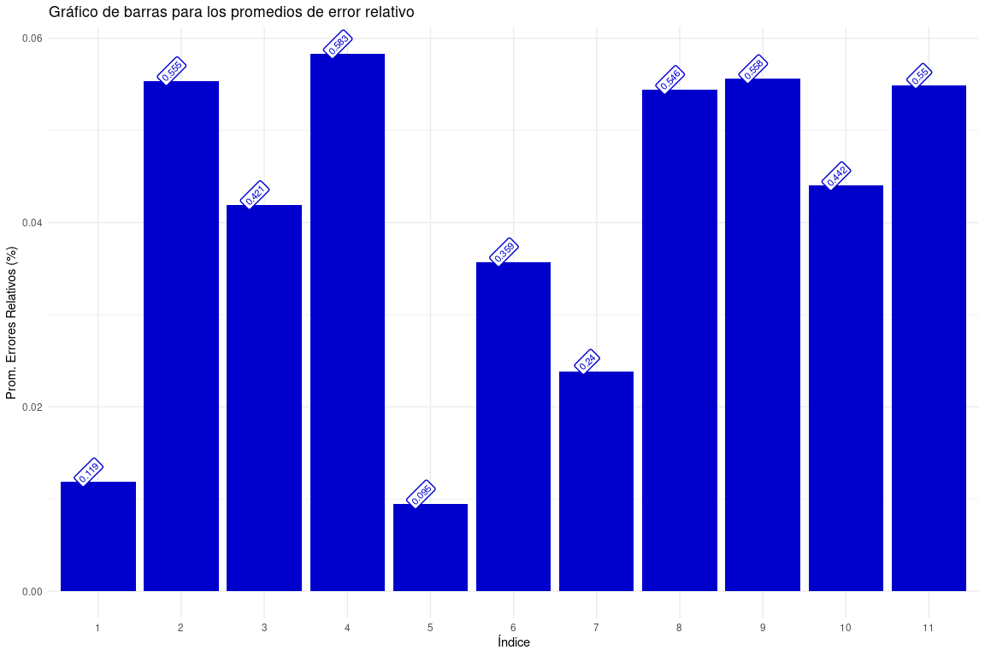

### Comparación Coeficiente de Variacion Entre Presión Real y Mediciones de la Estación WEMA

coeficiente de variacion, para las series de presión encontrada

| NoSerie | FechaInicio | HoraInicio | FechaFin | HoraFin | CantDatos | CoefVariacionOFENA | CoefVariacionWEMA | dif C.V |
| --- | --- | --- | --- | --- | --- | --- | --- | --- |
| 1 | 2024-12-19 | 00:00:00 | 2024-12-19 | 13:40:00 | 162 | 0.0009553 | 0.0010060 | 0.0000507 |
| 7 | 2025-01-08 | 14:10:00 | 2025-01-08 | 19:10:00 | 60 | 0.0009200 | 0.0007839 | 0.0001361 |
| 8 | 2025-01-09 | 00:00:00 | 2025-01-09 | 13:50:00 | 165 | 0.0011649 | 0.0011927 | 0.0000278 |
| 9 | 2025-01-09 | 14:00:00 | 2025-01-09 | 19:35:00 | 61 | 0.0003314 | 0.0002900 | 0.0000414 |
| 14 | 2025-01-13 | 00:00:00 | 2025-01-13 | 13:50:00 | 166 | 0.0011926 | 0.0012632 | 0.0000706 |
| 15 | 2025-01-13 | 14:00:00 | 2025-01-13 | 21:05:00 | 85 | 0.0010272 | 0.0012264 | 0.0001992 |
| 16 | 2025-01-14 | 00:00:00 | 2025-01-14 | 14:05:00 | 167 | 0.0007464 | 0.0007762 | 0.0000298 |
| 22 | 2025-01-25 | 00:00:00 | 2025-01-25 | 14:40:00 | 173 | 0.0006243 | 0.0005804 | 0.0000439 |
| 23 | 2025-01-25 | 14:50:00 | 2025-01-25 | 19:25:00 | 55 | 0.0009173 | 0.0009502 | 0.0000328 |
| 24 | 2025-01-26 | 00:00:00 | 2025-01-26 | 13:30:00 | 160 | 0.0009090 | 0.0009286 | 0.0000196 |
| 25 | 2025-01-26 | 13:40:00 | 2025-01-26 | 20:05:00 | 77 | 0.0003780 | 0.0003989 | 0.0000209 |

| Max. C.V WEMA | Min C.V WEMA | Max C.V OFENA | Min C.V OFENA |
| --- | --- | --- | --- |
| 0.0012632 | 0.00029 | 0.0011926 | 0.0003314 |

| Promedio General C.V OFENA | Promedio General C.V WEMA | Promedio General dif. C.V |
| --- | --- | --- |
| 0.0008333 | 0.0008542 | 6.12e-05 |

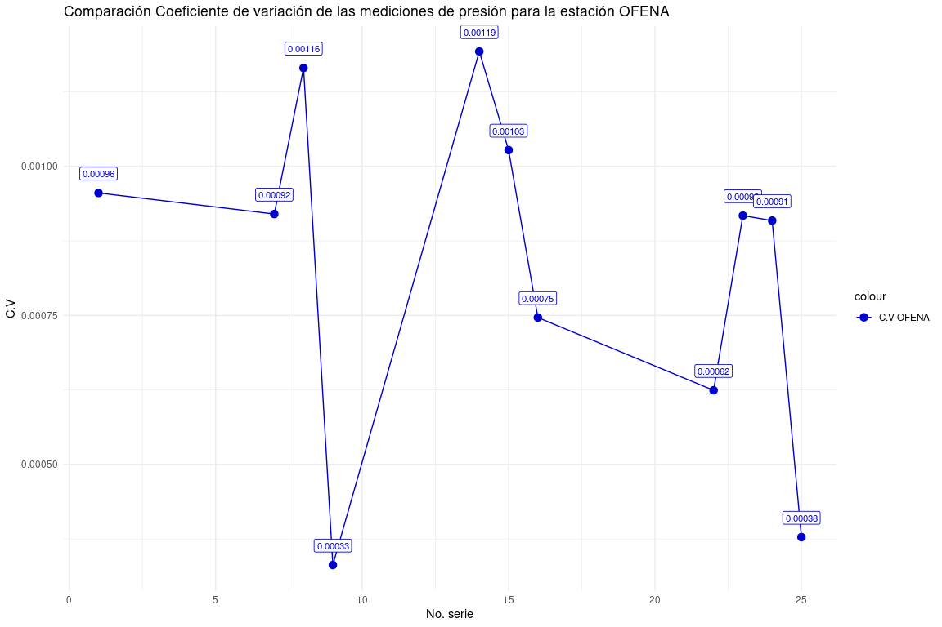

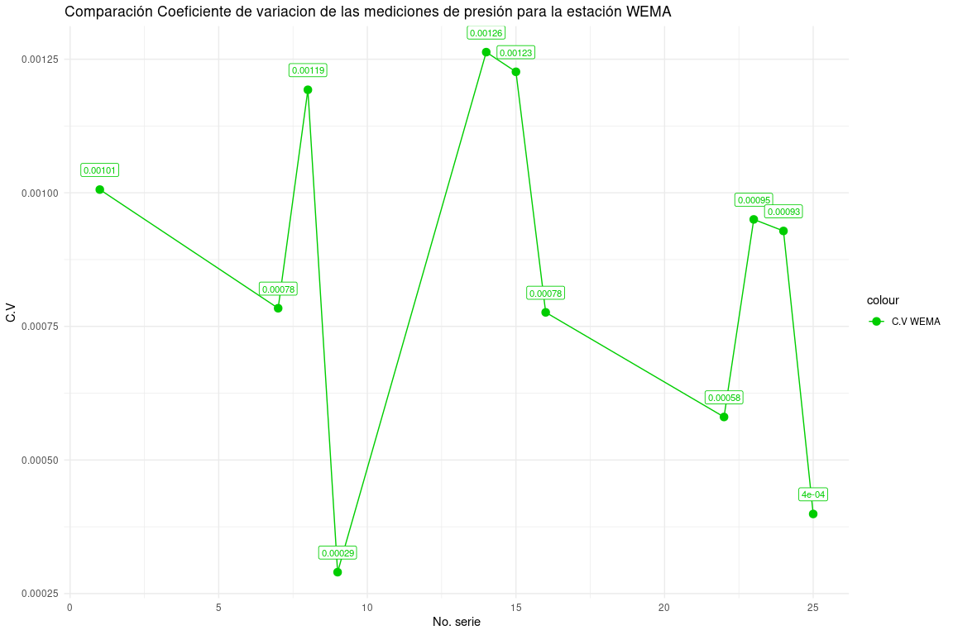

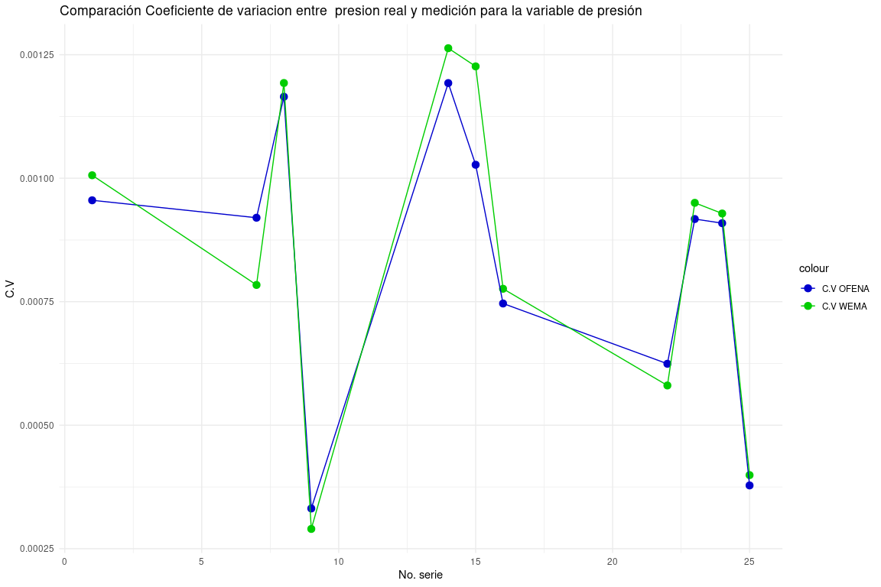

### Disponibilidad de la Variable Presion

* Fecha de inicio: 19/12/2024.
* Fecha de fin: 02/02/2024.

Frecuencia de interrupciones en la medición de presión

| MinutosNoDisponible | Frecuencia | TotalMinutos |
| --- | --- | --- |
| 2 | 170 | 340 |
| 3 | 1 | 3 |
| 26 | 1 | 26 |
| 293 | 1 | 293 |
| 1850 | 1 | 1850 |
| 5406 | 1 | 5406 |
| 8260 | 1 | 8260 |
| 16062 | 1 | 16062 |
| 25757 | 1 | 25757 |

Resumen de interrupciones en la medición de presion

| cantMinutosInterrupcion | cantHorasInterrupcion | cantParadas | TiempoTotalDispMin | TiempoTotalDispHora |
| --- | --- | --- | --- | --- |
| 57997 | 966.6167 | 178 | 8257 | 137.6167 |

Resultados de disponibilidad para la medición de presion

| MTBF | MTTR | Horas.Planificadas |
| --- | --- | --- |
| 0.636985 | 5.430431 | 1080 |

## Resultados de la Variable Humedad

### Limpieza de Datos OFENA

Resumen de limpieza de datos, para la variable de humedad datos OFENA

|  | Resultado |
| --- | --- |
| Cantidad datos OFENA original | 4999 |
| Cantidad de datos Nulos OFENA | 465 |
| Cantidad de datos limpios en intervalos de 5 minutos | 4534 |

### Limpieza de Datos WEMA

Resumen limpieza de datos, para la variable de humedad

|  | Resultado |
| --- | --- |
| Cantidad datos WEMA original | 8257 |
| Cantidad de datos Nulos WEMA | 0 |
| Cantidad de datos limpios en intervalos de 5 minutos | 1655 |

### Series de Datos Analizados

Resumen de las series de datos para la variable de presión

|  | Resultado |
| --- | --- |
| Cantidad de series a analizar | 28 series |
| Cantidad de series descartadas | 96 series |
| Cantidad de series encontradas | 124 series |

### Resumen Series de Mediciones Humedad

| Max. Prom E. Abs. | Min. Prom E. Abs. | Max. Prom E. Rel. | Min. Prom E. Rel |
| --- | --- | --- | --- |
| 18.69667 | 0.948754 | 0.01465 | 0.01465 |

| Prom. General E. Abs. | Prom. General E. Rel. | Mediciones Totales |
| --- | --- | --- |
| 3.455566 | 0.0546285 | 440 |

### Comparación de Errores para las Series de Humedad

Promedio de Errores para las series de humedad

| cantMediciones | PromEAbs | PromERel | PromEPorc |
| --- | --- | --- | --- |
| 48 | 4.654585 | 0.0502499 | 5.024993 |
| 10 | 2.313188 | 0.0382120 | 3.821197 |
| 20 | 3.011560 | 0.0558723 | 5.587231 |
| 17 | 3.413880 | 0.0730571 | 7.305712 |
| 23 | 2.336917 | 0.0450146 | 4.501459 |
| 63 | 4.440208 | 0.0608420 | 6.084201 |
| 15 | 1.618864 | 0.0281040 | 2.810402 |
| 16 | 2.859723 | 0.0536927 | 5.369272 |
| 27 | 3.304846 | 0.0697034 | 6.970344 |
| 21 | 3.077392 | 0.0748033 | 7.480333 |
| 20 | 2.171754 | 0.0383992 | 3.839918 |
| 45 | 3.168806 | 0.0632524 | 6.325235 |
| 18 | 1.149673 | 0.0194320 | 1.943196 |
| 30 | 18.696667 | 0.2111144 | 21.111443 |
| 43 | 6.445407 | 0.0834053 | 8.340526 |
| 11 | 2.378833 | 0.0343410 | 3.434099 |
| 20 | 0.948754 | 0.0146500 | 1.464999 |
| 7 | 1.949893 | 0.0336341 | 3.363410 |
| 46 | 3.373449 | 0.0712558 | 7.125577 |
| 23 | 2.554101 | 0.0404731 | 4.047306 |
| 15 | 5.536956 | 0.0784083 | 7.840826 |
| 15 | 3.153008 | 0.0457278 | 4.572781 |
| 30 | 1.368179 | 0.0209129 | 2.091288 |
| 23 | 3.779254 | 0.0528199 | 5.281992 |
| 11 | 1.401359 | 0.0207126 | 2.071258 |
| 16 | 1.533794 | 0.0256582 | 2.565824 |
| 26 | 2.574138 | 0.0471227 | 4.712272 |
| 44 | 3.540663 | 0.0787270 | 7.872703 |

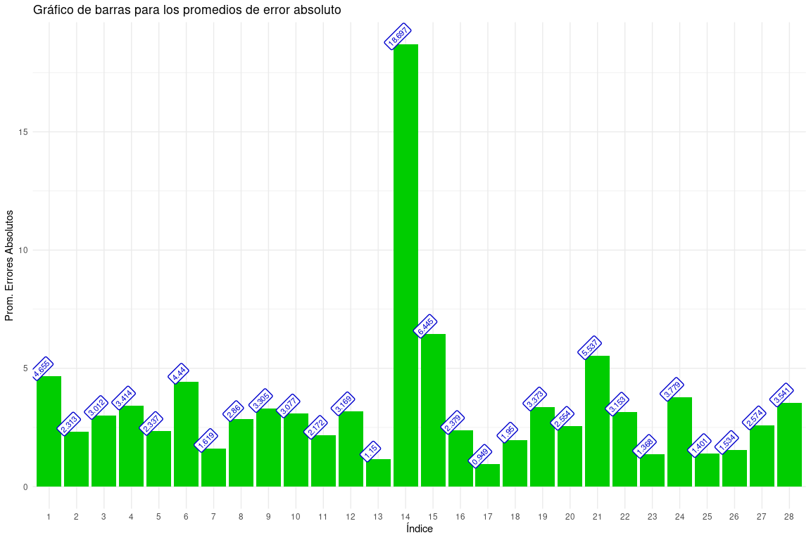

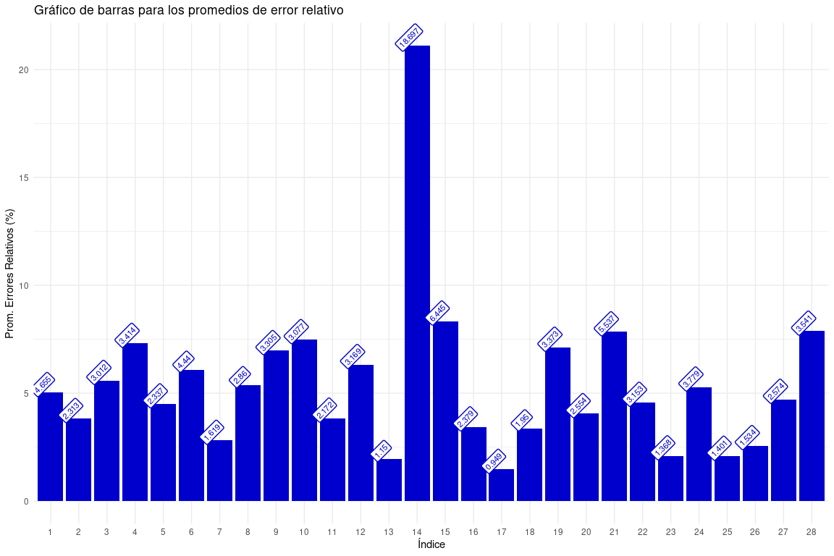

### Comparación Coeficiente de Variacion Entre Humedad Real y Mediciones de la Estación WEMA

coeficiente de variacion, para las series de humedad encontrada

| NoSerie | FechaInicio | HoraInicio | FechaFin | HoraFin | CantDatos | CoefVariacionOFENA | CoefVariacionWEMA | dif C.V |
| --- | --- | --- | --- | --- | --- | --- | --- | --- |
| 1 | 2024-12-19 | 00:45:00 | 2024-12-19 | 06:55:00 | 51 | 0.0261859 | 0.0271867 | 0.0010008 |
| 2 | 2024-12-19 | 08:40:00 | 2024-12-19 | 09:30:00 | 11 | 0.0235999 | 0.0338229 | 0.0102231 |
| 3 | 2024-12-19 | 09:40:00 | 2024-12-19 | 11:30:00 | 20 | 0.0294099 | 0.0249672 | 0.0044427 |
| 17 | 2025-01-08 | 11:35:00 | 2025-01-08 | 15:55:00 | 52 | 0.0459494 | 0.0531190 | 0.0071697 |
| 18 | 2025-01-08 | 16:05:00 | 2025-01-08 | 17:55:00 | 23 | 0.0442122 | 0.0633838 | 0.0191716 |
| 19 | 2025-01-09 | 00:00:00 | 2025-01-09 | 05:20:00 | 64 | 0.0187901 | 0.0226739 | 0.0038838 |
| 20 | 2025-01-09 | 08:45:00 | 2025-01-09 | 10:00:00 | 16 | 0.0341085 | 0.0467736 | 0.0126651 |
| 21 | 2025-01-09 | 10:10:00 | 2025-01-09 | 11:25:00 | 16 | 0.0346274 | 0.0424229 | 0.0077955 |
| 22 | 2025-01-09 | 11:35:00 | 2025-01-09 | 13:55:00 | 28 | 0.0591076 | 0.0584179 | 0.0006897 |
| 23 | 2025-01-09 | 14:05:00 | 2025-01-09 | 16:15:00 | 27 | 0.0425317 | 0.0430835 | 0.0005519 |
| 51 | 2025-01-13 | 10:40:00 | 2025-01-13 | 12:15:00 | 20 | 0.0446200 | 0.0602228 | 0.0156029 |
| 52 | 2025-01-13 | 12:25:00 | 2025-01-13 | 16:20:00 | 45 | 0.0397979 | 0.0495456 | 0.0097477 |
| 53 | 2025-01-13 | 16:30:00 | 2025-01-13 | 17:55:00 | 18 | 0.0135866 | 0.0127970 | 0.0007896 |
| 54 | 2025-01-13 | 19:50:00 | 2025-01-13 | 22:20:00 | 31 | 0.0193944 | 0.0282866 | 0.0088922 |
| 55 | 2025-01-14 | 00:00:00 | 2025-01-14 | 03:40:00 | 44 | 0.0229436 | 0.0319381 | 0.0089945 |
| 56 | 2025-01-14 | 05:30:00 | 2025-01-14 | 06:20:00 | 11 | 0.0333975 | 0.0438981 | 0.0105006 |
| 57 | 2025-01-14 | 06:30:00 | 2025-01-14 | 08:05:00 | 20 | 0.0272796 | 0.0322383 | 0.0049587 |
| 58 | 2025-01-14 | 08:15:00 | 2025-01-14 | 10:30:00 | 18 | 0.0103406 | 0.0364666 | 0.0261260 |
| 75 | 2025-01-25 | 10:00:00 | 2025-01-25 | 16:50:00 | 81 | 0.0438871 | 0.0443443 | 0.0004572 |
| 76 | 2025-01-25 | 20:25:00 | 2025-01-25 | 22:15:00 | 23 | 0.0224654 | 0.0346034 | 0.0121379 |
| 77 | 2025-01-25 | 22:25:00 | 2025-01-25 | 23:35:00 | 15 | 0.0314867 | 0.0543467 | 0.0228601 |
| 78 | 2025-01-26 | 00:40:00 | 2025-01-26 | 01:55:00 | 16 | 0.0149681 | 0.0161875 | 0.0012194 |
| 79 | 2025-01-26 | 02:05:00 | 2025-01-26 | 04:35:00 | 31 | 0.0303585 | 0.0378368 | 0.0074782 |
| 80 | 2025-01-26 | 04:45:00 | 2025-01-26 | 06:40:00 | 23 | 0.0245748 | 0.0366474 | 0.0120726 |
| 81 | 2025-01-26 | 07:20:00 | 2025-01-26 | 08:10:00 | 11 | 0.0202601 | 0.0292942 | 0.0090341 |
| 82 | 2025-01-26 | 08:20:00 | 2025-01-26 | 09:40:00 | 17 | 0.0229033 | 0.0376587 | 0.0147554 |
| 83 | 2025-01-26 | 09:50:00 | 2025-01-26 | 12:00:00 | 26 | 0.0285548 | 0.0313120 | 0.0027571 |
| 84 | 2025-01-26 | 12:40:00 | 2025-01-26 | 17:15:00 | 56 | 0.0395588 | 0.0487564 | 0.0091977 |

| Max. C.V WEMA | Min C.V WEMA | Max C.V OFENA | Min C.V OFENA |
| --- | --- | --- | --- |
| 0.0633838 | 0.012797 | 0.0591076 | 0.0103406 |

| Promedio General C.V OFENA | Promedio General C.V WEMA | Promedio General dif. C.V |
| --- | --- | --- |
| 0.0303179 | 0.0386511 | 0.0087563 |

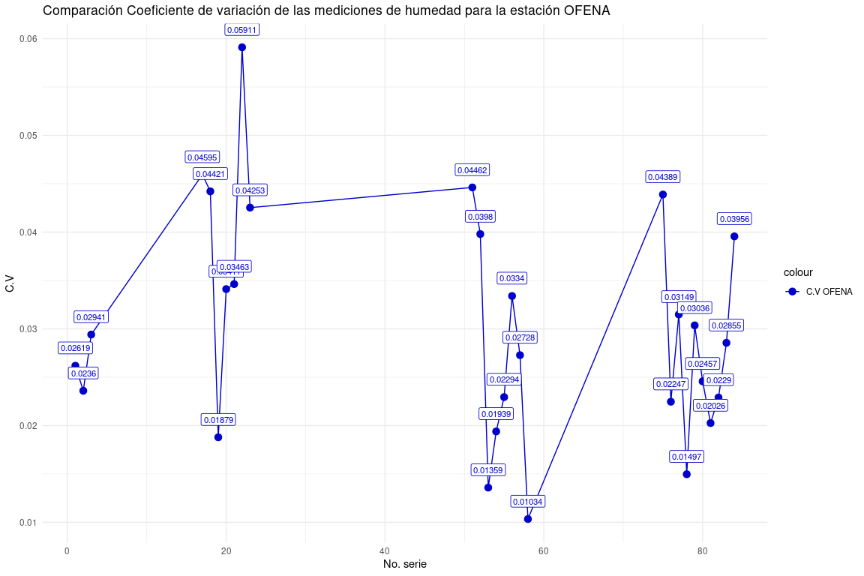

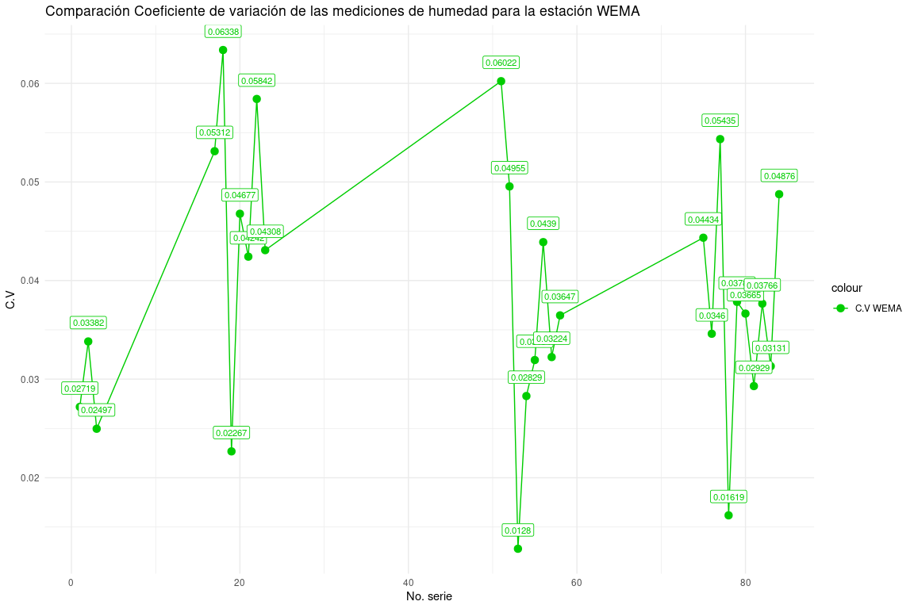

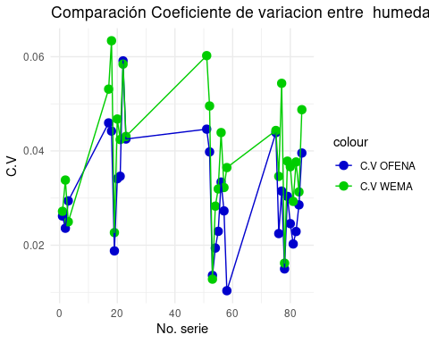

### Disponiblidad de la Variable Humedad

* Fecha de inicio: 19/12/2024.
* Fecha de fin: 02/02/2024.

Frecuencia de interrupciones en la medición de humedad

| MinutosNoDisponible | Frecuencia | TotalMinutos |
| --- | --- | --- |
| 2 | 170 | 340 |
| 3 | 1 | 3 |
| 26 | 1 | 26 |
| 293 | 1 | 293 |
| 1850 | 1 | 1850 |
| 5406 | 1 | 5406 |
| 8260 | 1 | 8260 |
| 16062 | 1 | 16062 |
| 25757 | 1 | 25757 |

Resumen de interrupciones en la medición de humedad

| cantMinutosInterrupcion | cantHorasInterrupcion | cantParadas | TiempoTotalDispMin | TiempoTotalDispHora |
| --- | --- | --- | --- | --- |
| 57997 | 966.6167 | 178 | 8257 | 137.6167 |

Resultados de disponibilidad para la medición de humedad

| MTBF | MTTR | Horas.Planificadas |
| --- | --- | --- |
| 0.636985 | 5.430431 | 1080 |

## Resultados de la Variable Direccion del Viento

### Limpieza de Datos OFENA

Resumen de limpieza de datos, para la variable de dirección del viento datos OFENA

|  | Resultado |
| --- | --- |
| Cantidad datos OFENA original | 4999 |
| Cantidad de datos Nulos OFENA | 465 |
| Cantidad de datos limpios en intervalos de 5 minutos | 4534 |

### Limpieza de Datos WEMA

Resumen limpieza de datos, para la variable de dirección del viento

|  | Resultado |
| --- | --- |
| Cantidad datos WEMA original | 8257 |
| Cantidad de datos Nulos WEMA | 0 |
| Cantidad de datos limpios en intervalos de 5 minutos | 1655 |

### Series de Datos Analizados

Resumen de las series de datos para la variable de dirección del viento

|  | Resultado |
| --- | --- |
| Cantidad de series a analizar | 0 series |
| Cantidad de series descartadas | 9 series |
| Cantidad de series encontradas | 9 series |

### Resumen Series de Mediciones Direccion del Viento

[1] "No se encontraron series para analizar."

### Comparación Coeficiente de Variacion Entre Direccion del Viento Real y Mediciones de la Estación WEMA

[1] "No hay datos para analizar."

### Disponiblidad de la Variable Direccion del Viento

* Fecha de inicio: 19/12/2024.
* Fecha de fin: 02/02/2024.

Frecuencia de interrupciones en la medición de direccion de viento

| MinutosNoDisponible | Frecuencia | TotalMinutos |
| --- | --- | --- |
| 2 | 170 | 340 |
| 3 | 1 | 3 |
| 26 | 1 | 26 |
| 293 | 1 | 293 |
| 1850 | 1 | 1850 |
| 5406 | 1 | 5406 |
| 8260 | 1 | 8260 |
| 16062 | 1 | 16062 |
| 25757 | 1 | 25757 |

Resumen de interrupciones en la medición de direccion de viento

| cantMinutosInterrupcion | cantHorasInterrupcion | cantParadas | TiempoTotalDispMin | TiempoTotalDispHora |
| --- | --- | --- | --- | --- |
| 57997 | 966.6167 | 178 | 8257 | 137.6167 |

Resultados de disponibilidad para la medición de direccion del viento

| MTBF | MTTR | Horas.Planificadas |
| --- | --- | --- |
| 0.636985 | 5.430431 | 1080 |

## Resultados de la Variable Velocidad del Viento

### Limpieza de Datos OFENA

Resumen de limpieza de datos, para la variable de velocidad del viento OFENA

|  | Resultado |
| --- | --- |
| Cantidad datos OFENA original | 4999 |
| Cantidad de datos Nulos OFENA | 465 |
| Cantidad de datos limpios en intervalos de 5 minutos | 4534 |

### Limpieza de Datos WEMA

Resumen limpieza de datos, para la variable de velocidad del viento

|  | Resultado |
| --- | --- |
| Cantidad datos WEMA original | 8257 |
| Cantidad de datos Nulos WEMA | 0 |
| Cantidad de datos limpios en intervalos de 5 minutos | 1655 |

### Series de Datos Analizados

Resumen de las series de datos para la variable de velocidad del viento

|  | Resultado |
| --- | --- |
| Cantidad de series a analizar | 14 series |
| Cantidad de series descartadas | 48 series |
| Cantidad de series encontradas | 62 series |

### Resumen Series de Mediciones Velocidad del Viento

| Max. Prom E. Abs. | Min. Prom E. Abs. | Max. Prom E. Rel. | Min. Prom E. Rel |
| --- | --- | --- | --- |
| 3.092598 | 0.4371663 | 0.278318 | 0.278318 |

| Prom. General E. Abs. | Prom. General E. Rel. | Mediciones Totales |
| --- | --- | --- |
| 1.463243 | 0.4234002 | 440 |

### Resumen Series de Mediciones Direccion del Viento

Promedio de Errores para las series de velocidad del viento

| cantMediciones | PromEAbs | PromERel | PromEPorc |
| --- | --- | --- | --- |
| 56 | 0.4371663 | 0.3240387 | 32.40387 |
| 21 | 2.2506484 | 0.3038913 | 30.38913 |
| 10 | 1.5284096 | 0.3554239 | 35.54239 |
| 10 | 0.9881312 | 0.4232989 | 42.32989 |
| 93 | 0.9517134 | 0.6828948 | 68.28948 |
| 13 | 1.9511852 | 0.5203438 | 52.03438 |
| 17 | 1.6327680 | 0.3308056 | 33.08056 |
| 44 | 2.2475556 | 0.4384804 | 43.84804 |
| 13 | 3.0925982 | 0.3804718 | 38.04718 |
| 57 | 0.9898678 | 0.5729567 | 57.29567 |
| 16 | 1.4880840 | 0.2783180 | 27.83180 |
| 13 | 1.0144517 | 0.3157210 | 31.57210 |
| 19 | 0.9586796 | 0.5868096 | 58.68096 |
| 58 | 0.9541407 | 0.4141488 | 41.41488 |

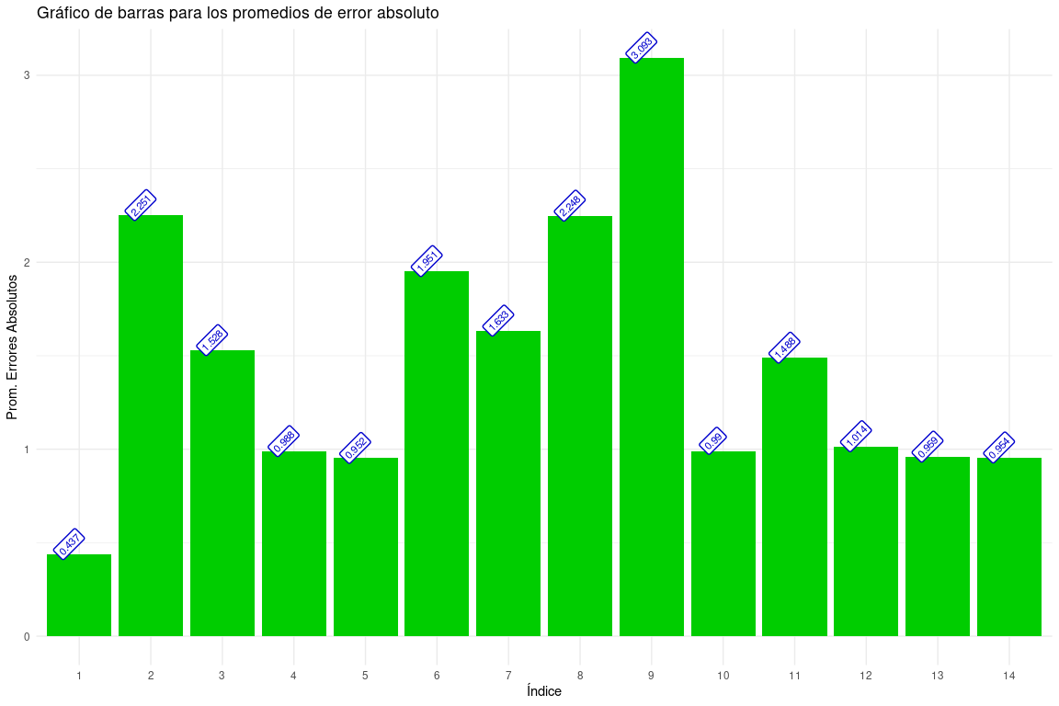

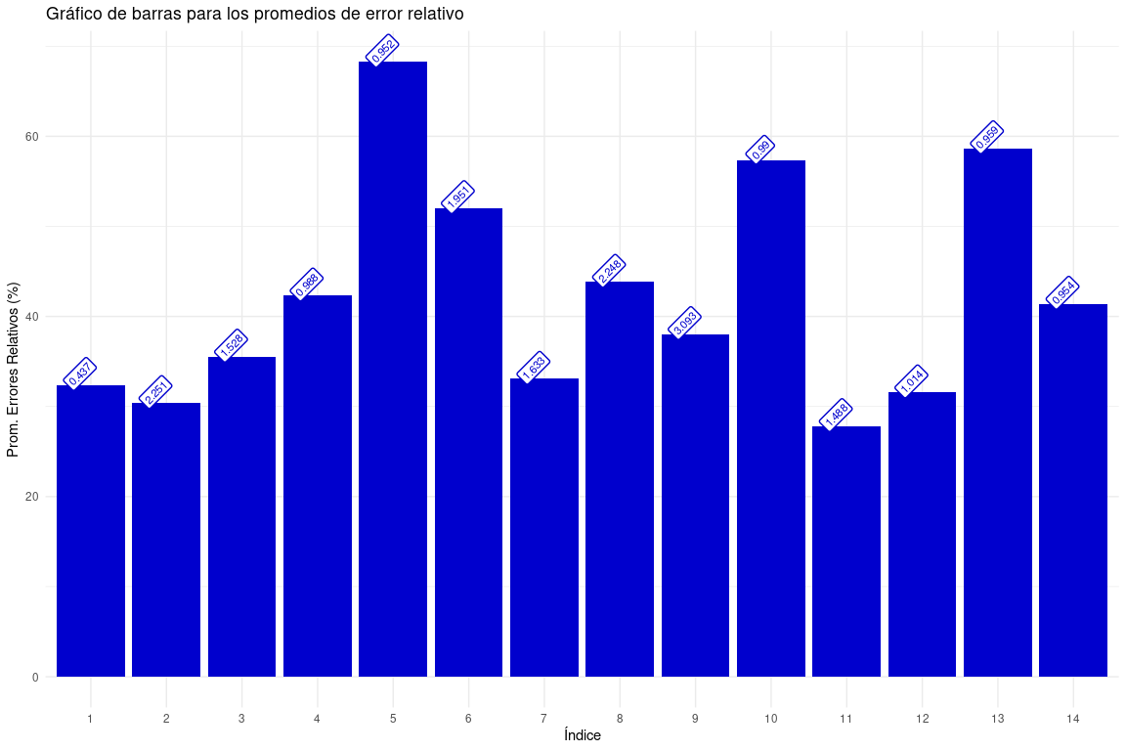

### Comparación Coeficiente de Variacion Entre Velocidad del Viento Real y Mediciones de la Estación WEMA

coeficiente de variacion, para las series de velocidad del viento encontrada

| NoSerie | FechaInicio | HoraInicio | FechaFin | HoraFin | CantDatos | CoefVariacionOFENA | CoefVariacionWEMA | dif C.V |
| --- | --- | --- | --- | --- | --- | --- | --- | --- |
| 1 | 2024-12-19 | 00:45:00 | 2024-12-19 | 08:10:00 | 59 | 1.6240611 | 2.9128763 | 1.2888153 |
| 2 | 2024-12-19 | 09:00:00 | 2024-12-19 | 11:00:00 | 22 | 0.4094870 | 0.4132327 | 0.0037457 |
| 3 | 2024-12-19 | 12:30:00 | 2024-12-19 | 14:30:00 | 25 | 0.4570923 | 0.3923518 | 0.0647405 |
| 11 | 2025-01-08 | 15:50:00 | 2025-01-08 | 16:40:00 | 11 | 0.4093520 | 0.6023386 | 0.1929866 |
| 12 | 2025-01-09 | 00:00:00 | 2025-01-09 | 07:50:00 | 94 | 0.8930553 | 1.1318096 | 0.2387543 |
| 13 | 2025-01-09 | 08:15:00 | 2025-01-09 | 09:20:00 | 14 | 0.4587060 | 0.4377678 | 0.0209382 |
| 14 | 2025-01-09 | 12:00:00 | 2025-01-09 | 13:30:00 | 18 | 0.3815123 | 0.4878524 | 0.1063401 |
| 29 | 2025-01-13 | 09:10:00 | 2025-01-13 | 13:30:00 | 53 | 0.3491590 | 0.4173820 | 0.0682229 |
| 30 | 2025-01-13 | 15:35:00 | 2025-01-13 | 16:45:00 | 13 | 0.2661391 | 0.4188953 | 0.1527562 |
| 31 | 2025-01-14 | 00:00:00 | 2025-01-14 | 04:50:00 | 58 | 1.0154679 | 0.9587846 | 0.0566833 |
| 32 | 2025-01-14 | 07:30:00 | 2025-01-14 | 10:00:00 | 22 | 0.3622432 | 0.3941966 | 0.0319534 |
| 43 | 2025-01-26 | 00:50:00 | 2025-01-26 | 01:55:00 | 14 | 0.4901948 | 0.4868051 | 0.0033897 |
| 44 | 2025-01-26 | 02:20:00 | 2025-01-26 | 03:50:00 | 19 | 0.7068560 | 0.7638795 | 0.0570235 |
| 45 | 2025-01-26 | 04:25:00 | 2025-01-26 | 09:20:00 | 59 | 0.6106053 | 0.5345734 | 0.0760319 |

| Max. C.V WEMA | Min C.V WEMA | Max C.V OFENA | Min C.V OFENA |
| --- | --- | --- | --- |
| 2.912876 | 0.3923518 | 1.624061 | 0.2661391 |

| Promedio General C.V OFENA | Promedio General C.V WEMA | Promedio General dif. C.V |
| --- | --- | --- |
| 0.6024237 | 0.7394818 | 0.1687415 |

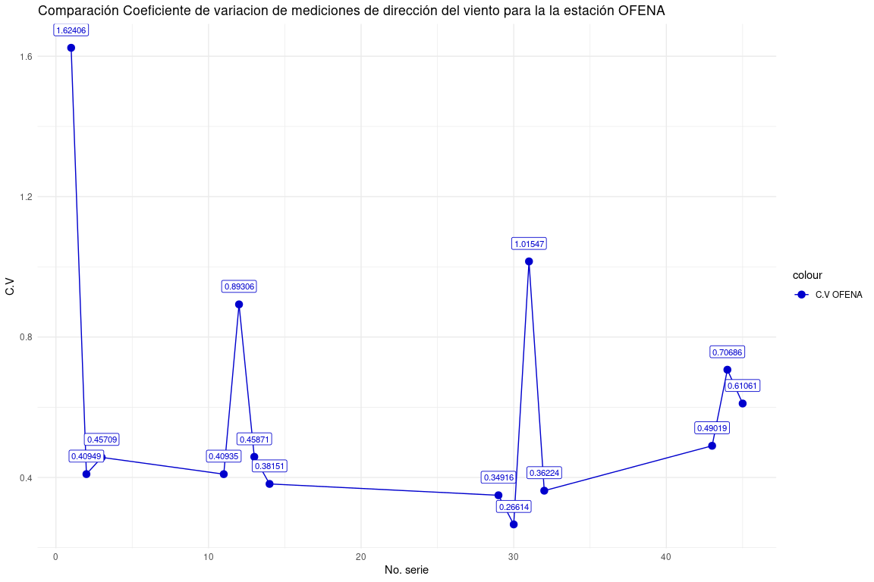

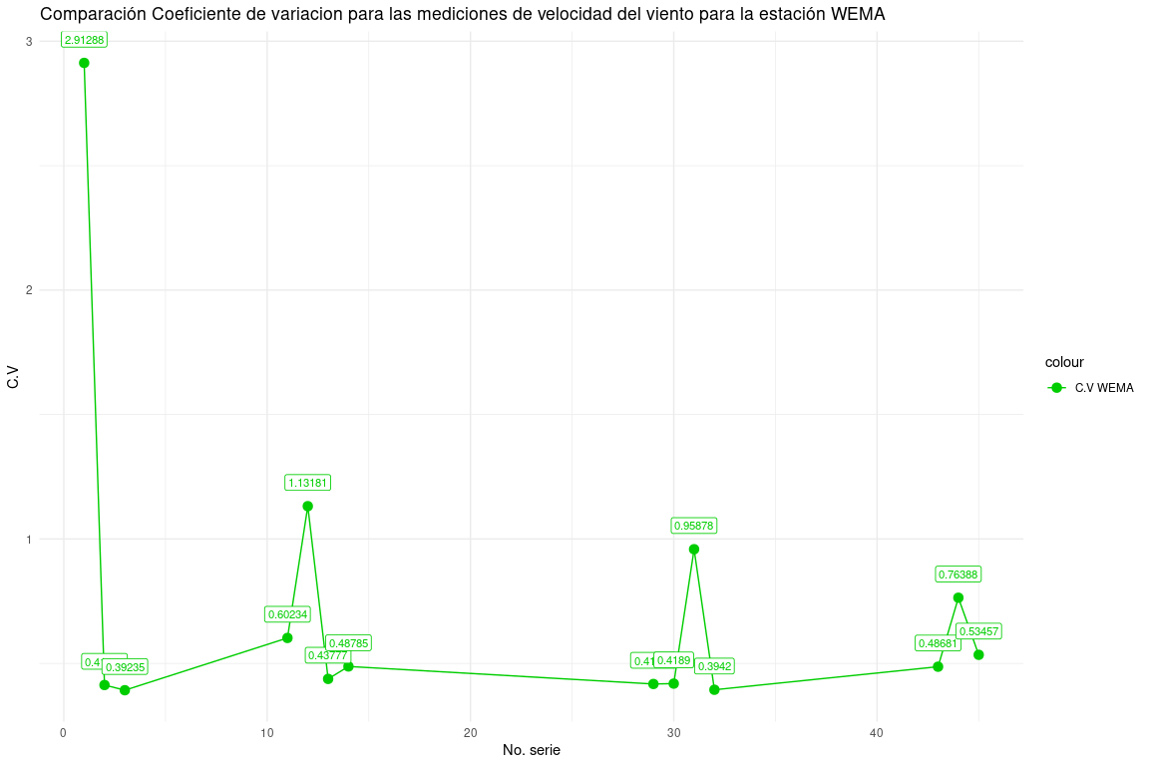

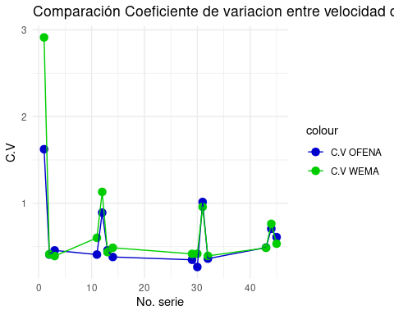

### Disponiblidad de la Variable Velocidad del Viento

* Fecha de inicio: 19/12/2024.
* Fecha de fin: 02/02/2024.

Frecuencia de interrupciones en la medición de velocidad del viento

| MinutosNoDisponible | Frecuencia | TotalMinutos |
| --- | --- | --- |
| 2 | 170 | 340 |
| 3 | 1 | 3 |
| 26 | 1 | 26 |
| 293 | 1 | 293 |
| 1850 | 1 | 1850 |
| 5406 | 1 | 5406 |
| 8260 | 1 | 8260 |
| 16062 | 1 | 16062 |
| 25757 | 1 | 25757 |

Resumen de interrupciones en la medición de velocidad de viento

| cantMinutosInterrupcion | cantHorasInterrupcion | cantParadas | TiempoTotalDispMin | TiempoTotalDispHora |
| --- | --- | --- | --- | --- |
| 57997 | 966.6167 | 178 | 8257 | 137.6167 |

Resultados de disponibilidad para la medición de velocidad del viento

| MTBF | MTTR | Horas.Planificadas |
| --- | --- | --- |
| 0.636985 | 5.430431 | 1080 |