Wesley Muehlhausen

Homework 1 Reflection

Feb 2, 2020

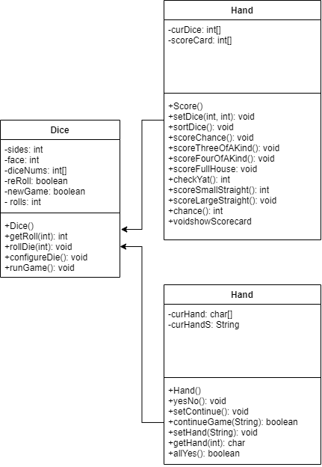 The overall purpose of this assignment was to create a java program that would play Yahtzee. For this assignment we did not have every nook and cranny in it such as multiple players but we did have to create an interface that would display the game and be playable. The design I used for the program was to start in a dice class where the dice would be rolled and the user would input which dice they wanted to replace. Then, the dice class would invoke the had class and the score class. The hand class pretty much just sorted the hand so that it could be analyzed by the score class. The score class did all of the math for calculating the score as well as displaying the scoreboard at he end of the program.

The main issue I had was that I had a good portion of my dice class in main. This is bad practice for any coder and it took a lot of time to transfer it to the dice class mainly in runGame(). Another problem I had was with using strings in if statements. For example it took me a really long time to get the game to where it would skip to the score card it the input was yyyyy. This also affected me when I tried to input the “do you want to play another game”. I could not get the program to correctly execute that command. Overall though, I think my code could be more condensed and used smarter. I feel like a lot of the functions worked, but were really inefficient. It retrospective, I would definitely just try to code the whole thing like I did, but then after that, try to redo the thing from scratch to make it better.