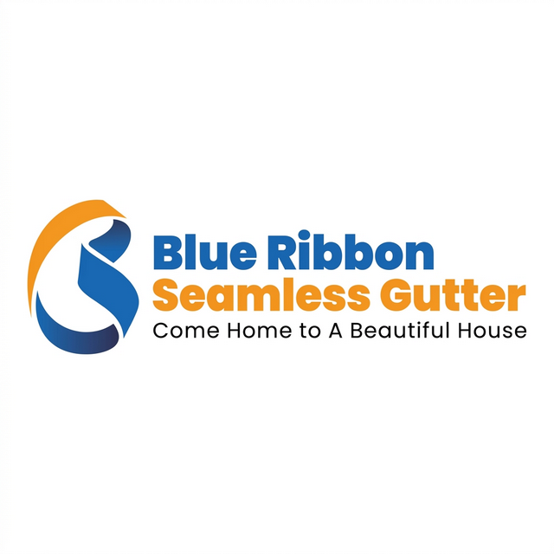

Blue Ribbon Gutters – Nextdoor Playbook
Be the name neighbors trust in Limerick, Stowe, West Pottsgrove, Sanatoga, Lower Pottsgrove, North Coventry, South Limerick, Kenilworth, Parker Ford, Boyertown, Douglassville, Gilbertsville, Royersford.

⭐ STEP 1 — Get More Faves & Recommendations
Goal: Hit 5+ Nextdoor recommendations for the shiny Neighborhood Favorite badge.
How:
• Text or email happy customers in your towns.
• Ask them to give Blue Ribbon a quick thumbs‑up on Nextdoor.
• Hit 5+ and your posts show to 30% more people!

📍 STEP 2 — Claim Your Zip Sponsorship
Buy the zip codes you work in. You’ll always appear first when neighbors search “gutters.”
Average cost: $32–$150 a month. Way cheaper than a print ad.
Checklist:
☐ Log into Nextdoor Business page
☐ Search Neighborhood Sponsorships
☐ Claim your zips

🌦️ STEP 3 — Post When Weather Hits
When rain or snow is coming, drop a friendly neighbor post:
"Hey Limerick neighbors! Heavy rain on Thursday. Clear your downspouts— we’re doing checks in Gilbertsville and Royersford this week."

📸 STEP 4 — Show You’re Local
Use real photos, not stock images.
☑ Truck parked by a local landmark
☑ Before/after shots
☑ Tag the street or town name

🔔 STEP 5 — Jump on Threads Fast
Turn on alerts for 'gutter', 'leak', 'roof', 'recommendation.'
Reply quick:
"Hi [Name]! We’re Blue Ribbon Gutters here in Parker Ford. Just finished a job nearby—happy to stop by today!"

Bojako vs. Blue Ribbon – Quick Comparison
Feature | Bojako (Old Way) | Blue Ribbon (Smart Way)
Visibility | Rely on old reviews | Sponsors local ZIPs
Content | Generic posts | Weather alerts + local photos
Response | Waits for tags | Jumps in fast
Conversion | Links to homepage | Links to local pages

Weekly Checklist
☐ Get at least 1 new Nextdoor Fave
☐ Make 1 weather post
☐ Share 1 real job photo
☐ Reply to 1 neighbor thread
☐ Keep sponsorship active
People hire the neighbor they see and hear from the most — not the one with the biggest sign. Show up, share real work, and stay friendly.
Blue Ribbon Gutters – Serving Limerick, Stowe, West Pottsgrove, Sanatoga, Lower Pottsgrove, North Coventry, South Limerick, Kenilworth, Parker Ford, Boyertown, Douglassville, Gilbertsville, Royersford.
https://blueribbongutters.com

