

VideoTexture Sample for Direct3D 12

# *This sample is compatible with the Windows 10 Anniversary Update SDK (14393)*

# Description

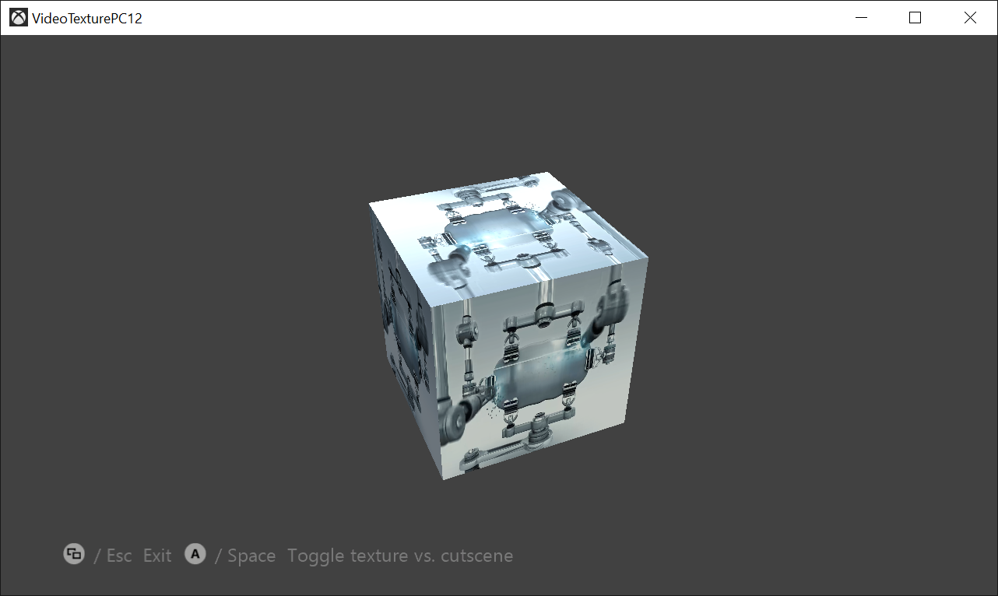

This sample demonstrates using the Media Foundation APIs on Windows 10 to play a video on a Direct3D texture.

# Using the sample

The sample opens a WMV video and plays it back (with audio), then exits when the video is complete.

|  |  |  |
| --- | --- | --- |
| Action | Gamepad | Keyboard |
| Toggles between a textured 3D cube and a flat 2D render of the video | A button | Space |
| Exit | View Button | Esc |

# Implementation notes

The sample makes use of the [IMFMediaEngine](https://docs.microsoft.com/en-us/windows/desktop/api/mfmediaengine/nn-mfmediaengine-imfmediaengine) interface which provides a simplified API for basic playback scenarios.

The **MediaEnginePlayer.cpp/.h** contains the bulk of the Media Foundation API usage in this sample, which includes creating a separate Direct3D 11 device and utilizing [DXGI surface sharing](https://docs.microsoft.com/en-us/windows/desktop/direct3darticles/surface-sharing-between-windows-graphics-apis) to render on a Direct3D 12 device.

This sample requires the Media Foundation components which are not present by default on Windows 10 N Editions. The sample uses DLL Delay Loading to provide runtime detection in the **Main.cpp** for this scenario. For more information, see [this blog post](https://blogs.msdn.microsoft.com/chuckw/2010/08/13/who-moved-my-windows-media-cheese/).

# Update history

August 2018 initial release.

# Privacy Statement

When compiling and running a sample, the file name of the sample executable will be sent to Microsoft to help track sample usage. To opt-out of this data collection, you can remove the block of code in Main.cpp labeled “Sample Usage Telemetry”.

For more information about Microsoft’s privacy policies in general, see the [Microsoft Privacy Statement](https://privacy.microsoft.com/en-us/privacystatement/).