DirectX Tool Kit Simple Sample

# *This sample is compatible with the Windows 10 Anniversary Update SDK (14393)*

# Description

The SimpleSample demo shows how to link to the DirectXTK library and demonstrates the use of several DirectXTK components:

* SpriteBatch is used to render a Windows logo
* SpriteFont and SpriteBatch are used to render text
* GeometricPrimitive is used to render a teapot
* PrimitiveBatch is used to render the grid
* Model is used to render a mesh loaded from the legacy DirectX SDK .SDKMESH file "Tiny.SDKMESH"
* Several textures are loaded using DDSTextureLoader
* Plays a looping sound and timed 'one-shot' audio
* Demonstrates a simple handling of audio device scenarios for DirectX for Audio

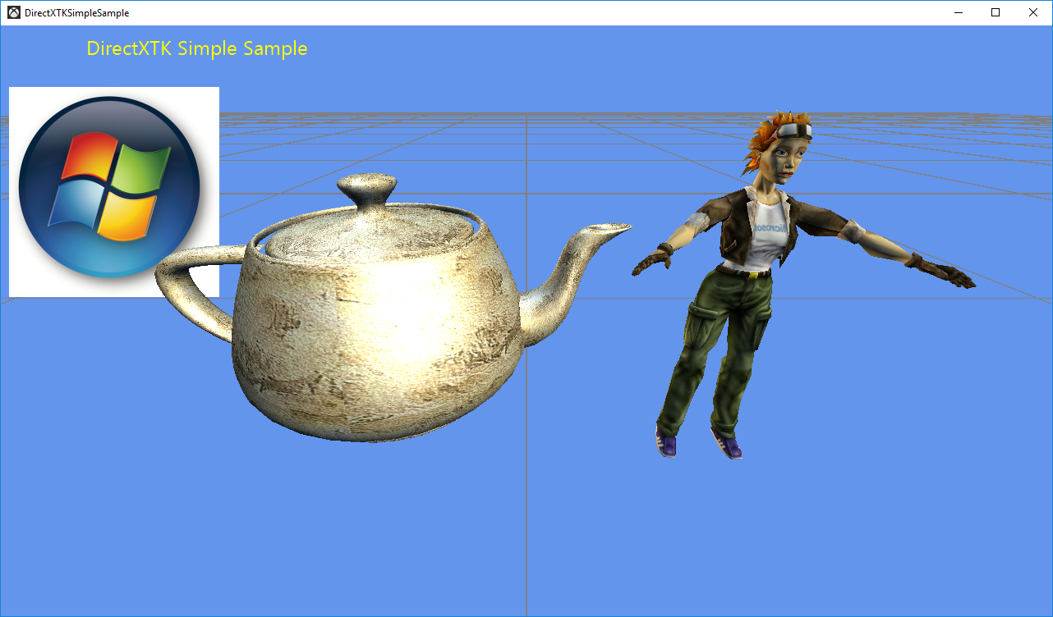

# Using the sample

The sample has no controls other than exiting via the Esc key.

# Implementation notes

This sample includes the DirectX Tool Kit library which is available on [GitHub](https://github.com/Microsoft/DirectXTK/).

## System Requirements

This sample is compatible with Windows 8 or later, as it makes use of XAudio 2.8.

It is possible to configure the sample to build with Windows 7 Service Pack 1 compatibility but requires making use of the legacy DirectX SDK and the *DirectX End-User Runtime* to deploy XAudio 2.7. For more information on this scenario, see [this blog post](https://blogs.msdn.microsoft.com/chuckw/2012/04/02/xaudio2-and-windows-8/) as well as the [GitHub wiki](https://github.com/Microsoft/DirectXTK/wiki/Audio#xaudio-27-vs-28). It also requires the DirectX 11.1 Runtime ([KB 2670838](https://support.microsoft.com/en-us/help/2670838/platform-update-for-windows-7-sp1-and-windows-server-2008-r2-sp1)). See [this blog post](https://blogs.msdn.microsoft.com/chuckw/2013/02/26/directx-11-1-and-windows-7-update/) for additional information.

# Update history

Initial release March 2016