

SimpleCompute Sample for Direct3D 11

*This sample is compatible with the Windows 10 Anniversary Update SDK (14393)*

# Description

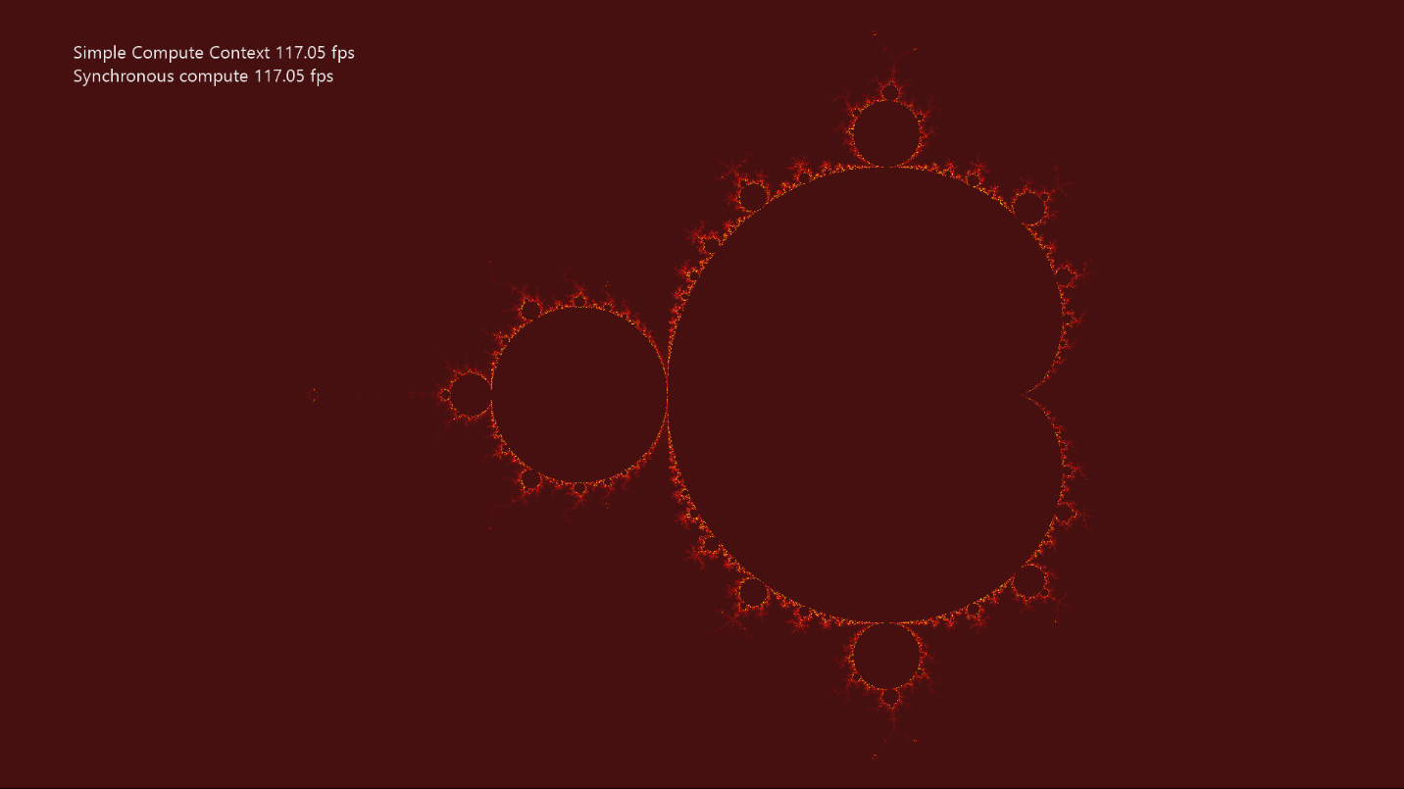

SimpleCompute shows how to use DirectCompute™ (i.e. Direct3D Compute Shader). It updates a texture by computing the Mandelbrot set using a compute shader.

# Using the sample

|  |  |  |
| --- | --- | --- |
| Action | Gamepad | Keyboard |
| Reset Viewport to Default | Y button | Home |
| Pan Viewport | Left stick | WASD |
| Zoom Viewport | Right stick | PgUp/PgDn |
| Increase Zoom Speed | Right trigger | Shift + PgUp/PgDn |
| Exit | View Button | Esc |
| Menu | Show/hide help | F1 |

# Implementation notes

The primary purpose of this sample is to familiarize the reader with creating and using a simple compute shader.

* **CreateDeviceDependentResources**: This is where the compiled compute shader is loaded and the various Direct3D rendering resources are created. The shaders are compiled by Visual Studio.
* **Render**: The compute shader is dispatched before the draw call that needs the results is dispatched. This updates the texture every frame.

## Hardware Feature Level Requirement

The DirectCompute (Shader Model 5) feature of DirectX 11 requires [Direct3D Hardware Feature Level 11.0](https://blogs.msdn.microsoft.com/chuckw/2012/06/20/direct3d-feature-levels/) or better hardware. Note that a limited form of DirectCompute (Shader Model 4.x) is optionally supported on some Feature Level 10.x hardware, but this scenario is not supported by this sample.

## System Requirements

This sample is compatible with Windows 8 or later.

This sample will also run on Windows 7 Service Pack 1 provided the DirectX 11.1 Runtime has been installed ([KB 2670838](https://support.microsoft.com/en-us/help/2670838/platform-update-for-windows-7-sp1-and-windows-server-2008-r2-sp1)). See [this blog post](https://blogs.msdn.microsoft.com/chuckw/2013/02/26/directx-11-1-and-windows-7-update/) for additional information.

# Update history

Initial release June 2018.