

Simple Lighting Sample (DX12)

*This sample is compatible with the Windows 10 Anniversary Update SDK (14393)*

# Description

This sample demonstrates how to create a static Direct3D 12 vertex, index, and constant buffer to draw indexed geometry lit by using static and dynamic Lambertian lighting.

The sample renders a large cube that is lit by two lights, one white and one red, also represented as cubes. The white light is stationary while the red light orbits around the central cube. The central cube also rotates. The motion allows you to observe the effects of the colored lights from different angles.

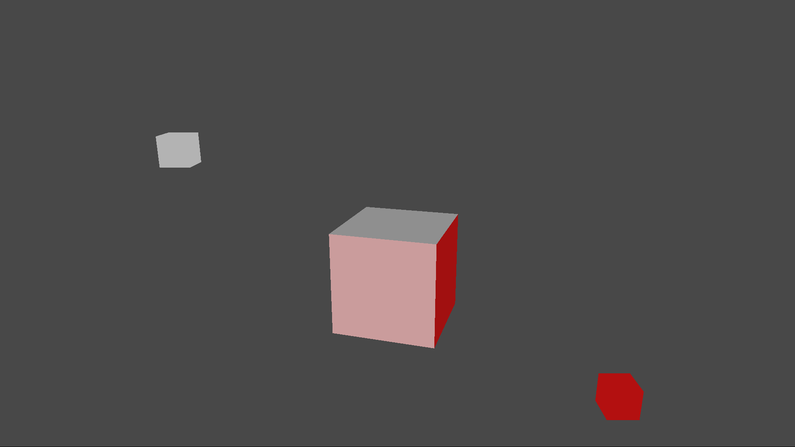

# Using the sample

|  |  |  |
| --- | --- | --- |
| Action | Gamepad | Keyboard |
| Exit | View Button | Esc |

# Implementation notes

## Shaders

## The sample uses three shaders to render the scene – a vertex shader (“TriangleVS”) and two pixel shaders (“LambertPS”, “SolidColorPS”.) The compiled shader blobs are loaded in CreateDeviceDependentResources and then referenced when creating the Pipeline State Objects for each of the shader combinations. All shaders are defined in the same HLSL include file, “SimpleLighting.hlsli” and three stub shaders include this file. Each stub shader is compiled, for a different entry point, in order to create the three shader blobs.

## Pipeline State Objects (PSOs)

The Simple Lighting sample has two unique shader combinations: first is TriangleVS combined with LambertPS and the second is TriangleVS with SolidColorPS. In DirectX 12, you need to create a Pipeline State Object (PSO) for every unique shader combination. As the name suggests, the PSO encapsulates all the pipeline state that you will need for possibly several draw calls using a particular set of shaders. The PSO combines a root signature, shaders for the various stages of the pipeline, state settings such as rasterizer state, depth stencil state, blend state, etc. (for more details see the documentation on MSDN.)

## Root Signature

The root signature defines the types of resources that are bound to the graphics pipeline and how the resources are laid out. A root signature is analogous to an API function signature, it describes the types of parameters, parameter order, and layout but does not define any actual parameter instances. A root parameter is an actual data instance corresponding to an element of the root signature. The vertex shader for the sample needs only a single structure for the shader constants and so the root signature is consequently very simple. The root signature contains a single root parameter of type ConstantBufferView.

## Geometry

## The geometry for the scene is composed of static vertex and index arrays which contain data for the 24 vertices representing six quads of a cube. The two arrays are declared inside of Sample::CreateDeviceDependentResources where they are immediately used by ID3D12Device::CreateCommittedResource to create ID3D12Resources for the buffers. For simplicity the sample uses D3D12_HEAP_TYPE_UPLOAD since this allows you to create each resource while initializing it with the data in a single step. However, _UPLOAD heaps are a sub-optimal location for geometry data. A more efficient implementation would use a D3D12_HEAP_TYPE_DEFAULT for the geometry data. To initialize a _DEFAULT heap, you need to use an _UPLOAD heap so you end up using two heaps, which complicates the implementation.

Once the buffers for the geometry are create, the sample can create a D3D12_VERTEX_BUFFER_VIEW for the vertices and a D3D12_INDEX_BUFFER_VIEW for the indices. The views are used in Sample::Render when setting up the input assembler via calls to ID3D12GraphicsCommandList::IASetVertextBuffer and ID3D12GraphicsCommandList::IASetVertextBuffer.

## Managing Shader Constants

For this very simple scene, all the shader constants are lumped together into a single constant buffer which contains the following:

* World, View and Projection Matrices
* Light directions and colors
* Solid color

For a more complex scene, you would normally split the constants into multiple buffers depending on how frequently the constants are updated.

Since the large cube and the red light are animated the shader constants need to be updated multiple times per frame in between draw calls. Recall that the root signature contains a single root parameter of type ConstantBufferView which will need to reference a copy of the shader constants for use in each draw call. Since the CPU and GPU operate in parallel, the CPU should not attempt to update any constant buffer until the GPU is done using it. If there were only a single constant buffer, the CPU would have to block until the GPU finishes drawing which is unrealistic since the constants need to be updated for several draw calls. Therefore, the sample uses several constant buffers so that the CPU can continue to send constants to the GPU while the GPU is drawing.

The sample is simple and has a fixed number of draw calls per frame, which is known at compile time. The sample creates one buffer for each draw call multiplied by the number of back buffers in the swap chain. This number guarantees that there will always be a free buffer for the CPU to write to. All the constant buffers are stored in a single contiguous upload buffer created in Sample::CreateDeviceDependentResources. The upload buffer is immediately mapped to obtain the base memory address for both the CPU address space and the GPU address space.

In the Sample::Render method, constants are written to a location indexed off of the CPU base address of the constants upload heap. The same index is combined with the GPU address to bind the buffer to the pipeline via a call to ID3D12GraphicsCommandList::SetGraphicsRootConstantBufferView. The index must account for the back buffer cadence as well as the draw count. For more details please see the Sample::Render implementation.

## CPU/GPU Synchronization

If the CPU is able to issue command lists to the GPU faster than the GPU can process them, then eventually the CPU will have to wait for the GPU to catch up. This sample uses the constant buffer memory in a round-robin fashion which means that the buffer slots will be reused after a fixed period. In general, before reusing a shared resource, it is important to use some kind of synchronization strategy to make sure that the resource is not in-use. The sample uses an ID3D12Fence to synchronize the CPU and GPU. The CPU inserts a command into the command queue to “signal” the fence object with the frame index value. The provided frame index value then becomes visible to the CPU as soon as the signal command is processed on the GPU. This enables the CPU to compare the current frame index with the last frame index signaled by the GPU in order to determine how far behind the GPU is compared to the CPU. If the difference between the GPU frame count and the CPU frame count exceeds the number of back buffers, then the CPU will need to wait.

# Update history

Initial release April 2018.