Simple MSAA for DirectX 11

*This sample is compatible with the Windows 10 Anniversary Update SDK (14393)*

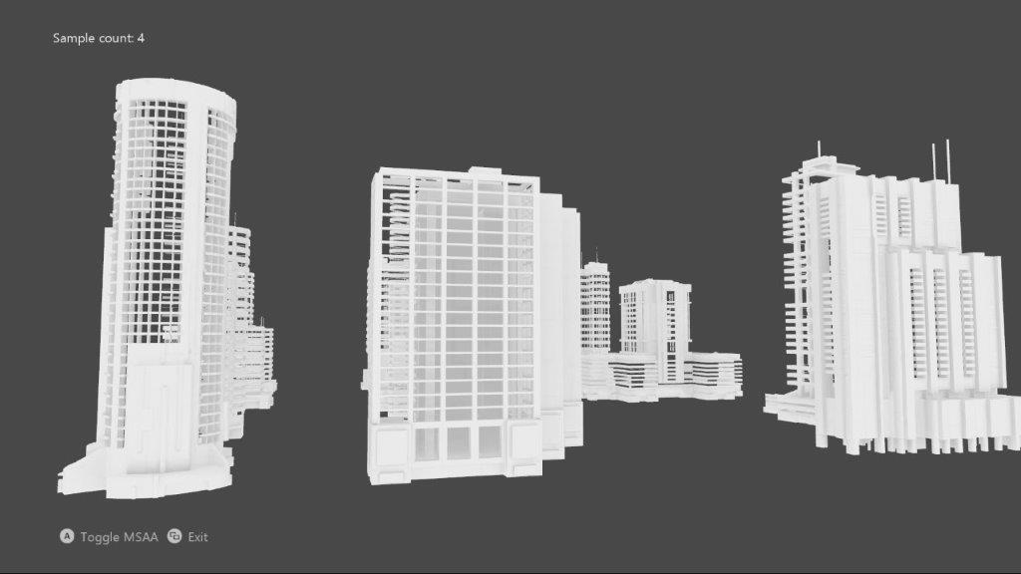

# Description

This sample implements an MSAA render target & depth/stencil buffer for a 3D scene using DirectX 11.

# Using the sample

|  |  |  |
| --- | --- | --- |
| Action | Gamepad | Keyboard |
| Toggle MSAA vs. single-sample | A button | Space |
| Exit | View Button | Esc |

# Implementation notes

The UI is drawn without MSAA, and makes use of an explicit resolve rather than relying on an implicit resolve of an MSAA swap chain.

## System Requirements

This sample is compatible with Windows 8 or later.

This sample will also run on Windows 7 Service Pack 1 provided the DirectX 11.1 Runtime has been installed ([KB 2670838](https://support.microsoft.com/en-us/help/2670838/platform-update-for-windows-7-sp1-and-windows-server-2008-r2-sp1)). See [this blog post](https://blogs.msdn.microsoft.com/chuckw/2013/02/26/directx-11-1-and-windows-7-update/) for additional information.

# Known issues

* Due to a bug in the Windows 10 validation layer prior to the Windows 10 Fall Creators Update (16299), a DirectX 11 Resolve with an sRGB format using new “flip-style” swapchain would fail. This has been fixed in the newer versions of Windows 10.

# Update history

Initial release May 2018.