Simple MSAA for DirectX 12

*This sample is compatible with the Windows 10 Anniversary Update SDK (14393)*

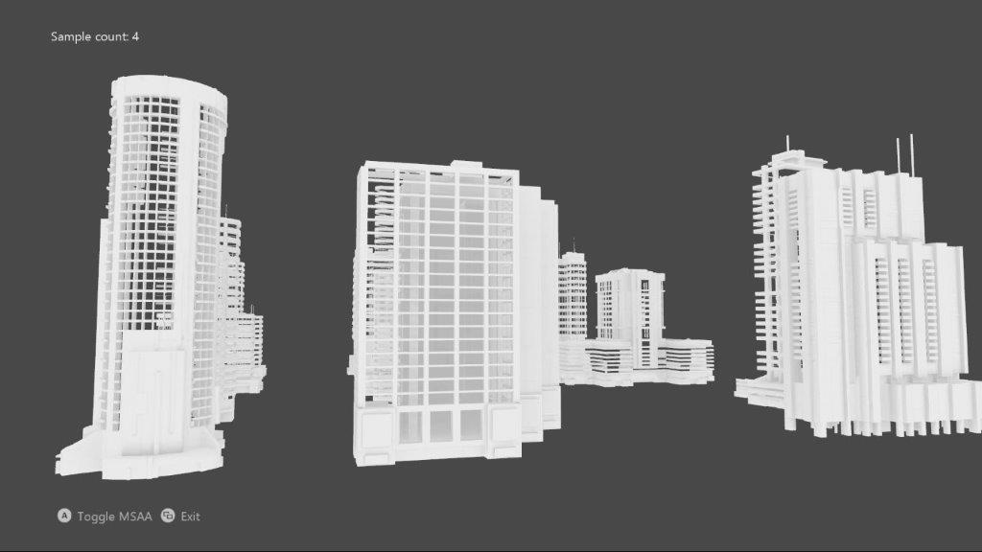

# Description

This sample implements an MSAA render target & depth/stencil buffer for a 3D scene using DirectX 12.

# Using the sample

|  |  |  |
| --- | --- | --- |
| Action | Gamepad | Keyboard |
| Toggle MSAA vs. single-sample | A button | Space |
| Exit | View Button | Esc |

# Implementation notes

The UI is drawn without MSAA, and makes use of an explicit resolve. Note that DirectX12 does not support using an implicit resolve of an MSAA swap chain as was the case with ‘classic’ DirectX 11.

# Known issues

* Due to a bug in the Windows 10 validation layer prior to the Windows 10 Creators Update (15063), a DirectX 12 Resolve with an sRGB format using new “flip-style” swapchain would fail. This has been fixed in the newer versions of Windows 10.

# Update history

Initial release May 2018.