Simple Texture Sample

# *This sample is compatible with the Windows 10 Anniversary Update SDK (14393)*

# Description

This sample demonstrates how to render a simple textured quad using Direct3D 11.

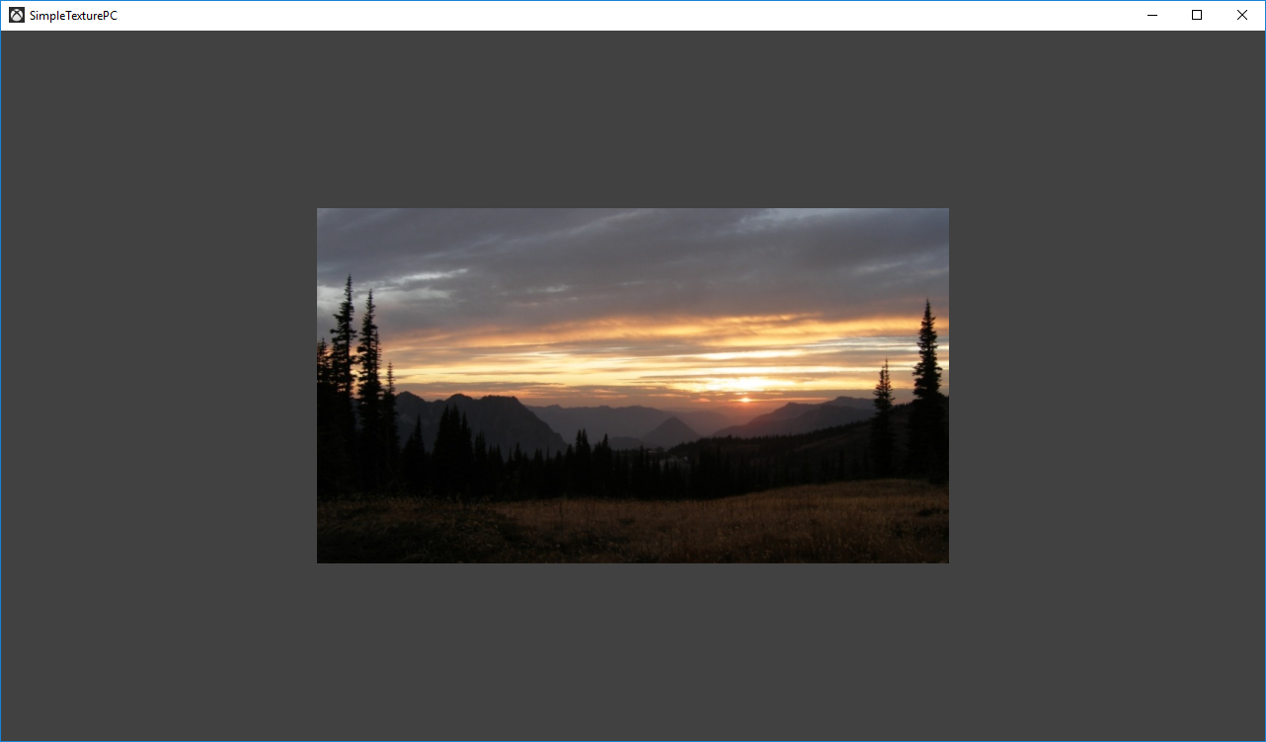

# Using the sample

The sample has no controls other than exiting.

# Implementation notes

The texture is loaded here using a simple helper that uses the Windows Imaging Component (WIC) and is designed for simplicity of learning. For production use, you should look at the DirectX Tool Kit’s [DDSTextureLoader](https://github.com/Microsoft/DirectXTK/wiki/DDSTextureLoader) and [WICTextureLoader](https://github.com/Microsoft/DirectXTK/wiki/WICTextureLoader).

## System Requirements

This sample is compatible with Windows 8 or later.

This sample will also run on Windows 7 Service Pack 1 provided the DirectX 11.1 Runtime has been installed ([KB 2670838](https://support.microsoft.com/en-us/help/2670838/platform-update-for-windows-7-sp1-and-windows-server-2008-r2-sp1)). See [this blog post](https://blogs.msdn.microsoft.com/chuckw/2013/02/26/directx-11-1-and-windows-7-update/) for additional information.

# Update history

Initial release April 2016