Simple Triangle Sample

# *This sample is compatible with the Windows 10 Anniversary Update SDK (14393)*

# Description

This sample demonstrates how to create a static Direct3D vertex buffer to render a triangle on screen.

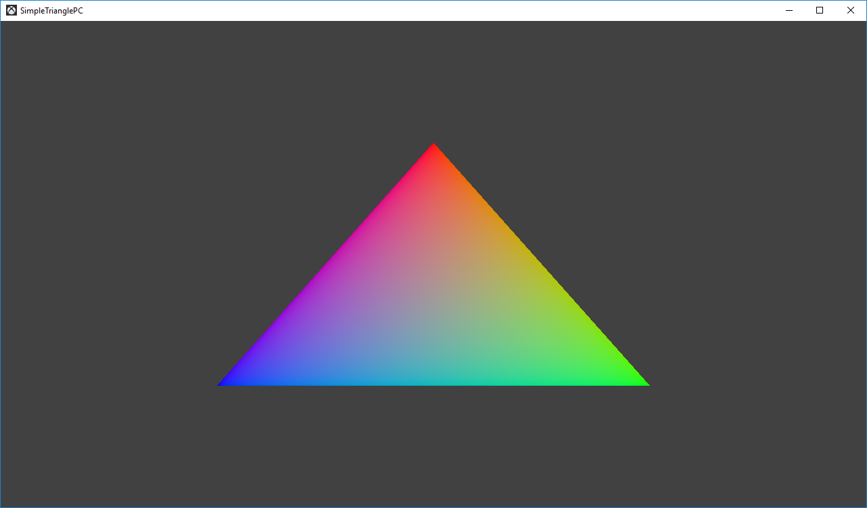

# Using the sample

The sample has no controls other than exiting.

# Implementation notes

The primary purpose of this sample is to familiarize the reader with the ATG samples template structure, as well as provide a simple demonstration of using Direct3D 11 APIs.

**CreateDeviceDependentResources**: This is where the compiled vertex and pixel shaders blobs are loaded and the various Direct3D rendering resources are created. *The shaders are compiled by Visual Studio.*

**Render:** This is where the triangle is rendered and presented to the screen.

For details on device creation and presentation handling, see [DeviceResources](https://github.com/Microsoft/DirectXTK/wiki/DeviceResources).

For details on the use of the loop timer, see [StepTimer](https://github.com/Microsoft/DirectXTK/wiki/StepTimer).

## System Requirements

This sample is compatible with Windows 8 or later.

This sample will also run on Windows 7 Service Pack 1 provided the DirectX 11.1 Runtime has been installed ([KB 2670838](https://support.microsoft.com/en-us/help/2670838/platform-update-for-windows-7-sp1-and-windows-server-2008-r2-sp1)). See [this blog post](https://blogs.msdn.microsoft.com/chuckw/2013/02/26/directx-11-1-and-windows-7-update/) for additional information.

# Update history

Initial release March 2016