Simple Raytracing Instancing PC (DXR)

*This sample is compatible with the Windows 10 May 2019 Update SDK (18362)*

# Description

This sample demonstrates how to set up [DirectX Raytracing (DXR)](https://docs.microsoft.com/en-us/windows/desktop/direct3d12/direct3d-12-raytracing) and render a number of triangles with instancing.

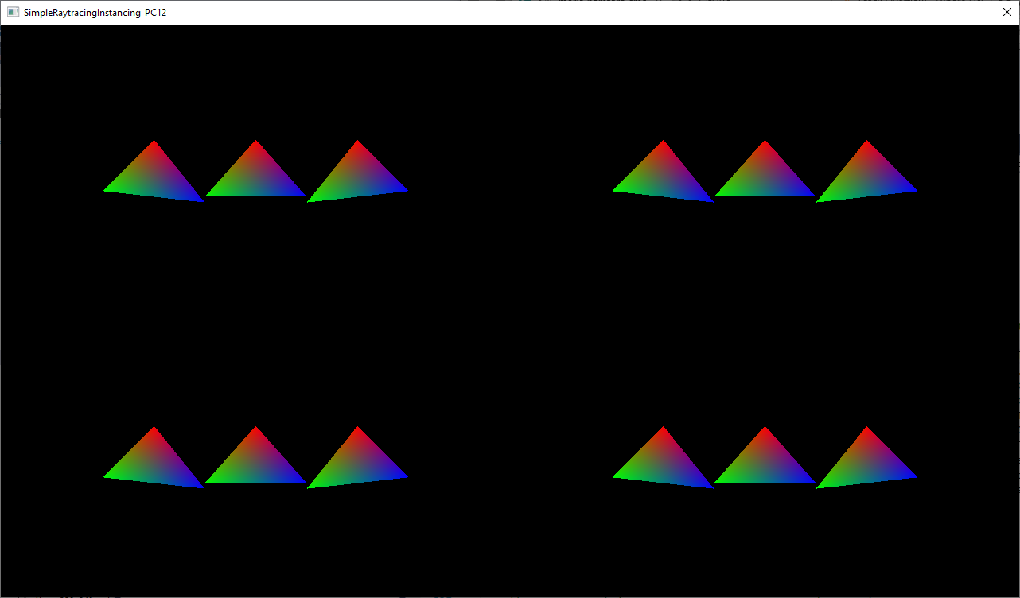

# Setup notes

DirectX Raytracing requires:

* Windows 10 October 2018 Update (17763) or later
* DirectX12 video card & driver that supports DirectX Raytracing
  + e.x. nVIDIA: Pascal, Volta, or Turing card

# Using the sample

The sample has no controls other than exiting.

# Update history

Initial release June 2019.