Simple Play Sound Stream Sample

*This sample is compatible with the Windows 10 October 2018 Update SDK (17763)*

# Description

This sample demonstrates how to stream a wav file using XAudio2 on the Xbox One.

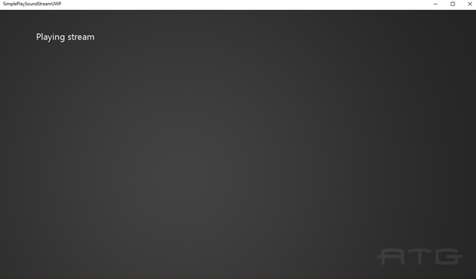

# Using the sample

The sample has no controls other than exiting via the View button.

# Implementation notes

This sample demonstrates how to stream wav files using its own WAV file parser.

For other examples of doing streaming with XAudio2, see [GitHub](https://github.com/walbourn/directx-sdk-samples/tree/master/XAudio2):

* **XAudio2AsyncStream** which prepares the .WAV data on disk to support Win32 non-buffered overlapped I/O
* **XAudio2MFStream** which uses Media Foundation Source Reader to decompress the data from an WMA file.

# Known issues

This sample does not support streaming xWMA .wav files.

# Update history

Initial release September 2018

# Privacy statement

When compiling and running a sample, the file name of the sample executable will be sent to Microsoft to help track sample usage. To opt-out of this data collection, you can remove the block of code in Main.cpp labeled “Sample Usage Telemetry”.

For more information about Microsoft’s privacy policies in general, see the [Microsoft Privacy Statement](https://privacy.microsoft.com/en-us/privacystatement/).