Simple WASAPI Play Sound Sample

*This sample is compatible with the Windows 10 October 2018 Update SDK (17763)*

# Description

This sample demonstrates how to play setup and play a simple sound (sine tone) to a WASAPI render endpoint in a Universal Windows Platform (UWP) app.

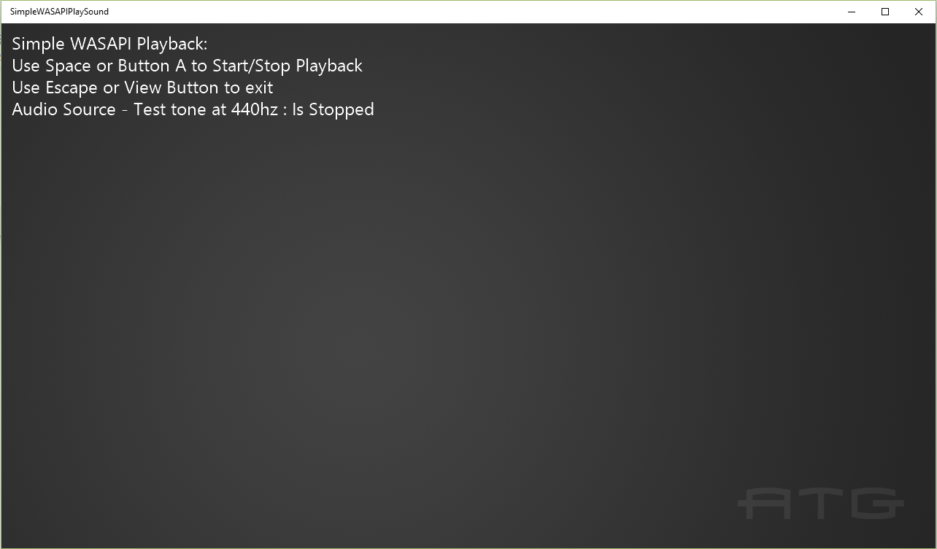

# Using the sample

Use Spacebar on keyboard or Button A on gamepad to start and stop the playback. Use Escape on keyboard or View Button to exit the app.

# Implementation notes

For more information on WASAPI see [MSDN](https://msdn.microsoft.com/en-us/library/windows/desktop/dd371455.aspx).

# Update history

Initial release May 2016

August 2018: Added support for changing renderers

# Privacy statement

When compiling and running a sample, the file name of the sample executable will be sent to Microsoft to help track sample usage. To opt-out of this data collection, you can remove the block of code in Main.cpp labeled “Sample Usage Telemetry”.

For more information about Microsoft’s privacy policies in general, see the [Microsoft Privacy Statement](https://privacy.microsoft.com/en-us/privacystatement/).