Simple Play Sound Sample

*This sample is compatible with the November 2015 Xbox One XDK or later.*

# Description

This sample demonstrates how to play a wav file using XAudio2 on the Xbox One.

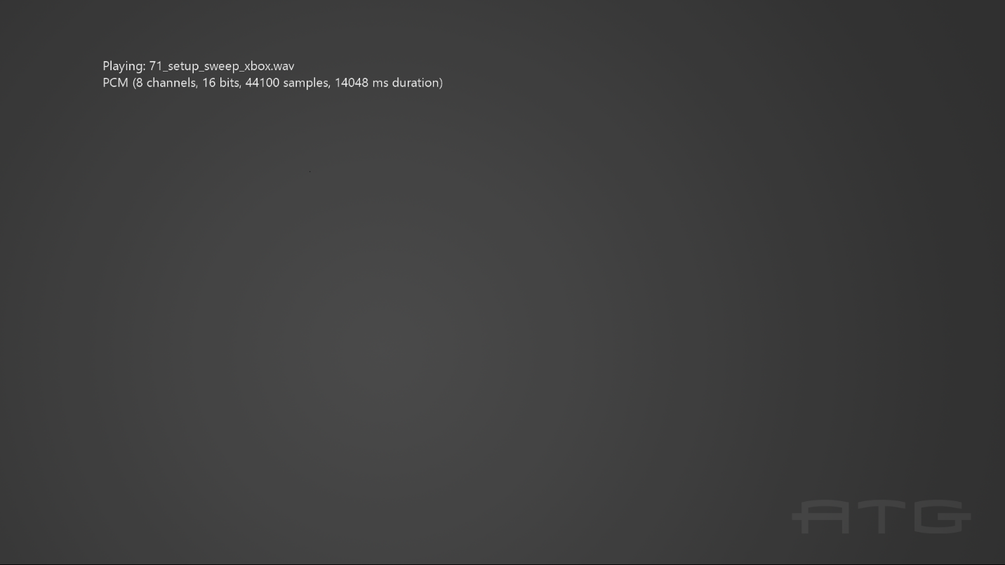

# Using the sample

The sample has no controls other than exiting via the View button. It automatically advances through the sample wav files as each completes.

# Implementation notes

This sample demonstrates how to play PCM, ADPCM, xWMA, and XMA2 format wav files. It uses helper code in the *ATG Tool Kit* files WAVFileReader.h/.cpp. This implements a simple wav file parser, along with code for computing the play time of the supported sound formats.

# Update history

Initial release March 2012. Rewrite using new ATG sample template released March 2016.

# Privacy statement

When compiling and running a sample, the file name of the sample executable will be sent to Microsoft to help track sample usage. To opt-out of this data collection, you can remove the block of code in Main.cpp labeled “Sample Usage Telemetry”.

For more information about Microsoft’s privacy policies in general, see the [Microsoft Privacy Statement](https://privacy.microsoft.com/en-us/privacystatement/).