

Advanced ESRAM 12 Sample

*\* This sample is compatible with the October 2016 Xbox One XDK.*

# Description

This sample demonstrates the use of advanced DirectX 12.x memory features to effectively alias memory for D3D resources. The APIs at the core of this sample are ID3D12CommandQueue’s ‘CopyPageMappingsX’ and ‘CopyPageMappingsBatchX’. These functions provide the ability to copy CPU page table entries to the GPU on the GPU timeline, allowing fully-virtual D3D resources to be mapped to memory pages on the fly.

Using this functionality, the sample implements a transient resource allocator that stages ESRAM & DRAM at the 64 KB page granularity. This keeps the GPU memory usage of the frame optimally compact which is used to leverage the full capability of ESRAM. Its interface mirrors pointed aspects of the XGMemoryLayout’s page mapping functions from the XG Memory library.

Note: The Xbox One X doesn’t have ESRAM, instead leveraging higher bandwidth DRAM. On this console the sample will simply render the scene with all ESRAM options and visualizations disabled.

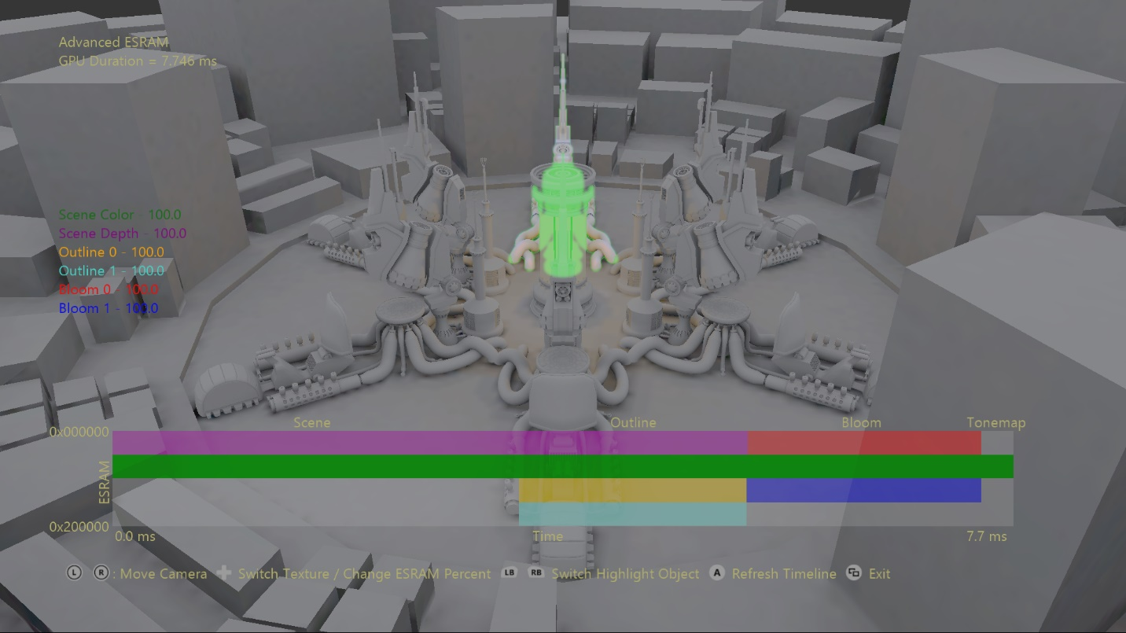

# Using the sample

The main functionality of the sample allows manipulation of where transient texture resources are allocated. The resources used in the frame are textures for scene color, scene depth, two for outline, and two for bloom. The resources’ ESRAM composition is displayed on the far left as a percentage of the resource memory. A visualization showcasing the layout of ESRAM provides immediate visual feedback of changes to each texture’s ESRAM & DRAM composition. The ESRAM footprint of each resource is displayed along the Y-axis, while their lifetime is visible along the X-axis. The GPU timings used along the temporal axis can be refreshed with the press of a button.

## Controls

|  |  |
| --- | --- |
| Action | Gamepad |
| Move camera toward/away from origin | Left Thumbstick Up/Down |
| Orbit camera | Right Thumbstick |
| Reset camera | Right Thumbstick (Click) |
| Cycle Transient Texture | D-Pad Left/Right |
| Change ESRAM Percentage | D-Pad Up/Down |
| Cycle Highlighted Object | Left/Right Bumper |
| Refresh Timeline | A Button |
| Exit | View Button |

# Implementation notes

A large virtual address space (VAS) is created to map blocks of 64 KB memory pages (page pools) allocated from ESRAM and DRAM. Page pools are registered with DirectX12 using ID3D12Device’s ‘RegisterPagePoolX’ function – when no longer in use they must be unregistered with ‘UnregisterPagePoolX’. This mapping serves to stage CPU page table entries for directly copying to GPU page tables.

The ID3D12CommandQueue’s ‘CopyPageMappingsX’ or ‘CopyPageMappingsBatchX’ functions enable page ranges within these page pools to be mapped to specified GPU virtual addresses on the GPU timeline. This allows fully-virtual D3D resources to be flexibly mapped to 64 KB physical pages on the fly. This capability makes memory aliasing between resources trivial and a whole heap-a-fun!

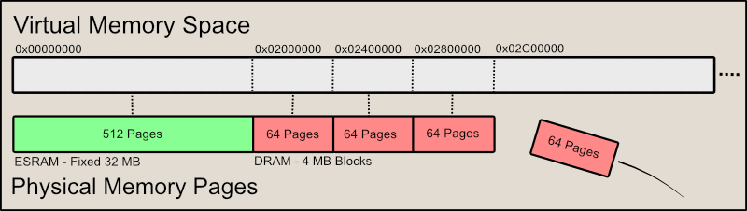

Figure 1: Memory mapping paradigm used in the sample. ESRAM (if available) is mapped to the first 32 MB of the VAS, while 4 MB DRAM page pools are appended as needed.

The creation and management of page blocks is performed by the PageAllocator class. A virtual address range is provided, and the allocator maps page pools into this range sequentially as needed. The page pools are then registered with DirectX12 using ‘RegisterPagePoolX’. The usage of the allocators pages is fully tracked – it allocates pages from first to last, replaces pages as they’re released back.

The TransientCache is responsible for managing the fully-virtual D3D resources. These are created on demand but are cached to avoid unnecessary overhead recreating common resources. The memory overhead of caching these resources is effectively zero since they only allocate virtual address space. Each resource may only be allocated once per frame.

This TransientAllocator class uses the page allocators and transient cache to fulfill resource requests to the user. When a resource is requested it grabs an instance from the TransientCache. It then allocates the required number of pages from the PageAllocators, parsing tokens to determine whether to use ESRAM or DRAM at a page-level granularity. The proper structures are then generated to later be supplied to ‘CopyPageMappingsBatchX’, namely vectors of D3D12XBOX_PAGE_MAPPING_BATCH and D3D12XBOX_PAGE_MAPPING_RANGE structures.

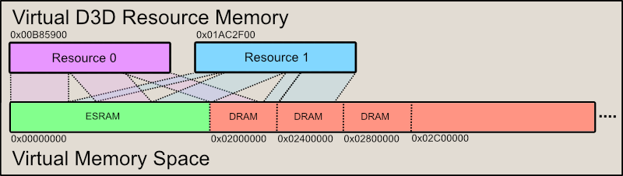

Figure 2: Virtual D3D resources being mapped to page ranges within the page pools to satisfy its memory requirement. These mappings are the result of the CopyPageMappingsX and CopyPageMappingsBatchX calls. For visual simplicity only two resources were used in this visualization, and no memory was aliased. However, memory aliasing is an expected benefit of this technique.

Due to memory aliasing the TransientAllocator is also responsible for performing shader and cache flushes where necessary. In DirectX12 flushes are inserted as part of resource barriers. Since we’ve circumvented this system to perform memory aliasing we must manually insert our own flushes. TransientAllocator determines which shader stages and caches should be flushed by examining the resource’s associated views.

Finally, before the command list using the allocated transient resources is submitted to its command queue, ‘Finalize’ must be called on the TransientAllocator to finish the resource mapping. It’s at this point the ‘CopyPageMappingsBatchX’ call is placed on the command queue, which sets up the resources’ memory mappings to be used in the subsequent command list.

# Update history

8/6/2018 – Sample creation.

# Privacy Statement

When compiling and running a sample, the file name of the sample executable will be sent to Microsoft to help track sample usage. To opt-out of this data collection, you can remove the block of code in Main.cpp labeled “Sample Usage Telemetry”.

For more information about Microsoft’s privacy policies in general, see the [Microsoft Privacy Statement](https://privacy.microsoft.com/en-us/privacystatement/).