

AsyncPresent Sample

*\* This sample is compatible with the August 2016 Xbox One XDK.*

# Description

This sample demonstrates how to yield the CPU rather than stalling when the title calls Present.

# Building the Sample

No special instructions

# Using the sample

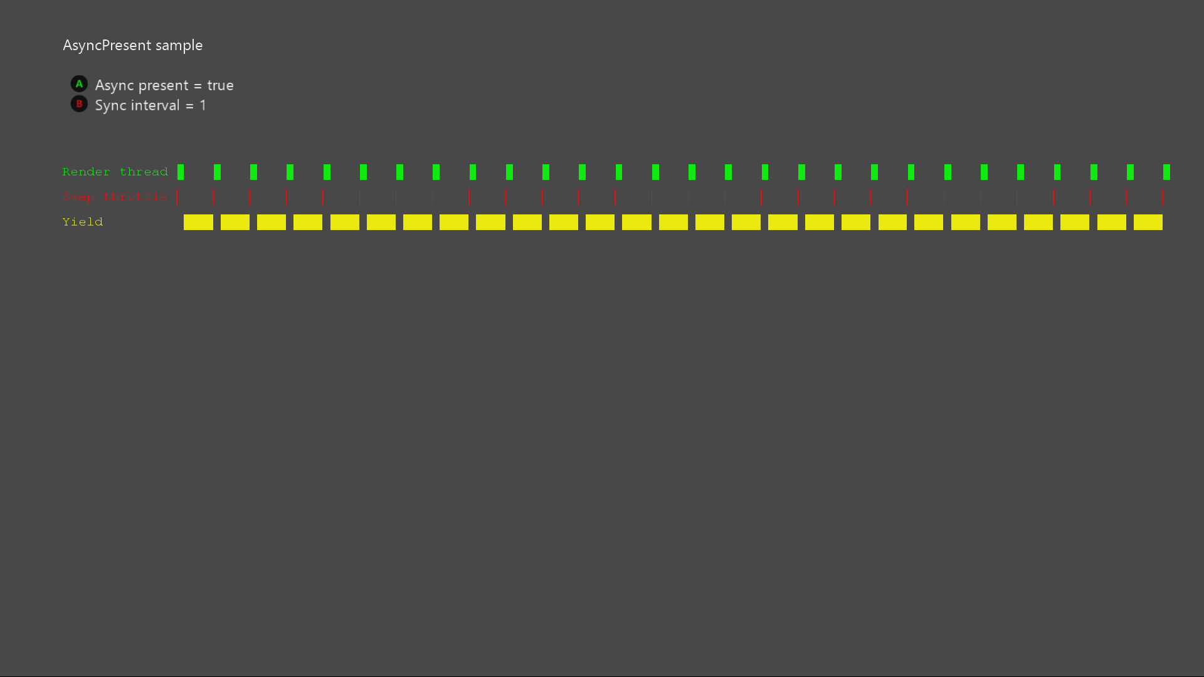

|  |  |
| --- | --- |
| Action | Gamepad |
| Toggle async present | A button |
| Modify sync interval | B button |
| Exit | View Button |

# Implementation notes

# This sample demonstrates the use of two new features in the July 2014 XDK:

# DXGI_PRESENT_DO_NOT_WAIT (exists on PC too): Allows calls to DXGIXPresentArray to return DXGI_ERROR_WAS_STILL_DRAWING if the swap chain isn't ready, rather than stalling.

# DXGIXSetVLineNotification (Xbox only): The title registers to receive a callback when scanout reaches a particular v-line.

# Titles can apply these features to avoid the D3D swap throttle, and call Present just in time for it to succeed. The CPU time which would normally be lost can instead be dedicated to other threads.

# Known issues

None

# Update history

* 2015/06 – initial release
* 2018/08 – port to D3D12 and new sample framework

# Privacy Statement

When compiling and running a sample, the file name of the sample executable will be sent to Microsoft to help track sample usage. To opt-out of this data collection, you can remove the block of code in Main.cpp labeled “Sample Usage Telemetry”.

For more information about Microsoft’s privacy policies in general, see the [Microsoft Privacy Statement](https://privacy.microsoft.com/en-us/privacystatement/).