

MP4Reader Sample

*This sample is compatible with the March 2016 Xbox One XDK.*

# Description

This sample shows how the Media Foundation Source Reader can be used to read a MP4 file which contains an H264 video stream, and decode it using hardware acceleration. It also demonstrates decoding the audio stream using XAudio2 and WASAPI. This sample is particularly useful for titles that need to integrate H264 video decoding into their existing movie playback pipeline.

This sample is not intended to demonstrate a movie playback solution, as it does not support synchronized playback of video based on the video source frame-rate.

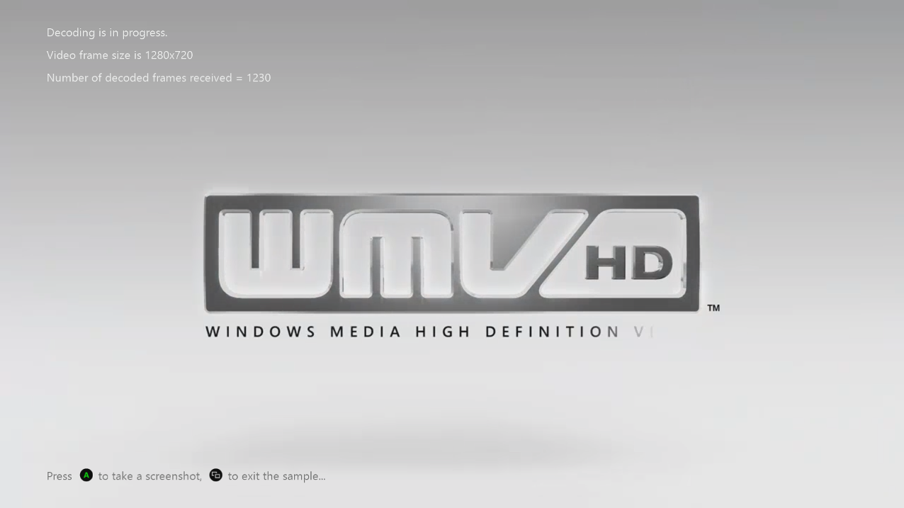

# Using the sample

This sample uses the following controls.

|  |  |
| --- | --- |
| Action | Gamepad |
| Take a screen shot | A button |
| Exit | View Button |

# Implementation notes

This sample reads an MPEG 4 file, which contains an H264 video stream, from the Media\Videos folder, and renders the decoded frames to the screen as soon as they are produced.

This sample only uses hardware accelerated decoding and does not support software decoding of the H.264 video stream. The audio streams are decoded using Microsoft Media Foundation and can be configured to render audio with XAudio2 or WASAPI. This is controlled by modifying which preprocessor define is set at the top of MP4Reader.h:

//

// Use one of these two definitions to see how the two different technologies perform.

//

//#define USE_XAUDIO2

#define USE_WASAPI

vs.

//

// Use one of these two definitions to see how the two different technologies perform.

//

#define USE_XAUDIO2

//#define USE_WASAPI

# Known issues

This sample doesn’t support DirectX 12 because the IXboxMV12MFSampleRenderer only supports DirectX 11.

# Update history

The original version using the legacy XSF-based sample framework was released in 2012. This rewrite was made in August 2018.

# Privacy Statement

When compiling and running a sample, the file name of the sample executable will be sent to Microsoft to help track sample usage. To opt-out of this data collection, you can remove the block of code in Main.cpp labeled “Sample Usage Telemetry”.

For more information about Microsoft’s privacy policies in general, see the [Microsoft Privacy Statement](https://privacy.microsoft.com/en-us/privacystatement/).